User Guide:

<https://docs.google.com/document/d/1lY3fYk0fA0PzhwkRBEqM5-i-Nke7znEMgDH-JxXqDa4/edit?usp=sharing>

1. Create a new folder.

- For this example it will be named *Wanzhen Folder*.

2. Then, create a new project in *Wanzhen Folder.*

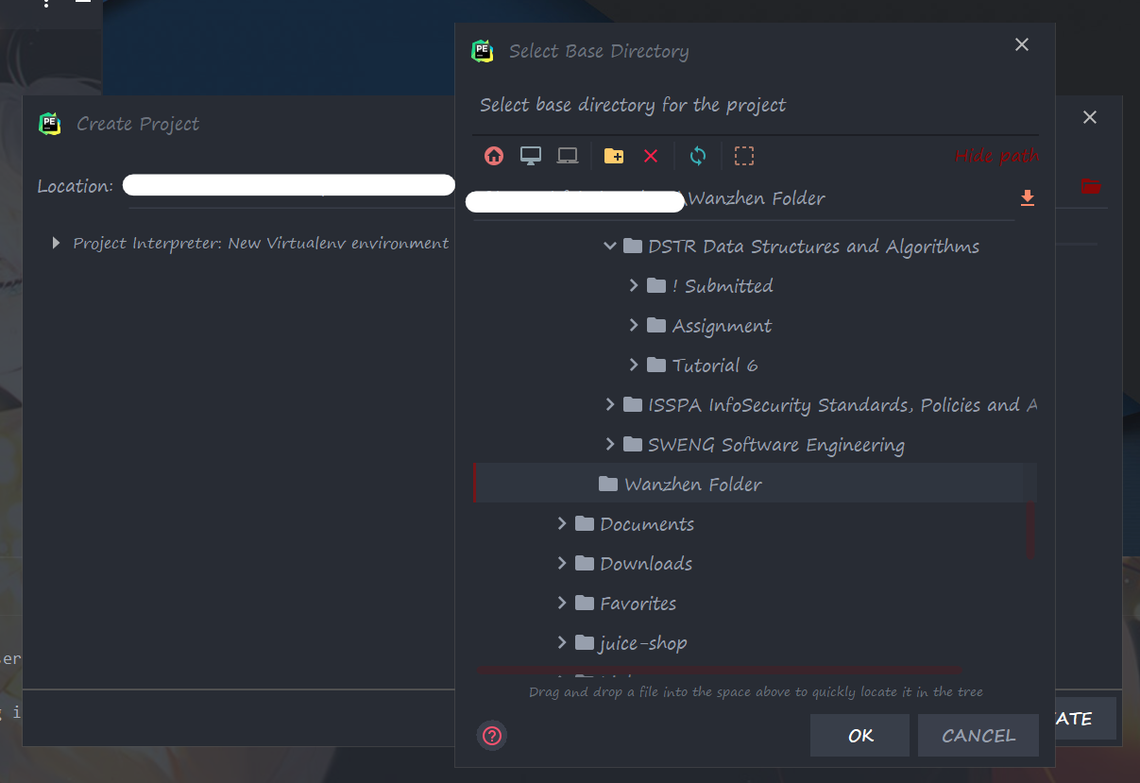

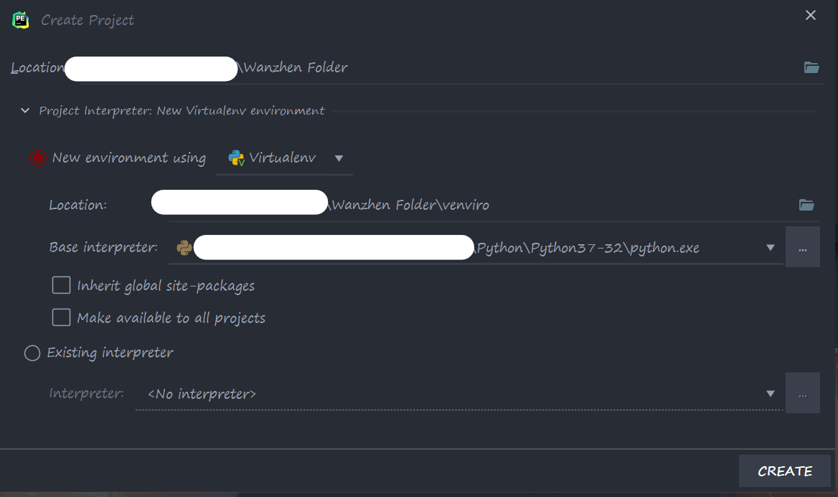

2. Extract zipped files from Blackboard to *Wanzhen Folder*

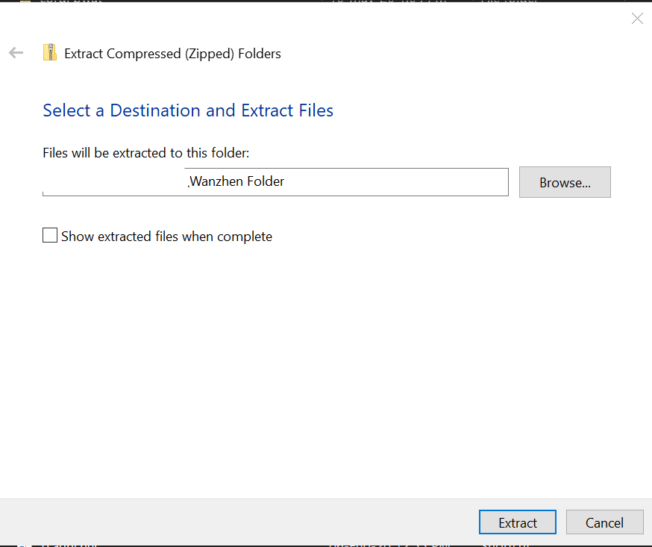

3. Looks like this

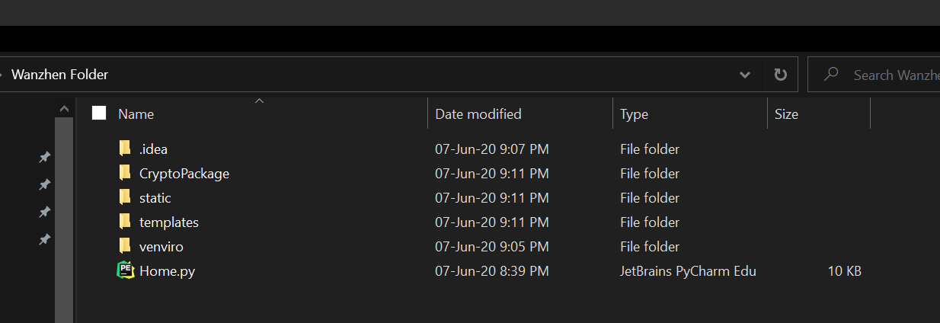

4. Install flask in python terminal

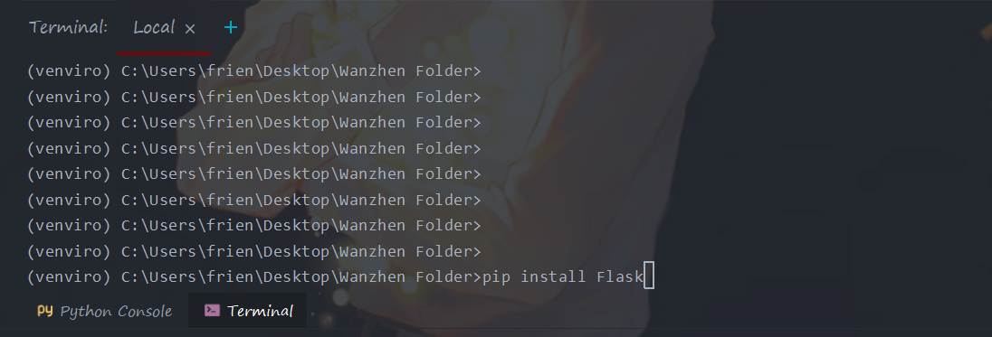

5. Go to PyCharm’s settings, click on project interpreter

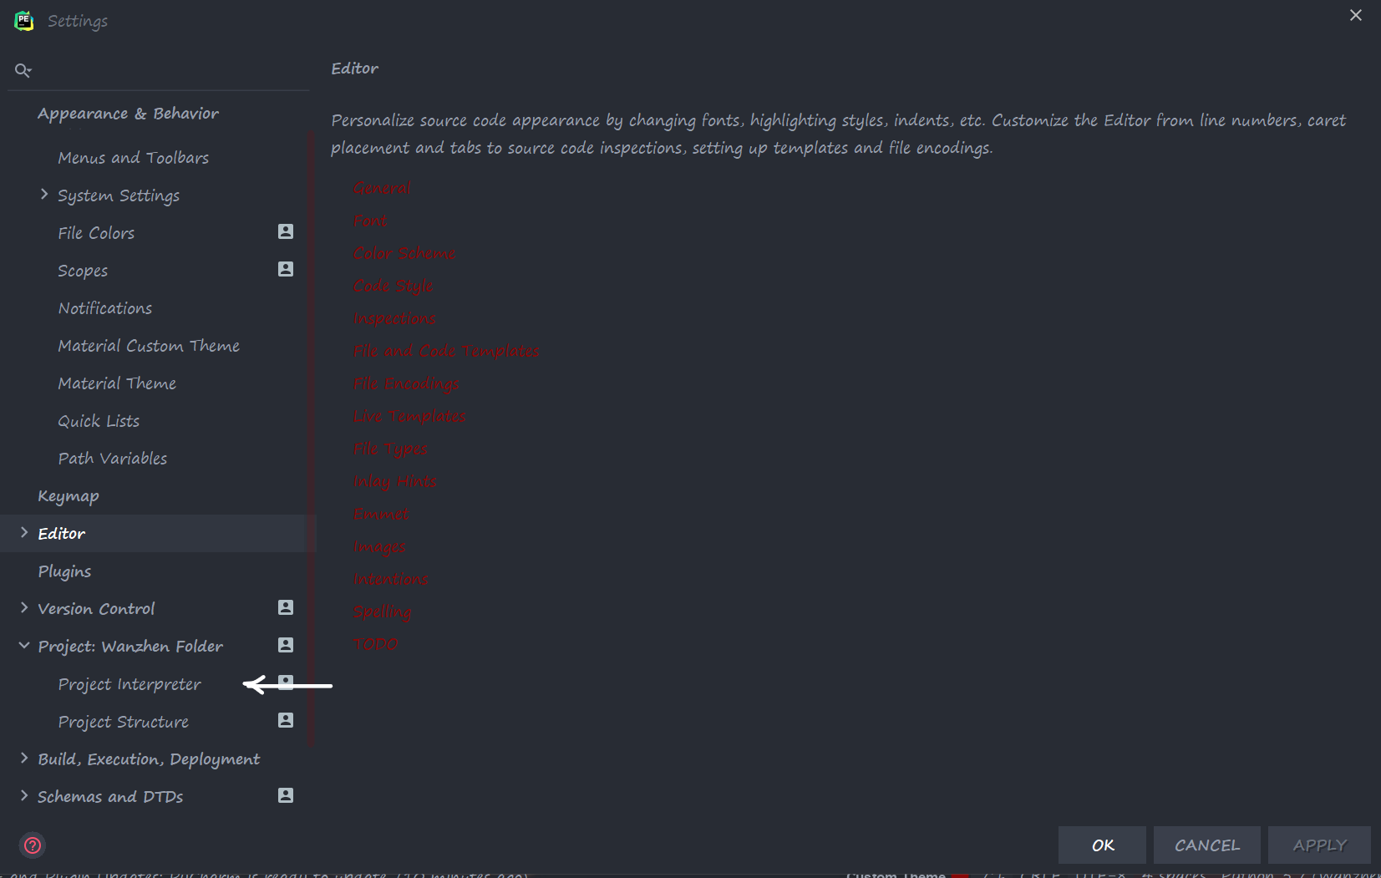

6. Click on addition sign

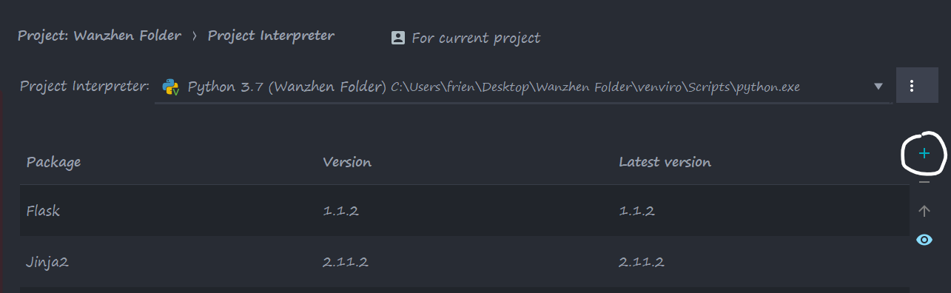

7. Search for package PyCryptoDome and install it

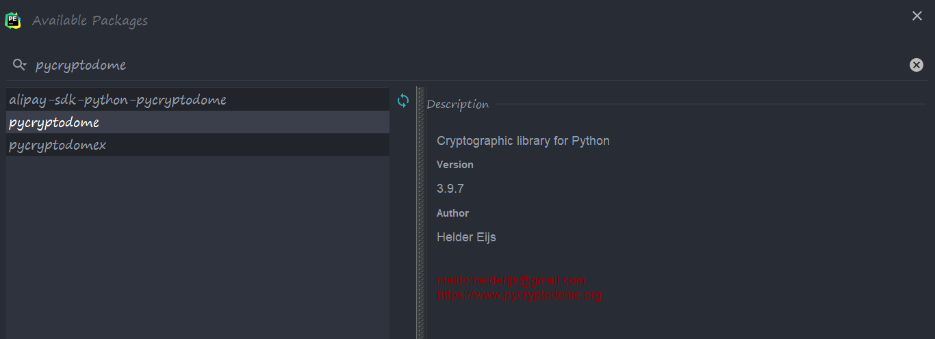

8. Check for all the installed packages by entering pip list into python terminal

It should look like this with pycryptodome and Flask and Jinja2 installed

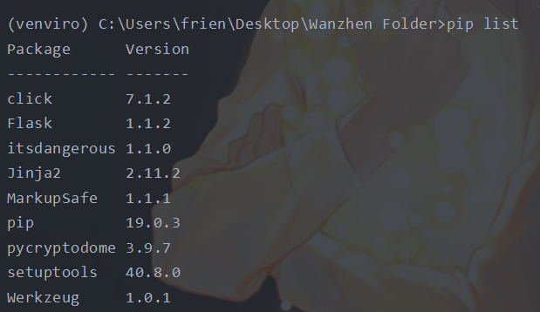

9. Go to Home.py and run it!

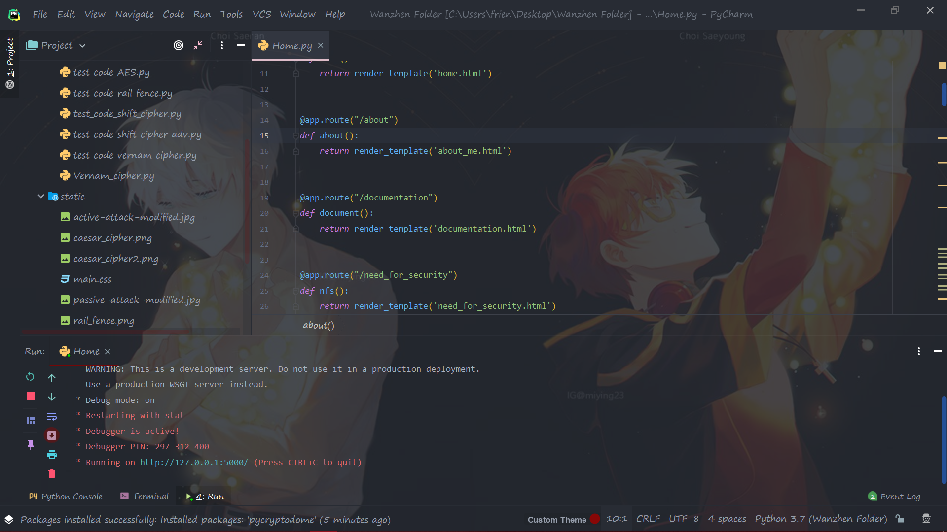

10. It should look like this!

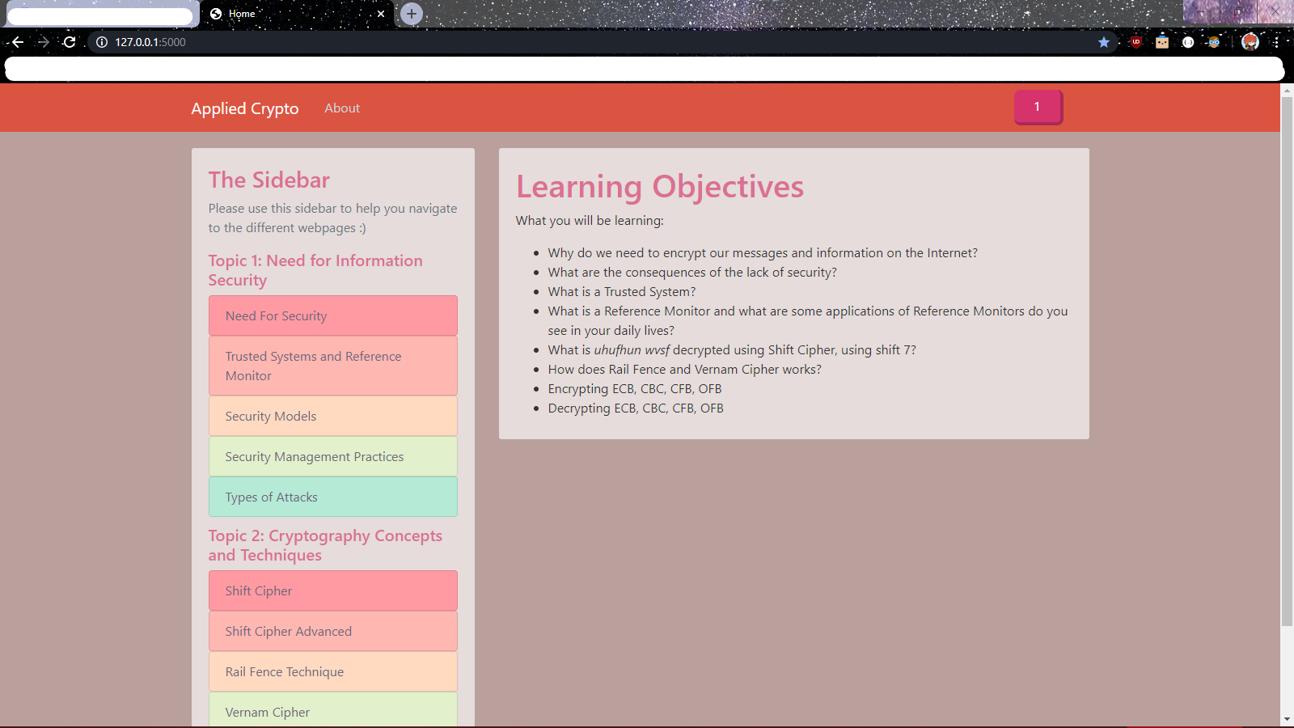

Any Technical Difficulties:

**MY CONTACT INFO**

[**lim.wanzhen.isme@gmail.com**](mailto:lim.wanzhen.isme@gmail.com)

**Please contact me if anything goes wrong or if you are unsure of how something (eg. Codes, installation, etc.) works.**

**Thank you very much**