Lubna Jamal

Capstone Project for IBM Professional Certificate

**Introduction:**

**Background:** According to a [2018 survey](https://www.statista.com/statistics/875526/share-alternative-diet-us-generation/), 50% of millennials in the United States opt for a vegetarian diet, and 38% prefer to go completely vegan. The graph below shows the further delineation by consumer group.

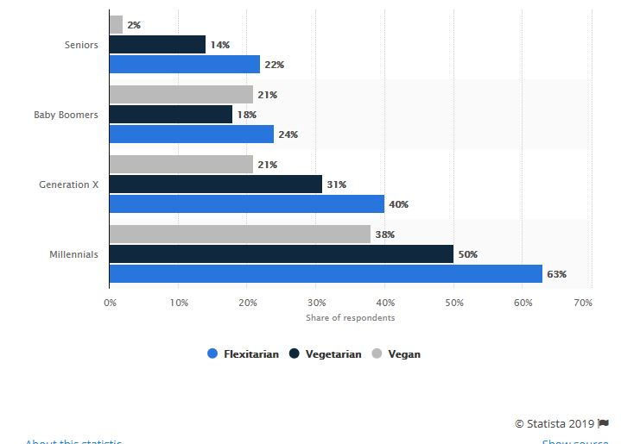

As is evident, there is a big market for opening a vegan/vegetarian restaurant as more consumers are opting for meat-free dishes. Flexitarians are defined as those that mostly adopt a plant-based diet with occasional meat consumption.

**Problem:**

A client wants to invest money to set up a vegan/vegetarian restaurant in a US metro area. They would like to know some statistical information with regards to how many vegetarian restaurants currently exist there. They would like to know how many restaurants in major metro areas offer vegetarian meals. Similarly, how many offer vegan options. In order to cater to the most popular demand, they would also like to analyze which cuisines are served up at most vegetarian restaurants. This would enable them to cater their menu according to market demand for vegetarian/vegan options.

**Interest:**

The restaurant industry in the United States has seen an increase in sales and profit-margins. The labor costs are mostly holding steady, and that coupled with the fact the most American like to eat out frequently, have signaled profitable business for the restaurant industry. However, there are a huge number of restaurants that already exist. In order for them to reap the profits, a restaurant has to set itself apart from the fierce competition. Hence, being on the forefront of the plant-based diet/vegan trend will prove to be a good option for opening a new restaurant.