|  |
| --- |
| iNoah |
| roWeb Engine |
| roWeb Engine System |

|  |
| --- |
| noahzao  2013/7/24 |

目录

introduction 2

develop environment 2

engine structure 2

com.inoah.ro 2

new structure 3

base user interface 3

character editor 4

job editor 5

skill editor 6

item editor 7

weapon editor 8

equip editor 9

monster editor 10

monster group editor 11

system config editor 12

# ****introduction****

## develop environment

develop platform: win7 flashbuilder4.7 airsdk3.7

target platform: pc, android, ios6, mac

using framework: Starling, Feathers, pureMVC, mornUI, Minimalcomps

# engine structure

[libCommon]

com.adobe.utils, feathers, pureMVC, starling

[dllLua]

flascc lua5.2

[project libMornUI]

mornUI

[project libMinimalcomps]

minimalcomps

[project libCore]

game.ui

inoah.data.map

inoah.game

## inoah.game

perLoader->Client->GameMediator->dllLua->load( game.lua )->initStarling()->run( game.lua )

ClientD5RoDemo.init()

façade-> new GameMediator

ClientD5RoDemo.tick()

GameMediator-> Starling-> starlingMain->mgrs

[assetMgr, textureMgr, sprMgr, displayMgr, keyMgr]

mornUI.init()->loginView->resInitLoad

GameMediator.onLogin()->initUserInfo()->resLoad()->mainView->mapMgr->battleMgr

mainView->mapView=>alertView=>joyStickView=>chatView=>skillView

mapMgr->mapMediator->changeMapCommand

battleMgr->battleMediator

# rmxp structure

## base user interface

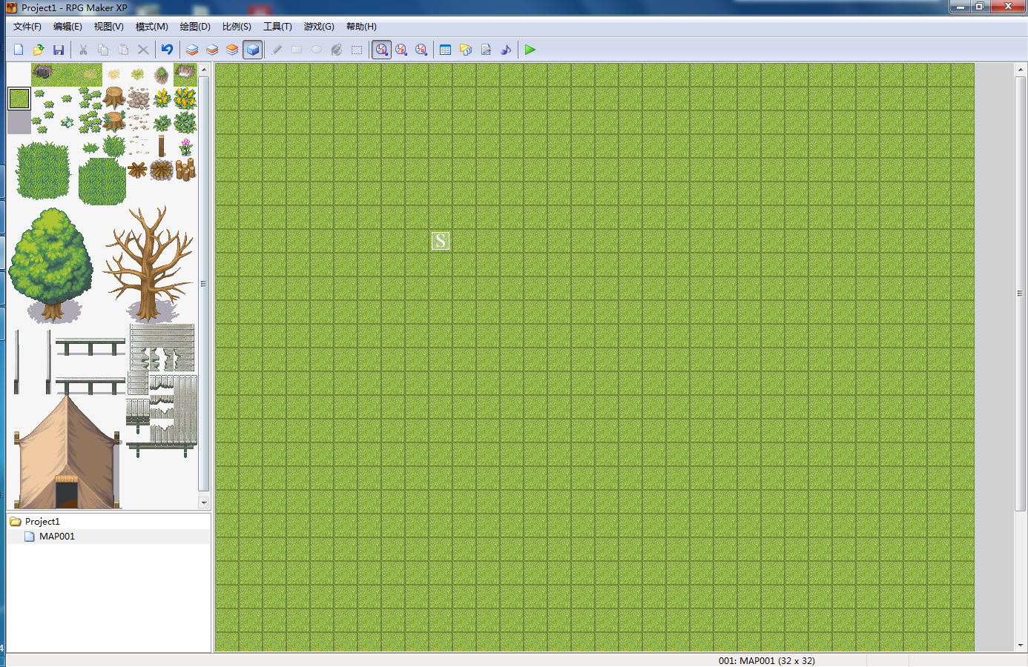

something like rmxp

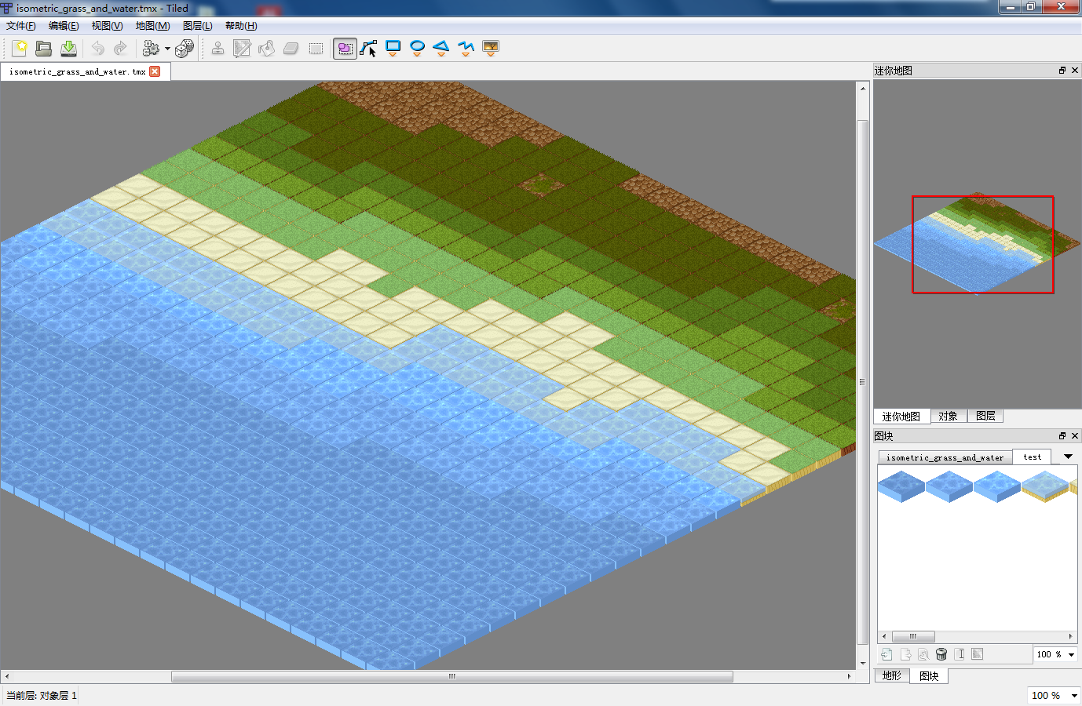

tiled mapeditor

## character editor

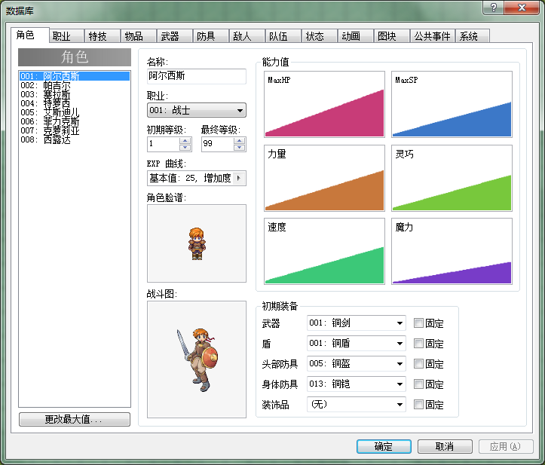

## job editor

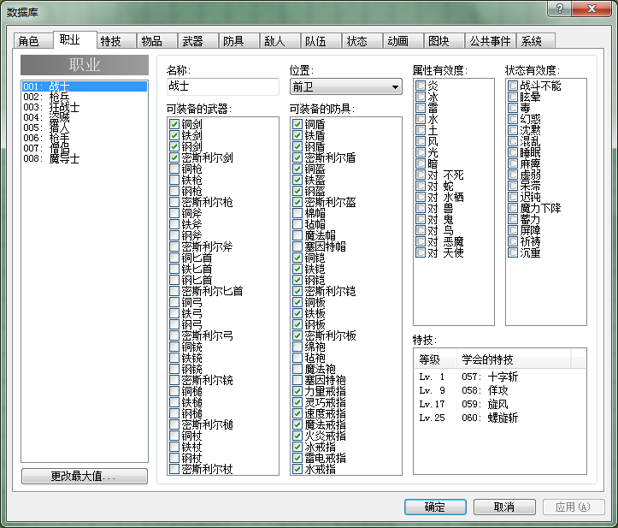

## skill editor

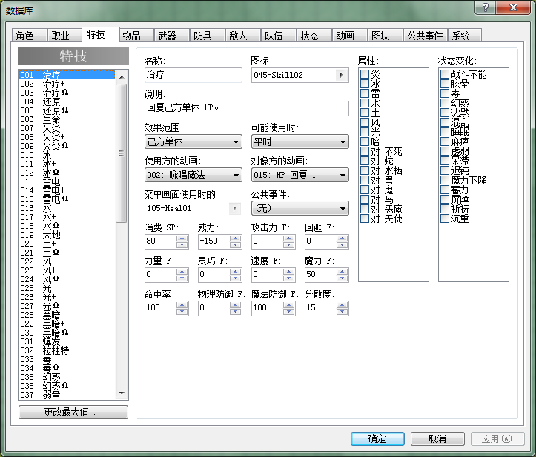

## item editor

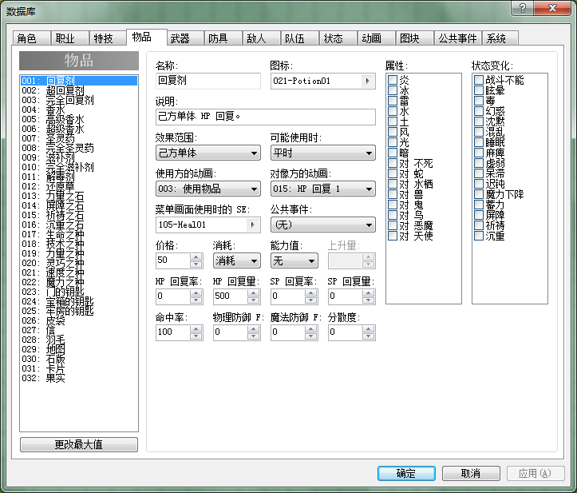

## weapon editor

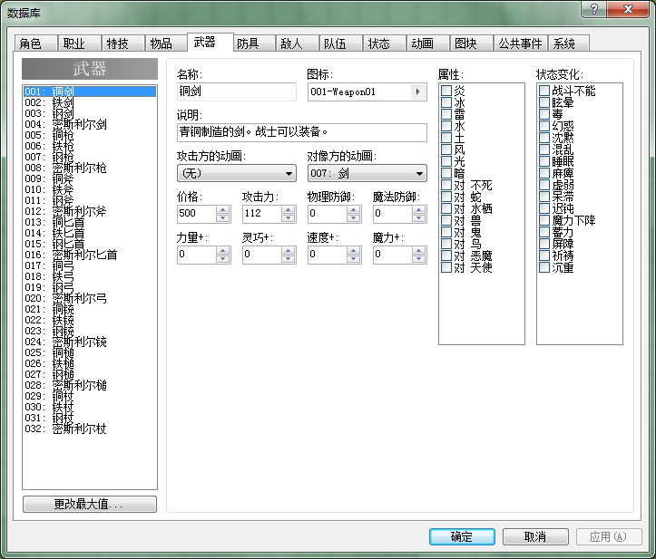

## equip editor

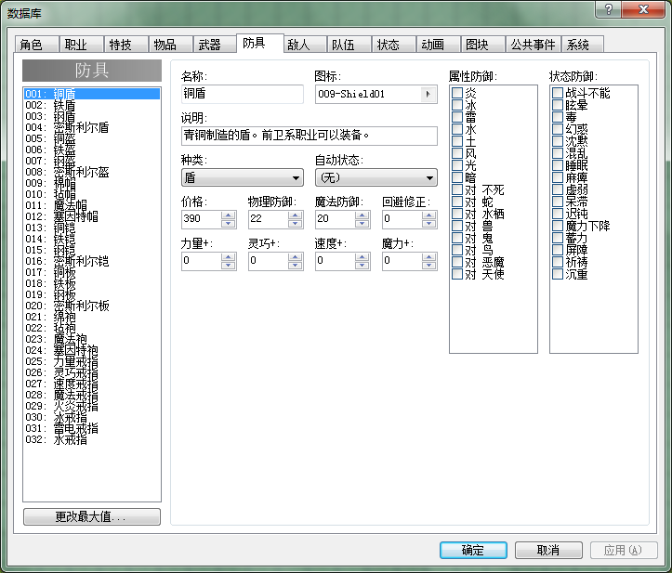

## monster editor

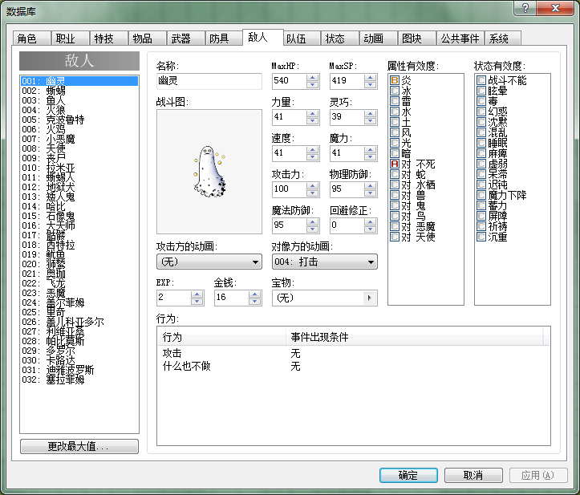

## monster group editor



## system config editor

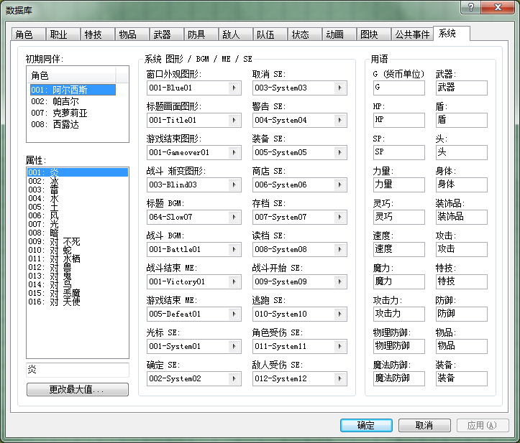

# data structure

## Global.as

IS_MOBILE

SCREEN_W, SCREEN_H

MAP_W, MAP_H

TILE_W, TILE_H

userInfo

debugTxt

ORDET_TIME

MAX_MONSTER_NUM

## sysConfig.xml

## languages.xml

## maps.xml

id

name

parent_id

order

expanded

scroll_x

scroll_y

## characters.xml

id

name

job

currentlv

maxlv

currentexp

characterres

maxhp

maxsp

str

dex

agi

int

weapon

equip

## jobs.xml

not avaliable

## skills.xml

## items.xml

## weapons.xml

## equips.xml

## monsters.xml

## monsterGroups.xml