# B00227257 – Michael Biggart – Coursework 2

Program has been tested and compiles successfully

* Ancestor inputs and stores successfully
* Able to add partner to a family members ID via integer input. If int input doesn’t match, then error displays
* Able to add a child to the family tree on to either ancestor or partner via int input is the ID of the family member
* Able to add additional partners and children on to either, ancestor, partner, or the children of their partners, to continue the family tree.
* Can’t add a partner to someone who already has a partner
* Can’t add a child with the same name to a family or error occurs
* Family members can’t have the same ID.
* The ID Counter is static which will create one copy of the counter variable that will be increase by +1 every time an object/node of the class is created. This is so that all objects of the class with have the same count value anywhere its used in the program.

Step 1 Compiled

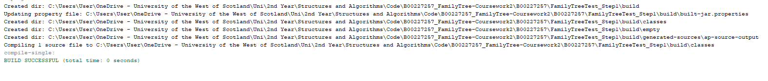

Step2 Compiled

