eWhammy Center Stability: Final Simulation Summary
  - A narrative summary of the problem, the design journey, and the final simulated solution
This document is written for readers who may not already know the eWhammy project, spring hysteresis, or the analog techniques used in the center-stability circuitry. The goal is not only to record the final result, but also to explain why earlier ideas were explored, what each one taught us, and why the final topology emerged as the best compromise.

1. The Problem We Are Solving
The eWhammy is an analog control-voltage system that tracks the motion of a spring-loaded arm. In a perfect world, when the player lets go of the arm, the control voltage would return to exactly the same center value every time. In the real world, the spring mechanism can return slightly differently depending on whether the arm was last bent upward or downward. That small return-to-center error is called hysteresis.
Why does hysteresis matter? Because the eWhammy is later interpreted as pitch control. A small voltage error at center becomes an audible pitch error. The challenge is to remove that lingering center error without making the arm feel sticky, without suppressing normal vibrato, and without adding awkward startup behavior or long-term drift.
In short, the problem is not merely to lock the center. The problem is to keep the center stable while preserving musical motion.

2. Key Terms
- Center stability: The ability of the output to return to the intended neutral value, here centered on VREF, after a bend or release.
- Spring hysteresis: The tendency of the spring mechanism to return to a slightly different resting position depending on the direction of the previous bend.
- Deadband: A small voltage window around center where the circuit forces or holds the output at the center value to suppress jitter or drift.
- High-pass bypass: An added path that lets faster motion, such as vibrato, pass through even while slower center-correction circuitry remains active.
- Differentiator: A stage that responds primarily to change. It turns motion into a signal proportional to rate of change.
- Integrator: A stage that accumulates the incoming signal over time. In this design it reconstructs position from the differentiated motion signal.
- Conditional reset or bleed: A reset path that is only enabled when the output is sufficiently close to center. It cleans up residual error without interfering with normal bends.

3. Design Requirements
The desired behavior became clearer as the simulations progressed. The final solution needed to satisfy all of the following at the same time:
- Return to center cleanly after large bends.
- Correct the lingering center error caused by spring hysteresis.
- Preserve normal vibrato rather than flattening it.
- Avoid a sticky or artificial feel near center.
- Avoid startup problems where the correction loop begins in the wrong state.
- Avoid long-term integrator drift.
- Remain simple enough to be practical in hardware.

4. The Simulation Input Model
All of the key simulations used a simplified behavioral source representing the raw Hall sensor output in the pre-gain domain. It is important to emphasize that this is not the final 5 V output domain. It is the smaller raw sensor domain before later amplification.
The model used the following assumptions:
- Resting baseline at 2.175 V
- Large upward bend reaching 2.425 V
- Return not to 2.175 V, but to 2.1825 V, representing a +7.5 mV spring-hysteresis shift after release
- A 5 Hz vibrato of ±10 mV applied for a limited time around the post-release center
- An initial delay before the first bend so startup behavior could be observed separately from bend behavior
This input model was deliberately chosen to test four things at once: large-signal bend handling, return-to-center behavior, hysteresis cleanup, and vibrato preservation. That made it far more useful than a simple sine wave or a purely symmetric step test.

5. The Design Journey
The final topology did not appear immediately. It emerged after several families of designs were explored and compared. Each one solved part of the problem and exposed the next missing piece.

5.1 Early deadband center-locking
The earliest family of solutions relied on deadband behavior near center. The basic idea was straightforward: define a small window around the center value and force the output to snap to or remain at 2.5 V while the signal is inside that window. This gave strong center stability, but it also introduced a familiar tradeoff. If the deadband is wide enough to cover the real mechanical hysteresis, the center can feel sticky and unresponsive.
This work evolved into the July 17, 2025 design described in “The E-Whammy: Center Stability Take Two.” That version used two offset half-wave precision rectifiers whose summed crossover naturally snapped the output to 2.5 V while avoiding the earlier jump that occurred when entering the deadband. It was elegant, and it taught an important lesson: center stability can be achieved very cleanly in principle, but explicit deadband behavior still tends to shape the feel at center. That article became a key milestone because it showed a more refined version of the deadband idea, not merely a rough first attempt.

5.2 Production deadband plus high-pass bypass
The next important milestone came much later, in the March 7, 2026 post “eWhammy: Last-Minute Refinements.” By then, practical production testing had revealed that the mass-produced spring plates exhibited more hysteresis than the earlier prototypes. Mechanical improvements such as a 3 mm fillet helped substantially, but some residual hysteresis remained. The workaround for that batch was a fixed deadband of ±2.5% plus a high-pass bypass so that small, faster wiggles could get through even while the center was still being stabilized by the deadband circuit.
This was a clever and practical production fix. It showed that a high-pass path could restore musical vibrato while a deadband handled the larger center problem. But it also made clear that the solution was now becoming layered and somewhat artificial. The deadband solved the center problem. The high-pass path then had to solve the musical feel problem created by the deadband. That was informative, but it suggested that an even cleaner architecture might exist.

5.3 Always-on DC servo
The next major line of thought was a DC servo. Instead of snapping to center with a deadband, one could compare the output to VREF and slowly integrate the error until the center drift disappeared. In principle, this is attractive because it replaces the hard center lock with continuous negative feedback. In practice, the plain always-on servo did center the output, but it also behaved exactly like a musician would fear: it fought sustained bends and suppressed vibrato. The faster the servo time constant, the stronger the suppression. Slowing the servo preserved more vibrato, but then the centering became sluggish. This revealed a fundamental compromise in the always-on approach.
That stage of the investigation was still extremely valuable. It proved that DC correction works, but it also proved that a correction loop which is always awake will inevitably start treating intentional motion as error.

5.4 Windowed DC servo
To escape that compromise, the servo was then given a hold window. The idea was simple: allow the servo to correct only when the output is sufficiently near center, and force the servo input to VREF when the output moves well outside that window. This was a major improvement. It protected large bends and prevented the loop from chasing them as if they were drift. It also made it possible to bound the servo action with either a hard clamp or a softer limiter around the integrator input. This line of investigation taught two valuable lessons. First, the hold idea was sound. Second, startup could become tricky if the preamp output started far from center, because the hold logic could accidentally freeze the loop before it ever had a chance to acquire the correct center. That problem was solvable, but it showed that the architecture was becoming more elaborate.

5.5 The final solution: differentiator plus integrator with conditional reset
The next major shift in thinking was to stop asking a correction loop to distinguish motion from drift. Instead, the main signal path itself could be built so that it naturally responds to motion while ignoring static offset. That is where the differentiator plus integrator pair entered the picture.
A differentiator responds to change rather than to absolute level. In frequency-domain terms, its gain rises with frequency, forming a straight-line upward slope on a Bode magnitude plot. At exactly DC, its gain is zero. That is the crucial point. A steady offset, no matter how wrong it is, is not changing, so the differentiator does not pass it. In this design, that means ordinary center drift and very slow mechanical bias are naturally rejected by the first stage.
An integrator has the opposite frequency response. Its gain is highest at very low frequency and then falls as frequency rises. When an integrator is placed after a differentiator, the two responses largely cancel over the useful signal band. In effect, the integrator reconstructs the motion that the differentiator extracted. One crucial exception remains: because the differentiator has exactly zero gain at DC, the missing DC component can never be reconstructed. The pair therefore preserves motion while naturally blocking offsets and very slow drift.
This was the first approach that felt fundamentally different from both the deadband family and the DC-servo family. Large bends and vibrato were preserved naturally, startup behavior was clean, and the main signal path no longer depended on a deadband or on an always-on correction loop.
To make the idea practical, two refinements were needed. The differentiator was band-limited so that it would not amplify high-frequency noise, and the integrator was given a conditional reset or bleed path that becomes active only when the output is close enough to center. That reset path removes the lingering center error caused by spring hysteresis and prevents long-term drift, but because it is only active near center, it does not interfere with normal bends or vibrato.
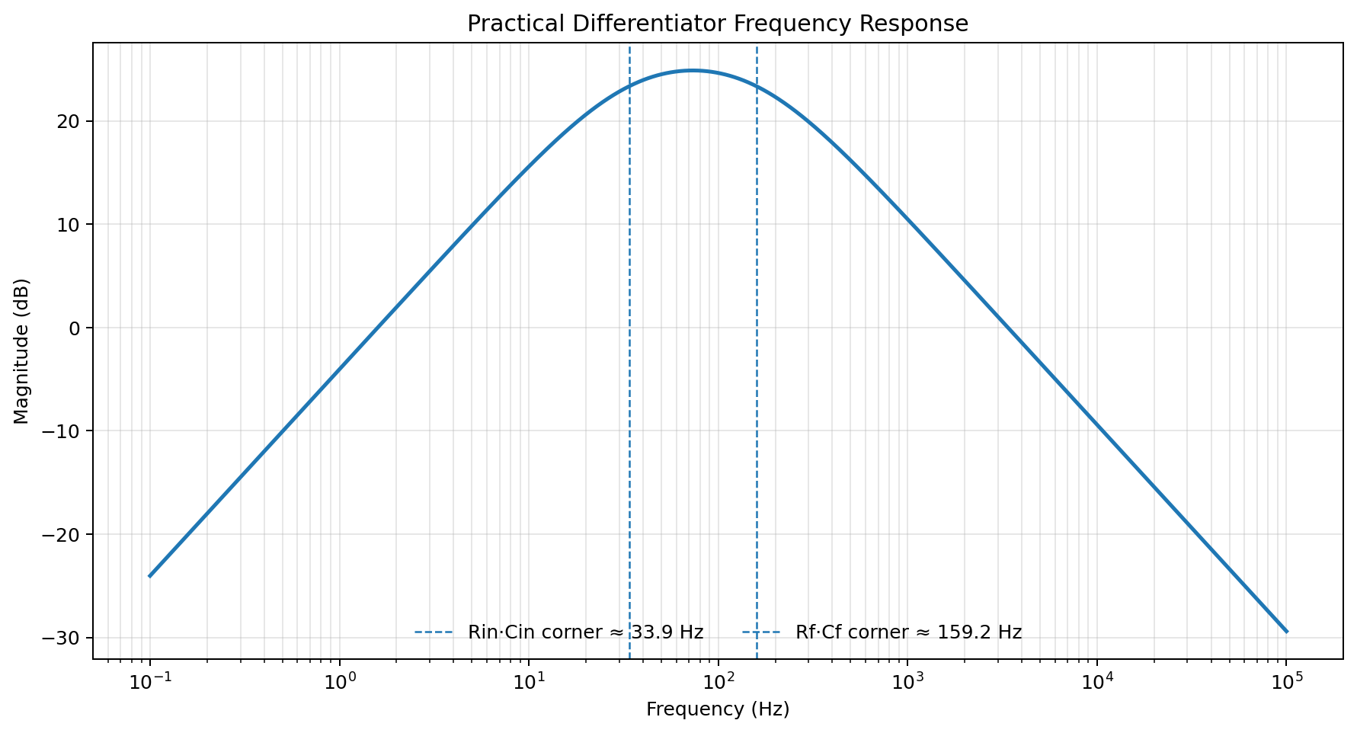
Figure 2. Magnitude response of the final practical differentiator. The 47 kΩ/100 nF input network sets the lower corner at about 33.9 Hz, while the 1 MΩ/1 nF feedback network sets the upper corner at about 159.2 Hz.

6. Final Simulated Circuit Blocks
The final simulation used the following values:
- Band-limited differentiator: R3 = 47 kΩ, C1 = 100 nF, R1 = 1 MΩ, C3 = 1 nF
- Integrator: R2 = 100 kΩ, C2 = 100 nF
- Conditional reset or bleed: R4 = 2 MΩ, enabled when the output is sufficiently near center
- Reference values: VREF = 2.5 V, supply = 5 V
With the final differentiator values, the input RC corner is approximately 33.9 Hz and the feedback RC corner is approximately 159.2 Hz. Together they create a practical, band-limited differentiator: low-frequency drift is rejected, useful motion is emphasized, and high-frequency noise is prevented from growing without bound.
The reset or cleanup time constant is set by R4·C2. With R4 = 2 MΩ and C2 = 100 nF, the cleanup time constant is 0.2 s. In practice this means the residual error is reduced quickly once the bleed is enabled, but not so quickly that normal motion is flattened or made to feel abrupt.
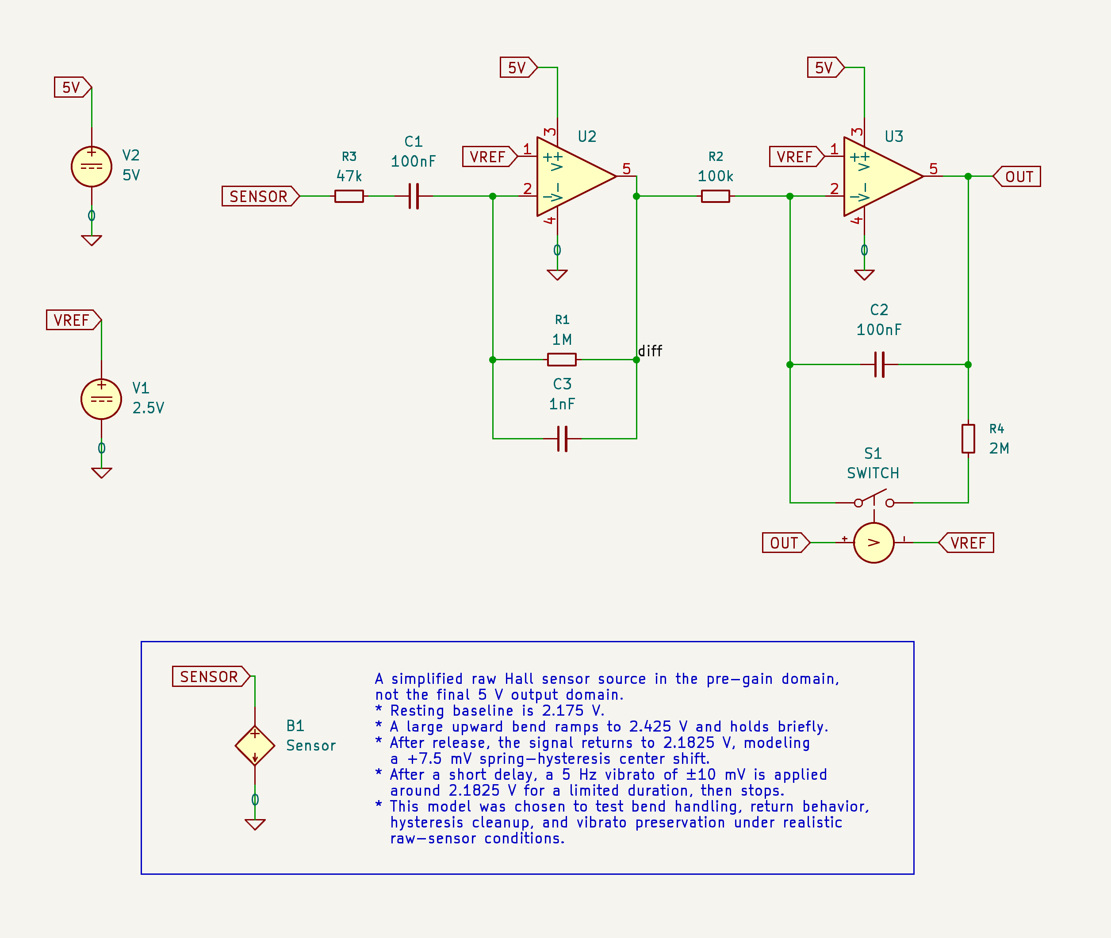
Figure 1. Final simulation schematic. The band-limited differentiator feeds an integrator, while a conditional reset/bleed path is enabled only when the output returns sufficiently close to VREF.

7. Why This Topology Works
The final topology succeeds because it avoids asking any one block to do two conflicting jobs. A deadband can stabilize center, but it tends to affect feel. A pure DC servo can cancel drift, but it tends to fight motion. A pure differentiator-plus-integrator preserves motion beautifully, but it also preserves the hysteresis step. The final topology solves this by dividing the problem correctly.
Block | Values | Purpose
Differentiator input network | R3 = 47 kΩ, C1 = 100 nF | Couples the raw sensor into the differentiator while rejecting static offset.
Differentiator feedback | R1 = 1 MΩ, C3 = 1 nF | Provides motion sensitivity while limiting high-frequency noise gain.
Integrator input | R2 = 100 kΩ | Sets the scaling into the reconstruction stage.
Integrator capacitor | C2 = 100 nF | Stores the reconstructed position state.
Conditional bleed path | R4 = 2 MΩ and S1 | Bleeds the integrator only when the output is near center.
Reference and logic | VREF = 2.5 V, switch controlled by OUT relative to VREF | Defines the center and enables cleanup only in the near-center region.
The differentiator plus integrator path preserves the performance gesture.
Because the differentiator has zero gain at DC, the main signal path never carries a steady center error in the first place. Because the integrator follows it, the wanted motion is reconstructed. Because the reset path is only active near center, the remaining error caused by spring hysteresis is cleaned up afterward, without flattening the gesture itself.
The bleed path is conditional rather than continuous, so it behaves like housekeeping rather than part of the performance gesture.
The reset is resistive rather than a hard short, so cleanup is controlled rather than abrupt.

8. Comparison with Earlier Approaches
The table below summarizes the main strengths, weaknesses, and lessons from each approach.

Approach | Strengths | Weaknesses | Main Lesson
Deadband center-locking | Strong center stability, conceptually simple. | Can feel sticky. Explicitly changes behavior near center. | Center locking works, but feel matters.
Deadband plus HP bypass | Practical production fix. Vibrato can be restored. | Still layered. HP path compensates for a problem introduced by the deadband. | Useful workaround, but not the cleanest architecture.
Always-on DC servo | Centers automatically. Easy to understand in control terms. | Suppresses vibrato and can fight intentional bends. | An always-awake correction loop mistakes motion for error.
Windowed DC servo | Protects large bends and corrects near center. | Needs more logic and can create startup-state concerns. | The hold idea is good, but the architecture is still somewhat heavy.
Diff plus integrator only | Excellent motion preservation. No startup trouble. | Preserves spring hysteresis instead of canceling it. | Separating motion from slow bias is the right instinct, but cleanup is still needed.
Final hybrid: diff + int + conditional bleed | Preserves gesture, cleans residual hysteresis, avoids startup and drift problems. | Requires one extra conditional path and some tuning. | The best solution separates musical motion from housekeeping.

9. Final Outcome
The final simulations support the following conclusions:
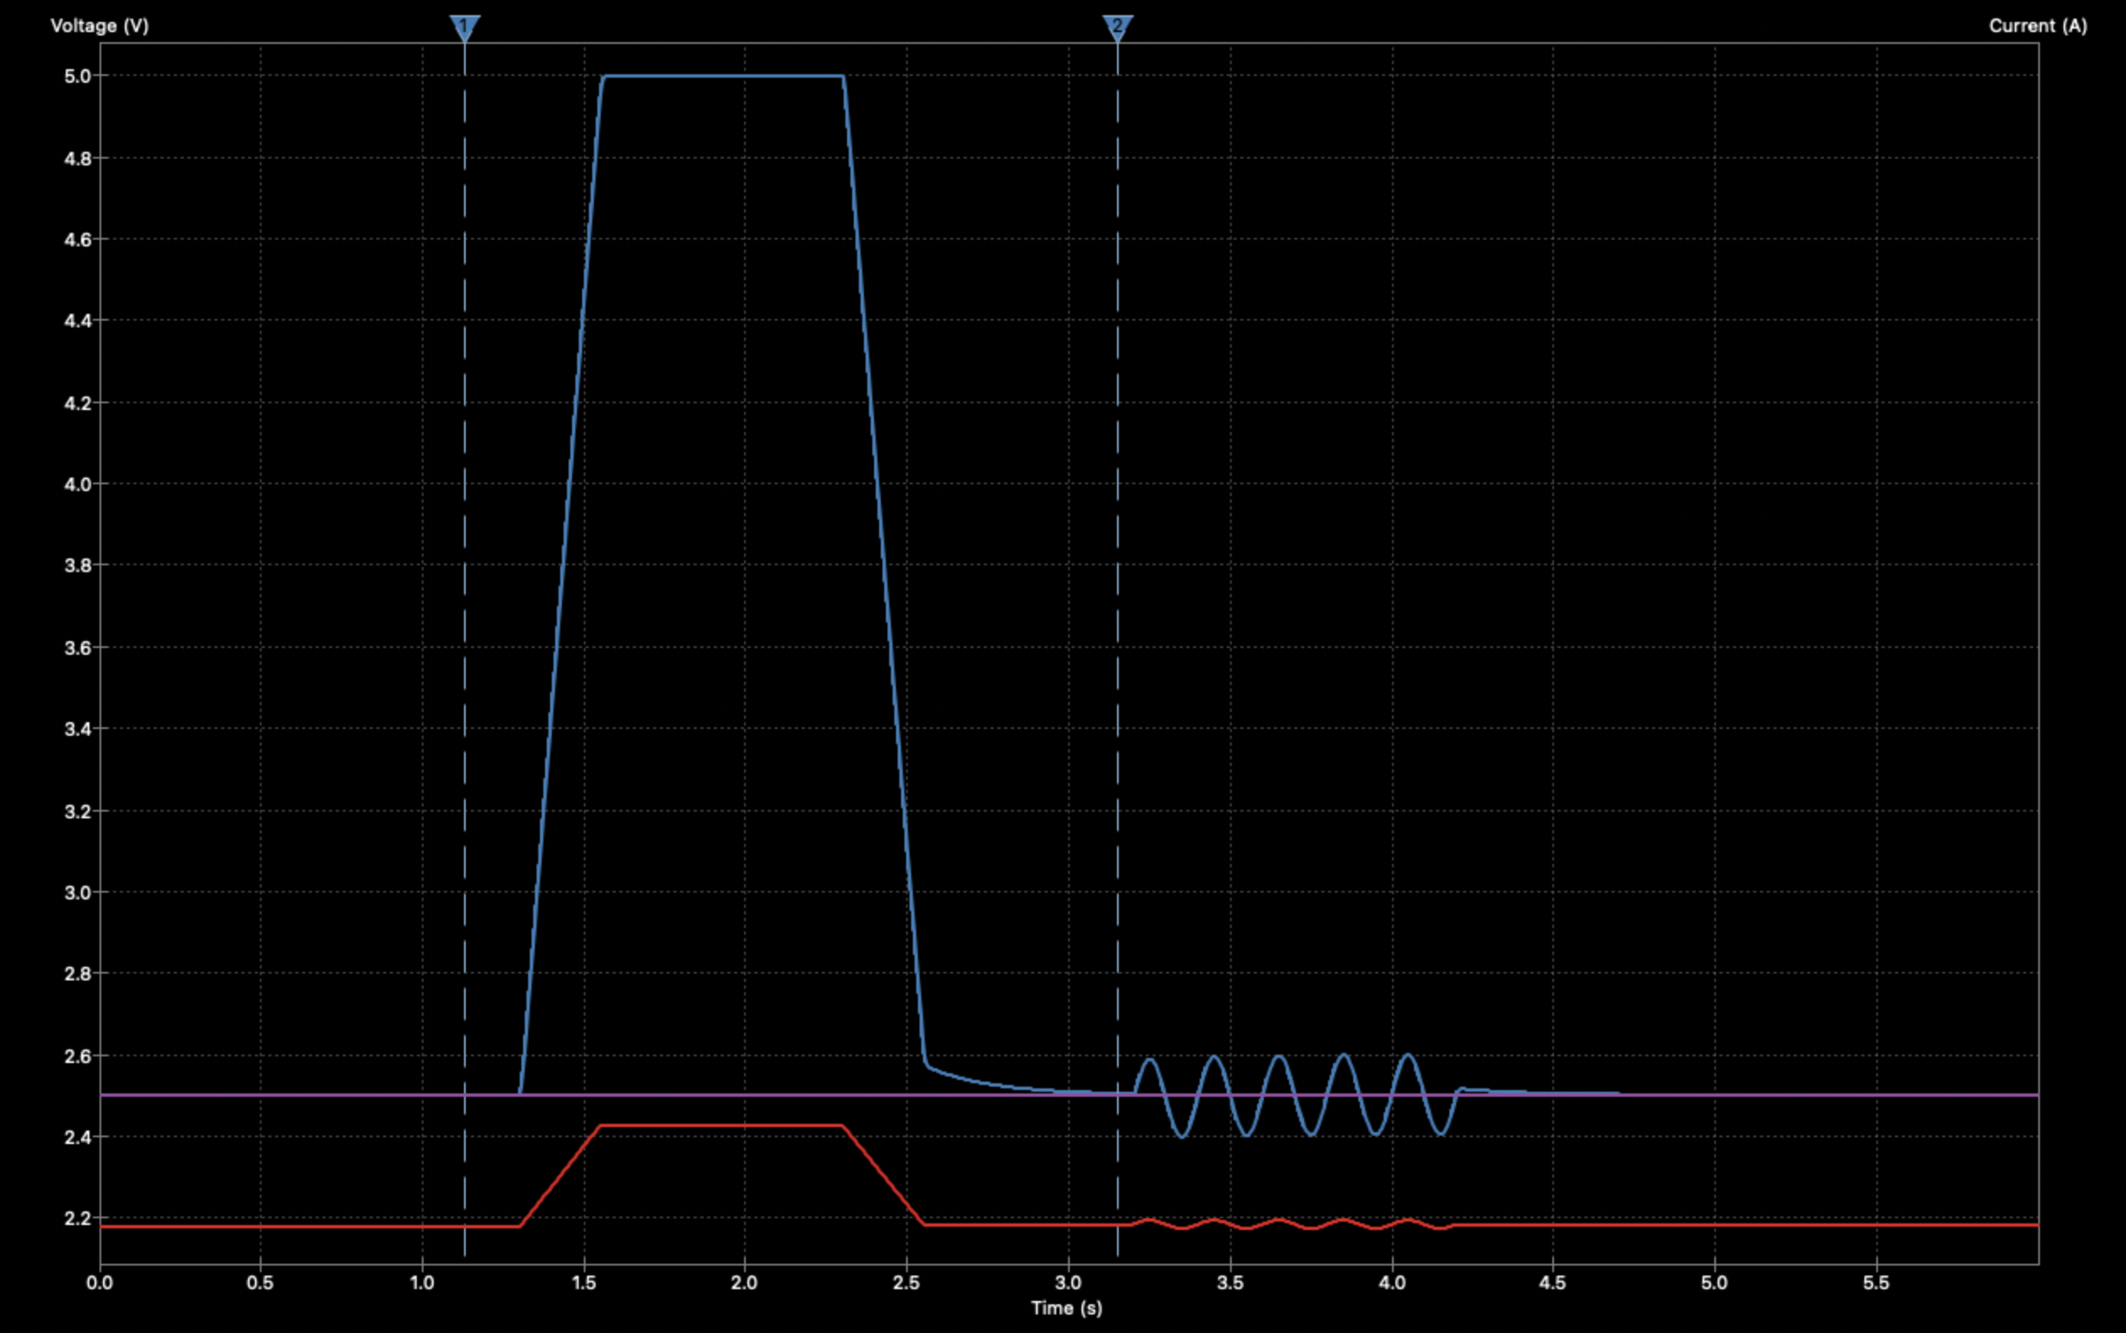
Figure 3. Representative transient response of the final topology. The raw sensor input (red) is reconstructed as a centered output (blue), and the conditional reset/bleed removes the residual post-bend error without flattening the vibrato.
- Startup behavior is clean. No special delayed-enable trick is needed.
- Long-term drift is controlled without making the integrator permanently leaky.
- Residual center error after a large bend is cleaned up in a controlled way.
- With the chosen values, cleanup occurs on the order of about half a second.
Vibrato is effectively preserved when the overall gain is set correctly. In the final tuning, the output vibrato reached about 198 mV peak-to-peak, essentially the full expected amplitude.
The final topology is simpler in feel than the deadband family and less intrusive than the always-on servo family.

10. Closing Reflection
This design journey is a good example of how engineering progress often works. Early designs were not wrong. They were incomplete. Each one solved a real part of the problem and exposed the next missing piece. The deadband designs taught what center stability requires. The high-pass bypass showed how vibrato can be saved. The DC servo taught what happens when error correction is always awake. The differentiator-plus-integrator path revealed how motion can be preserved naturally. The final conditional bleed completed the picture by handling the one thing the motion path should not be asked to handle forever: residual center error after a large bend.
The resulting topology is satisfying because it does not feel like a bag of patches. It feels like a system whose parts each do one job well. That is usually a strong sign that the design has finally found the right shape.

