

学生实验实习报告册

学年学期： | 2022 - 2023 学年 □春秋 学期
课程名称/编号： | 程序设计实践/ A2041240
开课单位： | 计算机学院
任课教师： | 蒋贵全
教师电话： | 13983763936
学生学院： | 计算机科学与技术学院
学生专业/班级： | 计算机科学与技术专业/04012103
学生学号： | 2021211948
学生姓名： | 张政余
最终成绩：

重庆邮电大学教务处印制

实验实习名 | 学生通信录
实验实习地点 | C405＋课下自学练习 | 完成起止日期 | 2023.4.28－2023.7.8
实验报告成绩  （满分30） |  | 现场考核成绩  （满分70）
教师评语 | 教师签名：蒋贵全  2023年7月10日
一、实验实习目的及要求
加强对java程序设计的深入理解，达到提高学生分析问题，解决综合问题的能力。
二、实验实习设备（环境）及要求（软硬件条件）
设备：PC机
操作系统：Windows
编译软件：IntelliJ IDEA 2022.1.1
三、实验实习内容简介：
- 系统应实现的主要功能：
1、增加联系人
2、修改联系人
3、删除联系人
4、查询联系人
- 各模块的具体功能和简单算法：
1、通过对输入的联系人数据进行合法性校验，校验通过，追加写入data.txt文件，实现增加联系人功能。
2、通过原始的电话号码，先查询出原始信息进行回显便于修改，然后将修改后的信息先进行数据合法性校验，校验通过，覆盖原始信息，实现修改联系人功能。
3、根据所需删除联系人的号码进行删除联系人。
4、根据输入的查询关键字，对联系人姓名进行模糊匹配，只要包含该关键字即满足条件，最后将匹配结果进行显示，实现查询联系人功能。
- 流程图：
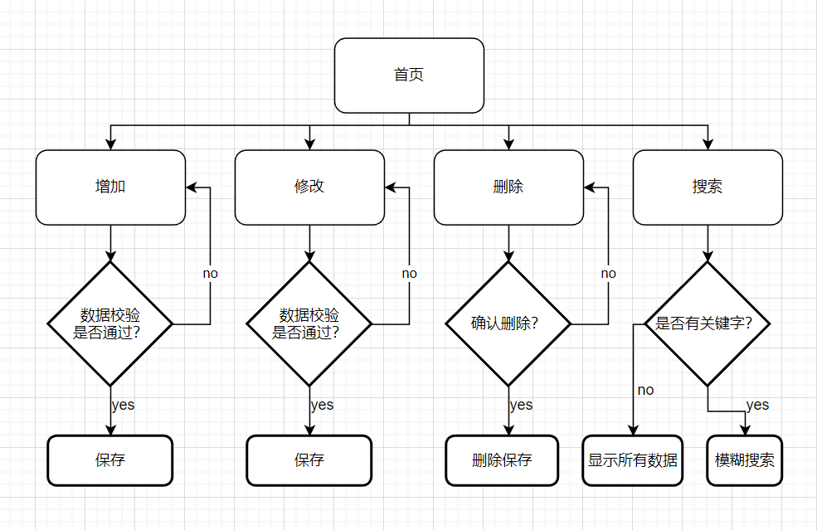
四、源程序（代码）
1、contactBook
Contact.class
- package contactBook;

- public class Contact {
- private String name;//联系人姓名
- private String phone;//电话号码
- private String email;//电子邮件
- private String address;//居住地址

- public Contact() {
- }

- public Contact(String name, String phone, String email, String address) {
- this.name = name;
- this.phone = phone;
- this.email = email;
- this.address = address;
- }

- public String getName() {
- return name;
- }

- public void setName(String name) {
- this.name = name;
- }

- public String getPhone() {
- return phone;
- }

- public void setPhone(String phone) {
- this.phone = phone;
- }

- public String getEmail() {
- return email;
- }

- public void setEmail(String email) {
- this.email = email;
- }

- public String getAddress() {
- return address;
- }

- public void setAddress(String address) {
- this.address = address;
- }

- }

ContactBook.class
- package contactBook;

- import java.io.*;
- import java.util.ArrayList;
- import java.util.Scanner;
- import java.util.Vector;

- public class ContactBook {
- private ArrayList<Contact> contacts = new ArrayList<>();
- private ArrayList<Contact> searchResult = new ArrayList<>();
- private String searchName = "";
- private String dataFilePath = "data.txt";

- public ContactBook() {
- loadContactsFromFile(dataFilePath);
- }

- //添加联系人
- public boolean addContact(Contact contact) {
- if (isPhoneUsed(contact.getPhone(), "null")) {
- return false;
- }
- contacts.add(contact);
- saveContactsToFile(dataFilePath);
- return true;
- }

- //通过名字搜索联系人
- public void searchContactByName(String name) {
- if (searchName.equals(name)) {
- return;
- }
- searchResult.clear();
- searchName = name;
- for (Contact contact : contacts) {
- if (contact.getName().indexOf(name) >= 0) {
- searchResult.add(contact);
- }
- }
- return;
- }

- //通过电话号码搜索联系人
- private Contact searchContactByPhone(String oldPhone) {
- for (Contact contact : contacts) {
- if (contact.getPhone().equals(oldPhone)) {
- return contact;
- }
- }
- return null;
- }

- //获取单个联系人信息
- public Contact getContactByPhone(String phone) {
- for (int i = 0; i < contacts.size(); i++) {
- Contact contact = contacts.get(i);
- if (phone.equals(contact.getPhone())) {
- return contact;
- }
- }
- return new Contact();
- }

- //编辑联系人
- public boolean editContact(String OldPhone, Contact contact) {
- if (isPhoneUsed(contact.getPhone(), OldPhone)) {
- return false;
- }
- Contact oldContact = searchContactByPhone(OldPhone);
- if (oldContact == null) {
- return false;
- }
- oldContact.setName(contact.getName());
- oldContact.setPhone(contact.getPhone());
- oldContact.setEmail(contact.getEmail());
- oldContact.setAddress(contact.getAddress());

- saveContactsToFile(dataFilePath);
- return true;
- }

- //删除后联系人
- public boolean deleteContact(String[] phones) {
- for (int i = 0; i < phones.length; i++) {
- Contact contact = searchContactByPhone(phones[i]);
- if (contact != null) {
- contacts.remove(contact);
- }
- }
- saveContactsToFile(dataFilePath);
- return true;
- }

- //检测手机号是否已经存在
- public boolean isPhoneUsed(String phone, String oldPhone) {
- if (phone.equals(oldPhone)) {
- return false;
- }
- for (Contact contact : contacts) {
- if (contact.getPhone().equals(phone)) {
- return true;
- }
- }
- return false;
- }

- // 从文件读取联系人信息到ArrayList
- public void loadContactsFromFile(String filename) {
- try {
- File file = new File(filename);
- if (!file.exists()) {
- try {
- file.createNewFile();

- } catch (IOException e) {
- e.printStackTrace();
- }
- }
- Scanner scanner = new Scanner(file);
- while (scanner.hasNextLine()) {
- String line = scanner.nextLine();
- String[] parts = line.split(",");
- if (parts.length == 4) {
- String name = parts[0].trim();
- String phone = parts[1].trim();
- String email = parts[2].trim();
- String address = parts[3].trim();
- Contact contact = new Contact(name, phone, email, address);
- contacts.add(contact);
- }
- }
- scanner.close();
- } catch (IOException e) {
- e.printStackTrace();
- }
- }

- // 将ArrayList中的联系人信息保存到文件
- public void saveContactsToFile(String filename) {
- try {
- File file = new File(filename);
- PrintWriter writer = new PrintWriter(file);
- for (int i = 0; i < contacts.size(); i++) {
- Contact contact = contacts.get(i);
- writer.write(contact.getName() + "," + contact.getPhone() + "," + contact.getEmail() + "," + contact.getAddress());
- writer.write("\n");
- }
- writer.close();
- } catch (FileNotFoundException e) {
- e.printStackTrace();
- }
- }

- public TableData getContacts(String searchText, int pageNum, int pageSize) {
- Vector<Vector<Object>> data = new Vector<>();
- if (contacts == null) {
- return new TableData(0, data);
- }

- if (!searchText.equals("")) {
- searchContactByName(searchText);
- return getTableData(pageNum, pageSize, data, searchResult);
- } else {
- return getTableData(pageNum, pageSize, data, contacts);
- }
- }

- private TableData getTableData(int pageNum, int pageSize, Vector<Vector<Object>> data, ArrayList<Contact> contacts) {
- for (int i = (pageNum - 1) * pageSize; i < pageNum * pageSize && i < contacts.size(); i++) {
- Vector<Object> row = new Vector<>();
- Contact contact = contacts.get(i);
- row.addElement(i + 1);
- row.addElement(contact.getName());
- row.addElement(contact.getPhone());
- row.addElement(contact.getEmail());
- row.addElement(contact.getAddress());
- data.addElement(row);
- }
- return new TableData(contacts.size(), data);
- }

- }

TableData.class
- package contactBook;

- import java.util.Vector;

- public class TableData {
- int total;
- Vector<Vector<Object>> dataList;

- public TableData(int total, Vector<Vector<Object>> dataList) {
- this.total = total;
- this.dataList = dataList;
- }

- public int getTotal() {
- return total;
- }

- public void setTotal(int total) {
- this.total = total;
- }

- public Vector<Vector<Object>> getDataList() {
- return dataList;
- }

- }

2、handler
AddViewHandler.class
- package handler;

- import contactBook.Contact;
- import view.addView.AddView;
- import view.mainView.MainView;

- import javax.swing.*;
- import java.awt.event.ActionEvent;
- import java.awt.event.ActionListener;
- import java.util.regex.Pattern;

- public class AddViewHandler implements ActionListener {
- private AddView addView;
- private MainView mainView;

- public AddViewHandler(AddView addView, MainView mainView) {
- this.addView = addView;
- this.mainView = mainView;
- }

- @Override
- public void actionPerformed(ActionEvent e) {
- JButton jBtn = (JButton) e.getSource();
- String text = jBtn.getText();
- if ("添加联系人".equals(text)) {
- Contact newContact = addView.buildContact();
- if ("null".equals(newContact.getName())) {
- JOptionPane.showMessageDialog(addView, "联系人姓名不能为空！");
- return;
- }
- if (!Pattern.matches("^1[3-9]\\d{9}$", newContact.getPhone())) {
- JOptionPane.showMessageDialog(addView, "请填写正确的联系电话！");
- return;
- }
- boolean addResult = mainView.getContactBook().addContact(addView.buildContact());
- if (addResult) {
- mainView.reloadTable();
- addView.dispose();
- } else {
- JOptionPane.showMessageDialog(addView, "添加失败,手机号已存在！");
- }
- }
- }

- }

EditViewHandler.class
- package handler;

- import contactBook.Contact;
- import view.editView.EditView;
- import view.mainView.MainView;

- import javax.swing.*;
- import java.awt.event.ActionEvent;
- import java.awt.event.ActionListener;
- import java.util.regex.Pattern;

- public class EditViewHandler implements ActionListener {
- private EditView editView;
- private MainView mainView;

- public EditViewHandler(EditView editView, MainView mainView) {
- this.editView = editView;
- this.mainView = mainView;
- }

- @Override
- public void actionPerformed(ActionEvent e) {
- JButton jBtn = (JButton) e.getSource();
- String text = jBtn.getText();
- if ("修改信息".equals(text)) {
- Contact newContact = editView.buildContact();
- if (newContact.getName().equals("null")) {
- JOptionPane.showMessageDialog(editView, "联系人姓名不能为空！");
- return;
- }
- if (!Pattern.matches("^1[3-9]\\d{9}$", newContact.getPhone())) {
- JOptionPane.showMessageDialog(editView, "请填写正确的联系电话！");
- return;
- }
- boolean editResult = mainView.getContactBook().editContact(editView.getOldPhone(), newContact);
- if (editResult) {
- mainView.reloadTable();
- editView.dispose();
- } else {
- JOptionPane.showMessageDialog(editView, "修改失败，手机号已存在！");
- }
- }
- }
- }

MainViewTableHandler.class
- package handler;

- import contactBook.Contact;
- import view.mainView.MainViewTable;

- import javax.swing.*;
- import java.awt.*;
- import java.awt.datatransfer.Clipboard;
- import java.awt.datatransfer.StringSelection;
- import java.awt.datatransfer.Transferable;
- import java.awt.event.ActionEvent;
- import java.awt.event.ActionListener;
- import java.awt.event.MouseAdapter;
- import java.awt.event.MouseEvent;

- public class MainViewTableHandler extends MouseAdapter implements ActionListener {
- MainViewTable mainViewTable;
- JPopupMenu popupMenu;
- private Contact contact;

- public MainViewTableHandler(MainViewTable mainViewTable, JPopupMenu popupMenu) {
- this.mainViewTable = mainViewTable;
- this.popupMenu = popupMenu;
- }

- @Override
- public void actionPerformed(ActionEvent e) {
- JMenuItem item = (JMenuItem) e.getSource();
- String text = item.getText();
- if ("复制姓名".equals(text)) {
- Clipboard clip = Toolkit.getDefaultToolkit().getSystemClipboard();
- Transferable tText = new StringSelection(contact.getName());
- clip.setContents(tText, null);

- } else if ("复制电话".equals(text)) {
- Clipboard clip = Toolkit.getDefaultToolkit().getSystemClipboard();
- Transferable tText = new StringSelection(contact.getPhone());
- clip.setContents(tText, null);

- } else if ("复制邮箱".equals(text)) {
- Clipboard clip = Toolkit.getDefaultToolkit().getSystemClipboard();
- Transferable tText = new StringSelection(contact.getEmail());
- clip.setContents(tText, null);

- } else if ("复制地址".equals(text)) {
- Clipboard clip = Toolkit.getDefaultToolkit().getSystemClipboard();
- Transferable tText = new StringSelection(contact.getAddress());
- clip.setContents(tText, null);

- }
- }

- @Override
- public void mouseClicked(MouseEvent e) {
- if (e.getButton() == java.awt.event.MouseEvent.BUTTON3) {
- //通过点击位置找到点击为表格中的行
- int focusedRowIndex = mainViewTable.rowAtPoint(e.getPoint());
- int focusedColumnIndex = mainViewTable.columnAtPoint(e.getPoint());
- if (focusedRowIndex == -1) {
- return;
- }
- if (focusedColumnIndex == 0) {
- return;
- }
- //将表格所选项设为当前右键点击的行
- mainViewTable.setRowSelectionInterval(focusedRowIndex, focusedRowIndex);
- String name = mainViewTable.getValueAt(focusedRowIndex, 1).toString();
- String phone = mainViewTable.getValueAt(focusedRowIndex, 2).toString();
- String email = mainViewTable.getValueAt(focusedRowIndex, 3).toString();
- String address = mainViewTable.getValueAt(focusedRowIndex, 4).toString();
- contact = new Contact(name, phone, email, address);
- //弹出菜单
- popupMenu.show(mainViewTable, e.getX(), e.getY());

- }
- }
- }

MainViewHandler.class
- package handler;

- import view.addView.AddView;
- import view.editView.EditView;
- import view.mainView.MainView;

- import javax.swing.*;
- import java.awt.event.ActionEvent;
- import java.awt.event.ActionListener;

- public class MainViewHandler implements ActionListener {
- private MainView mainView;

- public MainViewHandler(MainView mainView) {
- this.mainView = mainView;
- }

- @Override
- public void actionPerformed(ActionEvent e) {
- JButton jBtn = (JButton) e.getSource();
- String text = jBtn.getText();
- if ("增加".equals(text)) {
- new AddView(mainView);
- } else if ("修改".equals(text)) {
- String[] phones = mainView.getSelectedPhones();
- if (phones.length == 0) {
- JOptionPane.showMessageDialog(mainView, "请选择要修改的行");
- return;
- }
- if (phones.length != 1) {
- JOptionPane.showMessageDialog(mainView, "一次只能修改一行");
- return;
- }
- new EditView(mainView, phones[0]);
- } else if ("删除".equals(text)) {
- String[] phones = mainView.getSelectedPhones();
- if (phones.length == 0) {
- JOptionPane.showMessageDialog(mainView, "请选择要删除的行");
- return;
- }
- int option = JOptionPane.showConfirmDialog(mainView, "你确认要删除选择的" + phones.length + "行吗？", "确认删除", JOptionPane.YES_NO_OPTION);
- if (option == JOptionPane.NO_OPTION) {
- return;
- }
- boolean deleteResult = mainView.getContactBook().deleteContact(phones);
- if (deleteResult) {
- mainView.reloadTable();
- } else {
- JOptionPane.showMessageDialog(mainView, "删除失败");
- }

- } else if ("搜索".equals(text)) {
- mainView.setPageNum(1);
- mainView.reloadTable();

- } else if ("上一页".equals(text)) {
- mainView.setPageNum(mainView.getPageNum() - 1);
- mainView.reloadTable();
- } else if ("下一页".equals(text)) {
- mainView.setPageNum(mainView.getPageNum() + 1);
- mainView.reloadTable();
- }

- }

- }

3、view.addView
AddView.class
- package view.addView;

- import contactBook.Contact;
- import handler.AddViewHandler;
- import view.mainView.MainView;

- import javax.swing.*;
- import java.awt.*;

- public class AddView extends JDialog {
- JPanel jPanel = new JPanel(new FlowLayout(FlowLayout.CENTER, 10, 20));
- JLabel nameLabel = new JLabel("姓名", JLabel.RIGHT);
- JTextField nameText = new JTextField();
- JLabel phoneLabel = new JLabel("电话", JLabel.RIGHT);
- JTextField phoneText = new JTextField();
- JLabel emailLabel = new JLabel("邮箱", JLabel.RIGHT);
- JTextField emailText = new JTextField();
- JLabel addressLabel = new JLabel("住址", JLabel.RIGHT);
- JTextField addressText = new JTextField();
- JButton addBtn = new JButton("添加联系人");

- public AddView(MainView mainView) {
- super(mainView, "添加联系人", true);
- AddViewHandler addViewHandler = new AddViewHandler(this, mainView);

- nameLabel.setPreferredSize(new Dimension(30, 30));
- nameText.setPreferredSize(new Dimension(200, 30));
- jPanel.add(nameLabel);
- jPanel.add(nameText);

- phoneLabel.setPreferredSize(new Dimension(30, 30));
- phoneText.setPreferredSize(new Dimension(200, 30));
- jPanel.add(phoneLabel);
- jPanel.add(phoneText);

- emailLabel.setPreferredSize(new Dimension(30, 30));
- emailText.setPreferredSize(new Dimension(200, 30));
- jPanel.add(emailLabel);
- jPanel.add(emailText);

- addressLabel.setPreferredSize(new Dimension(30, 30));
- addressText.setPreferredSize(new Dimension(200, 30));
- jPanel.add(addressLabel);
- jPanel.add(addressText);

- addBtn.addActionListener(addViewHandler);
- jPanel.add(addBtn);

- getContentPane().add(jPanel);
- setSize(300, 400);
- setDefaultCloseOperation(DISPOSE_ON_CLOSE);
- setLocationRelativeTo(null);
- setResizable(false);
- setVisible(true);
- }

- public Contact buildContact() {
- Contact contact = new Contact();
- if ("".equals(nameText.getText())) {
- contact.setName("null");
- } else {
- contact.setName(nameText.getText());
- }

- if ("".equals(phoneText.getText())) {
- contact.setPhone("null");
- } else {
- contact.setPhone(phoneText.getText());
- }

- if ("".equals(emailText.getText())) {
- contact.setEmail("null");
- } else {
- contact.setEmail(emailText.getText());
- }

- if ("".equals(addressText.getText())) {
- contact.setAddress("null");
- } else {
- contact.setAddress(addressText.getText());
- }
- return contact;
- }
- }
4、view.editView
EditView.class
- package view.editView;

- import contactBook.Contact;
- import handler.EditViewHandler;
- import view.mainView.MainView;

- import javax.swing.*;
- import java.awt.*;

- public class EditView extends JDialog {
- JPanel jPanel = new JPanel(new FlowLayout(FlowLayout.CENTER, 10, 20));
- JLabel nameLabel = new JLabel("姓名", JLabel.RIGHT);
- JTextField nameText = new JTextField();
- JLabel phoneLabel = new JLabel("电话", JLabel.RIGHT);
- JTextField phoneText = new JTextField();
- JLabel emailLabel = new JLabel("邮箱", JLabel.RIGHT);
- JTextField emailText = new JTextField();
- JLabel addressLabel = new JLabel("住址", JLabel.RIGHT);
- JTextField addressText = new JTextField();
- JButton editBtn = new JButton("修改信息");
- String oldPhone;

- public String getOldPhone() {
- return oldPhone;
- }

- public void setOldPhone(String oldPhone) {
- this.oldPhone = oldPhone;
- }

- public EditView(MainView mainView, String phone) {
- super(mainView, "修改联系人", true);
- oldPhone = phone;
- Contact contact = mainView.getContactBook().getContactByPhone(phone);

- EditViewHandler editViewHandler = new EditViewHandler(this, mainView);
- nameLabel.setPreferredSize(new Dimension(30, 30));
- nameText.setPreferredSize(new Dimension(200, 30));
- nameText.setText(contact.getName());
- jPanel.add(nameLabel);
- jPanel.add(nameText);

- phoneLabel.setPreferredSize(new Dimension(30, 30));
- phoneText.setPreferredSize(new Dimension(200, 30));
- phoneText.setText(contact.getPhone());
- jPanel.add(phoneLabel);
- jPanel.add(phoneText);

- emailLabel.setPreferredSize(new Dimension(30, 30));
- emailText.setPreferredSize(new Dimension(200, 30));
- emailText.setText(contact.getEmail());
- jPanel.add(emailLabel);
- jPanel.add(emailText);

- addressLabel.setPreferredSize(new Dimension(30, 30));
- addressText.setPreferredSize(new Dimension(200, 30));
- addressText.setText(contact.getAddress());
- jPanel.add(addressLabel);
- jPanel.add(addressText);

- editBtn.addActionListener(editViewHandler);
- jPanel.add(editBtn);

- getContentPane().add(jPanel);
- setSize(300, 400);
- setDefaultCloseOperation(DISPOSE_ON_CLOSE);
- setLocationRelativeTo(null);
- setResizable(false);
- setVisible(true);
- }

- public Contact buildContact() {
- Contact contact = new Contact();
- if ("".equals(nameText.getText())) {
- contact.setName("null");
- } else {
- contact.setName(nameText.getText());
- }

- if ("".equals(phoneText.getText())) {
- contact.setPhone("null");
- } else {
- contact.setPhone(phoneText.getText());
- }

- if ("".equals(emailText.getText())) {
- contact.setEmail("null");
- } else {
- contact.setEmail(emailText.getText());
- }

- if ("".equals(addressText.getText())) {
- contact.setAddress("null");
- } else {
- contact.setAddress(addressText.getText());
- }
- return contact;
- }
- }
5、view.mainView
MainView.class
- package view.mainView;

- import contactBook.ContactBook;
- import contactBook.TableData;
- import handler.MainViewHandler;

- import javax.swing.*;
- import java.awt.*;
- import java.awt.event.KeyEvent;
- import java.awt.event.KeyListener;

- public class MainView extends JFrame implements KeyListener {

- JPanel topPanel = new JPanel(new FlowLayout(FlowLayout.LEFT));
- JButton addBtn = new JButton("增加");
- JButton editBtn = new JButton("修改");
- JButton deleteBtn = new JButton("删除");
- JTextField searchText = new JTextField(15);
- JButton searchBtn = new JButton("搜索");

- JPanel bottomPanel = new JPanel(new FlowLayout(FlowLayout.RIGHT));
- JButton preBtn = new JButton("上一页");
- JButton nextBtn = new JButton("下一页");
- MainViewTable mainViewTable = new MainViewTable();

- private int pageNum = 1;
- private int pageSize = 20;
- MainViewHandler mainViewHandler;

- private ContactBook contactBook;

- public MainView() {
- super("通信管理系统");
- contactBook = new ContactBook();
- //初始化界面
- this.initContactBookJFrame();
- //初始化菜单
- this.initJPanel();
- }

- private void initContactBookJFrame() {
- //设置界面宽高
- this.setSize(800, 800);
- //设置界面标题
- this.setTitle("通信管理系统");
- //设置界面置顶
- this.setAlwaysOnTop(true);
- //设置界面居中
- this.setLocationRelativeTo(null);
- //设置关闭模式
- this.setDefaultCloseOperation(3);
- //取消默认的居中放置，只有取消了才会按照xy轴的方式添加组件
- // this.setLayout(null);
- this.setVisible(true);
- }

- private void showPreNext(int total) {
- if (pageNum == 1) {
- preBtn.setEnabled(false);

- } else {
- preBtn.setEnabled(true);
- }
- int pageCount;
- if (total % pageSize == 0) {
- pageCount = total / pageSize;
- } else {
- pageCount = total / pageSize + 1;
- }
- if (pageNum == pageCount) {
- nextBtn.setEnabled(false);
- } else {
- nextBtn.setEnabled(true);
- }
- }

- private void initJPanel() {
- mainViewHandler = new MainViewHandler(this);
- Container contentPane = this.getContentPane();

- addBtn.addActionListener(mainViewHandler);
- editBtn.addActionListener(mainViewHandler);
- deleteBtn.addActionListener(mainViewHandler);
- searchBtn.addActionListener(mainViewHandler);

- //顶部组件
- topPanel.add(addBtn);
- topPanel.add(editBtn);
- topPanel.add(deleteBtn);
- topPanel.add(searchText);
- topPanel.add(searchBtn);
- contentPane.add(topPanel, BorderLayout.NORTH);

- //中间组件
- TableData data = contactBook.getContacts("", pageNum, pageSize);
- MainViewTableModel mainViewTableModel = MainViewTableModel.assembleModel(data.getDataList());
- showPreNext(data.getTotal());
- mainViewTable.setModel(mainViewTableModel);
- mainViewTable.renderRule();
- JScrollPane jScrollPane = new JScrollPane(mainViewTable);
- contentPane.add(jScrollPane, BorderLayout.CENTER);

- //底部组件
- preBtn.addActionListener(mainViewHandler);
- nextBtn.addActionListener(mainViewHandler);
- bottomPanel.add(preBtn);
- bottomPanel.add(nextBtn);
- contentPane.add(bottomPanel, BorderLayout.SOUTH);

- }

- public int getPageNum() {
- return pageNum;
- }

- public void setPageNum(int pageNum) {
- this.pageNum = pageNum;
- }

- public int getPageSize() {
- return pageSize;
- }

- public void setPageSize(int pageSize) {
- this.pageSize = pageSize;
- }

- public ContactBook getContactBook() {
- return contactBook;
- }

- public void setContactBook(ContactBook contactBook) {
- this.contactBook = contactBook;
- }

- @Override
- public void keyTyped(KeyEvent e) {

- }

- @Override
- public void keyPressed(KeyEvent e) {

- }

- @Override
- public void keyReleased(KeyEvent e) {

- }

- public void reloadTable() {
- TableData data = contactBook.getContacts(searchText.getText().trim(), pageNum, pageSize);
- MainViewTableModel.updateModel(data.getDataList());
- showPreNext(data.getTotal());
- mainViewTable.renderRule();
- }

- public String[] getSelectedPhones() {
- int[] selectedRows = mainViewTable.getSelectedRows();
- String[] phones = new String[selectedRows.length];
- for (int i = 0; i < selectedRows.length; i++) {
- int rowIndex = selectedRows[i];
- Object phone = mainViewTable.getValueAt(rowIndex, 2);
- phones[i] = phone.toString();
- }
- return phones;
- }
- }

MainViewCellRender.class
- package view.mainView;

- import javax.swing.*;
- import javax.swing.table.DefaultTableCellRenderer;
- import java.awt.*;

- public class MainViewCellRender extends DefaultTableCellRenderer {
- @Override
- public Component getTableCellRendererComponent(JTable table, Object value, boolean isSelected, boolean hasFocus, int row, int column) {
- if (row % 2 == 0) {
- setBackground(Color.LIGHT_GRAY);
- } else {
- setBackground(Color.WHITE);
- }
- setHorizontalAlignment(DefaultTableCellRenderer.CENTER);
- return super.getTableCellRendererComponent(table, value, isSelected, hasFocus, row, column);
- }
- }

MainViewTable.class
- package view.mainView;

- import handler.MainViewTableHandler;

- import javax.swing.*;
- import javax.swing.table.JTableHeader;
- import javax.swing.table.TableColumn;
- import java.awt.*;
- import java.util.Vector;

- public class MainViewTable extends JTable {
- JPopupMenu popupMenu = new JPopupMenu();
- JMenuItem copyNameMenItem = new JMenuItem("复制姓名");
- JMenuItem copyPhoneMenItem = new JMenuItem("复制电话");
- JMenuItem copyEmailMenItem = new JMenuItem("复制邮箱");
- JMenuItem copyAddressMenItem = new JMenuItem("复制地址");

- public MainViewTable() {

- JTableHeader tableHeader = getTableHeader();
- tableHeader.setFont(new Font(null, Font.BOLD, 16));
- tableHeader.setForeground(Color.RED);

- //设置表格体
- setFont(new Font(null, Font.PLAIN, 14));
- setForeground(Color.BLACK);
- setGridColor(Color.BLACK);
- setRowHeight(30);
- //设置多行选择
- getSelectionModel().setSelectionMode(ListSelectionModel.MULTIPLE_INTERVAL_SELECTION);

- MainViewTableHandler mainViewTableHandler = new MainViewTableHandler(this, popupMenu);
- copyNameMenItem.addActionListener(mainViewTableHandler);
- copyPhoneMenItem.addActionListener(mainViewTableHandler);
- copyEmailMenItem.addActionListener(mainViewTableHandler);
- copyAddressMenItem.addActionListener(mainViewTableHandler);

- popupMenu.add(copyNameMenItem);
- popupMenu.add(copyPhoneMenItem);
- popupMenu.add(copyEmailMenItem);
- popupMenu.add(copyAddressMenItem);
- addMouseListener(mainViewTableHandler);
- }

- //设置表格渲染方式
- public void renderRule() {
- Vector<String> columns = MainViewTableModel.getColumns();
- MainViewCellRender render = new MainViewCellRender();
- for (int i = 0; i < columns.size(); i++) {
- TableColumn column = getColumn(columns.get(i));
- column.setCellRenderer(render);
- if (i == 0) {
- column.setPreferredWidth(50);
- column.setMaxWidth(50);
- column.setResizable(false);
- } else {
- column.setMinWidth(100);
- }
- }
- }
- }

MainViewTableModel.class
- package view.mainView;

- import java.util.*;

- import javax.swing.table.DefaultTableModel;

- public class MainViewTableModel extends DefaultTableModel {

- static Vector<String> columns = new Vector<>();

- static {
- columns.addElement("编号");
- columns.addElement("姓名");
- columns.addElement("电话");
- columns.addElement("邮箱");
- columns.addElement("地址");
- }

- public MainViewTableModel() {
- super(null, columns);
- }

- private static MainViewTableModel mainViewTableModel = new MainViewTableModel();

- public static MainViewTableModel assembleModel(Vector<Vector<Object>> data) {
- mainViewTableModel.setDataVector(data, columns);
- return mainViewTableModel;
- }

- public static void updateModel(Vector<Vector<Object>> data) {
- mainViewTableModel.setDataVector(data, columns);

- }

- public static Vector<String> getColumns() {
- return columns;
- }

- public boolean isCellEditable(int row, int column) {
- return false;
- }
- }

五、源程序调试过程
1、在程序第一次初始化时，由于是用文件模拟数据库，可能文件不存在，直接打开文件报错。解决办法：通过添加文件是否存在的逻辑判断，若存在即正常运行；若不存在，则先创建文件，在重新运行。
2、在对通讯录信息进行更改后，没有及时保存到文件，当程序异常终止后，会导数据修改失败和数据丢失的情况。解决办法：在每一个数据变化的操作逻辑后面都添加一个保存的文件的逻辑操作，以保证更新的数据及时保存。
3、在添加新联系时，没有对数据的合法性进行检验，导致出现了许多非法数据，也导致在数据解析时出现空指针异常。解决办法：在添加联系人时，对联系人属性进行数据校验，如姓名和电话号码的非空校验，电话号码的格式校验等等，以此来保证数据的正确性，保证程序正常运行。
4、在进行删除操作时，没有进行二次确认操作，容易出现误删情况，导致用户的使用体验不好。解决办法：添加弹出框，提醒用户。
六、实验实习结果及分析（程序运行结果截图要求测试用例尽量全面）
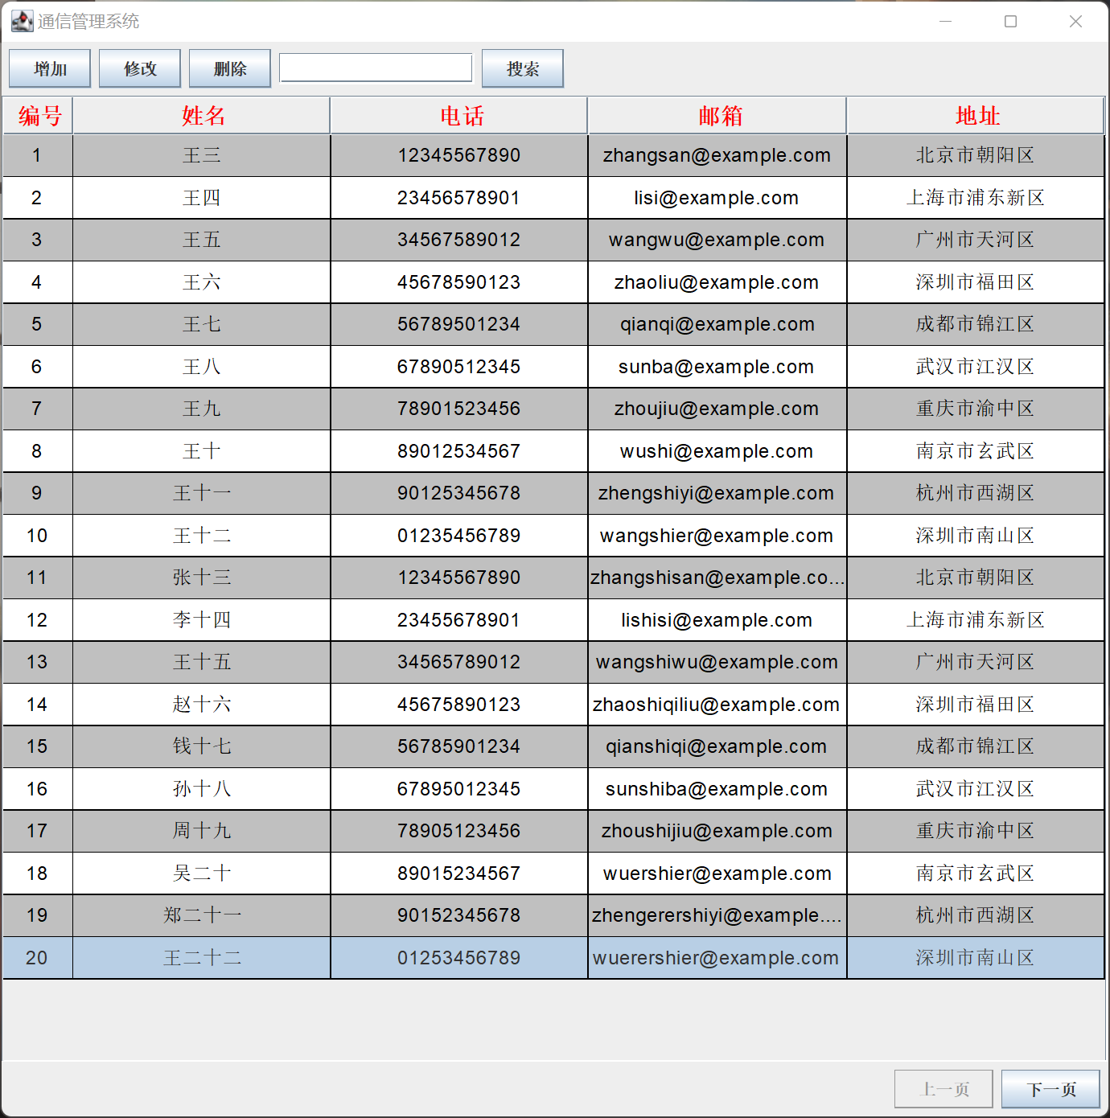
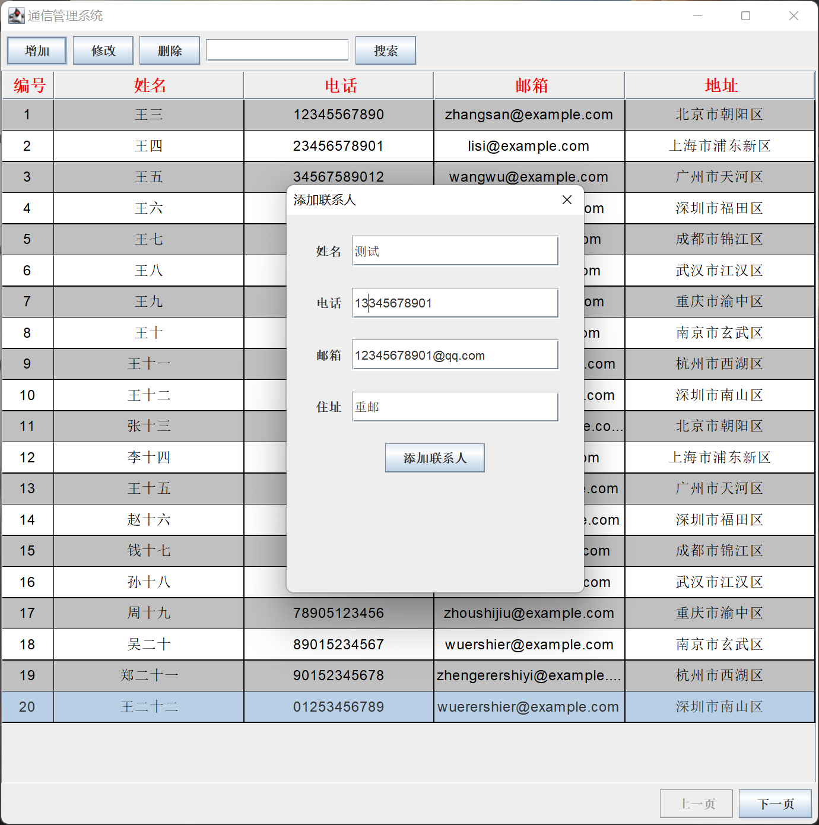
首页
添加联系人
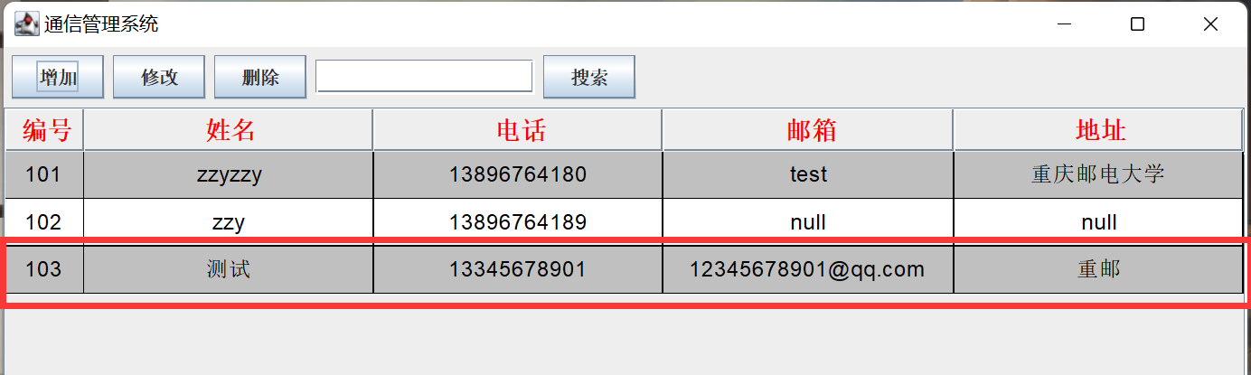
添加结果（成功）

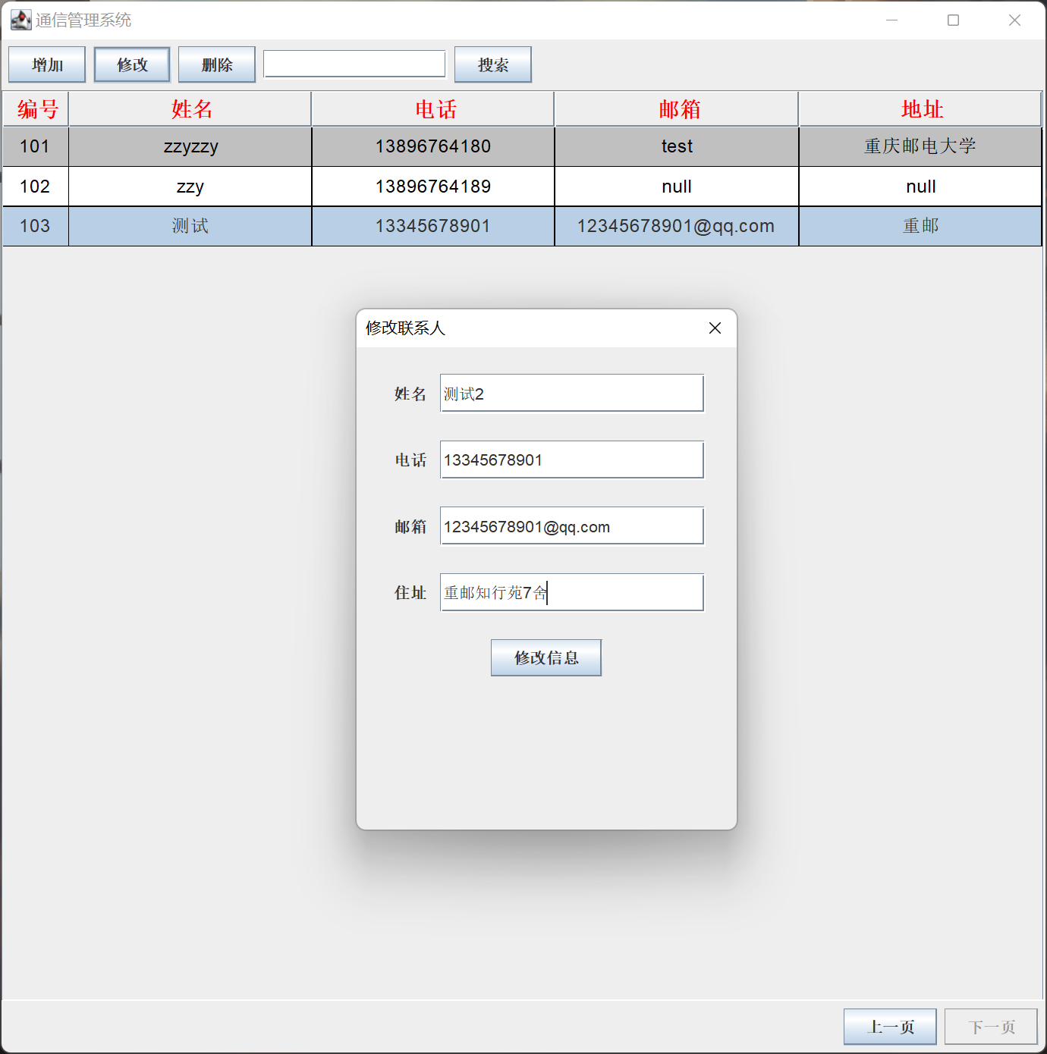
修改联系人
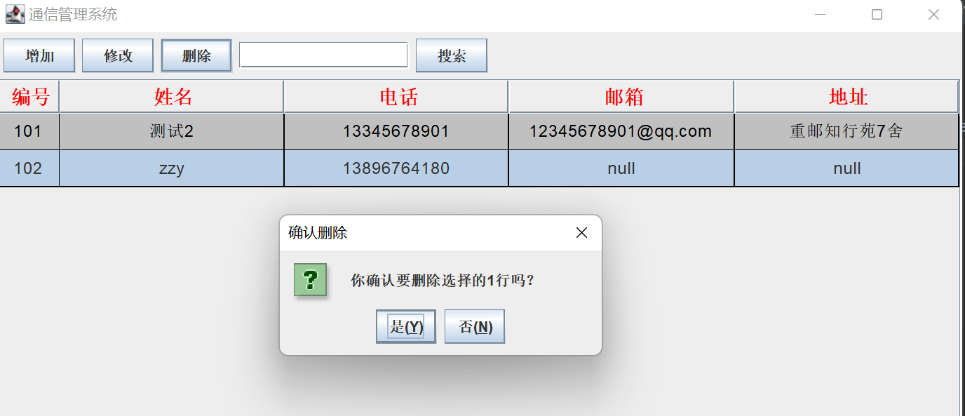
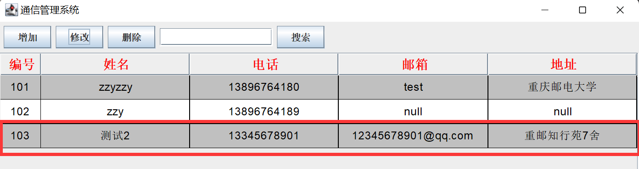
修改结果（成功）
删除联系人
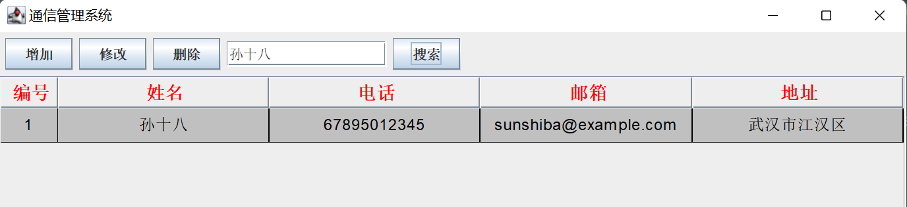
搜索联系人
七、总结：
在设计和具体实现环节中，在添加图形化界面时，学习了如何使用Swing框架创建用户界面。同时，在加入文件读取和保存的功能时，也学习了如何在Java中操作文件。最终达到了预期结果，成功实现了一个简单的通讯录程序，并加入了图形化界面和文件读写功能。不足之处在于界面美观性上需要进一步改进。同时，在实现时考虑的细节方面也还有很大的提升空间，如异常处理、输入检查等。

