Padding is one of the strategies used to develop convolution neural networks and often produces better results when used. What is padding? The term padding could be defined as a technique used in convolution neural networks where additional data is added to the edges of a dataset in order to prevent loss of information(Rio et al., 2020). This owes to the truth that filters used in CNNs always result in loss of information in the edges of a dataset. Critical to the discussion is the fact that a CNN could have more than one layer where filtering is done implying that a CNN model could implement padding in more than one layer. It is notable that evidence from literature reveals different types of padding strategies exist. Vital to the debate is the fact that different publications have different names for different padding strategies but they could refer to the same strategy.
Types of Padding
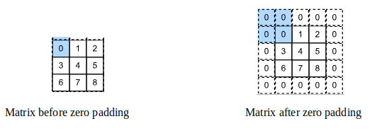
Zero Padding: This padding strategy has been used widely and occurs when zeros are added around an image at the expense of cropping or resizing an image. It is vital to note that this strategy has an advantage of maintaining all features of an image because adding zeros around an image has no effect on the output image after the image is subjected to a kernel filter.
Same Padding: This padding strategy could also is similar to zero padding when zeros are added to to the edges of an image. However a different figure, say 1, could be added on the edges of an image, which would make the padding strategy different from zero padding. This type of padding is also called constant padding.
Valid Padding: valid padding occurs when no extra data is placed at the borders of a matrix or image. Essentially, it is best understood as the absence of padding.
Reflection Padding: This padding technique works by extracting pixels from the border of an image and adding them to the same border in reverse order. It is notable that this padding technique is sometimes referred to as symmetric or edge padding.

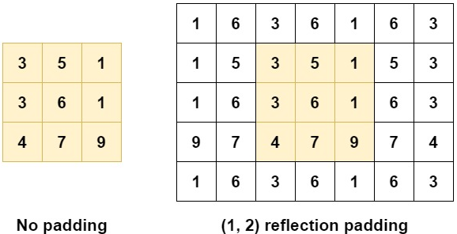

Replication Padding: replication padding is almost almost similar to reflective padding only that rather than creating a reflection of the pixels around the edges of a matrix or image it duplicates adjacent values on the edges of the matrix or image. This padding strategy is also called mirror padding.
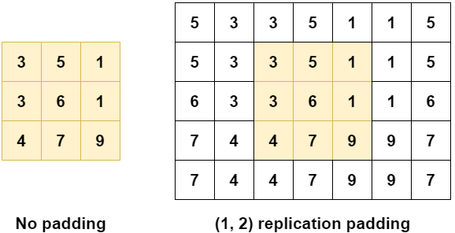

Circular Padding: Wraps the image values on one side around to the other side to provide the
the matrix with additional data that is required before a filter is applied. It is like data from the edges is extracted and placed in the opposite side of the matrix

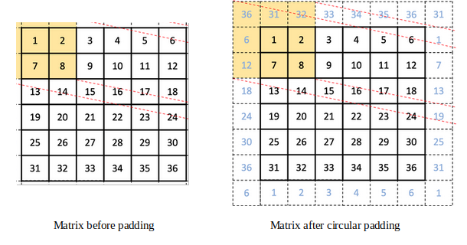

Sequence Padding: is a type of padding strategy commonly applied to sequential or time series data. This padding technique is thoroughly documented by Rio et al., (2020) and can be divided into truncation padding, post-padding and pre-padding. Truncation padding occurs when items in an array are trimmed to have the same length as an array with the least length. Another padding strategy under sequence padding is post-padding and occurs when a chosen value (usually zero) is added at the end of short array items to make all short arrays equal to the longest array. Pre-padding is the opposite of post-padding and occurs when a chosen value (usually zero) is added at the beginning of shorter arrays in a bid to make them equal to the longest array. This type of padding could also be called causal padding.
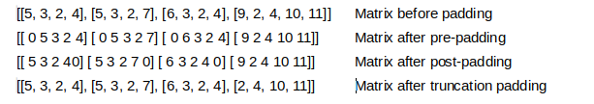
An array of studies have been published either introducing new padding strategies or applying the already existing padding techniques on different problems. For example Nguyen et al., (2021) discusses padding strategies such as partial convolution padding, mean interpolation padding, mean reflection padding. It is important to note that while the authors discuss the aforementioned padding strategies, the strategies are not the focal point of their publication. It is because the authors also discuss distribution padding and conduct an experiment on it. Eventually, the authors show that distribution padding performs better than zero padding in image classification problems. In a different publication, Ning et al,(2023) introduced the idea of learning-based padding arguing that it performs better than the traditional padding strategies. To be specific, the authors propose that learning based paradigms could be used to calculate padding values from data that is on the edge of images. The authors propose learning-based padding by attention and learning-based padding by convolution as methods that could be used to calculate padding values.
Other authors have also investigated padding by developing new padding strategies or examining how padding affects the training process of neural networks. As an evidence of this, Reddy and Reddy (2019) investigated the effect of post-padding and pre-padding in Long short-term memory (LSTM) neural networks and CNNs. The authors concluded that post-padding and pre-padding improve the accuracy of LSTMs but not CNNs because the architecture of CNNs forgets effects of time series variations. Tang et al., (2019) also investigate the effect of invalid and same padding using Pre-trained CNNs and concluded that padding with a stride size set with a value close to the half of the image dimension improves the performance. Another author, Cheng (2020), investigated the effect of zero padding at the bottom of a text only and on all sides of a text in natural language processing. Their study revealed that there is no difference between applying padding at the bottom of a text and on all sides of a text.

Other author investigating padding and how it relates to convolution neural networks is Alrasheedi et al., (2023). The authors acknowledge that padding has been investigated shallowly. It is then, that they propose a padding technique that learns from shifts in hyper parameters of a CNN before adjusting padding effectively. Finally, Alrasheedi et al., (2023) introduce a padding module providing evidence that it performs better 1.49% and 0.44% more better in classification accuracy than the zero padding when tested on the VGG16 and ResNet50. Clearly a considerable number of publications investigating how padding affects convolution neural networks have been made. Regardless, the number of publications that investigate how padding affects CNNs in computer vision still remain wanting. This owes to the fact that only one study has been made investigating how padding affects CNNs has been made. Moreover, no study has been found investigating the effect of padding on CNNs with respect to facial recognition has been found. This is a clear indicator that this proposed study will add value to the already existing literature in facial recognition.

References
Alrasheedi, F., Zhong, X., & Huang, P.C. (2023). Padding Module: Learning the Padding in Deep
Neural Networks. IEEE Access, 11, 7348-7357.
Nguyen, A.D., Choi, S., Kim, W., Ahn, S., Kim, J., & Lee, S. (2019). Distribution Padding in Convolutional Neural Networks. In 2019 IEEE International Conference on Image Processing (ICIP) (pp. 4275-4279).
Reddy, M. D., & Reddy, S. N. (2019). Effects of Padding on LSTMS and CNNS. Retrieved from: https://arxiv.org/abs/1903.07288. Retrieved on: 28 August, 2024.
Rio, L. A., Martin, M., Perera-Lluna, A., & Saidi, R. (2020). Effect Of Sequence Padding
On The Performance Of Deep Learning Models In Archaeal Protein Functional Prediction. Scientific Reports, 10(14634): n.p.
Tang, H., Ortis, A., & Battiato, S. (2019). The Impact of Padding on Image Classification by Using Pre-trained Convolutional Neural Networks. In E. Ricci, S. Rota Bulò, C. Snoek, O. Lanz, S. Messelodi, & N. Sebe (Eds.), Image Analysis and Processing -- ICIAP 2019 (pp. 337–344). Cham: Springer International Publishing.

