Python第三方地图库folium应用
pip install folium
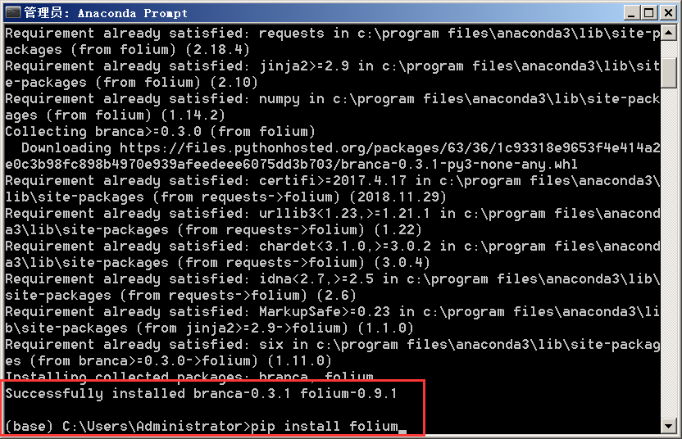

01 划轨迹

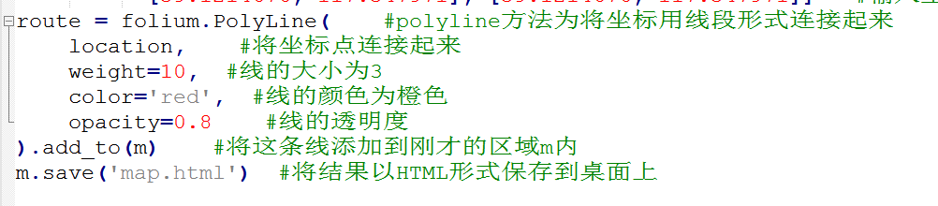
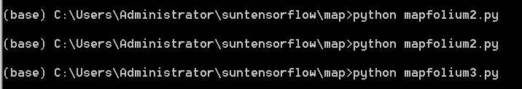
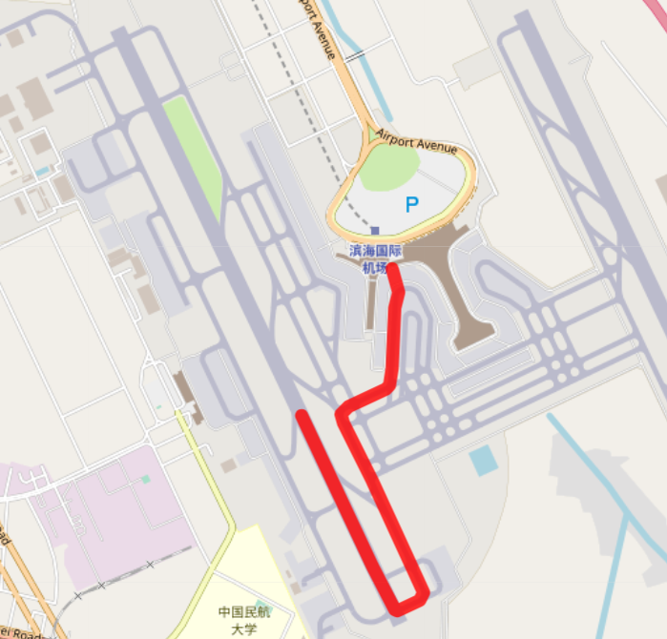
参考：
https://blog.csdn.net/AAAAAAAKing/article/details/83278441

02 划路线

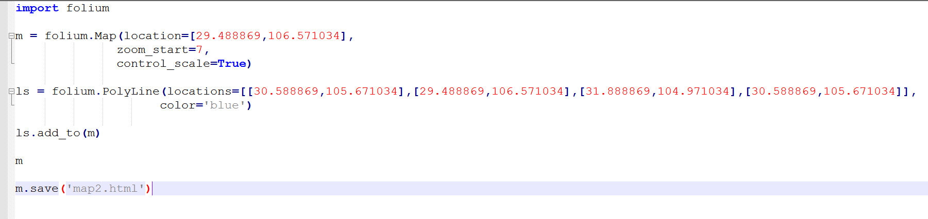
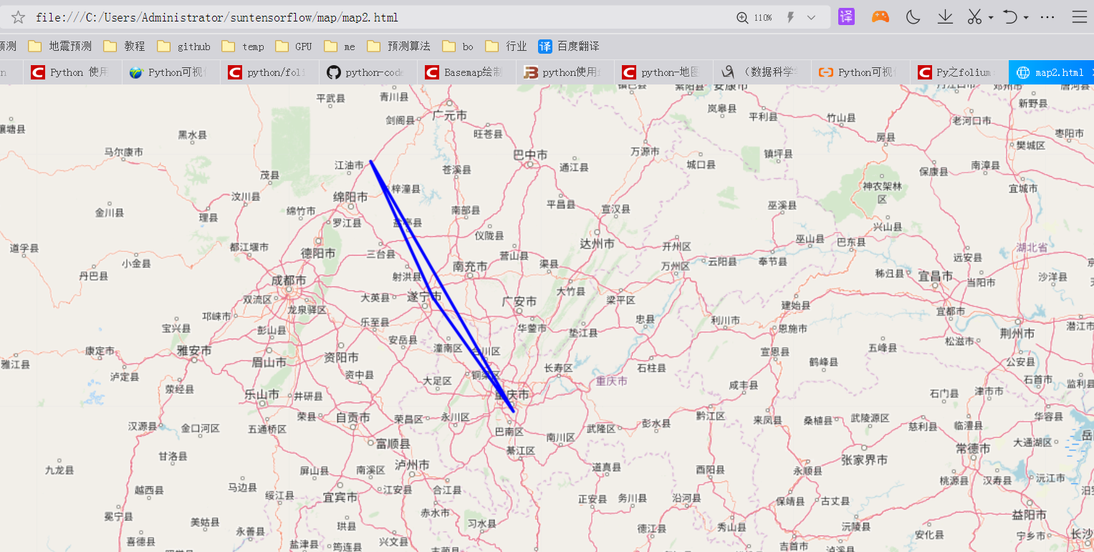
https://www.cnblogs.com/feffery/p/9282808.html

03.绘制热度图

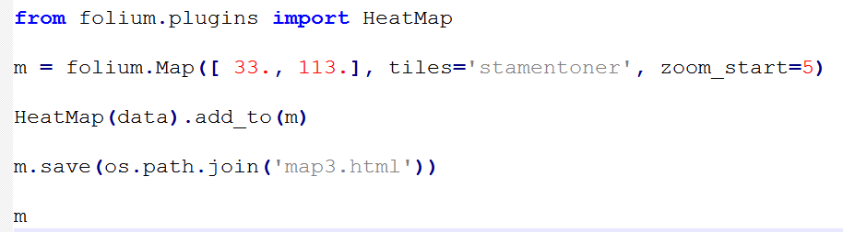
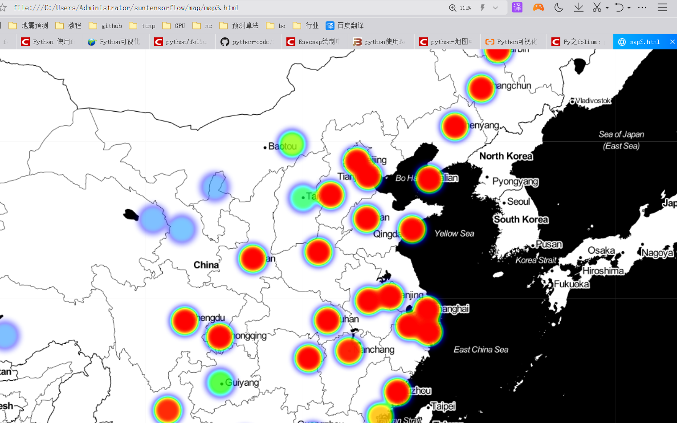
https://blog.csdn.net/qq_14906811/article/details/74906275

04地图热力图

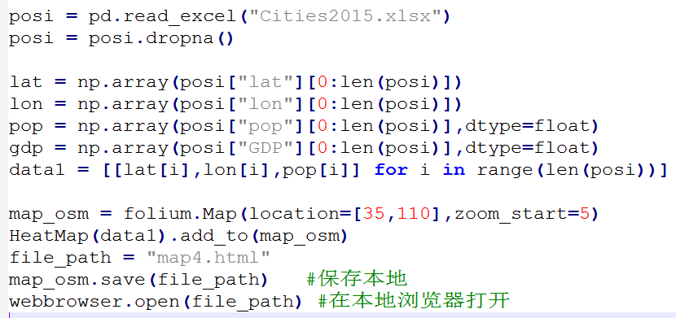
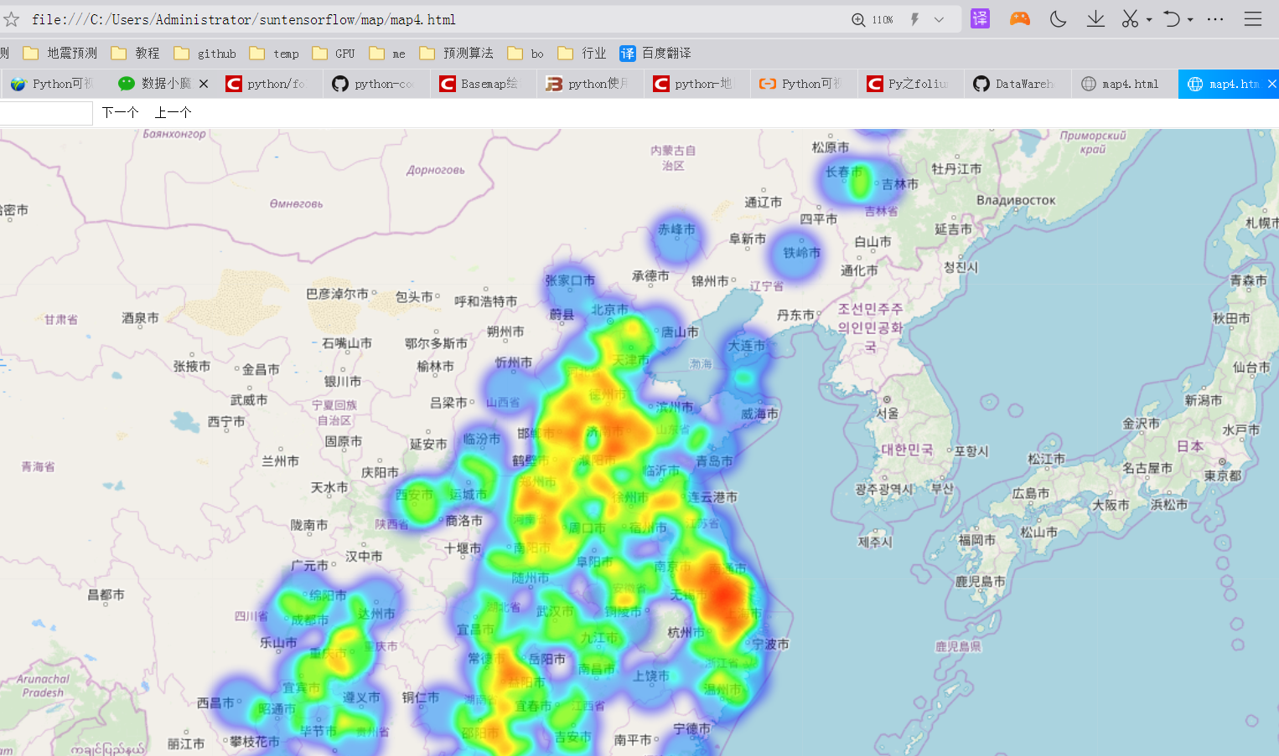
https://mp.weixin.qq.com/s?__biz=MzA3Njc0NzA0MA==&mid=2653192478&idx=1&sn=b5ccc5101c39310c57b9cd45dd7996f9&chksm=848cb951b3fb30472a66ac7122319fb0e0280591cbb37718372cdf1768136f802af5989e9c97&scene=21#wechat_redirect

https://github.com/ljtyduyu/DataWarehouse/tree/master/File

05中国人口热度图

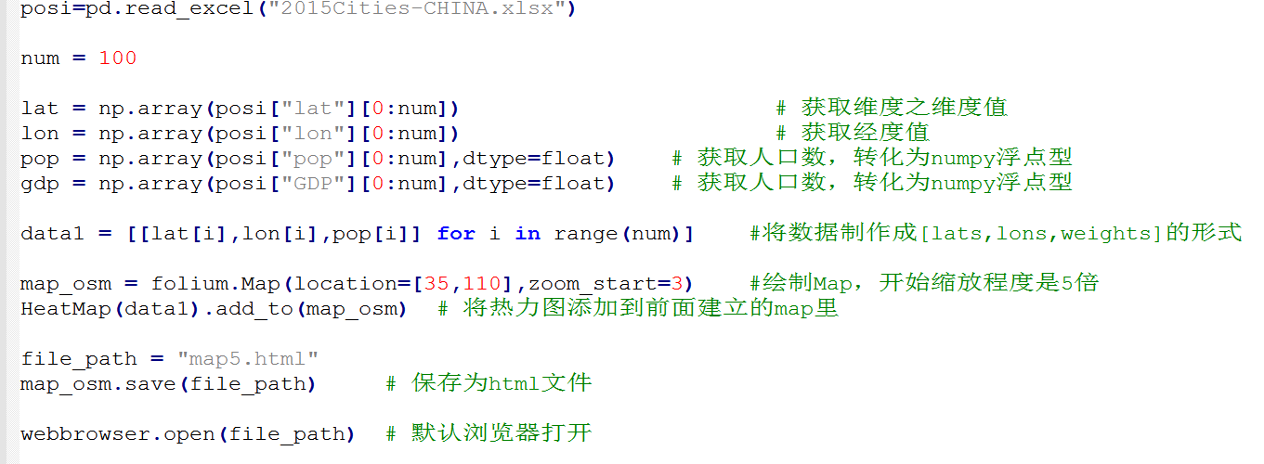

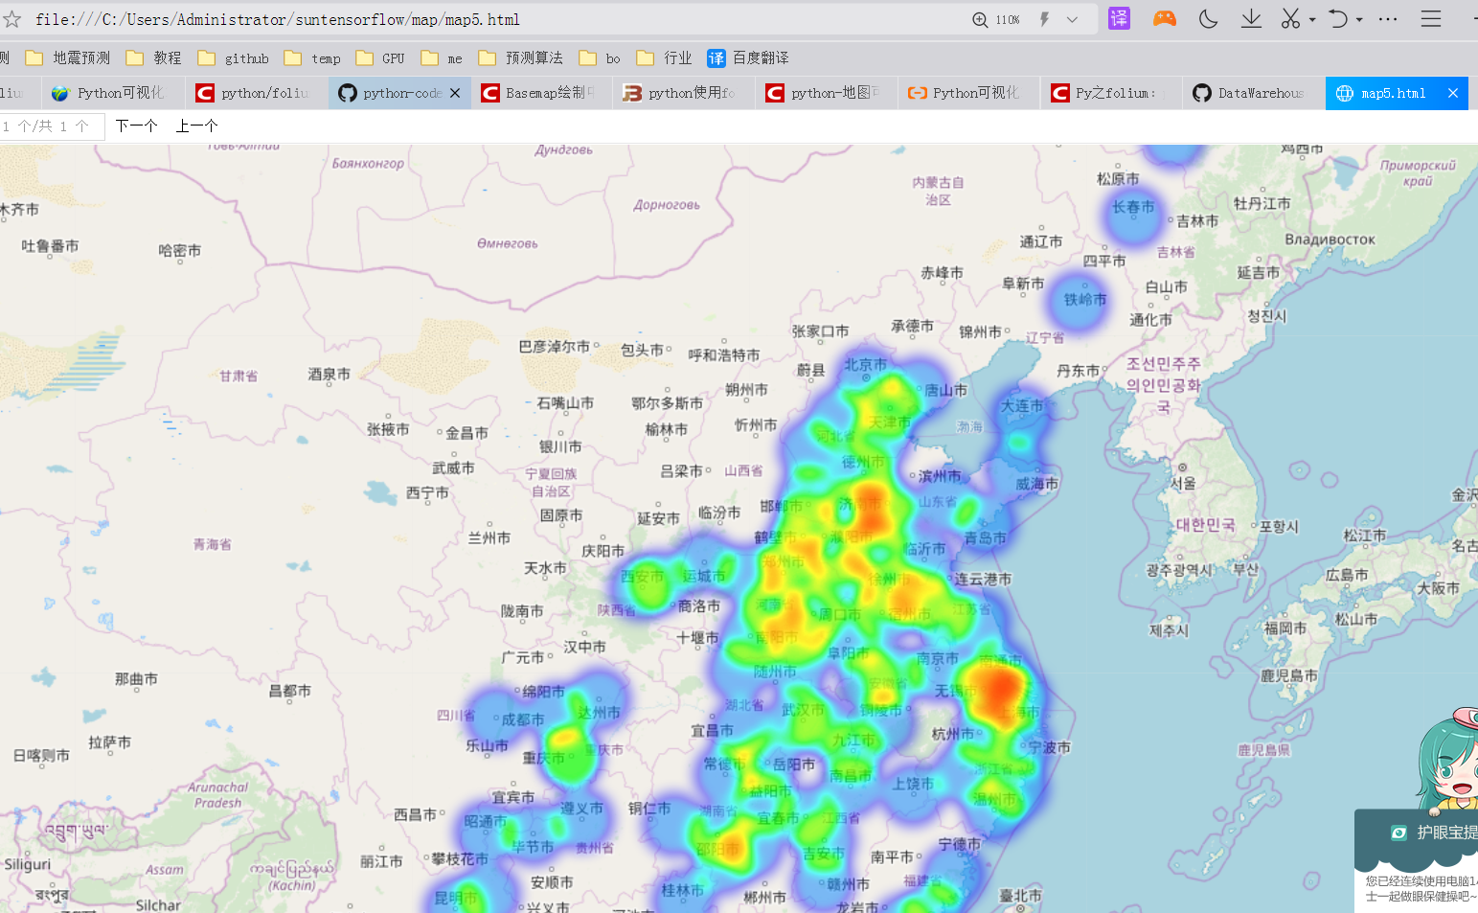
https://blog.csdn.net/ouening/article/details/78882094?utm_source=blogxgwz3

以下未完成
????
06绘制美国失业人口率地图

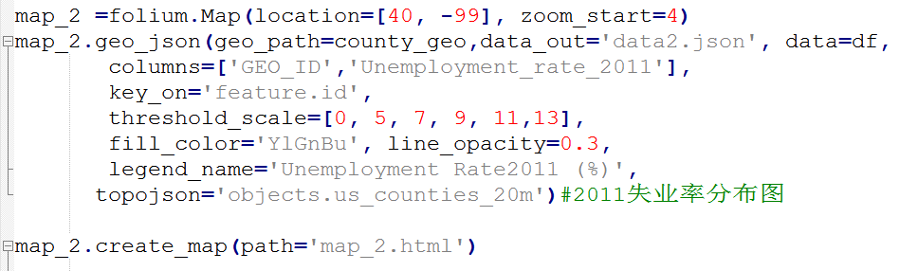
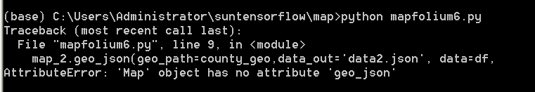
https://blog.csdn.net/qq_41185868/article/details/80806521

其他：
https://blog.csdn.net/junshan2009/article/details/87000143
https://ask.hellobi.com/blog/datamofang/14480
动态热度图
https://zhuanlan.zhihu.com/p/38193282

