Python Logging日志模块

文件：
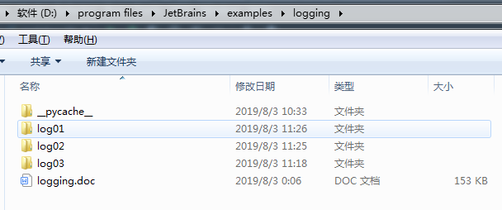
log01/mainlog.py
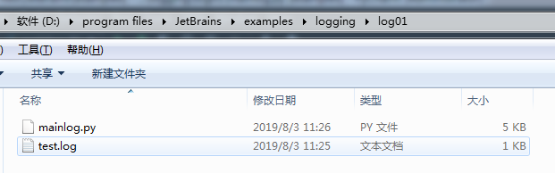
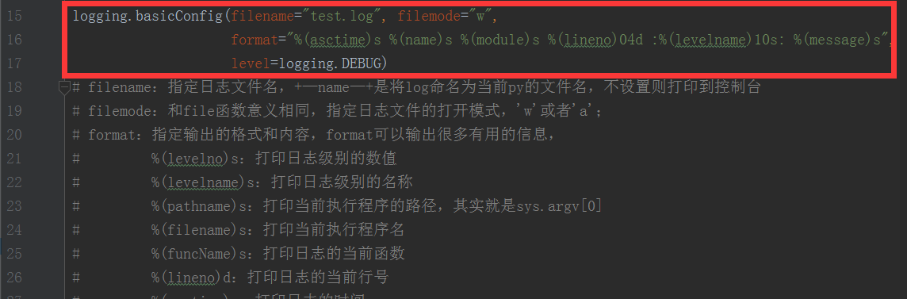
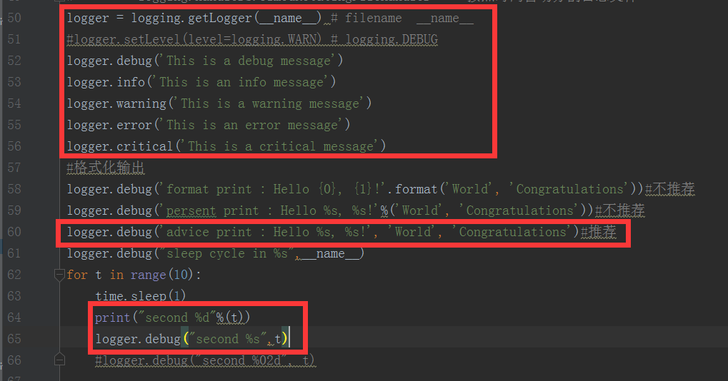

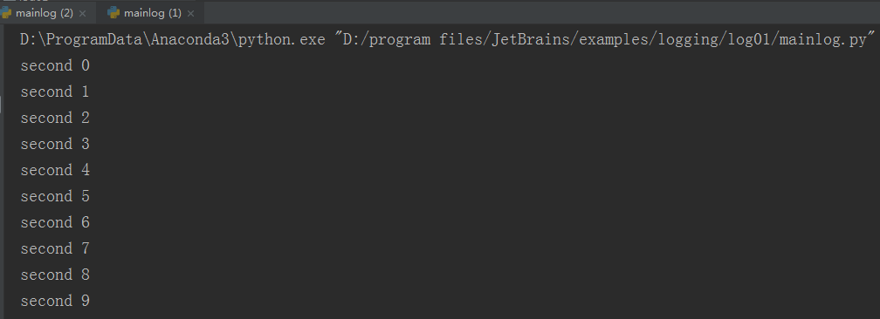
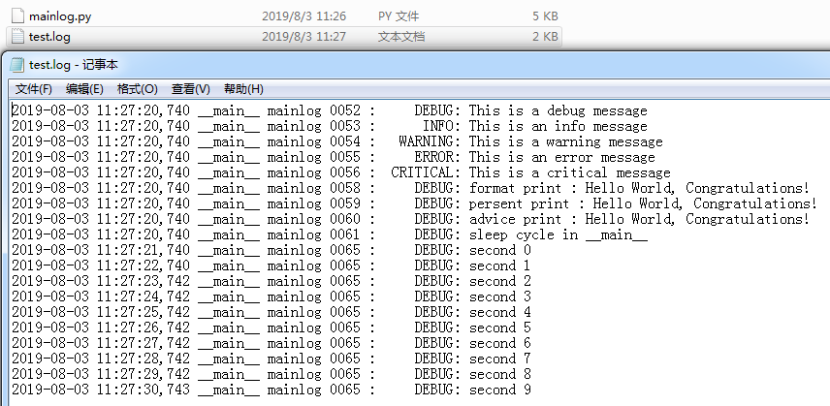

加入
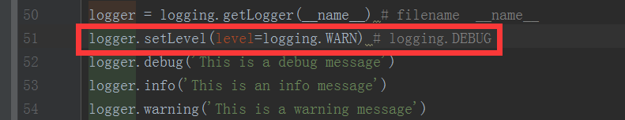
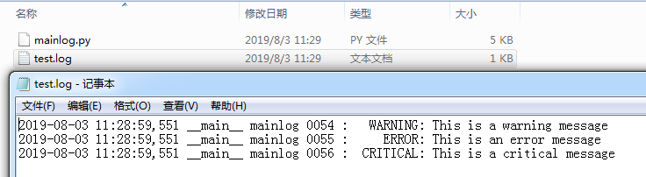

log02
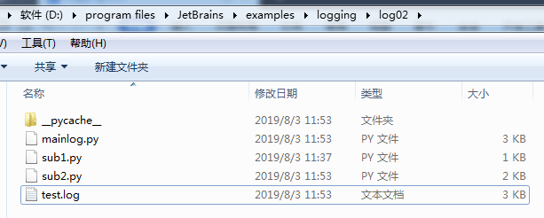
mainlog.py
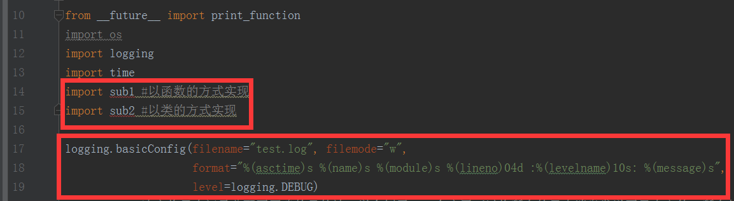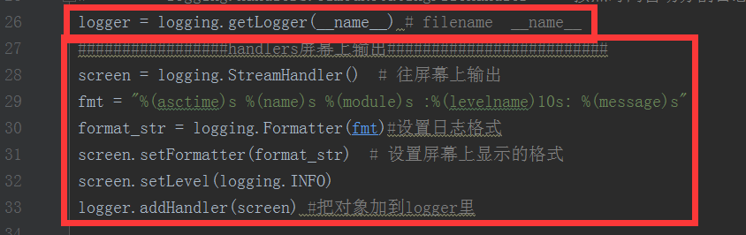
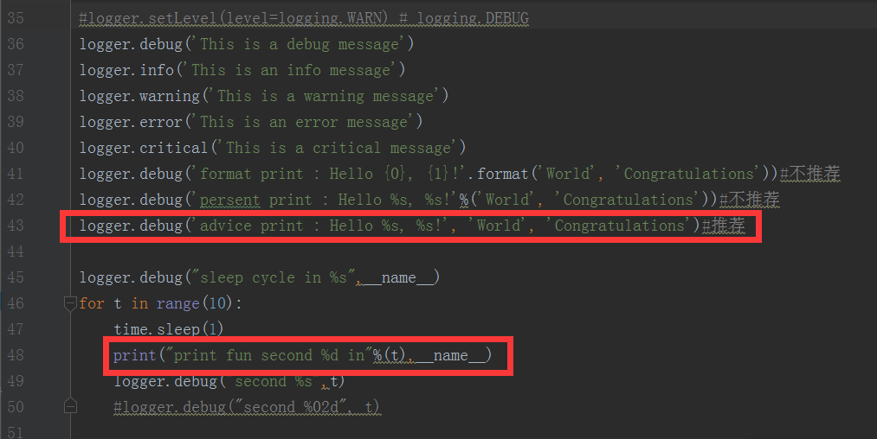
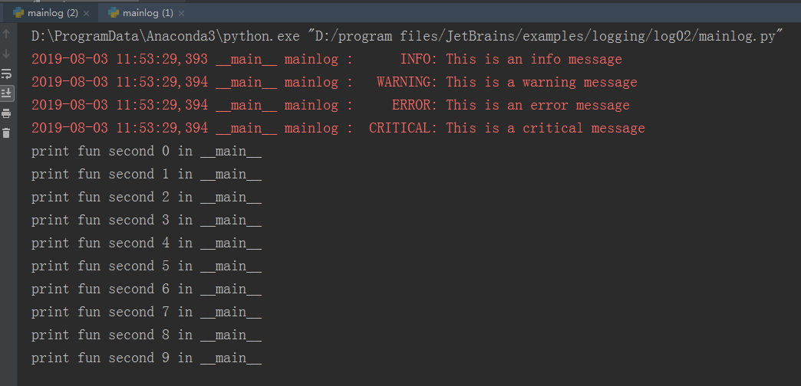
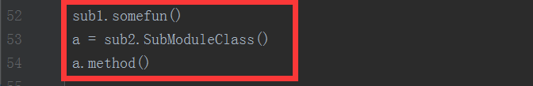
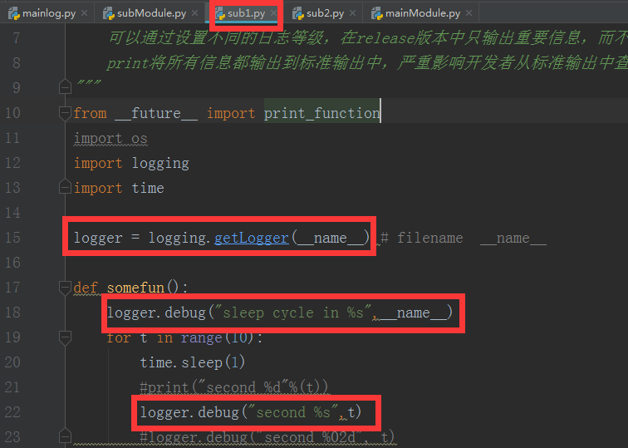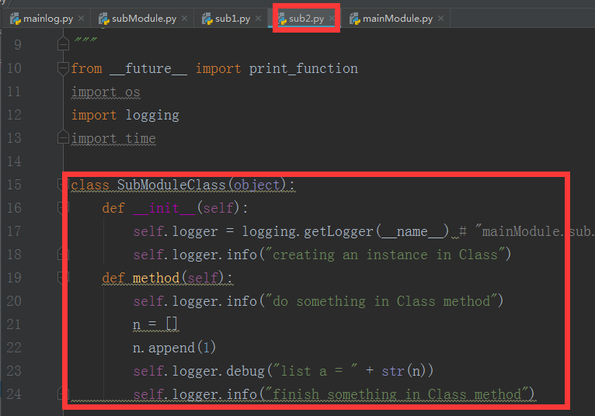
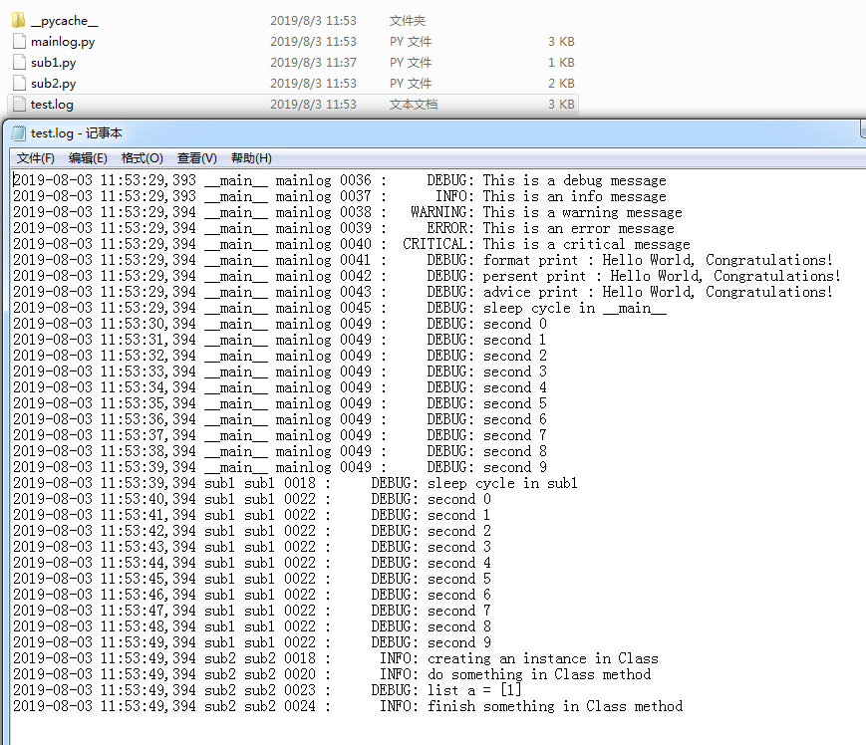
log03
mainModule.py
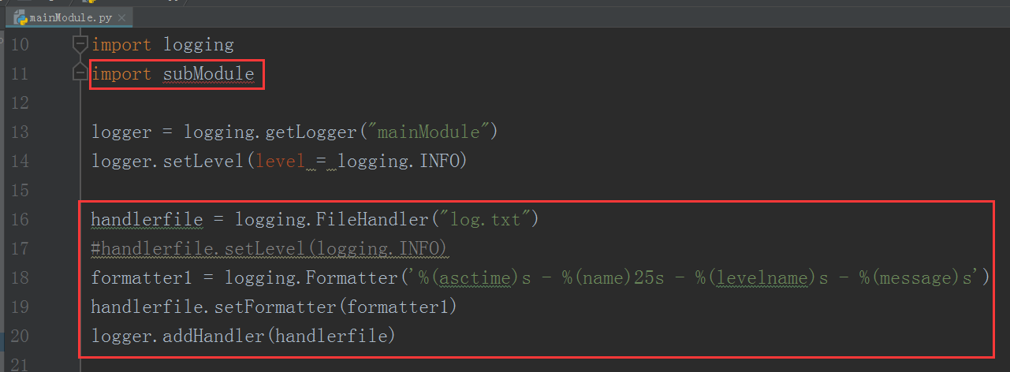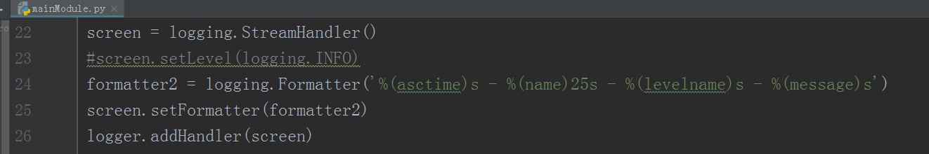
subModule.py
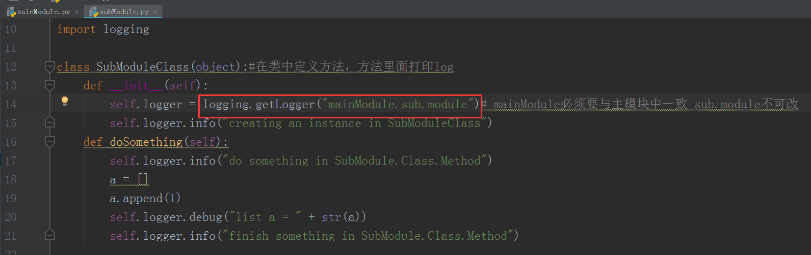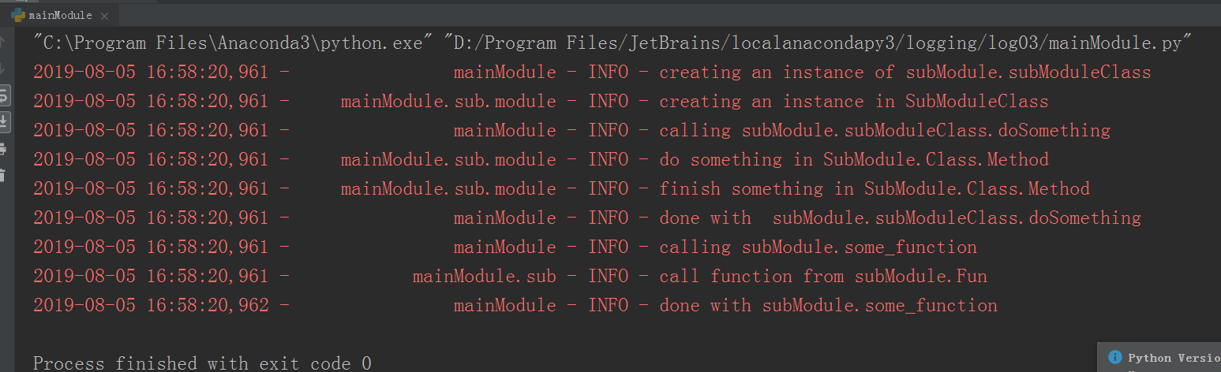
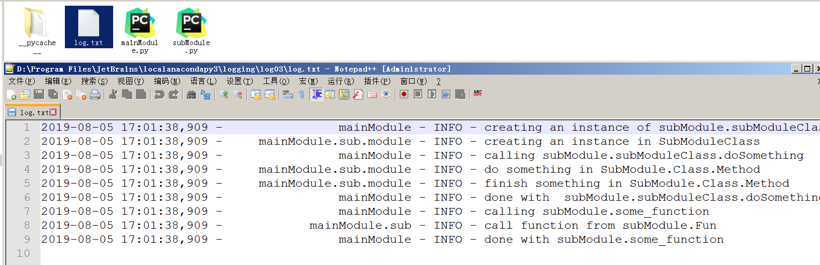

知识点
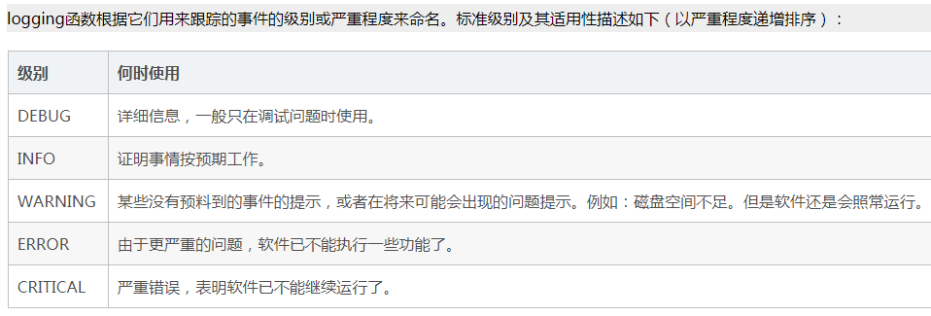
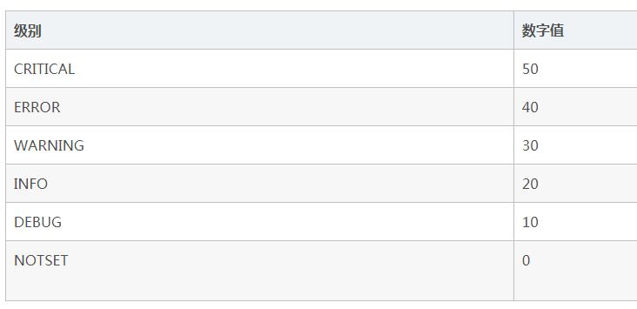
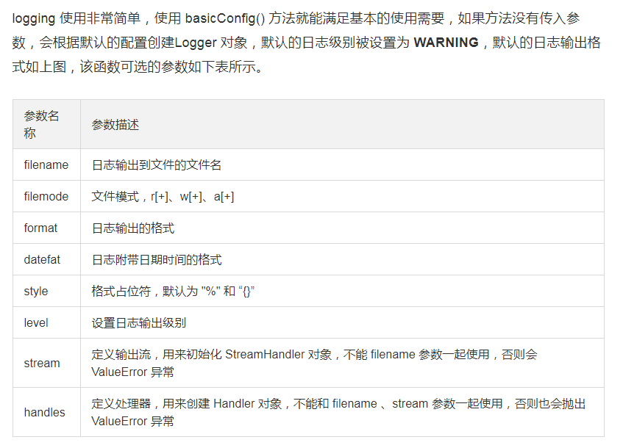
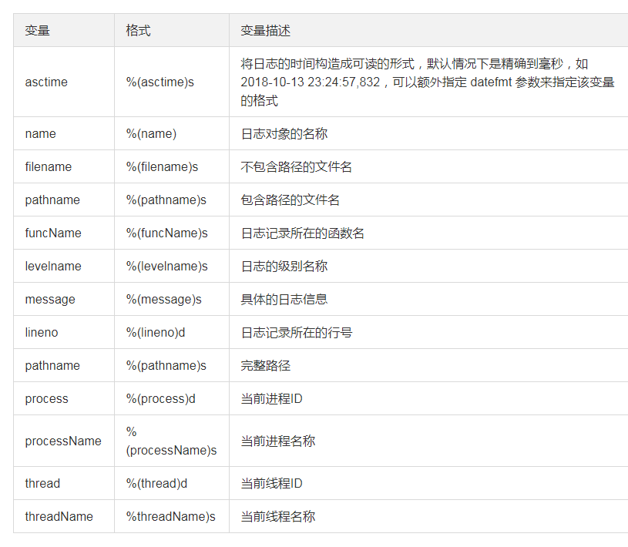

问题：
AttributeError: module 'logging' has no attribute 'basicConfig'
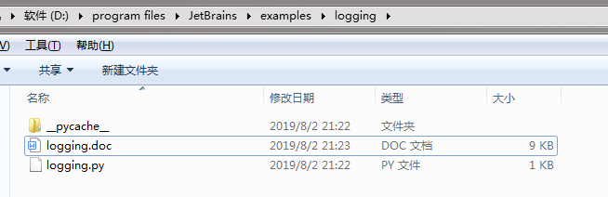
解决办法:
你的文件名字起了logging。

参考：
https://cuiqingcai.com/6080.html
https://blog.csdn.net/albertfly/article/details/80931623
https://www.baidu.com/link?url=HMSTa24xhh3jDDooI6-Mm1ybv_-pQDDXJ2S3Mv5laGEUb_9uTrNXXNKf0M81mRQbne7RSmrrQM6zk8zgp66QK_&wd=&eqid=c7ae29ff003fc8ca000000035d443884
https://cloud.tencent.com/developer/article/1354396
https://www.baidu.com/link?url=oIoROLhR19jMflDwrfALXopb2eLKLMSXixSX-RMpbbqLo4h5S8oZahr-MSZJTeYG&wd=&eqid=ab64a341002d057c000000035d444c2a

