Model | SSIM | MSE
FC-LSTM | 0.690 | 118.3
ConvLSTM | 0.707 | 103.3
TrajGRU | 0.713 | 106.9
CDNA | 0.721 | 97.4
DFN | 0.726 | 89.0
FRNN | 0.813 | 69.7
VPN | 0.870 | 64.1
ST-LSTM | 0.867 | 56.8
Causal LSTM | 0.898 | 46.5
Ours | 0.901 | 44.9
Table 1: A comparison of different models for predicting 10 frames on the Moving MNIST dataset.

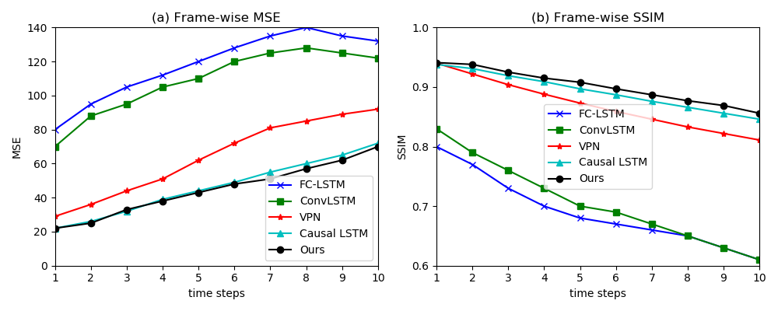
Figure 3: Frame-wise comparisons of different models for predicting 10 frames on the Moving MNIST dataset.

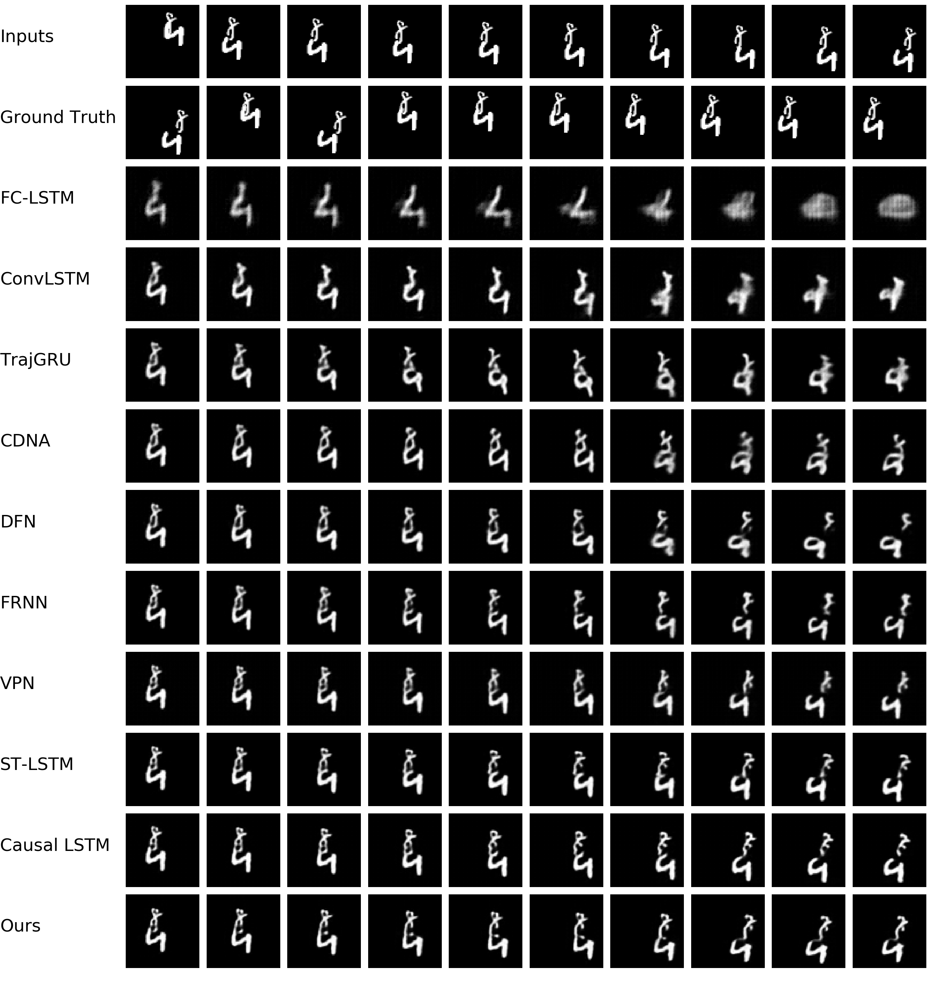
Figure 4: Prediction examples on the Moving MNIST test set.

Table 2: A comparison of different models for predicting 10 frames on the radar dataset.

Model | MSE | SSIM | PSNR
ConvLSTM | 3580.31 | 0.62 | 12.13
TrajGRU | 2088.88 | 0.69 | 14.13
ST-LSTM | 1252.49 | 0.74 | 15.9
Causal LSTM | 905.16 | 0.78 | 17.34
Ours | 888.81 | 0.79 | 17.48

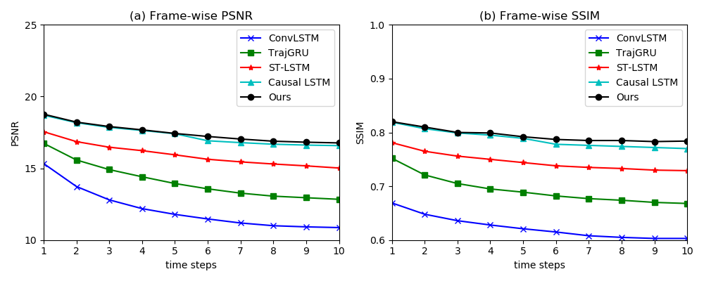
Figure 5: Frame-wise comparisons of different models for predicting 10 frames on the radar dataset.

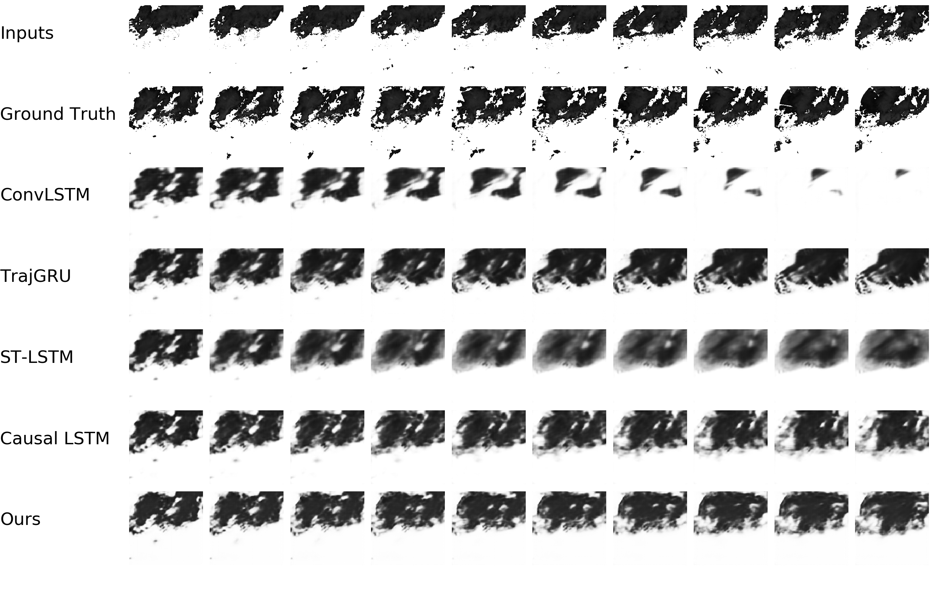
Figure 6: Prediction examples on the radar test set.

