matplot绘制三维图
功能：
Pandas读取CSV数据文件并做格式转换
matplot绘制三维图
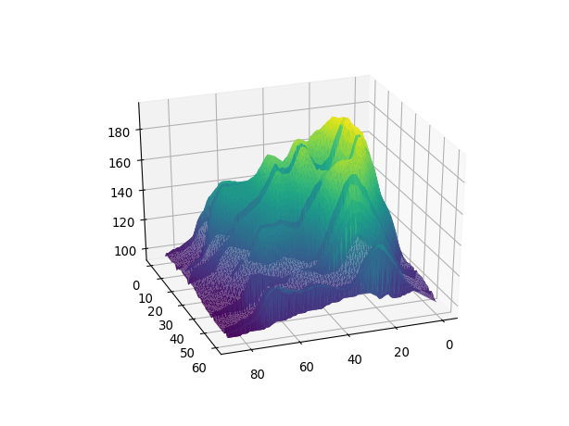
问题：
RuntimeWarning: More than 20 figures have been opened. Figures created through the pyplot interface (`matplotlib.pyplot.figure`) are retained until explicitly closed and may consume too much memory. (To control this warning, see the rcParam `figure.max_open_warning`).
fig = plt.figure()
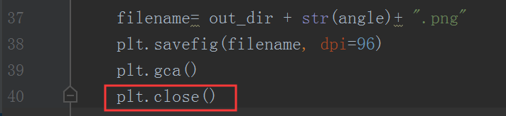
http://www.30daydo.com/question/42

参考：
https://mp.weixin.qq.com/s/e3VdY_Ru8KNVZ0uUHJLlmQ

