Tensorflow2.0 GPU试用例子tf.keras
01.拉去docker镜像，启动容器
拉去镜像
sunfengzhen@gpu:~$ docker pull tensorflow/tensorflow:latest-gpu-jupyter
创建容器
sunfengzhen@gpu:~$ docker run --runtime=nvidia -d --name geoai-gpu-desktop-sfz1225 -p 10028:5901 -p 10027:8888 -p 10026:6901 -e NVIDIA_VISIBLE_DEVICES=2 -e VNC_PW=333666 -e VNC_RESOLUTION=1920x1080 -v /home:/home --ipc=host tensorflow/tensorflow:latest-gpu-jupyter
启动容器
sunfengzhen@gpu:~$ docker start geoai-gpu-desktop-sfz1225
查看容器
sunfengzhen@gpu:~$ docker ps -a| grep sfz
删除容器
sunfengzhen@gpu:~$ docker rm geoai-gpu-desktop-sfz1223
进入容器
sunfengzhen@gpu:~$ docker exec -it 256ead059ab1 /bin/bash
sunfengzhen@gpu:~$ docker exec -it geoai-gpu-desktop-sfz1225 /bin/bash
查看当前正在运行的 Ubuntu 的版本号 cat /etc/issue
查看GPU型号 lspci | grep -i nvidia
查看NVIDIA驱动版本 cat /proc/driver/nvidia/version
查看 CUDA 版本：cat /usr/local/cuda/version.txt 通过命令查看：nvcc -V 或者是nvcc --version
查看 CUDNN 版本cat /usr/local/cuda/include/cudnn.h | grep CUDNN_MAJOR -A 2
查看nvidia-smi
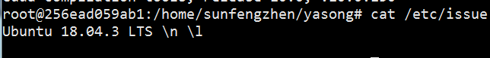
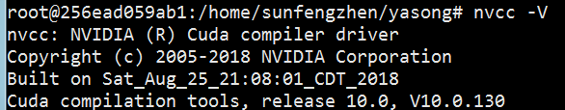
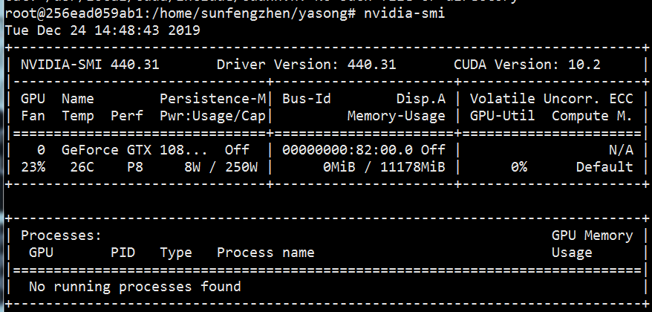

02.安装必须软件及库
默认已安装pip2（tensorflow-gpu2.0.0）python2 python3
# apt-get update先更新后安装
VIM VI安装 # apt-get install vim-gtk
Pip3安装 # apt install python3-pip
#apt-get install python-tk

Pip3安装tensorflow2.0.0
Pip3 install tensorflow==2.0.0a0
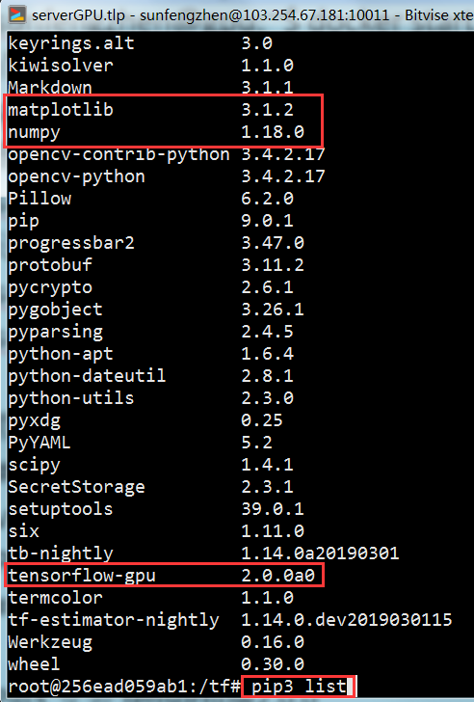

03.
修改源代码适配tensorflow2.0

04.
运行代码
# python mnist_cnn.py
# python conv_lstm.py
# python3 conv_lstm.py
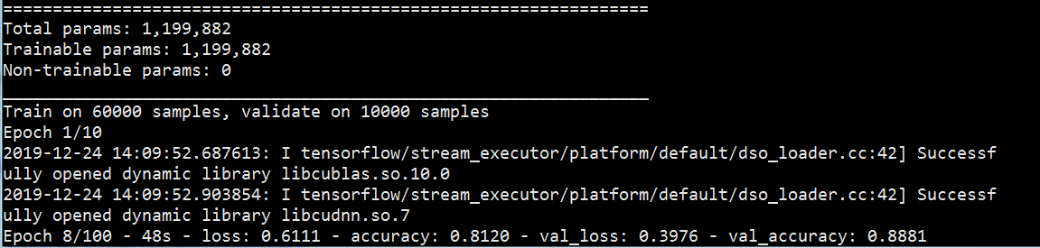
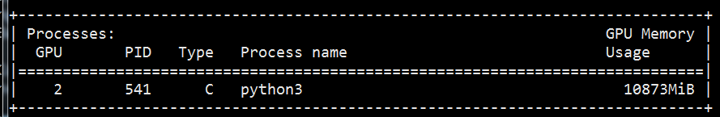
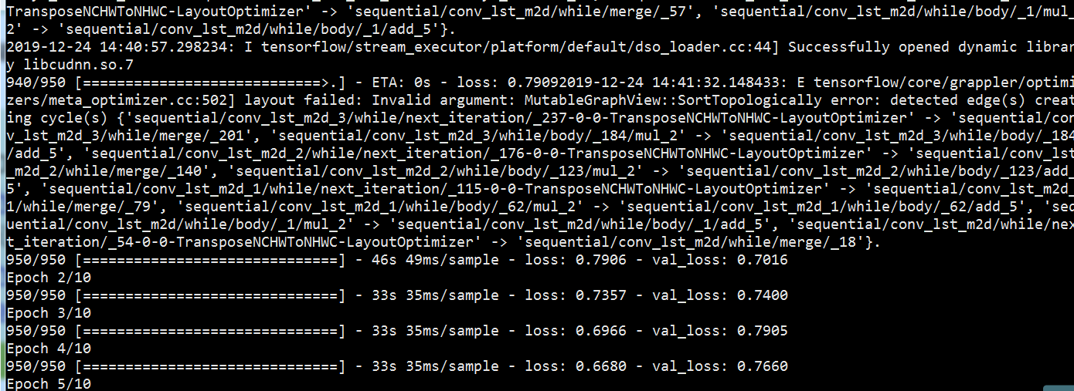
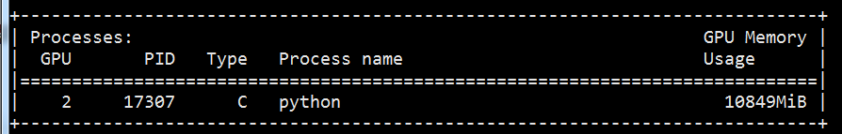

问题：
01.
RuntimeError: It looks like you are trying to use a version of multi-backend Keras that does not support TensorFlow 2.0. We recommend using `tf.keras`, or alternatively, downgrading to TensorFlow 1.14.
用tf.keras代替
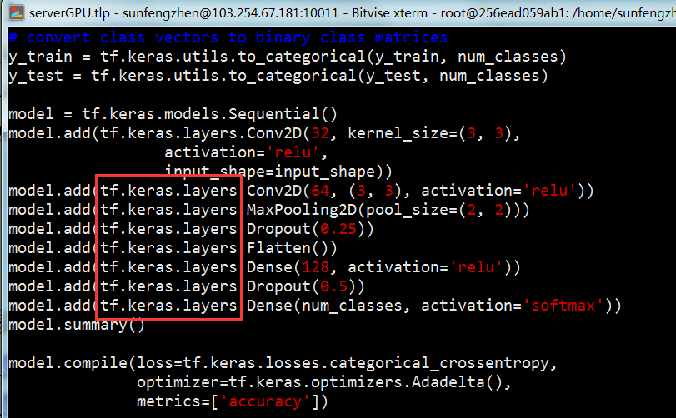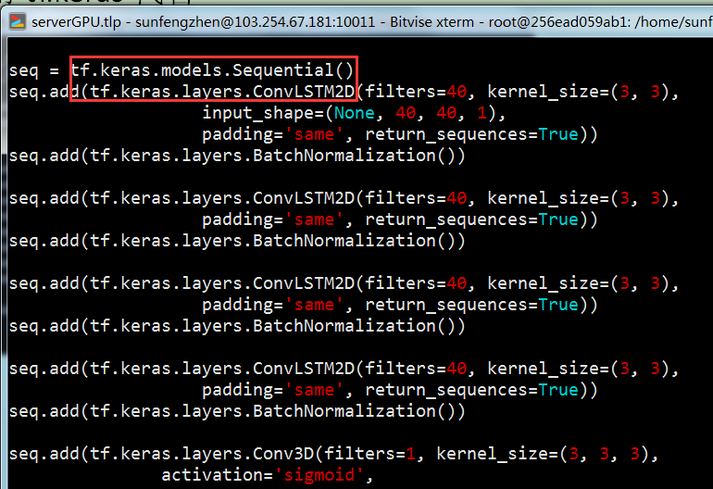
找不到的tf字库，https://tensorflow.google.cn/api_docs/python/tf?hl=en 里面查找

02.更新下载源，下载数据慢
拷贝文件夹.keras .pip到容器主目录下

参考：
https://tensorflow.google.cn/tutorials/quickstart/beginner
https://tensorflow.google.cn/api_docs/python/tf?hl=en
https://blog.csdn.net/hellocsz/article/details/88875304
http://baijiahao.baidu.com/s?id=1639543473065368111&wfr=spider&for=pc
https://tensorflow.google.cn/install/docker
https://hub.docker.com/r/tensorflow/tensorflow/tags

