2.55

程序运行结果如图

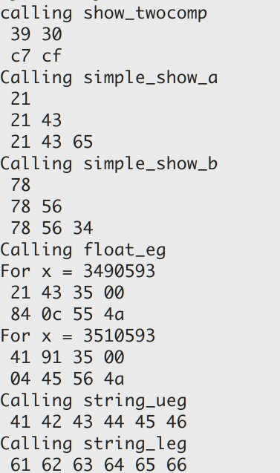

可以推断我的电脑为小段机。

2.83

A.

x = 0.yyyyyyyy...

x*2^k = y.yyyyyyyy...

x = y/(2^k-1)

B.

(a) 5/7

(b) 6/15 = 2/5

(c) 19/63

2.87

|  |  |  |  |  |  |
| --- | --- | --- | --- | --- | --- |
| 描述 | Hex | M | E | V | D |
| -0 | 8000 | 0 | -14 | -0 | -0.0 |
| 最小的>2的值 | 4001 | 1025/1024 | 1 | 1025/512 | 2.001953125 |
| 512 | 6000 | 1 | 9 | 512 | 512.0 |
| 最大的非规范数 | 03FF | 1023/1024 | -14 | 1023/(2^24) | 6.097555160522461e-05 |
| -∞ | FC00 | - | - | - | -∞ |
| 十六进制为3BB0 | 3BB0 | 123/64 | -1 | 123/128 | 0.9609375 |

2.91

A. 11.0010010000111111011011

B. 11.001001001001001...

C. 9th