The purpose of this folder is to store cycle ride data tracked with the Strava app. Please upload your cycle data here. We are collecting geo tracked cycle data for data analysis purposes. We believe this will be a persuasive tool in convincing investors.

# Instructions

### Download Data

* Login to Strava web app in your browser
* Click on the ride you want to download in your feed.

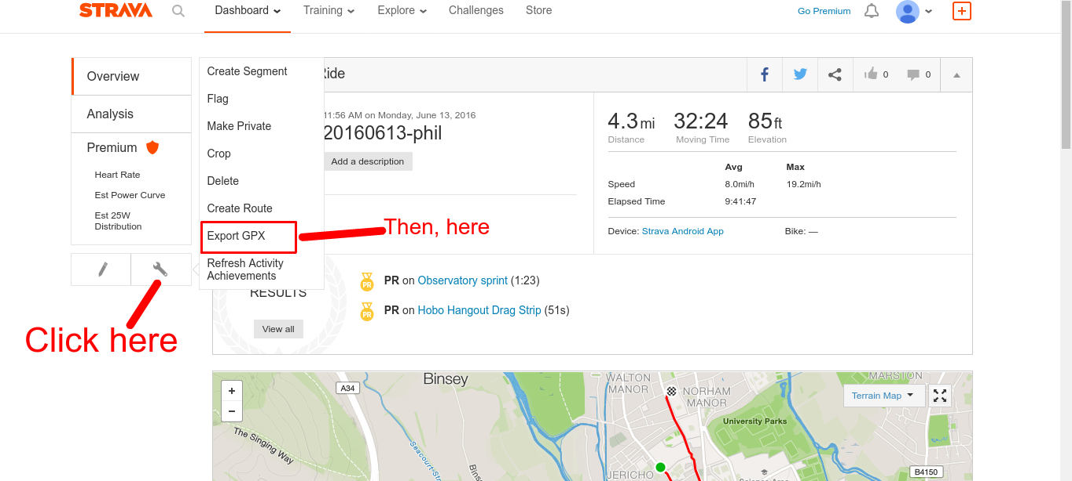

### Upload Data

* Find the GPX file location.
* Upload data to this Google Drive in YYYYMMDD_<NAME>.gpx
  + If you upload multiple rides on the same day, distinguish them with a “-<N>” suffix. E.g. 20160613_phil_2.gpx