Charlevoix Cycling Tour
Executive Summary 2
Vision and Objectives 2
Unique Selling Points 2
Target Audience 2
Collaboration and Outcomes 3
Logistical Overview 3
Market Need and Call to Action 3
Project Background 4
Inception of the Idea 4
Importance and Relevance in the Current Market 4
Alignment with Professional Goals and Values 4
Objectives 5
Short-Term Goal for 2024 5
Long-Term Expansion Goals 5
Market Analysis 6
Target Audience: Customer Avatar 6
Competitive Analysis 7
Market Demand and Potential Growth 7
Project Description 7
Overview 7
Duration and Structure 8
Accommodations 8
Culinary Experience 8
Tentative Gravel/Road Itineraries 9
Pricing and Offer 10
Exhibit and Links 11
Hotel Germain to Gare du Palais train 11
Camping Arthabaska 11

Executive Summary

We are excited to introduce a premier cycling camp experience set in the picturesque landscapes of Charlevoix, Quebec, designed to cater to the discerning cyclist seeking adventure, physical challenge, and personal growth. This unique offering is brought to life through the collaboration of two seasoned cyclists: Svein Tuft, a renowned figure in Canadian professional cycling, and Jean-Michel Lachance, whose expertise spans competitive cycling, logistics, and entrepreneurship.

Vision and Objectives
Our vision is to craft an unforgettable journey that transcends the typical cycling camp. By combining the thrill of scenic exploration and physical challenges with the pursuit of mental well-being and the "instant présent," we aim to create lasting memories and foster a positive mindset among our participants. This camp is not just about pushing physical limits; it's about rejuvenating the spirit and nurturing a profound sense of gratitude and groundedness.

Unique Selling Points
What sets our camp apart is the unparalleled guidance from Svein Tuft and Jean-Michel Lachance, ensuring a richly rewarding experience. The camp boasts meticulously organized logistics and support services, including massotherapy, meals prepared by a private chef, and a blend of rustic and high-end accommodations. This comprehensive approach ensures a comfortable, enriching, and hassle-free experience for all participants.

Target Audience
Our program is tailored for affluent cyclists with sufficient fitness levels to embark on this adventure. We seek individuals who are not only looking for a physical challenge but are also eager to immerse themselves in a journey of personal growth and discovery.

Collaboration and Outcomes
The involvement of Svein Tuft adds a significant layer of prestige and authenticity to the camp, with him serving as a guide and mentor alongside Jean-Michel. Participants can expect to conclude this journey with a renewed sense of gratitude, humility, and a rejuvenated spirit, carrying with them memories and lessons that extend well beyond the cycling paths.

Logistical Overview
While the full itinerary is being meticulously planned, we are targeting the dates between July 30th and August 25th for the camp. Detailed logistics, including accommodations, support staff, and transportation, are detailed in the upcoming section of this document.

Market Need and Call to Action
In alignment with the availability of our lead cyclists and the ideal timing for such an event, we are now in the crucial phase of budgeting, securing partnerships with campgrounds and hotels, finalizing staff support, and managing transport logistics. We are also initiating a waitlist to gauge interest and ensure we meet our budgetary break-even point.
We invite potential partners, sponsors, and interested cyclists to join us in bringing this vision to life, offering an unparalleled experience that promises not only to challenge the body but also to enrich the soul.

Project Background

Inception of the Idea
The concept for this unique cycling camp emerged from a series of discussions between Jean-Michel Lachance, a seasoned cyclist with a rich background in logistics and entrepreneurship, and Svein Tuft, one of Canada's most celebrated professional cyclists. Recognizing a shared passion for the sport and a mutual desire to offer something beyond the traditional cycling camp experience, the idea was born to create a camp that combines rigorous physical challenges with a focus on mental well-being, scenic exploration, and personal growth. This vision was fueled by the understanding that while many camps focus on the physical aspect of cycling, there is a significant opportunity to offer a more holistic experience that also nurtures the mind and spirit.

Importance and Relevance in the Current Market
In today's fast-paced world, individuals are increasingly seeking experiences that not only challenge them physically but also offer mental rejuvenation and a break from the digital overload of daily life. The cycling camp market is ripe for an offering that addresses these needs, providing a sanctuary where participants can immerse themselves in the beauty of nature, engage in physical activity, and also partake in mindfulness and personal development activities. Our camp's unique blend of high-level cycling, scenic routes, and emphasis on the "instant présent" taps into this growing demand, setting us apart from more traditional, performance-focused camps.

Alignment with Professional Goals and Values
For Jean-Michel Lachance, this project represents a synthesis of his diverse skill set, uniting his competitive cycling experience, logistical expertise, and entrepreneurial acumen. It offers a platform to share his passion for cycling and personal development with a broader audience, leveraging his insights to create an unparalleled experience for participants.
Svein Tuft brings to the project not only his prestige as a professional cyclist but also his deeply held belief in the power of cycling to transform lives. His role as a guide and mentor within the camp embodies his commitment to giving back to the cycling community, sharing the lessons he's learned from years of professional racing, and helping others to achieve their personal and physical potential.
The collaboration between Jean-Michel and Svein embodies a shared commitment to excellence, community building, and the transformative power of cycling. This project is not just an extension of their professional careers; it is a manifestation of their values and a contribution to the cycling community they both hold dear.

Objectives

Short-Term Goal for 2024
Launch in Charlevoix: Successfully host an inaugural collaborative cycling camp in Charlevoix, focusing on creating a memorable and impactful experience for the participants.
Content Creation and Testimonials: Document the camp through high-quality content creation, capturing the essence of the experience to share with a broader audience. Generate positive testimonials from participants to build credibility and attract future attendees.

Long-Term Expansion Goals
Geographical Expansion: Following a successful launch in Charlevoix, expand the camp offerings to include other geographical regions, starting with Latin America. This expansion aims to explore new terrains, cultures, and cycling challenges, diversifying the experiences available to participants.
Cycling Community: Establish a network of cycling camps across various locations, creating a global community of cyclists who share experiences, knowledge, and a commitment to cycling excellence and personal growth.

Market Analysis

Target Audience: Customer Avatar

Name: Alex Martin
Age: 35-55 years
Occupation: Professional/Executive in sectors like technology, finance, healthcare, or entrepreneurship.
Income Level: High-income bracket, with a disposable income that allows for investing in premium, experiential offerings like specialized cycling camps.
Location: Primarily based in urban centers across North America and Europe, with a willingness and capability to travel for unique experiences.

Cycling Proficiency Level: Intermediate to advanced cyclists who are looking for both a challenge and an opportunity to improve their skills. Alex has completed several long-distance rides and may have participated in amateur races.
Psychographics:
Values and Interests: Alex values health, wellness, and personal growth. They have a strong interest in outdoor activities, especially cycling, and are passionate about exploring new cultures and destinations.
Lifestyle: Active and adventurous, preferring high-quality experiences over material possessions. Alex often seeks opportunities for self-improvement and to overcome unique challenges.
Community Orientation: Looks for experiences that offer a sense of community and belonging, valuing connections with like-minded individuals.
Motivations:
Seeking a unique and premium cycling experience that combines physical challenges with educational and personal growth opportunities.
Desire to learn from and interact with renowned cyclists like Svein Tuft and Jean-Michel Lachance.
Interest in exclusive, scenic routes that offer both beauty and a test of endurance.

Competitive Analysis
Existing Cycling Camps: Many camps focus primarily on performance and physical training, often overlooking the mental and educational aspects of cycling.
Unique Selling Points: Our camp differentiates itself by offering a holistic experience that includes massotherapy, gourmet nutrition, and a blend of rustic and high-end accommodations, guided by esteemed professionals.
Market Position: A premium offering that caters to affluent cyclists seeking more than just physical training - a rejuvenating, educational, and community-oriented experience.

Market Demand and Potential Growth
Trends: There's a growing trend towards experiential travel and wellness retreats, with individuals seeking unique ways to combine their passions with personal development.
Demand: High demand among affluent professionals for exclusive, health-oriented vacations that offer personal attention and unique experiences.
Growth Potential: Significant growth potential exists in expanding geographically and catering to specific niches within the cycling community, such as women-only camps or culturally-themed tours.

Project Description

Overview
The inaugural edition of our cycling camp is a meticulously designed gravel cycling experience set in the breathtaking landscapes of Charlevoix, Quebec. This unique camp is tailored for cyclists seeking to push their limits through challenging point-to-point rides while also embracing the serenity of nature, away from the hustle of daily life.

Duration and Structure
Length: The camp spans seven days, offering a perfect balance between intense cycling, informal educational workshops, and restorative activities.
Daily activity:
Morning: Start with a gourmet, nutrient-rich breakfast prepared by our private chef, followed by a briefing on the day’s route and safety tips.
Daytime: Embark on guided gravel rides, ranging from challenging climbs to scenic flat routes, with rest and nutrition stops strategically placed along the way.
Evening: Return to the campsite or hotel for recovery sessions, including yoga/stretch and massotherapy, followed by a culinary feast under the stars.
Routes and Special Events
Routes: Each day features a different route designed to explore Charlevoix's natural beauty and rugged terrain. Routes are carefully selected to cater to intermediate and advanced cyclists, combining technical gravel paths with scenic views.
Special Events: The camp includes informal workshops on mindset, cycling techniques and nutrition, storytelling and insights from our esteemed coaches, and personal anecdotes from the professional cycling world.

Accommodations
Setting: Participants will stay in a combination of a high-end hotel and a remote, rustic campground chosen for its stunning natural beauty and tranquillity. The absence of cell coverage ensures a truly immersive experience, encouraging participants to connect with their surroundings and fellow cyclists.
Amenities: High-quality camping equipment includes comfortable tents, premium mattresses, and luxurious linen, ensuring a restful night’s sleep amidst the wilderness.

Culinary Experience
A private chef will cater all meals, snacks, and beverages. Using locally sourced, fresh ingredients, the culinary offerings are designed to fuel long days in the saddle while also delighting the palate.
Dietary preferences and restrictions are meticulously accommodated, ensuring every participant enjoys nourishing and delicious meals throughout the camp.

Tentative Gravel/Road Itineraries

Day 1
Pick up at the airport + drive to Camp Mercier
Accommodation: Camp Mercier chalet
Food: Private chef
Day 2
Camp Mercier - Arthabaska - 95km - 1405m
https://www.strava.com/routes/3192481258039489372
Accommodation: Camping Arthabaska
Food: Private chef
Day 3
Arthabaska - Arthabaska 52km - 860m
https://www.strava.com/routes/3192483770152904246
Accommodation: Camping Arthabaska
Food: Private chef
Day 4
Arthabaska
Rest Day / Optional easy ride / Fishing? Swimming
Accommodation: Camping Arthabaska
Food: Private chef
Day 5
Ride: Arthabaska - BSP - 85km - 1300m
https://www.strava.com/routes/3192547602368448016
Accommodation: Hotel Germain high end
Food: Hotel Germain
Day 6
Ride: BSP loop 110km - 1900m
https://www.strava.com/routes/3205930028432411002
Accommodation: Hotel Germain high end
Food: Hotel Germain
Day 7
Morning: optional easy ride + packing
A) Île aux coudre ride ? (if train leaving late)
50km - 800m (easy gradient)
https://www.strava.com/routes/3205930667069709690
B) Easy ride around BSP
40km (300m) + cheese factory tour
https://www.strava.com/routes/3205932905816923440
Panoramic hydrogen train from Hotel Germain to Gare du Palais, Quebec city
Accommodation: No accommodation or hotel in Quebec city high-end
Food: Hotel Germain / Quebec City restaurant

Pricing and Offer

- Solo Individual: TBD (private accommodation/hotel room and tent)
- Couple (1 cyclist, 1 companion (non-cyclist): TBD
- Shared accommodation (2 cyclists, shared accommodation (hotel room (1 or 2 beds, tent_

Exhibit and Links

Hotel Germain Baie St-Paul
https://www.germainhotels.com/fr/hotel-et-spa-le-germain/charlevoix
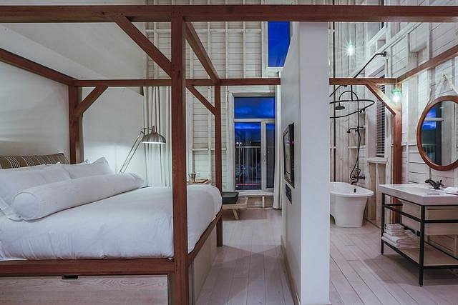

Hotel Germain to Gare du Palais train
https://traindecharlevoix.com/en/le-train/train-experience/
https://www.instagram.com/traindecharlevoix
Cost: 436$ / 4 person (group / river side)
Additional person: 99-119$
Note: Worth considering if Hotel Germain based for the whole camp - Roundtrip option 676$ (group / river side)

Camping Arthabaska
https://www.tourisme-charlevoix.com/en/attractions/camping-parc-national-des-grands-jardins-secteur-arthabaska/
https://www.sepaq.com/en/reservation/camping/parc-national-des-grands-jardins/arthabaska 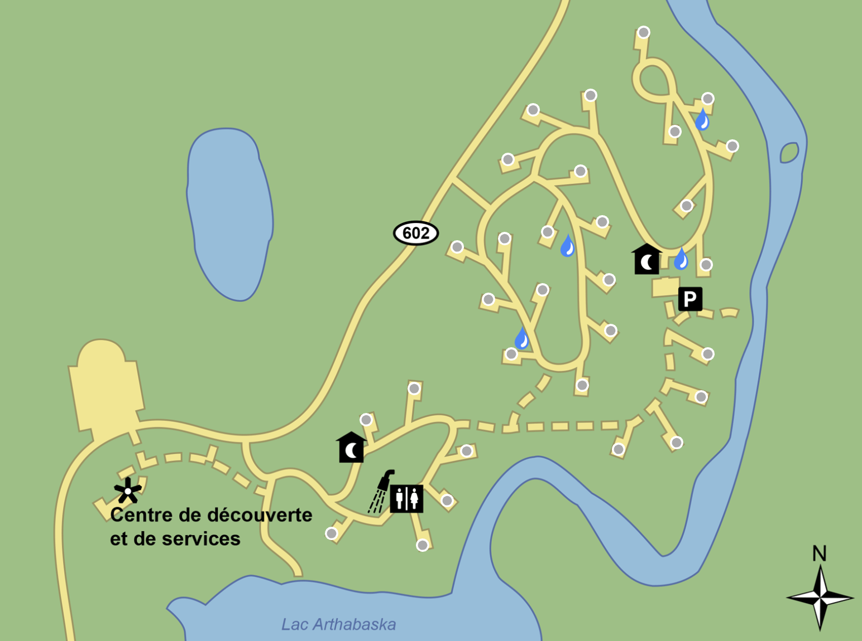

July 1st to 7th
July 15th to 28th

