

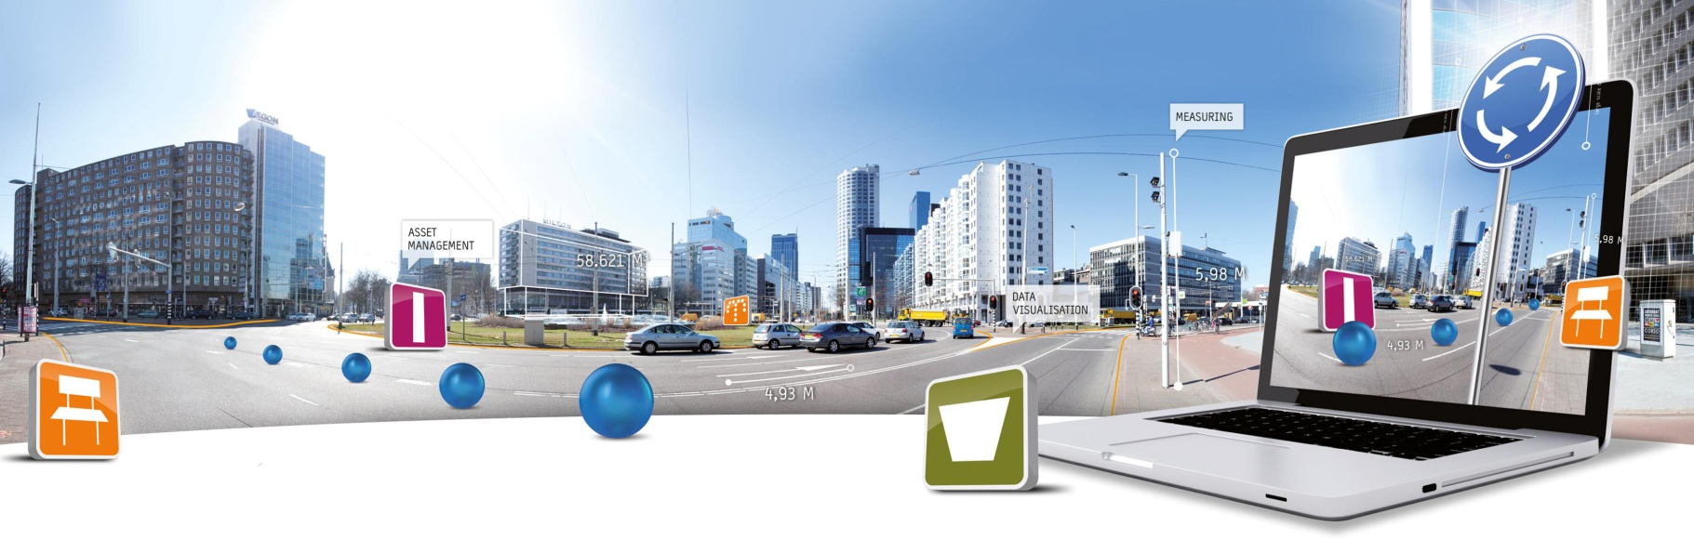

**GlobeSpotter for ArcGIS Desktop Installation Manual**

Datum: 21 januari 2014

CycloMedia Technology B.V. | **T** +31 (418) 556100 | **E**: [info@cyclomedia.com](mailto:info@cyclomedia.com)

# 1. Installation

To install GlobeSpotter for ArcGIS Desktop you must perform the following steps:

1. Check if ‘Adobe Flash Player’ is installed on your machine. If ‘Adobe Flash Player’ is not, installed, install ‘Adobe Flash Player’.
2. If you have installed a previous version of GlobeSpotter for ArcGIS Desktop, first delete the previous version:
   1. Start ArcMap.
   2. 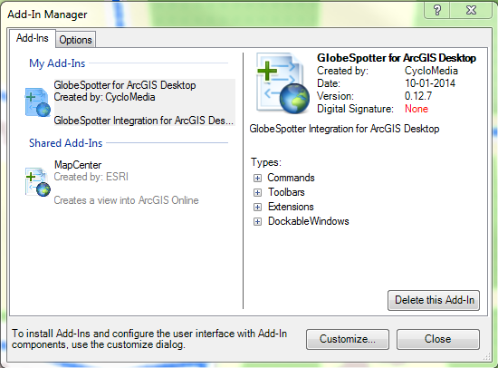Customize -> Add-In Manager (Figure 1)
   3. Select the ‘GlobeSpotter for ArcGIS Desktop’ Add-In and click on the button: <Delete this Add-In>

Figure 1: Add-In Manager

* 1. 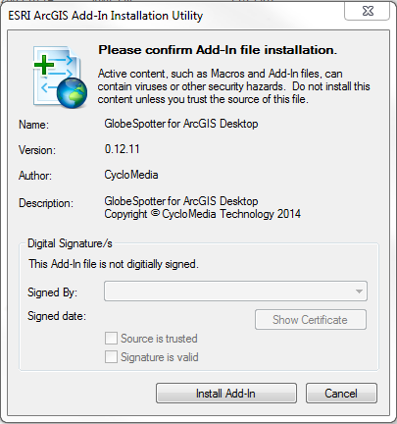Exit ArcMap

1. Double-click the GlobeSpotter for ArcGIS Desktop add-In and select <Install Add-In> to install the Add-In. (Figure 2)

Figure 2: GlobeSpotter for ArcGIS Desktop Add-In installation

1. Start ArcMap.
2. 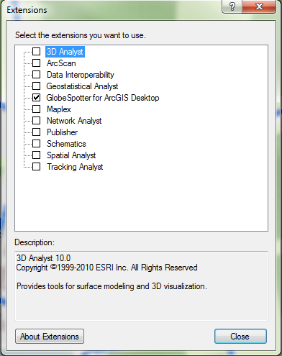Select the menu: Customize -> Extensions. (Figure 3).
3. Checkmark: ’GlobeSpotter for ArcGIS Desktop’ and you will now get the ‘GlobeSpotter for ArcGIS Desktop’ Agreement. (Figure 4)

Figure 3: Extensions menu

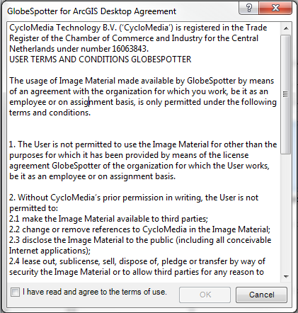

Figure 4: Agreement form

1. Checkmark: ‘I have read and agree to the terms of use’ and click on ÓK’. Now you can close the extensions menu.
2. Then select the GlobeSpotter toolbar: Customize -> toolbars -> GlobeSpotter. (Figure 6)
3. 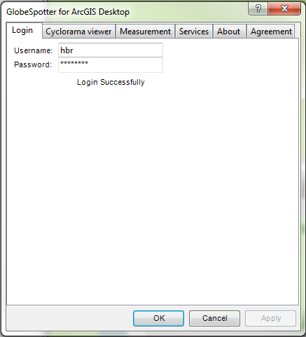Select the ‘GlobeSpotter for ArcGIS Desktop’ icon (Figure 5) of the Cyclorama toolbar. You get the ‘GlobeSpotter for ArcGIS Desktop’ form. (Figuur 7)

Figure 5: The selected 'GlobeSpotter for ArcGIS Desktop' icon

Figure 6: GlobeSpotter toolbar

Figuur 7: The GlobeSpotter for ArcGIS Desktop form

1. Enter your username and password and press: <Apply>
2. If you see ‘Login Successfully’, you are logged in.
3. Now you are ready for use the GlobeSpotter for ArcGIS Desktop Add-In.