Jose C Ramirez  Lead Software Engineer | Agile Practitioner | 1325 N Laveen Dr.  Chandler AZ 85226  4802093709(C)  cyclonesundevil@gmail.com  Github Repo
Adding value by supporting technology, processes, people and projects.  PROFESSIONAL EXPERIENCE    Wells Fargo  July 2014 – Present  Lead Software Engineer  - Atlassian Infrastructure and administration  - Software developer in java, javascript, groovy, C++, Python, Java  - SDLC CI/CD Development Operations setup processes  - SQL for data reporting, data mining, data extraction  - Orchestrate Business Continuity events for disaster recovery mitigation  - Engaged directors and executive leadership for project configuration of processes and execution flows in Jira, and Jira administration.  - Atlassian infrastructure application server upgrade and maintenance  - Served as Primary Technical Manager for Atlassian tools under the CICD / SDLCDEVOP organization under the Chief Technology Office for Wells Fargo.    Wells Fargo  Jan 2013– July 2014  Consultant Software Engineer  - Design, develop, and integrate software using in C++, Qt, Systinet, Code Synthesis, empress DB, SQL, SOAP, XML, Enterprise Architect, in a Linux OS environment  - Troubleshooter, bug fixer  - Trained new personnel  - Master communicator  Datasoft Corporation  09/11 – 09/12  Lead Software Project Engineer at Datasoft Corp. Scottsdale, AZ  - Greenhills RTOS, C, C++  - Developed embedded real-time data modulation/demodulation software  - Real-Time embedded Green Hills board support package development, peripheral device driver development  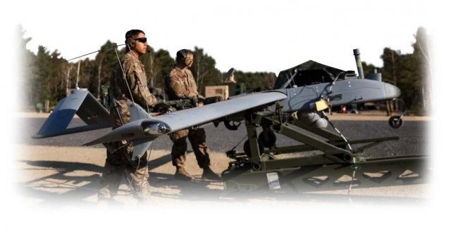  Textron/ AAI  October 2010 – September 2011  HuntValley MD  Consultant Software Engineer  - Unmanned aerial vehicle development Shadow TUAS UAV.  - Embedded LInux RTOS, C, C++ Development  - Lead and managed the port of embedded real-time software of embedded code from Lynx OS to Monta Vista Linux OS using GCC, GNU Make, and Eclipse SDE, Enterprise Architect.    General Dynamics  11/06 – 10/10  Software Consultant  Scottsdale AZ  - Design and development of embedded real-time software for digital combat radio (JTRS, HMS).  - Developed software for Cryptographic Interface Layer (CIL) software project using ARMv7, Advanced Infosec Machine ASIC  - Greenhills RTOS, C, C++    Safenet/Mykotronx  May 2005- May 2006  Staff Software Systems Engineer  Phoenix, AZ  - Software Developer for real-time embedded High Assurance Internet Protocol Encryption (HAIPE) router.  - Device driver development cryptographic ASIC, XScale Intel Chipset  Software Engineer, Orbital Sciences, Launch Systems Group, Chandler, AZ 10/03 – 10/05  Developer for real-time embedded rocket flight computer.  Software development for Flight Qualification Test software (C++).  System Test Engineer, Honeywell Inc., AFCS, Glendale, AZ 2/03 – 6/03  System Validation and Verification for real-time embedded flight management system.  Software flight control validation and verification.  Software Consultant, Indra Systemas, F14-D Simulator, Orlando, FL 2/02 – 2/03  Developed real-time embedded software for display panel  Software development of flight simulator software.  Consultant at Raytheon Missile Systems, Tucson, AZ  Requirements analysis.  Consultant at Lucent Technologies, Whippany, NJ  11/00 – 4/01 Real-time embedded software for UMTS Base Station Cellular Transceiver.  Requirements analysis.  Software Engineer Raytheon Systems, Saint Petersburg, FL  1/00 – 11/00 real-time software for Naval radar system.  Software development.  Software Engineer, Engineering Animation Inc, Ames, IA 1/97 – 12/99  Software Development  EDUCATIONAL  MBA  Arizona State University  BSCE  Iowa State University of Science and Technology | Skills  AI Python  Agile Methodology  Application Lifecycle Management  SQL  C++  Java  Python  Linux  Technology Infrastructure  Application Upgrades  Training  AZ-900 Certified, MS0996203333  Agile Scrum  AWS Cloud  Information Security  Secure Systems Development  Interests  AI AntiGravity Python Development  Chat GPT  LLMs
| www.microcompit.com

Independent Software Developer
Auto-Recruiter Responder Bot | Jan 2026 - Present
Developed a Python application integrating Google Gemini 2.5 API to autonomously triage incoming recruiter emails and generate dynamically tailored docx resumes based on job requirements.
Built a robust pipeline operating over the Gmail API and Discord Webhooks via Python AsyncIO for real-time alerting and asynchronous system monitoring.
Integrated Twilio API to handle SMS alerts and remote commands (Pause/Resume/Status) ensuring continuous reliability.
Independent Software Developer - Auto-Recruiter Responder Bot | Jan 2026 - Present
Developed a Python application integrating Google Gemini 2.5 API to autonomously triage incoming recruiter emails and generate dynamically tailored docx resumes based on job requirements.
Built a robust pipeline operating over the Gmail API and Discord Webhooks via Python AsyncIO for real-time alerting and asynchronous system monitoring.
Integrated Twilio API to handle SMS alerts and remote commands (Pause/Resume/Status) ensuring continuous reliability.

