Twitter and the Politics of the Federal Deficit
Cy Coldiron
University of California, Santa Barbara
Department of Economics
Department of Statistics & Data Science coldiron@ucsb.edu

Abstract
Economists and political observers have long noted a recurring pattern in American politics: politicians change their messaging around the federal deficit depending on their relative power status by becoming more fiscally conservative in periods of opposition (minority). This paper examines this claim by tracking U.S congressional members deficit related tweets between 2017-2023. Using a two-tier dictionary classification method, I identify tweets referencing the national debt and estimate how deficit-related messaging varies across institutional, legislative, and fiscal conditions using logistic regression.
Deficit-tweeting is low overall (~.7%) but varies significantly depending on a representative’s party affiliation and power status: Republicans tweet about the deficit five times as often when in the minority, while Democrats’ rates remain comparatively stable across majority/minority status. While legislative periods further amplify these patterns, the fiscal size of legislation (CBO estimates) has no impact on tweeting rates. Results confirm that deficit rhetoric is indeed correlated to political opportunity - not fiscal conditions - likely serving partisan communication goals and legislative agendas.
1

Introduction
Cy Coldiron

1 Introduction
“It has become standard fare in American politics to watch each party rail against deficits when they are out of power but hungrily embrace deficits when in control and able to advance their own agenda.” — Kenneth Rogoff, Our Dollar, Your Problem

1.1 Background
Debates over the size and scope of the Federal Deficit have been a central feature of American politics since its inception. Beginning as a constitutional question in the 1790s, deficits became increasingly normalized in the 20th century. By the late twentieth century, deficit discourse turned uniquely partisan. Political leaders, including then President Ronald Reagan, attributed the country’s economic woes—including record high inflation—to the opposition parties’ excessive spending policies. Reagan’s successful rhetorical campaigns greatly influenced the coming decades of political communication, especially with the rise of social media, which featured growing partisanship.
Aside from the Federal Deficits centrality in American political discourse, the national debt itself has implications for both the domestic and global economy. Beyond the stimulus effects of deficit spending, long-term imbalances can exacerbate inflationary pressures, burden future generations with higher borrowing costs, and contribute to asset bubbles and macroeconomic instability.
Yet despite both the rhetorical and economic significance of deficits —there exists little empirical analysis of when and why deficit rhetoric is used by elected officials. For instance, does political attention to the national deficit increase in response to rising debt levels—and is it correlated with other macroeconomic outcomes? And does an elected official’s deficit rhetoric change in response to their power status or during legislative periods? This paper seeks to answer these questions. Using elected officials tweets, we examine the evolution of deficit rhetoric (i.e, how often politicans tweet about the debt) and analyze how messaging varies across institutional contexts (who holds power), legislative periods, and macroeconomic

conditions, providing the first large-scale empirical assessment of how deficit rhetoric functions within the incentive structure of American politics.

1.2 Motivation
Political discourse can influence public perceptions by directing public attention to certain issues (e.g., health care, immigration) and influencing how citizens assign responsibility for policy outcomes (McCombs & Shaw 1972; Iyengar 1991). If this same mechanism applies to the public debt, then changes to public opinion on deficit spending may influence legislative agendas—giving political capital for party leaders to advance policy agendas. For instance, if online deficit rhetoric impacts public support for fiscal stimulus—then the majority party’s legislative agenda may be forced to change, thereby impacting the economic trajectory of the country. In addition to economic influence, deficit rhetoric can have substantial impacts on political outcomes. Considering deficit rhetoric shapes voters’ beliefs about the fiscal responsibility of elected officials and the parties they represent—political entities that are more persuasive in their online messaging, whether that be denigrating the opposition, or advocating for their own policies, will have greater success in electoral campaigns. If this is the case, elected officials would have reason to communicate about the deficit in such a way that maximizes their political outcomes—whether it be consistent with their actual policies or not. By analyzing the rhetorical patterns of these officials—we can understand how political actors use the federal deficit, across varying institutional and economic contexts, to influence voters’ beliefs, and shape public opinion.
1.3 Why Twitter?
Twitter (now X) is a uniquely effective medium for this analysis. It is widely and consistently used by members of Congress and is a direct representation of each representative’s rhetorical intentions. Moreover, tweets are standardized in format—meaning each post is timestamped, have the same character constraints, and are tied to verifiable individuals, allowing for large-scale and reproducible time-series analysis. Tweets, unlike floor speeches or hearings (which vary in length and frequency) are published daily by almost all congressional members. This provides a far more comprehensive dataset (in this case 3.6M tweets), giving us greater statistical power, allowing us to draw stronger conclusions about key explanatory relationships.

2

Literature Review
Cy Coldiron
Literature Review

2.1 Overview of Deficit Rhetoric Literature
A substantial body of literature has examined various aspects of U.S. federal deficit spending and the partisan nature of public finance more broadly (Alesina & Tebellini 1990; Pettersson-Lidbom 2001; Alesina & Passalacqua 2016). This research provides extensive insight into the determinants of fiscal outcomes, including how political institutions, electoral incentives, and partisan control over legislation influence government spending decisions.
While this research provides extensive analysis of actual fiscal outcomes, it offers little insight into the actual political communication surrounding the national debt itself. There is limited systematic evidence on how elected officials publicly discuss deficits or how such rhetoric varies across political contexts and fiscal conditions. To our knowledge, this paper is the first comprehensive analysis of how politician’s deficit-related messaging varies with political context, including legislative periods and shift in institutional power.

Data Overview
Cy Coldiron
Data

3.1 Tweet Data Overview
The dataset used for classifying tweets is Tweets of Congress (maintained by Alex Litel), which contains all tweets (original, retweets, and quoted retweets) from the official accounts of U.S. congressional members between June 2017 and January 2023. The data was generated via an open-source, serverless application that interfaces with the Twitter API, querying for new tweets at the top of each hour. Each observation (tweet) is stored as an object (with one JSON file corresponding to each day). This automated pipeline ensures comprehensive, continuous coverage of congressional Twitter activity during that period, with accounts updated through routine synchronization with legislator metadata. For instance, this system automatically adds newly sworn-in members to the metadata and removes non-members (i.e., those who lost an election, resigned, etc.)—thereby reflecting Congress’s true composition at each point in time.
Although more recent data (2024-2025) would provide greater relevance and utility, especially with the passage of the Big Beautiful Bill (2025), the cost of x.com’s current API access— which changed following Elon Musk’s acquisition—is beyond this project’s financial resources. For reference, under current pricing structures, replicating a dataset of a similar size (roughly six million tweets) would cost between $30,000 and $42,000.
While the raw dataset itself includes party committee accounts (oversight, armed services, education, etc.) and institutional accounts (housedems, senateGOP), our project focuses exclusively on the rhetorical patterns of congressional members. Thus, we remove all accounts not directly tied to an individual congressional member, finalizing the dataset at roughly 3.6 million tweets.

3.2 Tweet classification Strategy
To identify deficit-related tweets, I implemented a two-tier keyword strategy in Python (pandas). The full code can be seen at the projects GitHub Repo.
Tier 1 – Anchor Keywords. Tweets were flagged as deficit-related if they contained unambiguous anchor phrases (e.g., “national debt,” “balanced budget,” “fiscal responsibility”). These strong keywords identify explicit deficit references with high confidence.
Tier 2 – Contextual Expansion. Tweets containing weaker terms (e.g., “debt”) were only flagged if they co-occurred with contextual phrases (e.g., “federal,” “budget,” “tax,” “spending”).
The logic of my labeling framework is to balance the two key countervailing forces in text classification: precision and coverage. While a larger keyword dictionary would capture more subtle deficit references, it would also reduce precision by inflating the number of false positives. For instance, while including phrases like ‘trillions of dollars’ may capture references that would otherwise be missed, it also risks falsely tagging a growing number of unrelated tweets, such as discussions of income inequality or GDP growth. By contrast, a smaller dictionary would reduce false positives but would also diminish overall coverage, leading to more deficit related tweets going un-labeled.
Illustrative Example:
Figures 1 and 2 demonstrates the labeling logic. Rep. Alexandria Ocasio-Cortez’s reference to “student loan debt” is not flagged: “debt” is a weak keyword but lacks an accompanying context term. By contrast, Speaker Kevin McCarthy’s reference to the “national debt” matches a strong anchor keyword and is thus labeled as deficit related.
(Note: Speaker McCarthy’s tweet was published outside our analytical timeframe (January 2023) but still serves as an informative example).
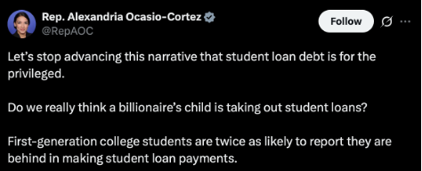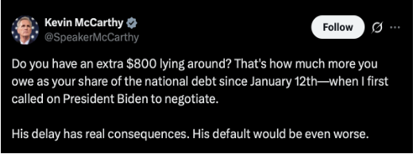
Figure 1: Rep. Alexandria Ocasio-Cortez Figure 2: Rep. Kevin McCarthy

3.3 Biases and Limitations
While this classification provides simplicity and replicability, it also introduces potential sources of bias. These fall into two main categories:
- Dictionary Limits: Precision vs. Coverage
As noted, the challenge in using a dictionary-based method is balancing precision with coverage. In practice, I adjusted the specificity of both dictionaries iteratively based on the accuracy of their given outputs —which I assessed manually by checking the data. While bias in either direction is statistically possible, I’d argue that my strategy almost certainly underestimates total deficit rhetoric, since there are theoretically infinite ways to reference the federal debt.
- Variation in Rhetoric and Style
Bias may also arise from differences in rhetorical style across time, parties, and individuals. For instance, members who consistently use explicit terms like “national debt” are captured reliably, while those who reference deficits more vaguely or implicitly are systematically undercounted. If such variation correlates with party or institutional context (e.g., legislative periods), it could bias comparisons.

3.4 Model Improvement: A Machine Learning Approach
For future research considerations—whether involving similar or identical data—it is important to consider alternative, complementary approaches to improve labeling accuracy.
My current strategy relies on a rule-based dictionary method, where I defined Tier 1 and Tier 2 terms and applied them directly to the full dataset. While transparent, and easily adjustable, this approach inevitably misses implicit deficit references and requires subjective judgment in constructing the dictionaries.
A possible improvement would be to use a supervised dictionary validation approach. This method first requires manually labeling enough positive-class instances (i.e., deficit-related tweets), capturing both explicit and implicit references. Because deficit tweets are rare (~1–3% of all tweets), one would need to label roughly 20–30k tweets under an active learning strategy— or 100k+ under random sampling—to obtain 2–3k positive instances. This threshold aligns with best practices for addressing class imbalance (Japkowicz & Stephen 2002; He & Garcia 2009). After constructing this training data, one would build and test multiple dictionary configurations, each with varying levels of specificity, and then select the configuration with the highest validated accuracy.
Accuracy would be assessed with two measures:
- Coverage: the share of true deficit tweets correctly labeled.
- Precision: the false-positive rate.
Selecting the best model would thus require one to determine the ideal “accuracy” metric or determining the relative weight of coverage vs precision. This decision—similar to my dictionary choices—requires intuition and could be adjusted based on the researcher’s preference.
In sum, a supervised dictionary validation approach would reduce under-detection of implicit references but would not fully eliminate the two forms of bias referenced in 3.2. For instance, expanding the dictionary to improve coverage risks a higher false-positive rate. The training dataset would capture less explicit tweets, and the best-performing dictionary would detect many of these indirect cases. Yet the same expansion may also misclassify unrelated tweets, raising the false-positive ratio. Thus, even if the most comprehensive model achieved the greatest overall accuracy, the fundamental bias would persist, albeit at a smaller scale.

3.5 Other Data
To contextualize congressional tweeting among broader political and economic phenomena, I integrated a wide set of temporal covariates into the dataset. Economic indicators—sourced from the U.S. Treasury and Federal Reserve—include ten-year interest rates, inflation (U.S CPI YoY) and multiple measures of federal debt (publicly held debt, intragovernmental holdings, and total debt outstanding).
Institutional context is captured through variables on presidential party, House and Senate control, majority and minority leadership, and whether government is unified or divided, as well as monthly congressional approval ratings.
Legislative periods are represented by data on major bills from 2017 to 2023 (e.g., CARES Act, PPP, CHIPS Act, IRA). Periods are defined by one month before and after passage. For instance, the Tax Cuts and Jobs Act was signed into law by President Trump in December 2017 making its designated legislative period November 2017 - January 2018. Fiscal impact estimates for each bill come from the Congressional Budget Office (CBO) and are normalized when included in regression specifications.
Finally, I construct a partisanship score to capture the level of partisan division in each legislative period. The measure is defined as the absolute difference between Democratic and Republican support rates for a given bill:
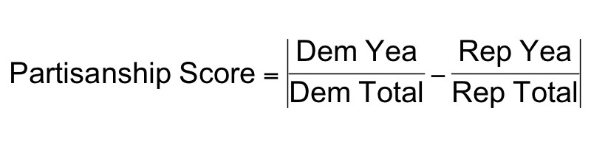
Figure 3: Partisanship score definition.
This score ranges from 0 (perfect bipartisan support) to 1 (completely partisan support, with only one party voting in favor). For regression analysis, I normalize the score to standardize across legislative periods.

Methodology
Cy Coldiron
4 Methodology

4.1 Regression Methodology
This project’s primary analysis is conducted using logistic regression. There are two reasons for this choice. First, the dependent variable—share of tweets that are deficit related—is a binary variable: a congressional member either tweeted about the deficit (1) or did not (0). Second, we are concerned with the probability of tweeting about the deficit (values between 0 and 1). Thus, a traditional regression model—which does not constrain predicted values— would not be appropriate, as it would allow for probabilities to be less than zero (negative) or greater than 1. Moreover, logistic regression allows us to explore how these probabilities, or odds, change with levels of explanatory variables (party, legislative context, fiscal conditions etc)—which is a key consideration in this research. For instance, logistic regression allows us to see how odds of tweeting about the deficit change among parties when the fiscal impact of policy bills increase.
The unit of analysis is the member–month: for each member i in month t, the dependent variable is the share of tweets that are deficit-related. Models include member fixed effects (𝛼_{𝑖}) and month fixed effects (𝛾_{𝑡}). Standard errors are two-way clustered by member and month, accounting for correlation within legislators over time and across legislators in the same month. Formally,
log( 𝑃(𝑌𝑖𝑡 = 1) ) = 𝛼𝑖 +𝛾𝑡 +𝛽𝑋𝑖𝑡 +𝜀𝑖𝑡 1−𝑃(𝑌_{𝑖𝑡} = 1)

4.1.1 Fixed Effects
Member fixed effects absorb differences across legislators and between parties. For example, Senator Rand Paul tweets far more often than Senator Ted Cruz, and Republicans tweet more about deficits than Democrats. These baseline differences are captured by , so estimates rely on within-member changes over time. Moreover, month fixed effects absorb shocks common to all legislators in each month. For instance, during COVID-19 legislative periods (i.e., CARES Act), both parties reduced deficit rhetoric at similar rates. Month fixed effects, , ensures such that shared shocks, such as COVID-19, are not misattributed to partisan–institutional dynamics.

4.1.2 Interpreting Coefficients
Coefficients are presented as odds ratios and should be understood relative to the omitted (baseline) category. Odds ratios (ORs) indicate how the odds of an event— in this case, tweeting about the deficit—change with different levels of predictor variables, holding all other factors constant. The baseline condition, for which coefficients should be compared to, is always Democrats outside legislative windows under the institutional baseline of each specification. By “institutional baseline,” I mean the makeup of congressional and executive power used in the model.
In each model, the main effect — the coefficient (GOP) — represents the baseline tweeting gap: the differences in tweeting between Republicans and Democrats in the baseline condition . Interaction coefficients capture shifts in that baseline partisan gap, which is represented by GOP, under specific institutional combinations (legislative windows, congressional control, etc.). An odds ratio greater than 1 means the Republican–Democrat gap widens (Republicans become relatively more deficit-focused), while an odds ratio less than 1 means the gap narrows, relative to the baseline.

4.1.3 Example Coefficient Interpretation

In the second regression model, the coefficient on GOP × Legislative window (OR = .38) shows that the partisan gap contracts during legislative months: Republicans’ odds of tweeting about the deficit decrease to 62% lower than Democrats’ odds relative to the baseline condition.

4.2 Regression Design
Our research goal is to understand how deficit rhetoric—specifically among Democrats and Republicans—changes with varying institutional, fiscal and legislative conditions. To do this, we estimate a sequence of specifications that control for these variables in a progressively specific manner. The baseline model (Regression 1) interacts with party affiliation with legislative windows. Furthermore, it includes coefficients to describe how this baseline tweeting gap changes with differing levels of bill partisanship and fiscal impact (CBO estimate of the bill). Such coefficients help us to understand the relationship—or lack thereof—between the divisiveness of a bill, or its fiscal impact, and how members talk about it on twitter.
The second model (Regression 2) adds a further control by conditioning on the presidential party; that is, which party controls the White House. The change in coefficient estimates between Regression 2 and the preceding model indicate that conditioning on presidential power is an important consideration when analyzing deficit rhetoric. In other words, tweeting gaps among parties are partly a function of whose party holds executive power. Without including this condition, one would improperly interpret the significance of tweeting differences. Finally, the last specification (Regression 3) adds further detail by controlling for the composition of the legislative branch (congress).

Results
Cy Coldiron
2026-03-02

5 Results

5.1 Macro Trends
Figure 1 shows the monthly share of congressional deficit tweets, by party, from June 2017 to January 2023. Shaded areas indicate legislative periods – defined as the month before, during, and after the passage of a fiscally significant bill. Legislative periods exclude small appropriations, procedural votes, and commemorations.
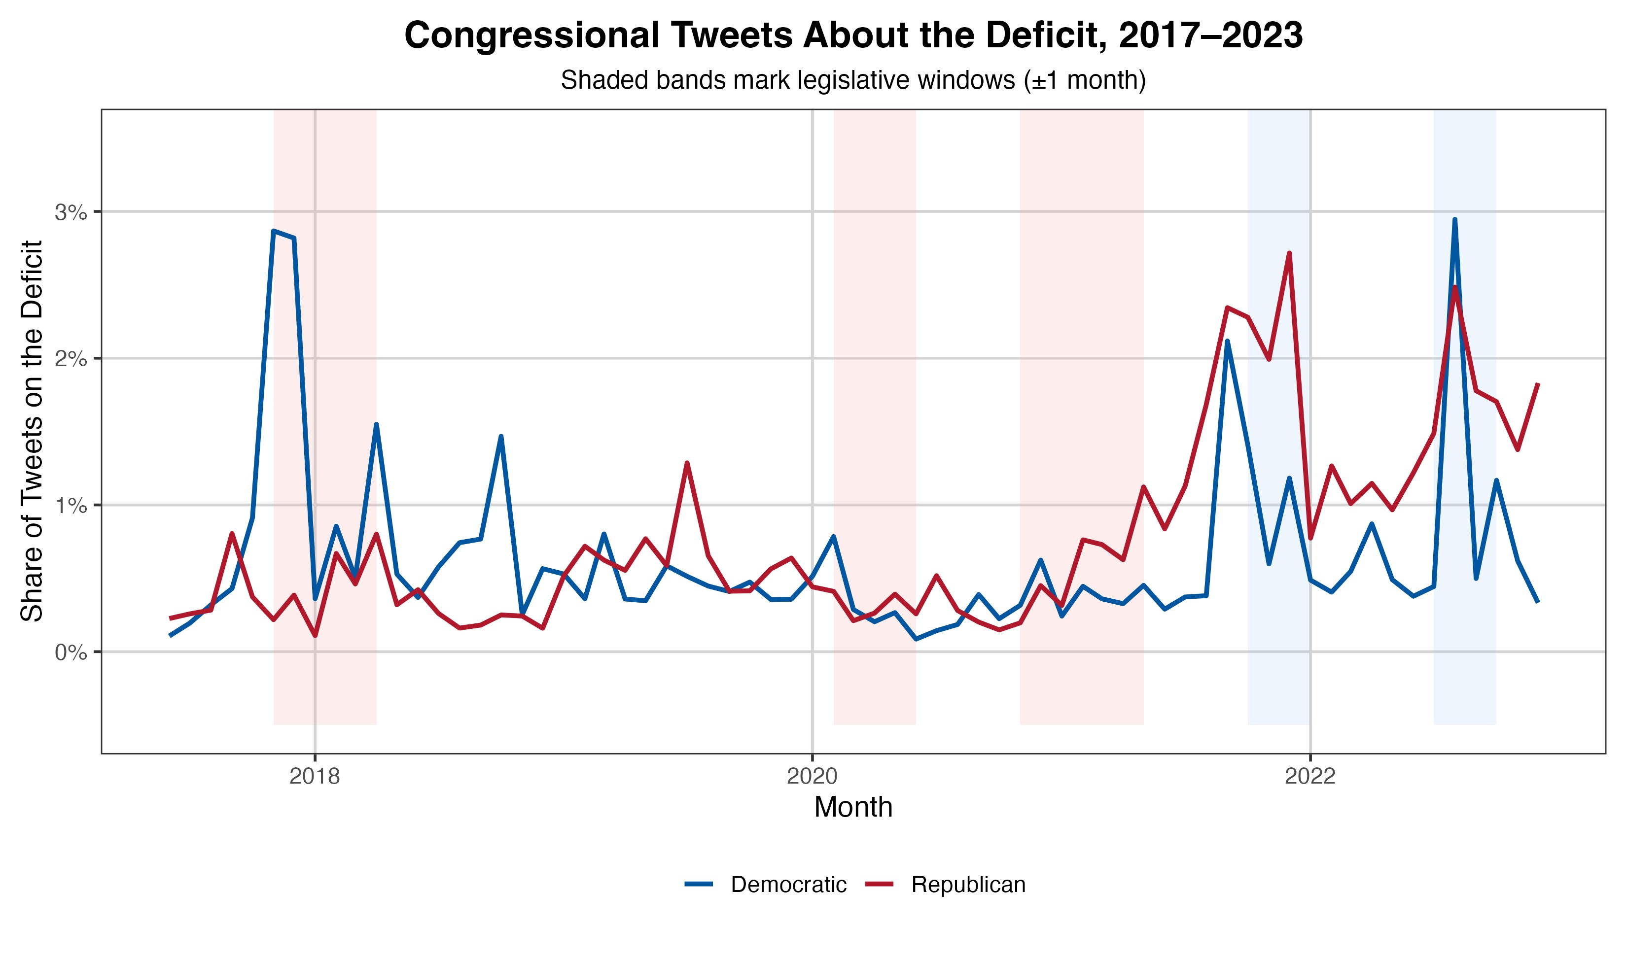
Figure 1: Share of congressional tweets about the deficit.
The baseline deficit tweeting share for both parties is low, generally under 1% when averaged across members over six years, with notable accelerations occurring around legislative periods. Democratic tweeting patterns remain relatively consistent across the six years, with three notable peaks, all during legislative periods: December 2017 (Tax Cuts and Jobs Act), October 2021 (Infrastructure Investment and Jobs Act), and August 2022 (Inflation Reduction Act, CHIPS & Science Act). Republicans, however, demonstrate consistently higher deficit tweeting rates as the minority party, as illustrated in the peaks (2022, 2023) compared to relatively low rates from 2017-2021.

5.2 Economic Indicators
Figure 2 plots deficit tweet share against US CPI inflation (YoY) reveals a relatively strong positive relationship, as indicated by its large r-value (.78). There are a few plausible explanations for this linear relationship. First, the elevated inflation rates of 2022, peaking at 9.1% in June (40-year high), may have increased elected officials concern about deficit spending. Public discontent over higher prices may have also pressured representatives to take a more hawkish approach on federal expenditures.
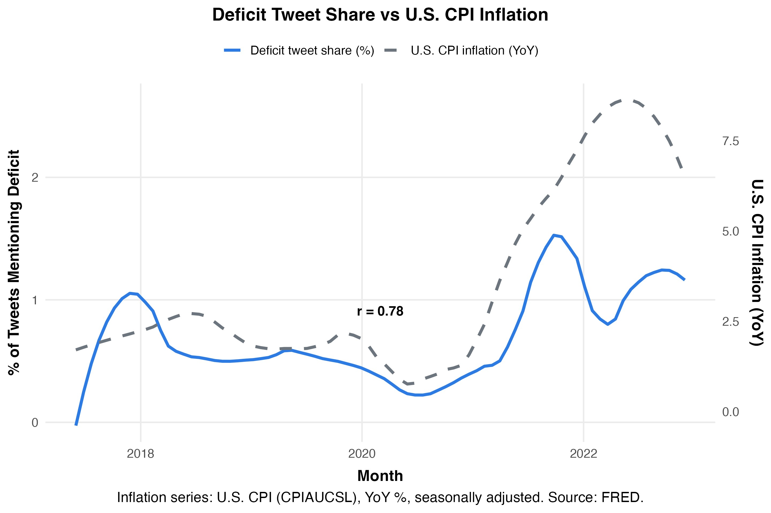
Figure 2: Deficit tweet share vs. U.S. CPI inflation.
Another explanation could be that along with higher inflation, the significant, and controversial, fiscal legislation being proposed in the summer of 2022 (e.g., IRA, CHIPS) may have drawn concerns from representatives, prompting more congressional tweets on the topic.

5.3 Member-Level Patterns
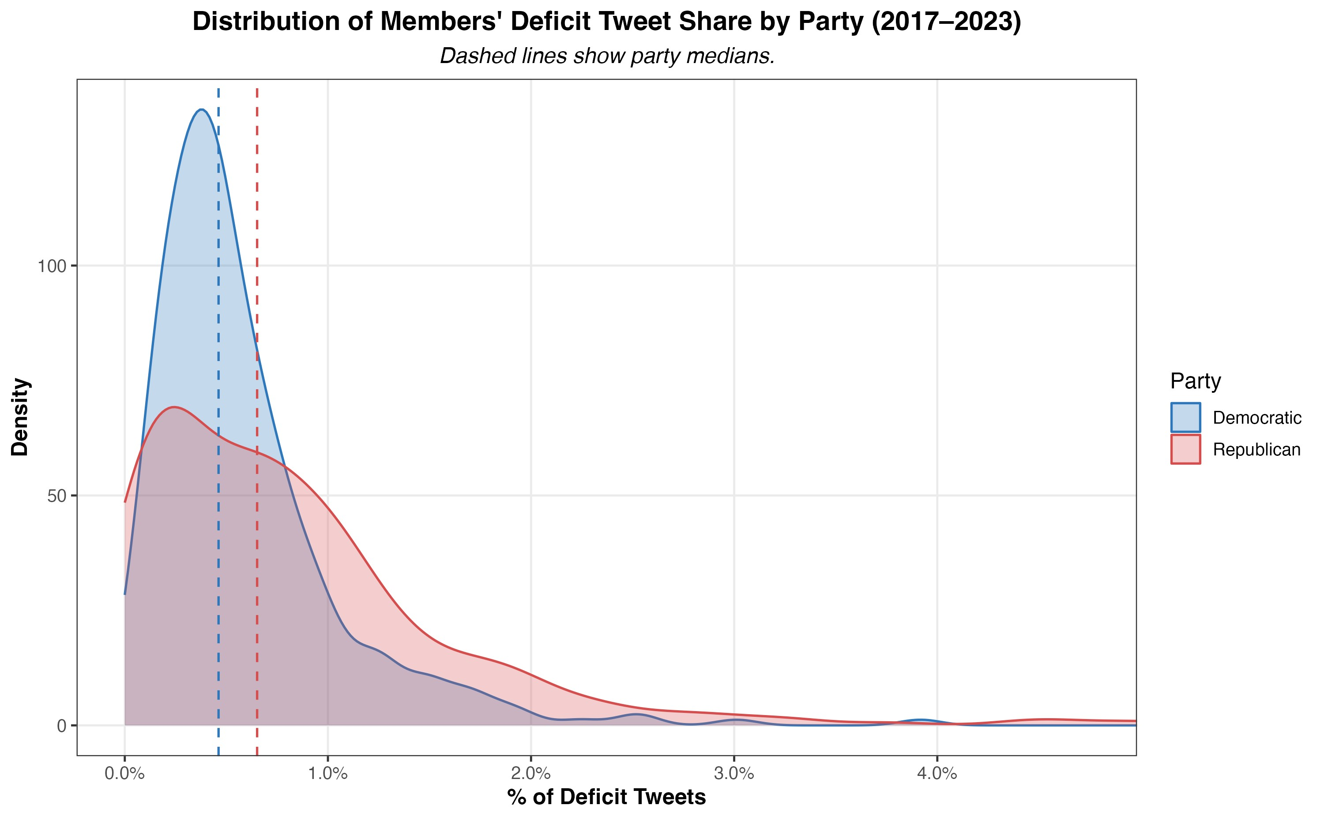
Figure 3: Share of deficit tweets by party (member-level distribution).
Figure 3 presents member-level distributions of deficit tweeting, calculated as the share of each member’s tweets that mention the deficit over the entire period. As illustrated by the dashed lines (party medians),
Republicans tweet about the deficit more frequently than Democrats, with average shares of 0.81% and 0.62%, respectively.
Democrats display a relatively compact distribution, with most representatives falling below 0.7%, indicating less intra-party variation in deficit tweeting. Republicans, however, show far greater variability within their party. The GOP’s right tail distribution illustrates that, compared to their Democratic colleagues, a far greater proportion of members tweet about the deficit at much higher rates, with outliers reaching 4–8%.
Figure 4 breaks down these distributions further by institutional power status (majority vs. minority). The left and right panels juxtapose the distribution when a member’s party controls the presidency (in-power) versus when it does not (out-of-power). For instance, Democrats would be considered in-power from January 2021 to January 2023 under President Joe Biden, while Republicans would be out-of-power during this same period.
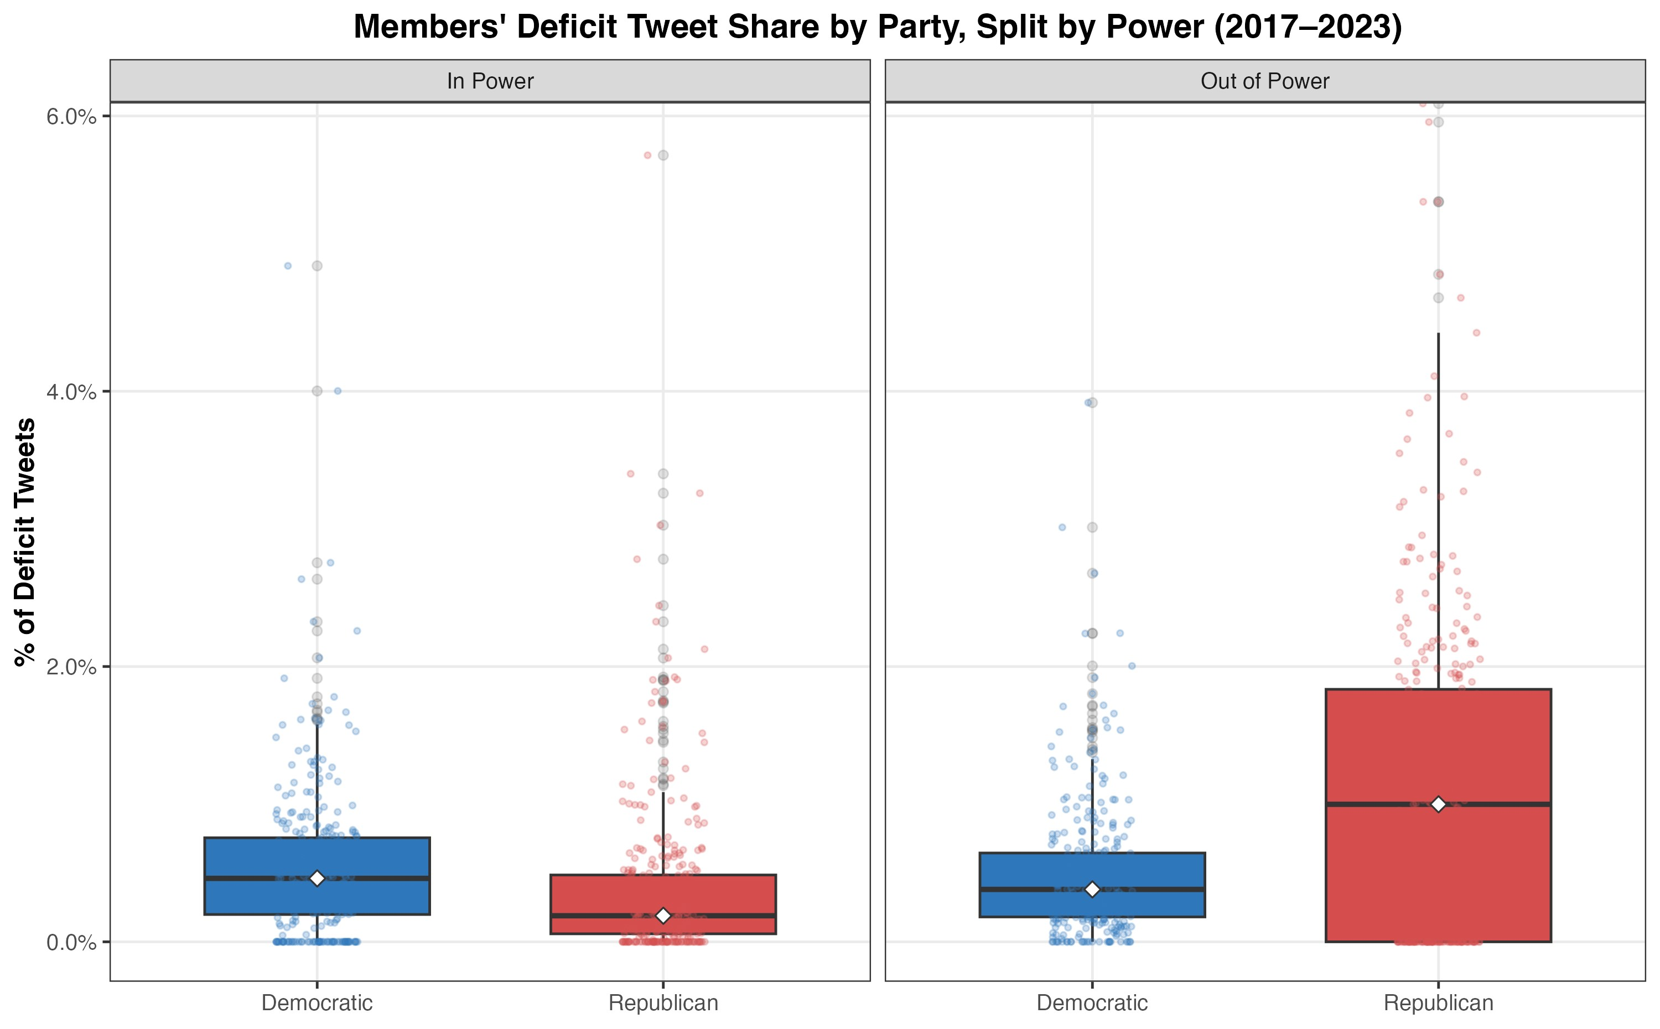
Figure 4: Distribution of deficit tweets by power (boxplot).
Figure 4 shows a clear asymmetry in Republican tweeting patterns between these periods. When moving between power contexts, the GOP median tweet share increases five-fold, from 0.2% to 1.0% and the interquartile range from 0.6% to 1.8%. Put simply, Republicans were far more likely to tweet about the deficit under President Biden than under President Trump. Democrats, by contrast, remain relatively stable across contexts and in fact demonstrate a modest increase in spread and averages when in power.
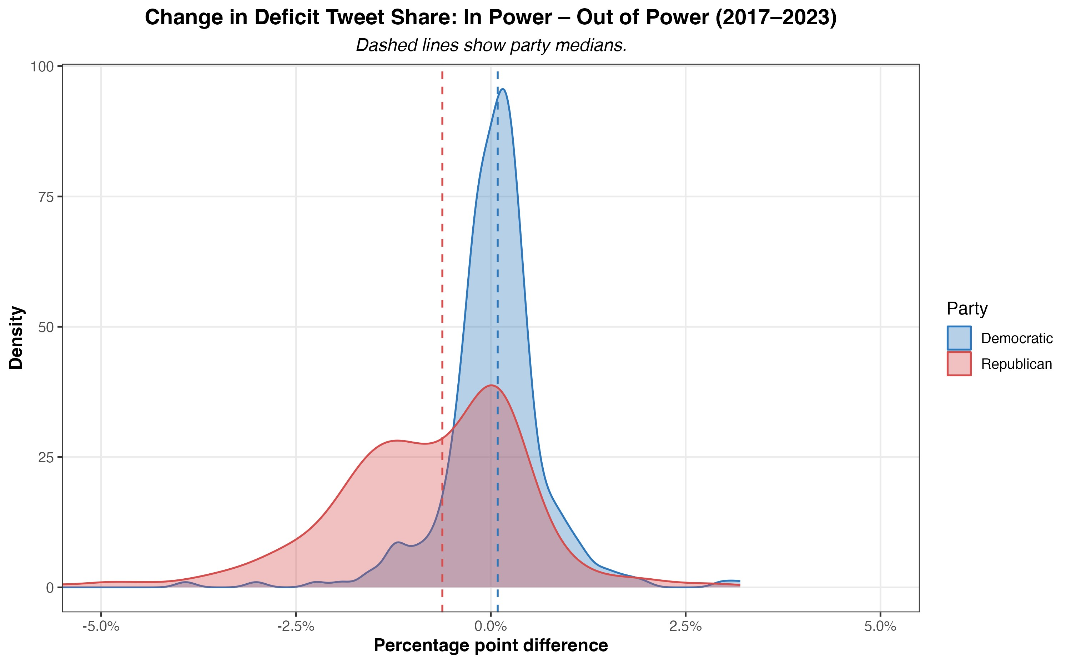
Figure 5: In–out shifts in deficit tweeting (histogram).
Figure 5 visualizes these shifts more directly by plotting the distribution of changes in deficit tweeting when moving from in-power to out-of-power contexts. The x-axis represents the difference in deficit tweet share between these two periods for each member (in minus out). Positive values indicate that a member tweeted more about the deficit when in power, while negative values indicate higher tweeting rates when out of power. The GOP’s comprehensive party shift is evident, with the bulk of the party’s distribution skewed negative.
Taken together, Figure 4 and Figure 5 suggest that Republicans are far more sensitive to power status when deciding how frequently to tweet about the deficit, while Democrats maintain a more consistent messaging strategy regardless of institutional control. These results also illustrate a broader point about the degree of strategic messaging among parties: the systematic increase in Republican deficit tweeting supports the notion of uniform, top-down messaging within the party. Democrats, by contrast, show less cohesion in their messaging strategy, with members displaying a wider range of tweeting behaviors across power contexts.

5.4 Leadership Analysis
Figure 6 summarizes deficit-tweeting by House and Senate leaders across majority/minority contexts. Patterns differ by party and chamber, with the sharpest contrasts in the Senate: Senator Chuck Schumer tweeted about deficits far more as Majority Leader (4.0%) than as Minority Leader (1.0%), while Senator Mitch McConnell did the reverse (1.9% in the minority vs. 0.05% in the majority). In the House, Representative Pelosi tweeted about deficits more in the minority (1.1%) than as Speaker (0.5%).
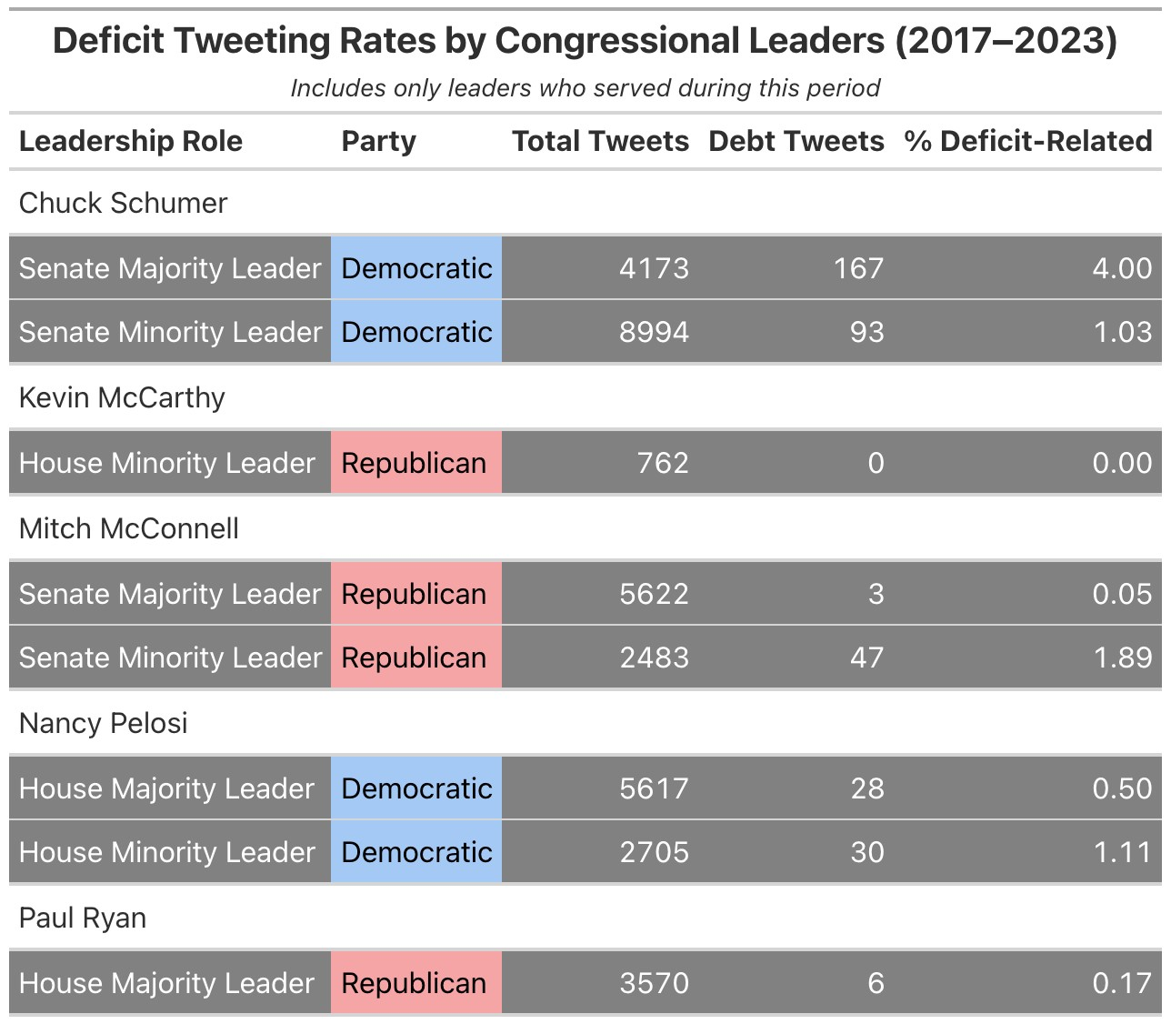
Figure 6: Deficit tweeting by congressional leaders (House and Senate; majority vs. minority roles).
Notably, Representative McCarthy has relatively few tweets (762). Because leaders often switch or add handles when roles change, the data collection process may have failed to include relevant accounts. Thus, McCarthy’s deficit tweet share should be interpreted cautiously.
Taken together, these patterns illustrate that deficit rhetoric among congressional leaders varies systematically with institutional role and party, mirroring—and in some cases, amplifying—the broader party-level trends documented above.
While preceding analysis covers broader party-level trends, exploring individual leaders’ tweeting patterns provides us insight into how key political figures communicate about the deficit in varying institutional contexts. Considering the legislative and electoral significance of these figures, their messaging strategies are more influential and calculated than rank-and-file members. For instance, party leaders may use specific communication strategies around legislative periods to catalyze or bar the passage of key bills. Thus, examining these trends can help illustrate the degree of strategic communication employed by top legislators, and by extension - the party they represent.

Aside from highlighting rhetorical patterns in key legislators, Figure 6 also underscores a broader point about communication uniformity among party leaders and rank-and-file representatives. Previous research establishes the growing polarization in congressional ideology and party-line voting (CQ Roll Call 2024). My research provides insight into the specific polarities of a single rhetorical subject—the federal deficit. For Democrats, the divergent tweeting patterns of Speaker Pelosi and Senator Schumer suggest a comparatively weaker intra-party alignment in messaging. These patterns are consistent with the broader Democratic caucus, which shows no discernible difference in deficit tweeting between power contexts (as shown in Figure 4 and Figure 5).
The GOP, however, presents a more uniform party dynamic. Senator McConnell’s increase in deficit tweeting in out-of-power contexts mirrors the broader Republican trend illustrated in Figure 5. Furthermore, McConnell’s tweeting patterns confirm long-held conceptions about his communication and political style, which emphasizes unrelenting opposition to Democratic fiscal policies.
The two messaging strategies employed by party leaders reflect a broader division in party dynamics between Democrats and the GOP. These results provide nuance to our understanding of the communication strategies of key political figures, such as Representative Ryan and Senator McConnell, whose “deficit” messaging has had significant implications for historical and contemporary American fiscal policy.

5.5 Legislative Context
Figure 7 reports the conditional share of tweets mentioning the deficit within ±1-month windows around major bills, split by party (with a pooled/overall column for reference). At baseline, Republicans tweet about the deficit more often 0.8% than Democrats 0.6% – a gap that persists across most legislative windows. During the Inflation Reduction Act (2022) and CHIPS Act (2022) periods, Republicans’ tweets accelerated, with deficit mentions at nearly 2.0%, compared to 1.3% among Democrats. However, the TCJA (2017)—a partisan GOP tax cut—is a noticeable and stark exception. During these three months, the Democrats’ deficit share spikes to 2.0%, while the Republicans’ share falls to just 0.2%, reflecting a partisan realignment around a highly divisive bill. In contrast, during the COVID relief period in 2020 – a non-partisan voting context – both parties converged at very low levels (0.3–0.4%).
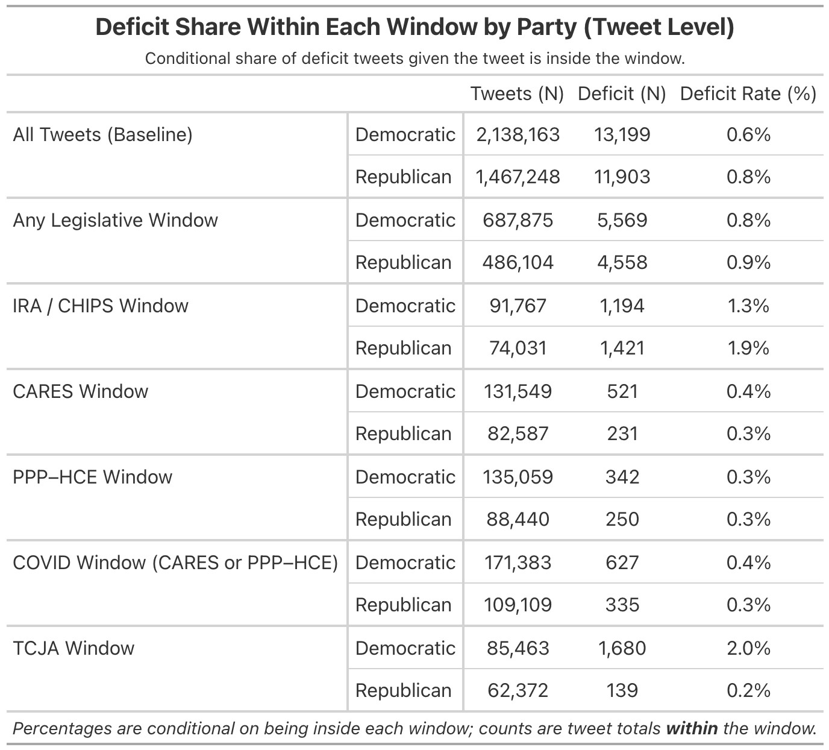
Figure 7: Deficit share within legislative windows, by party.

5.6 Regression Visualization
The following regression models offer a structured approach to examining how institutional, fiscal, and partisan contexts affect the probability of congressional deficit tweeting.
Since the specifications rely heavily on interaction terms, it is useful to provide a framework for their interpretation first. The coefficients are expressed as odds ratios: values above one indicates that Republicans are more likely to tweet about deficits relative to Democrats. In contrast, values below one indicates a narrowing of the GOP-Dem gap. Each model includes majority interaction coefficients of the general form GOP × Conditioning Variable. These coefficients indicate whether the baseline Republican–Democratic difference changes under specific conditions (legislative windows, presidential control, chamber control, or trifectas).
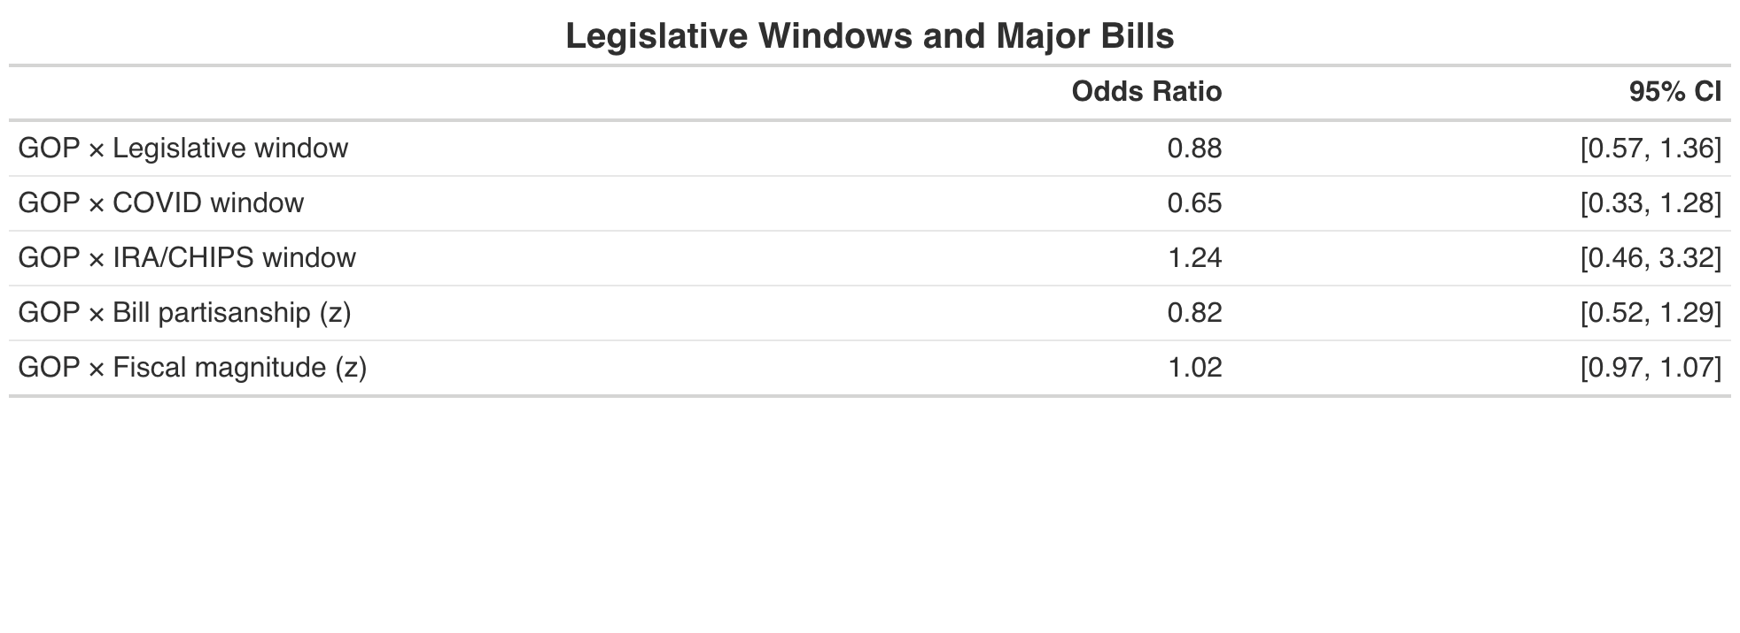
Figure 8: Regression 1: Legislative windows.
The baseline model, Figure 8, examines partisan differences in legislative periods without conditioning on institutional control. The non-significant results suggest that, when averaged across both Democratic and Republican presidencies, legislative windows themselves do not systematically impact the partisan gap in deficit tweeting.
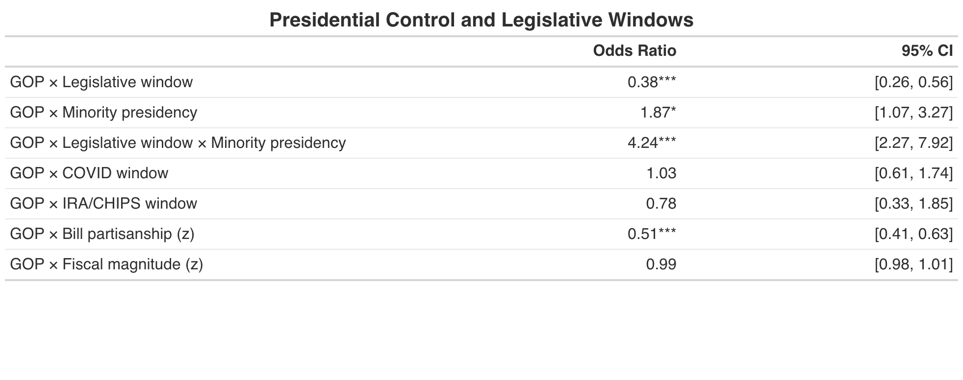
Figure 9: Regression 2: Majority context (presidency).
Figure 9 controls for presidential party by adding an indicator for serving under the out-party president (GOP under a Democratic president; Democrats under a Republican president) and by interacting it with Legislative window, plus the three-way term GOP × Legislative window × Minority presidency. These terms let the GOP–Dem deficit-tweeting gap differ under Democratic vs. Republican presidents and specifically during legislative months.
Republicans’ odds of tweeting about deficits are nearly double (OR = 1.87) when not holding the presidency (i.e., Joe Biden is President) compared to Democrats under the same condition. In contrast, GOP × Legislative window (OR= 0.38) highlights that under a Republican presidency, the partisan gap narrows during legislative months—the odds of the GOP tweeting are 62% lower than those of Democrats, compared to the baseline context. This pattern aligns with Figure 1, which shows that Republican tweeting contracts while Democratic tweeting spikes as Congress passes the Tax Cuts and Jobs Act in late 2017. However, the three-way interaction coefficient GOP × Legislative window × Minority presidency reveals a reversal of this trend (OR= 4.24). Under a Democratic presidency (Joe Biden), Republicans’ odds of tweeting are more than four times higher than those of Democrats in the same condition.
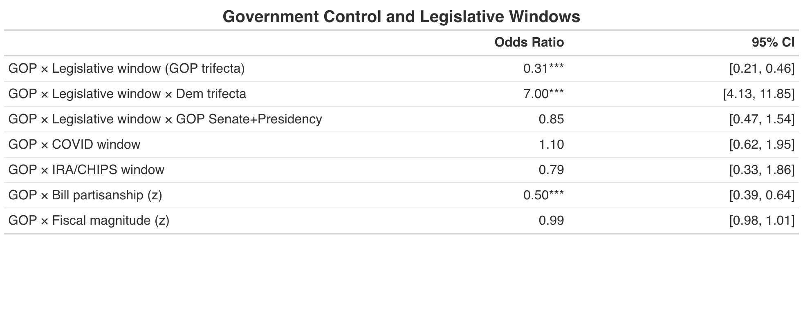
Figure 10: Regression 3: Majority context — chamber and presidency combinations.
Figure 10 examines how the tweeting gap changes by who controls congressional and executive branches. A GOP trifecta means Republicans held the presidency, House, and Senate simultaneously—a condition they held from 2017 to 2019 during the 115th congress. The model includes indicators for these control combinations: the baseline is Democrats outside legislative windows when their party controls no institution (minority in both chambers and not holding the presidency). This context would describe Democrats, between 2017 and 2019, in non-legislative periods (i.e., not during Tax Cuts and Jobs Act).
GOP x Legislative window (OR = 0.31) indicates that during legislative months, when holding a trifecta, Republicans’ odds of tweeting are 69% lower than Democrats. The Tax Cuts and Jobs Act (2017) – a legislative window under a GOP trifecta – is an illustration of this condition. However, once we condition on a Democratic trifecta, this effect reverses. Relative to the baseline condition (a GOP trifecta), Republicans’ odds of deficit tweeting are seven times higher than those of Democrats in the same context. The juxtaposition of these two coefficients (OR = 0.31) versus (OR = 7.00) illustrates that legislative timing by itself isn’t a determinate of tweeting gaps—but who governs is. Under Democratic control (i.e., 2021-2023), Republicans accelerate deficit rhetoric during legislative months, while under the GOP trifecta (i.e., 2017-2019), they significantly reduce deficit tweeting frequencies.

5.6.1 Bill Partisanship and Fiscal Magnitude
Across all three specifications, the coefficients for Fiscal magnitude (z) are statistically insignificant (~1.0). These coefficients, based on a normalized measure of a given bill’s 10-year CBO estimate, suggest that the fiscal consequences of policy do not systematically impact partisan tweeting gaps.
Bill partisanship (z), however, shows significant contractions in the GOP-Dem tweeting gap once institutional control is included (OR ~ 0.50). In other words, for each one-SD increase in a bill’s partisanship score, the GOP-Dem gap contracts by roughly half. Notably, because these variables are continuous (ie, z-scores), the coefficients represent slopes rather than a baseline-specific effect. For example, in the context of bill partisanship, if Republicans are twice as likely as Democrats to tweet at z = 0 (OR = 2.0), that gap narrows to parity at z = 1 (OR = 1.0).

Discussion Section
Cy Coldiron
6 Discussion

6.1 Core Empirical Findings
Our research finds that deficit rhetoric on Twitter among U.S. congressional members is low— fluctuating between averages of .5% to 2% throughout the six-year periods (or 5-20 “deficit tweets” per 1000 tweets). However, our results highlight significant and important nuances. Specifically, we find that variation in deficit tweeting is strongly tied to two factors: relative institutional power and legislative timing. We also find that deficit rhetoric is not tied to the fiscal magnitude of policy bills: tweeting rates are uncorrelated with the long-term fiscal impact of legislation (measured by its 10-year CBO estimate).

Institutional power—whether a member’s party holds congressional and or executive control— is a key determinant of deficit tweeting among Republicans, but not Democrats, and it helps to explain significant variations in tweeting gaps among the parties. Republicans’ deficit rhetoric increases five-fold (.2% to 1%) when transitioning into out of power-contexts (holding all other factors constant) while Democrats rates remain constant throughout. Republican leaders mirror the trends of their rank-and-file members (increase deficit in out-of-power contexts), while Democratic leaders show no discernible pattern in contextual tweeting among each other.
Regression analysis also indicates that legislative windows influence deficit tweeting only after conditioning on presidential and or congressional control. In other words, Republican-Democrat tweeting differences only change once we consider who is in power.
These results suggest that, for Republicans, deficit rhetoric functions as a context-dependent communication resource: members will emphasize the deficit when political accountability is externalized—that is, when Democrats hold power. On the other hand, Republicans, especially among their leadership, will decrease deficit tweeting rates when legislative responsibility is internalized.

6.3 Fiscal Conditions, Policy Substance, and the Limits of Economic Explanations
Results show no discernible relationship between the fiscal magnitude of legislation and deficit tweeting: members do not increase references to the deficit in legislative periods that are characterized by large spending. In other words, deficit tweeting is the same for policy bills that have a low fiscal impact (such as the Inflation Reduction Act) and legislation with high fiscal impact (such as the Tax Cuts and Jobs Act).
Common sense would suggest that deficit rhetoric should derive from the very thing it is in reference to: the federal deficit. Our research, however, suggests that no such relationship exists. Instead, communication patterns appear a function of political contexts—not fiscal circumstances. This is an important relationship, or lack thereof, that stakeholders (voters, journalists, and forecasters) should understand: deficit rhetoric, most of the time, should not be interpreted as a direct proxy for fiscal concern, but rather as a reflection of a representative’s power and political incentives.

6.4 Party Asymmetry and Organizational Messaging Patterns
Our research shows two important asymmetries between political parties’ communication patterns. First, Republicans exhibit greater sensitivity to power status: their deficit tweeting rates fluctuate significantly depending on who controls Congress and the presidency.
The second asymmetry which warrants consideration, is the difference in coordination and alignment among party leaders and rank-and-file members. While preceding analysis covers broader party-level trends, exploring individual leaders’ tweeting patterns provides us insight into how key political figures communicate about the deficit in varying institutional contexts. Examining these trends can help illustrate the degree of strategic communication employed by top legislators, and by extension—the party they represent.
For instance, consider Representative Paul Ryan—a self-described fiscal conservative, Speaker of the House from 2017-2019, and a central political figure in modern discourse surrounding the national deficit. While Ryan frequently branded himself a “deficit hawk,” his public deficit messaging was minimal during unified GOP control as Congress advanced the Tax Cuts and Jobs Act, which the CBO estimated would add roughly $1.5 trillion to the debt over ten years. In short, Ryan rarely emphasized the deficit while orchestrating a major deficit-increasing legislative agenda. Ryan’s self-contradictory tweeting behavior is emblematic of the claim we have highlighted in this section: deficit messaging, especially for Republicans, is not a proxy for genuine fiscal worries, but is a reflection of a representative’s political incentives.
As the only Republican to serve as both the minority and majority leader, Mitch McConnell serves as an effective illustration of a representative cyclically aligning their rhetoric to serve political means.

As Figure 6 shows, during his four-year role as majority leader McConnell tweeted about the deficit just three times out of 5622 total tweets—a staggering 0.05% deficit-tweet rate. This serves in sharp contrast to his tweeting patterns as the minority leader, under President Joe Biden, where McConnell’s deficit tweeting rates increased to 1.89%—a 38-fold increase. Speaker McConnell—the spokesperson for the Republican party—made a conscious effort to vastly alter his deficit-rhetoric during his time in the opposition. Equally important, the broader Republican party followed in unison with his messaging goal—increasing deficit tweeting rates significantly in minority contexts. Taken together, these rhetorical trends suggest a top-down messaging dynamic among Republicans: party leaders establish rhetorical cues that are consequently adopted by rank-and-file members.
By comparison, the Democratic party illustrates both less intra-party coordination and less sensitivity to changes in their relative power. For example, the diverging tweeting patterns of Speaker Pelosi and Senator Schumer suggest a comparatively weaker intra-party alignment in messaging. Speaker Pelosi tweets at higher rates in the minority versus majority (1.11 vs 0.50), while Mr. Schumer tweets at significantly higher rates in the majority (1.03 vs 4.00). Our results suggest that Democratic messaging is far more heterogeneous at both the leadership level (Pelosi and Schumer), and among rank-and-file members themselves. Overall, we see that Republicans—intentional or not—are far more successful in articulating organized and context-specific messaging.

6.5 Broader Implications for Political Communication
As the avenues for maximizing political outreach have become progressively centered around social media, it is becoming increasingly important to analyze, and understand the messaging strategies deployed by political representatives, and the parties they represent. In understanding the relative frequency in which politicians emphasize a specific topic, such as the federal deficit, we can begin to understand both the messaging goal of that specific entity, and the political incentives that are catalyzing such communication.

6.6 Incentives and Congressional Communication
While the precise motivations underlying elected officials’ communication choices cannot be directly observed—i.e., we cannot know the reasoning behind every tweet—the systematic patterns in our data provide a constructive foundation for interpretive analysis. Our findings suggest there is no evidence that deficit tweeting is exclusively, or even partly, a function of the actual deficit itself: there is no correlation between the growth of the deficit and tweeting rates. This is a central question of this research: why should tweeting rates vary with political contexts rather than fiscal outcomes?

Kent Weaver’s theory of blame avoidance offers a constructive conceptual framework. Given that voters are more sensitive to negative outcomes than positive ones (negativity bias), politicians are motivated to be ‘blame minimizers’, not ‘credit maximizers’. Simply put, politicians achieve better political outcomes by suppressing negativity than by advocating their achievements. Therefore, blame avoidance is most pronounced for policies with the highest visible costs (e.g., budget cuts, tax increases), which also have the greatest political impact, given voters’ negativity bias. Under Weaver’s framework, governing parties would therefore have an incentive to suppress deficit rhetoric to minimize the visibility of a loss-allocating topic (the national debt). He also highlights a key distinction between governing powers: while majority parties can legislate and initiate policy, the opposition party has one key source of power—blame generation. These contrasting incentive structures would explain why minority parties’ tweet at higher rates: because the national debt is a negative-sum game, opposition parties have an incentive to increase deficit rhetoric, thereby generating blame for the governing party and likely improving their own political popularity.
Consider this framework applied to the Republican party. From 2017-2021 the GOP had mostly majority legislative control (aside from losing the house in 2019). Considering they are the ones with “the power of the purse”, there exists no political incentive to mention the federal deficit. Rather, they want to focus their messaging on convincing the public that their current governance and policies are improving the country—not on why such policies may be contributing to the growth of the national debt. However, once they no longer have legislative power (2021-2023), their political incentives reverse, motivating them to now externalize fiscal blame to the Democratic party. Through this lens, we can view deficit rhetoric not as proxy for fiscal concern, but as a political tool that is used when political parties no longer have power through traditional congressional means.
Justin Grimmer offers a complementary theory of what drives political communication, asserting that communication is used to signal ideology that benefits politicians’ electoral positioning. This framework could explain why members emphasize the deficit more: politicians want to signal to voters that they are fiscally responsible. If, for example, Republican voters value fiscal responsibility, Republican politicians would be motivated to emphasize the deficit to signal their hawkish ideology. This assumption about Republican voters’ preferences would help explain why Republicans have higher deficit-tweeting rates. Grimmer also makes an important distinction between public communication and voting patterns: what legislators say publicly is not the same as how they vote. Representatives may tweet about the deficit for electoral and ideological reasons but also vote in favor of deficit spending due to political constraints (party leadership, coalition requirements, etc.). Such a phenomenon would explain how some congressional members have historically supported fiscal stimulus while also having relatively high deficit tweeting rates.

6.7 Deficit Rhetoric in an Era of Elevated Debt & Social Media
Deficit rhetoric, particularly on social media, will likely remain a central feature of political discourse—both in electoral campaigns and day-to-day messaging. First, the underlying fiscal conditions of the U.S, characterized by record high debt levels, elevated borrowing costs, and financial de-globalization, suggest that the federal deficit will play an even more important role in determining the spending patterns and economic trajectory of the country. Additionally, the growing centrality of social media as a channel for communication makes understanding such trends even more important.

6.8 Implications for Voters, Journalists, and Public-Facing Institutions
Voters make decisions based on their interpretation of candidate’s policy and governing intentions. These interpretations are partly constructed through the information voters consume— whether that be through speeches, interviews, or social media posts. Thus, if voting decisions are based on a specific topic, such as the national debt, then voters will naturally prefer candidates who choose to align with such preferences. However, in the case of the federal deficit, political messaging around the national debt (for the most part) is not a reflection of genuine fiscal concern but is instead a reflection of institutional positioning and political incentives. Therefore, it is essential for those who consider the national debt as a significant factor in voting decisions to understand the underlying political incentives driving a politician’s messaging. Our research suggests that an uptick in a representative’s deficit rhetoric will often reflect a change in political contexts (power status, legislative timing) rather than a sincere change in policy perspective. Voters should therefore be aware of the current political atmosphere when drawing conclusions of a representative or candidates’ opinions on the national debt.
As stated previously, voters (and the public more broadly) form their political perspectives based on the information and news they consume. The media therefore plays an outsized role in forming current and future political environments. Thus, it is imperative for journalists to understand the relationship surrounding deficit rhetoric and political incentives to maximize the objectivity, and fairness, of their political coverage.
Generally speaking, understanding the dynamics of deficit rhetoric is important for any stakeholders (researchers, forecasters, political strategists) whose decisions are based upon the messaging of representatives and political parties more broadly. Thus, like voters and journalists, impacted entities should understand the dynamic between political contexts and political messaging when constructing forecasts and making decisions.

6.9 Directions for Future Research
Our research, while comprehensive in many respects, is solely focused on deficit tweeting rates among U.S. congressional members from 2017-2023. This leaves many avenues for supplemental research. Most notably, future research could examine whether the trends identified here extend beyond Twitter— whether that be to other social media platforms or to other communication channels entirely, including floor speeches, press releases, fundraising emails, or televised appearances. Moreover, it would be informative to perform similar analysis from either a more recent or larger timeframe—giving us greater insight into how parties, political leaders, and rank-and-file members change their messaging across fiscal and political contexts including the 2024 election and the passage of the Big Beautiful Bill (2025).
A second consideration would be to analyze the degree of engagement (likes, retweets, views etc.). One could examine whether engagement interacts with political contexts (power status, legislative periods etc.). Such analysis would help to inform us on the degree to which political incentives shape deficit rhetoric. For instance, there may be an additional political incentive for representatives to engage in such tweeting when it benefits their engagement levels systematically.

6

