-- q1
select distinct shipname, substr(shipname,1,instr(shipname,'-')-1)
from 'order'
where shipname like "%-%"
order by shipname
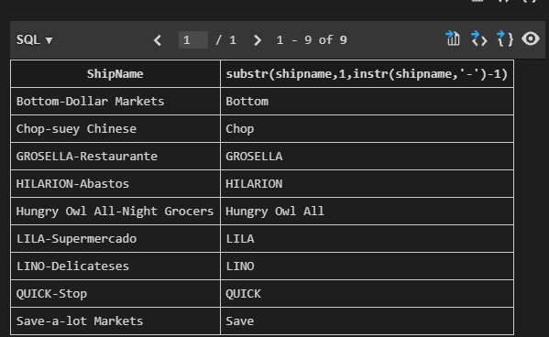
-- q2
SELECT Id,ShipCountry,
(
CASE
ShipCountry
WHEN 'USA' THEN 'NorthAmerica'
WHEN 'Mexico' THEN 'NorthAmerica'
WHEN 'Canada' THEN 'NorthAmerica'
ELSE 'OtherPlace'
END
) as Area
FROM 'ORDER'
WHERE Id >= 15445
ORDER BY Id
LIMIT 20
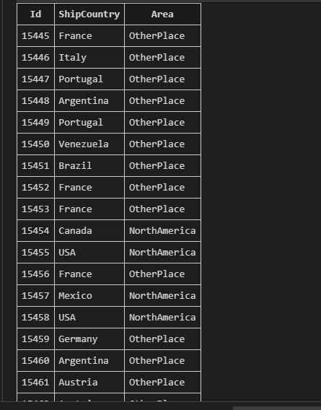
--q3
SELECT CompanyName,ROUND((lt*1.0/al)*100,2)As PER
from
(SELECT COUNT(*) AS al,CompanyName
FROM 'Order',Shipper
WHERE Shipper.Id=ShipVia
GROUP BY ShipVia)
NATURAL JOIN
(SELECT COUNT(*) AS lt,CompanyName
FROM 'Order',Shipper
WHERE Shipper.Id=ShipVia
AND ShippedDate > RequiredDate
GROUP BY ShipVia)
order by PER
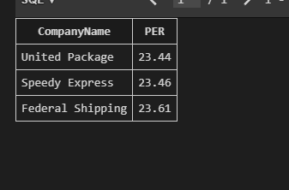
-- q4
SELECT C.CategoryName,count(*)NUM,Round(avg(P.UnitPrice),2)AVG,
min(P.UnitPrice)MIN,max(P.UnitPrice)MAX,Sum(P.UnitsOnOrder)SUM,C.Id
FROM Product P,Category C
WHERE C.Id=P.CategoryId
GROUP BY P.CategoryId
HAVING count(*)>10
Order BY C.Id DESC
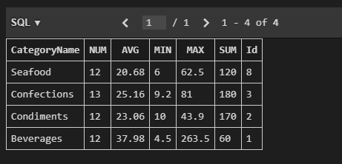
-- q5
select productname, companyname, contactname from(
select P.productname, min(O.orderdate), customerid
from product as P, orderdetail as OD, 'order' as O
where P.discontinued = 1 and P.id = OD.productid and OD.orderid = O.id
group by P.productname
order by P.productname
), customer as C
where customerid = C.id
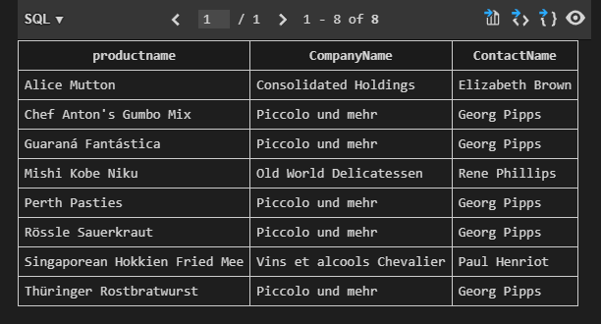
-- q6
SELECT a.Id,a.OrderDate,
lag(OrderDate,1,OrderDate) OVER(Order BY OrderDate) as Previous,
round(julianday((a.OrderDate))-julianday(lag(OrderDate,1,OrderDate) OVER(Order BY OrderDate)),2) as Differ
FROM(
SELECT o.Id,o.OrderDate
FROM `Order` o
WHERE o.CustomerId='BLONP'
Order BY OrderDate
) a
Order BY OrderDate
LIMIT 10
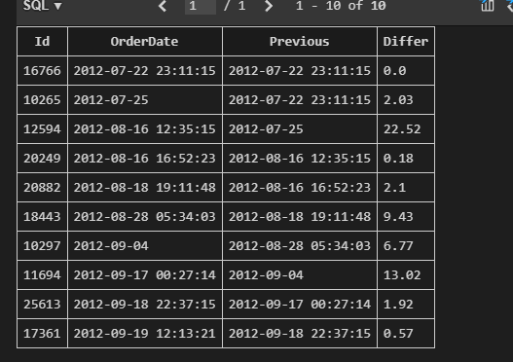
-- q7
select companyname, customerid, exp from(
select companyname, customerid, exp,
ntile(4) over (
order by exp asc
) as ntile from(
select companyname, all_c.customerid , round(sum(unitprice * quantity), 2) as exp
from(
select ifnull(companyname, 'MISSING_NAME') as companyname, customerid from(
select distinct customerid
from 'order'
) as O left outer join customer as C on C.id = O.customerid
) as all_c, 'order' as O, orderdetail as OD
where all_c.customerid = O.customerid and O.id = OD.orderid
group by all_c.customerid
)
)
where ntile = 1
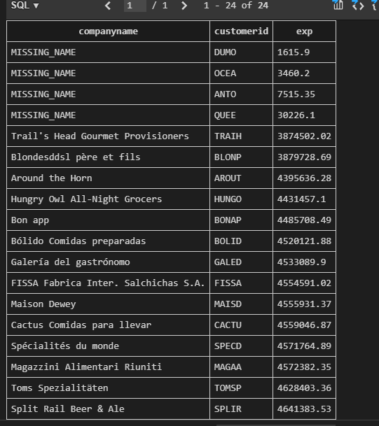
--q8
SELECT r.RegionDescription,e.FirstName,e.LastName,max(e.BirthDate)
FROM EmployeeTerritory et,Employee e,Territory t,Region r
WHERE et.EmployeeId=e.Id and et.TerritoryId=t.Id and t.RegionId=r.Id
GROUP BY r.Id
