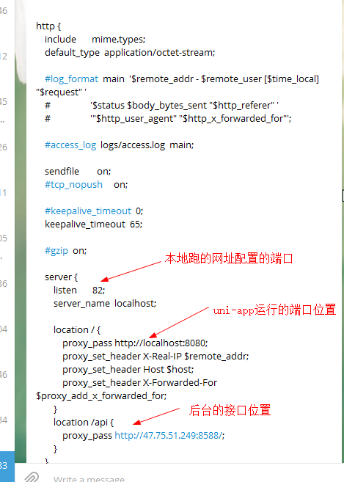
#user nobody;
worker_processes 1;

#error_log logs/error.log;
#error_log logs/error.log notice;
#error_log logs/error.log info;

#pid logs/nginx.pid;

events {
worker_connections 1024;
}

http {
include mime.types;
default_type application/octet-stream;

#log_format main '$remote_addr - $remote_user [$time_local] "$request" '
# '$status $body_bytes_sent "$http_referer" '
# '"$http_user_agent" "$http_x_forwarded_for"';

#access_log logs/access.log main;

sendfile on;
#tcp_nopush on;

#keepalive_timeout 0;
keepalive_timeout 65;

#gzip on;

server {
listen 82;
server_name localhost;

location / {
proxy_pass http://localhost:8080;
proxy_set_header X-Real-IP $remote_addr;
proxy_set_header Host $host;
proxy_set_header X-Forwarded-For $proxy_add_x_forwarded_for;
}
location /api {
proxy_pass http://47.75.51.249:8588/;
}
}

}

