**Weekly Update of Currencies**

This is the weekly update of the project progress.

28 May 2023 16:05

Top 5 currencies:

|  |  |  |  |
| --- | --- | --- | --- |
| **Name** | **Last Price** | **Change** | **% Change** |
| GBP/JPY | 173.674 | 1.14 | +0.66% |
| EUR/JPY | 150.87 | 0.648 | +0.43% |
| USD/JPY | 140.595 | 0.544 | +0.39% |
| USD/THB | 34.712 | 0.115 | +0.33% |
| USD/GBP | 1.2349 | 0.0028 | +0.22% |

|  |  |  |  |
| --- | --- | --- | --- |
| **Name** | **Last Price** | **Change** | **% Change** |
| USD/MXN | 17.608 | -0.2422 | -1.36% |
| USD/ZAR | 19.6449 | -0.1715 | -0.87% |
| USD/RUB | 79.45 | -0.595 | -0.74% |
| EUR/HUF | 370.59 | -2.21 | -0.59% |
| USD/MYR | 4.597 | -0.026 | -0.56% |

Bottom 5 currencies:

**Highlights:**

**GBP / JPY**

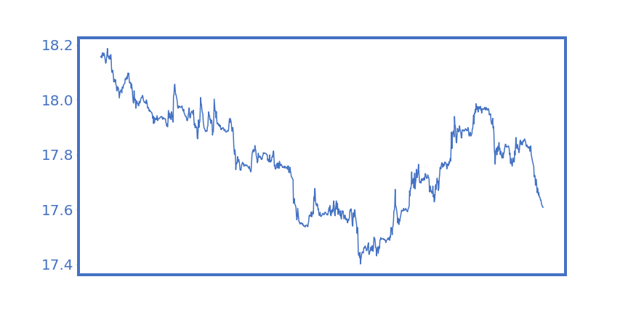

**USD / MXN**

