**Weekly Update of Currencies**

This is the weekly update of the project progress.

Updated on 9 Dec 2021 17:51

Top 5 currencies:

|  |  |  |  |
| --- | --- | --- | --- |
| **Name** | **Last Price** | **Change** | **% Change** |
| USD/ZAR | 15.7678 | 0.0545 | +0.35% |
| USD/THB | 33.459 | 0.115 | +0.34% |
| USD/PHP | 50.393 | 0.173 | +0.34% |
| USD/INR | 75.55 | 0.195 | +0.26% |
| USD/RUB | 73.6453 | 0.1587 | +0.22% |

|  |  |  |  |
| --- | --- | --- | --- |
| **Name** | **Last Price** | **Change** | **% Change** |
| USD/ZAR | 15.7678 | 0.0545 | +0.35% |
| USD/THB | 33.459 | 0.115 | +0.34% |
| USD/PHP | 50.393 | 0.173 | +0.34% |
| USD/INR | 75.55 | 0.195 | +0.26% |
| USD/RUB | 73.6453 | 0.1587 | +0.22% |

Bottom 5 currencies:

**Highlights:**

**USD / ZAR:**

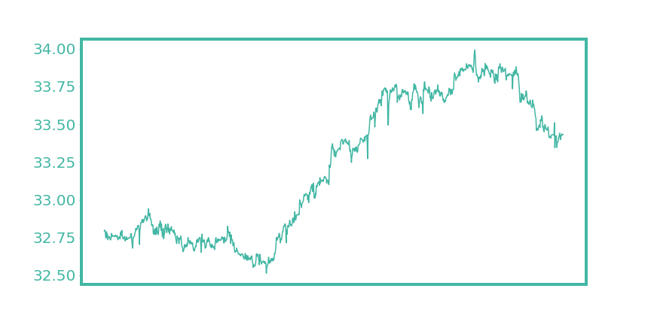

**USD / ZAR:**

