Defense In Depth Case Study
Prepared by: [Team Member 1], [Team Member 2], Cydney Goldstein, [Team Member 3]
CYBE 5750: Cybersecurity Technologies
Professor: [Instructor]
April 26, 2025

Table of Contents
Purpose 3
Scope 4
Resources 5
Business Case 5
Assurance Case 6
Reference Documents 7
Risk Mitigation Plan 7
Architecture of the Defense in Depth 13
Components of the Defense in Depth 18
Assurance Process for Deployed Countermeasures 21
Incident Response Plan Including Contingencies 29
Change Management Plan 33

Purpose – Cydney Goldstein
As Humongous Holdings continues to grow its technological business ventures, there is an inevitable expansion into health care electronics and data services. In this expansion, compliance with Public Law 104-191, otherwise known as the Health Insurance Portability and Accountability Act (HIPPA), is vital for the continuity of our business structures. HIPPA outlines the need for organizations to protect an individual’s medical records, combat fraud within the healthcare industry, and puts safeguards in place to allow for proper notification in the case of a breach in data. This law provides defenses not only for individuals, but also for healthcare providers, health insurers, healthcare clearinghouses, and any possible business associates in between.
HIPPA’s primary importance lies within its ability to protect patient’s sensitive health information. With the rise in technological infrastructure, the majority of healthcare information is now stored electronically. Electronic Protected Health Information (ePHI) refers to any health information that is created, stored, transmitted, or electronically received. This can include sensitive data such as medical records, billing information, and other personal identifiers that would be an incredible win for a threat actor if obtainable. HIPAA compliance is essential to ensuring the sustained operations of a business like Humongous Holdings. For the organization to succeed in the healthcare sector, it must establish and maintain trust with its customers by adhering to regulatory standards for protecting ePHI. A business’ foundation lies in its ability to effectively serve its customers. Without Humongous Holdings’ ability to establish and maintain a trust to safeguard medical data, the viability of the business’ healthcare sectors could be compromised.
Within the last twelve months, 92% of healthcare organizations were targeted by cybercriminals in attempts to compromise ePHI, according to a survey conducted by the Poneman Institute. Electronic Protected Health Information is on the rise in black market sale, as a single record can sell for upwards of $1000. Medical records are so valuable for black market sale, as they can steal identities of those who have been compromised or commit large-scale insurance fraud operations. In May of 2024, Ascension Health, one of the United States largest healthcare organizations, suffered a ransomware attack which compromised over 5 million patient records. Data such as names, addresses, social security numbers, and insurance information were accessed. Although Ascension worked with a third-party team to combat this breach, the proper safeguards were not put in place to prevent this type of attack from happening. Health care system cyber-attacks, like the one on Ascension Health, can cause disruptions of patient care, financial cost for the company at large, reputation damage, legal consequences, and the aforementioned patient identity compromises.
In accordance with NIST Special Publication 800-66, Humongous Holdings will undergo guidance to create a holistic security environment for entities who must comply with HIPPA, in order to combat against any potential threat actor. In accordance with the guide, Humongous Holdings will adapt administrative, technical and physical safeguards such as workplace policies, personnel access controls, and access management to protect all ePHI. Continuous evaluation of evolving threats via audits or updates will additionally be integrated. Additional documents such as NIST 800-37, FIPS 199, FIPS 200, etc. will provide the framework necessary to create an organization-wide risk management architecture.

Scope – [Team Member 3]
The scope of this working group will be securing electronic protected health information (ePHI) that is created, used, stored, and transferred in healthcare facilities that are owned and operated by Humongous Holding’s. The governing law which we will derive compliance requirements from is Public Law 104-191, more commonly known as the Health Insurance Portability and Accountability Act of 1996 (HIPAA). More specifically we will be protecting ePHI in accordance with (IAW) the HIPAA Security Rule. The Rule specifies administrative, physical, and technological protections, however, the protection scheme contained in this document will only encompass technological controls related to protecting ePHI.

Resources – [Team Member 1]
To ensure that ePHI will be secured and compliant with the HIPPA strong standards, Humongous Holdings will need to ensure that they will prioritize protection over classified assets. Some assets include medical records, patient billing information, and other personal identifiable information stored and transmitted through the health facility network. Workstations, servers and communication channels via email and other messaging software that are used to transfer sensitive data in and outside the organization should also be protected as well. The organization would need to commit to the new technology resources such as Firewalls and Intrusion Detection Systems to be able to monitor and prevent unauthorized users to access ePHI across the network. Encryption solutions will need to be in place to shield ePHI from any unauthorized action during information being transferred while being inputted into the system. Secured Authentication methods such as multi-factor and role-based access will need to be in place so that only certain authorized personnel have access to highly classified information. Data Loss prevention tools would be needed in place during any suspicious data transfers while making sure ePHI is protected while connected to the network perimeters. Lastly, backup and recovery systems would be crucial to have in place and have backups scheduled on a frequency basis to keep data stored and be able to be restored in case of an emergency. Working within the healthcare environment it is critical to have a security team in place to monitor, manage and respond to any incidents that occur. IT Support staff is imperative to have in place troubleshoot systems and make sure the systems stay up to date with security measures. Training and awareness program will need to take place frequently and agree of the confidentiality of hospital records.

Business Case – [Team Member 1]
Addressing the issue of securing electronic health records is a crucial investment for Humongous Holdings. Besides committing to resources such as ePHI this will also bring in business improvements all around. The impact that ePHI would have on the healthcare environment is by showing companies that this security method will have a great reputation for protecting information and gain the trust of people in the industry. There would also be financial benefits such as decreasing the risk of fines and legal suits with data being leaked. The amount of investment in ensuring that the system is secured will bring long-term savings by decreasing the potential risk of data breaches and the potential downtime that may occur. With ePHI there will also be an advantage of having advanced up to date equipment in place. There are companies all around the world who have outdated equipment and fail to meet the safety measures in protecting client's information. All in all, the overall investment in protecting ePHI is important for Humongous Holdings’.
Assurance Case – [Team Member 1]
The degree of assurance for securing ePHI and compliance focuses on making sure that there are advanced security controls in place to prevent information being breached. Humongous Holdings will require a certain level of assurance to continuously meet the requirements of security protocols. A couple of things would be within the degree of assurance would be risk management, assurance would need to be provided through different assessments, audits and testing different controls such as firewalls. The company should be able to require mid to high assurance business can remain in place during security incidents. As we know security incidents are bound to happen, but it is imperative that health environments can stay with software that can have that extra layer of service protection to continue work through an incident. The level of security measures is important when trying to secure high profile information. If you have a low level of assurance the risk of being breached is high and difficulties with recovering from the hack. If you have a medium level, it could lead to a lower level of risk through scheduled security audits along with making sure everything is approving with HIPPA. The best option would be the high level which would include multiple authentication methods, high value firewalls, and would ensure that the CIA triad with ePHI. To conclude, having good security measures in place is valuable to continuous success and bigger projects with the involvement of Humongous Holdings, the customers, data and creating different long-term opportunities.

Reference Documents – [Team Member 3]
Public Law 104-191, Health Insurance Portability and Accountability Act of 1996 (HIPAA)
HIPAA Privacy Rule, Security Rule, and Breach Notification Requirements
Required Technical Safeguards
FIPS 199, Standards for Security Categorization of Federal Information and Information Systems
FIPS 200, Minimum Security Requirements for Federal Information and Information Systems
NIST 800-37, Risk Management Framework for Information Systems and Organizations: A System Life Cycle Approach for Security and Privacy
NIST 800-53, Security and Privacy Controls for Information Systems and Organizations
NIST 800-53, All Control Families
NIST 800-60, Guide for Mapping Types of Information and Systems to Security Categories
NIST 800-66, Implementing the Health Insurance Portability and Accountability Act (HIPAA) Security Rule: A Cybersecurity Resource Guide

Risk Mitigation Plan – [Team Member 3]
According to Appendix A to Subpart C of Part 164—Security Standards: Matrix, which further references 164.312, Technical safeguards related to the HIPAA Security Rule, provides five families of technical controls to protect ePHI.
The high-level control families are Access Control, Audit Controls, Integrity, Person or Entity Authentication, and Transmission Security. The matrix further denotes the controls of each family as either Required (R) or Addressable (A). While (R) is self-explanatory (A) warrants further attention. Addressable does not mean optional, it means you must: Assess whether the safeguard is reasonable and appropriate If yes, implement it, if no, document why, and either implement an alternative or justify not doing so.
Our roadmap for compliance comes directly from the HIPAA Security Rule and is provided below. C-level executives were presented with a comprehensive risk analysis and fine schedule for non-compliance. They concluded that HH’s has the resources, budget, and the countermeasures conform to the principle of psychological acceptability, meaning that users will be abiding by them almost without even knowing that they are there.

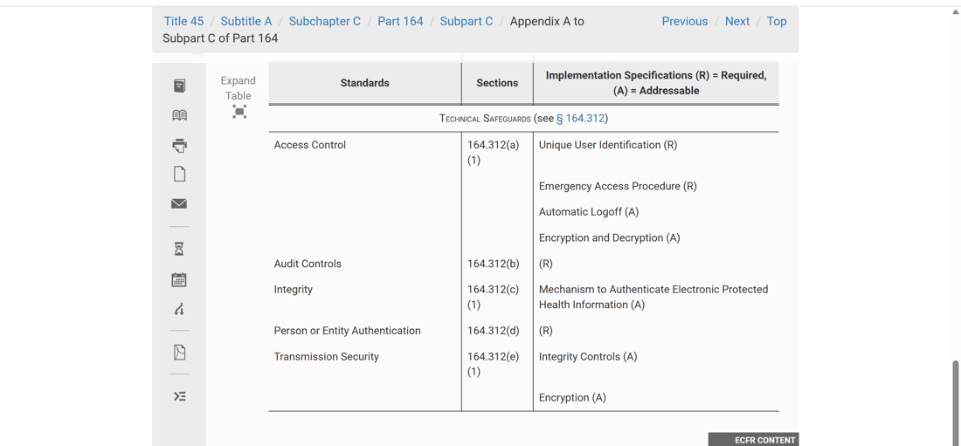
§ 164.312 Technical safeguards
A covered entity or business associate must, in accordance with § 164.306 implement:
(a) Access Control
(1) Standard: Access control. Implement technical policies and procedures for electronic information systems that maintain electronic protected health information to allow access only to those persons or software programs that have been granted access rights as specified in § 164.308(a)(4).
(2) Implementation specifications:
(i) Unique user identification (Required). Assign a unique name and/or number for identifying and tracking user identity.
(ii) Emergency access procedure (Required). Establish (and implement as needed) procedures for obtaining necessary electronic protected health information during an emergency.
(iii) Automatic logoff (Addressable). Implement electronic procedures that terminate an electronic session after a predetermined time of inactivity.
(iv) Encryption and decryption (Addressable). Implement a mechanism to encrypt and decrypt electronic protected health information.
Per 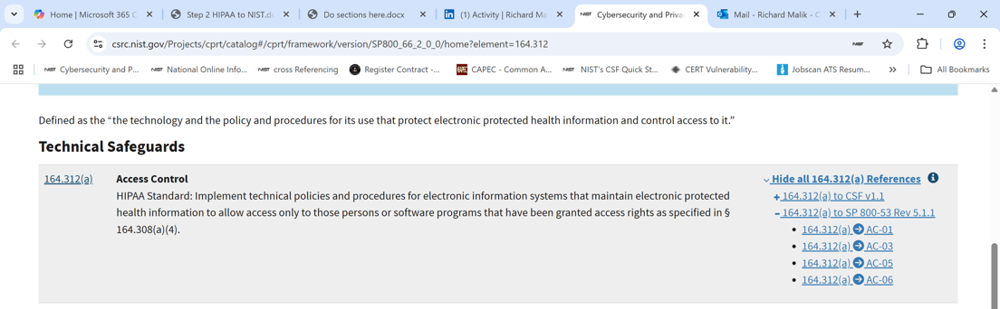
This requires NIST 800-53:
AC-1, Policies and Procedures
AC-3, Access Enforcement
AC-5, Separation of Duties
AC-6, Least Privilege

(b) Audit Control Implement hardware, software, and/or procedural mechanisms that record and examine activity in information systems that contain or use electronic protected health information.
Per 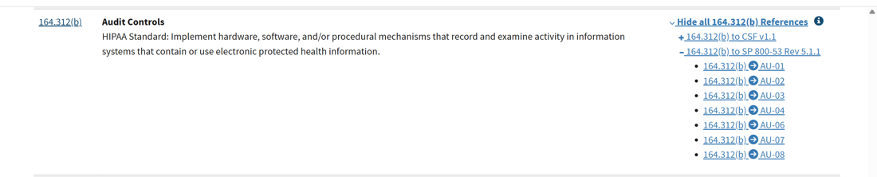

This requires NIST 800-53:
AU-1, Policies and Procedures
AU-2, Event Logging
AU-3, Content of Audit Records
AU-4, Audit Log Storage Capacity
AU-6, Audit Record Review, Record, Analysis and Reporting
AU-7, Audit Record Reduction and Report Generation
AU-8, Time Stamps

(c) Integrity
(1) Standard: Integrity. Implement policies and procedures to protect electronic protected health information from improper alteration or destruction.
(2) Implementation specification: Mechanism to authenticate electronic protected health information (Addressable). Implement electronic mechanisms to corroborate that electronic protected health information has not been altered or destroyed in an unauthorized manner.
Per 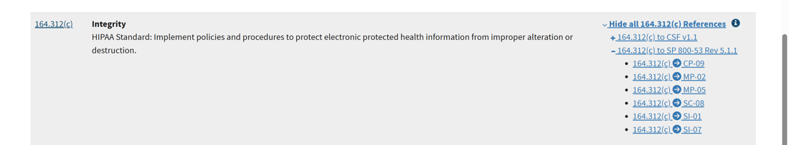

This requires NIST 800-53:
CP-9, System Backup
MP-2, Media Access
MP-5, Media Transport
SC-8, Transmission Confidentiality & Integrity
SI-1, System and Information Integrity Policies and Procedures
SI-7, Software, Firmware, and Information Integrity
(d) Person or Entity Authentication. Implement procedures to verify that a person or entity seeking access to electronic protected health information is the one claimed.

Per 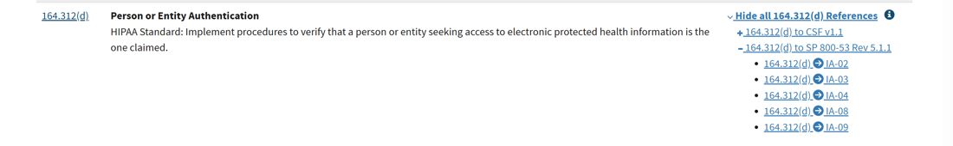
This requires NIST 800-53:
IA-2, Identification and Authorization (Organizational Users)
IA-3, Device Identification and Authentication
IA-4, Identifier Management
IA-8, Identification and Authentication (non-organizational users)
IA-9, Service Identification and Authentication

(e) Transmission Security
(1) Standard: Transmission security. Implement technical security measures to guard against unauthorized access to electronic protected health information that is being transmitted over an electronic communications network.
(2) Implementation specifications:
(i) Integrity controls (Addressable). Implement security measures to ensure that electronically transmitted electronic protected health information is not improperly modified without detection until disposed of.
(ii) Encryption (Addressable). Implement a mechanism to encrypt electronic protected health information whenever deemed appropriate.

Per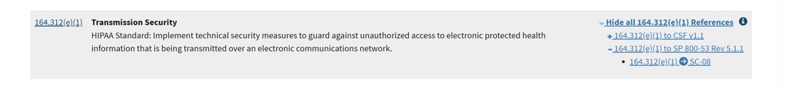
This requires NIST 800-53:
SC-8, Transmission Confidentiality and Integrity
Architecture of the Defense in Depth – [Team Member 2]
The architecture of Defense in Depth for Humongous Holdings leverages a multi-layered security approach designed for the systematic protection of confidentiality, integrity, and availability of critical applications, data, and infrastructure across global operations. This architecture implements overlapping layers of protection that reduce vulnerabilities while mitigating potential damage from cyber incidents.
Our defense strategy encompasses six integrated security layers:
- Perimeter security
- Network security
- Host and endpoint security
- Application security
- Data security
- Physical security

- Perimeter Security Layer
The perimeter security layer serves as the first line of defense, controlling external traffic and blocking unauthorized access to internal resources. This layer employs industry-specific configurations to defend against various threat actors.
1.1. Next-Generation Firewalls (NGFWs)
NGFWs are positioned at network ingress and egress points to provide granular inspection of incoming and outgoing traffic. The implementation uses Palo Alto Networks PA-series firewalls featuring:
- Deep packet inspection
- Advanced threat prevention
- URL filtering
- User identity control
- Application-aware traffic management

1.2. VPN Gateways
Secure remote access is provided through Cisco AnyConnect VPN, which creates encrypted tunnel communication for remote employees and locations accessing corporate resources. While providing excellent protection for standard remote access, VPN connections are supplemented with additional security measures for critical systems access.
- Network Security Layer
The Network Security layer protects and manages internal traffic, controlling lateral movement within the organization and detecting malicious activities. This layer implements a zero-trust model across all parts of the network.
2.1. Internal Firewalls
While perimeter firewalls keep threats out, internal firewalls using Cisco Firepower technology keep resources segmented and contained. These firewalls implement:
- Internal network segmentation
- Strict access control rules
- Micro-segmentation for critical assets
- Traffic monitoring between segments

2.2. Network Access Control (NAC)
Cisco Identity Services Engine provides authentication and authorization at network entry points, preventing unauthorized or compromised devices from connecting to internal network segments. This solution:
- Verifies device compliance before network access
- Implements role-based access restrictions
- Monitors device behavior on the network
- Automates response to suspicious device activity

2.3. Intrusion Detection and Prevention Systems
Cisco Secure IPS and Snort monitor and alert on malicious activities using anomaly detection with real-time threat response. Positioned at strategic points within the network, these systems detect both ingress/egress threats and lateral movement between internal hosts.
2.4. Jump Server/Bastion Host
For secure access to critical infrastructure components, hardened Cisco UCS X-series jump servers provide an additional security layer beyond VPN connections. These servers:
- Serve as controlled access points for administrative functions
- Implement enhanced authentication requirements
- Provide detailed logging and auditing of all activities
- Restrict direct access to sensitive systems

- Host-Based Security Layer
The host security layer focuses on protecting individual endpoint devices against various threats.
3.1. Endpoint Detection & Response (EDR) Solutions
Real-time monitoring, detection, and response capabilities are deployed to all endpoints to protect against malware, ransomware, and advanced persistent threats (APTs). The organization may expand to Extended Detection and Response (XDR) solutions in future phases.
3.2. COBO Devices
Mobile device security follows a strict Corporately Owned, Business Only (COBO) policy. All personnel are issued company-owned mobile devices configured exclusively for work purposes. These devices feature:
- Remote wipe capabilities
- Full disk encryption
- Biometric authentication
- Secure MFA token storage
- Comprehensive device management

- Application Security Layer
This layer protects software applications by mitigating vulnerabilities throughout the development lifecycle and during deployment.
4.1. Software Assurance
A comprehensive software assurance process is implemented with multiple security checkpoints, including:
- Secure coding practices and standards
- Static and dynamic analysis tools throughout the SDLC
- Regular code reviews and security testing
- Vulnerability management procedures
- Penetration testing for critical applications

4.2. Web Application Firewall (WAF)
Web-facing applications are protected by dedicated WAF solutions that defend against:
- Distributed Denial of Service (DDoS) attacks
- SQL injection and other code injection attacks
- Cross-site scripting (XSS)
- OWASP Top 10 vulnerabilities
- Zero-day exploit attempts

- Data Security Layer
The data security layer focuses on protecting sensitive information during storage, access, and transmission.
5.1. Encryption Solutions
Multiple encryption methods are employed based on specific use cases:
- Data at Rest Protection:
  - AES encryption standards (minimum) for stored data
  - Record-level encryption for sensitive database fields
  - Full disk encryption for endpoint devices
  - Volume and partition encryption for servers
  - File-level encryption for documents containing sensitive data
  - SHA256 (minimum) for data hashing
- Data in Transit Protection:
  - TLS encryption for HTTPS communications
  - Secure VPN tunnels for remote access
  - Digital certificates and PKI infrastructure
  - Secure file transfer protocols

5.2. Data Loss Prevention
Symantec DLP solutions monitor, detect, and prevent unauthorized exfiltration of sensitive corporate data, protecting against both accidental and intentional data leakage through:
- Email and web monitoring
- Endpoint protection
- Network monitoring
- Cloud application control
- Content inspection and classification

- Physical Security Layer
The final layer addresses physical infrastructure and access point protection.
6.1. Controlled Physical Access
Physical security measures include:
- Surveillance cameras with motion detection
- Electronic access control systems with multi-factor authentication
- Biometric authentication for sensitive areas
- Secure document handling and destruction
- Access control vestibules and mantrap entries
- Security personnel for critical facilities
- Physical barriers (fencing, bollards, reinforced entry points)

6.2. Secure Data Centers
Data center protection includes:
- Hardened server rooms with reinforced construction
- Comprehensive facility access controls
- Environmental monitoring and control systems
- Advanced fire detection and suppression
- Redundant power and cooling
- 24/7 monitoring and alerting

Components of the Defense in Depth – [Team Member 2]
This section provides detailed descriptions of the specific technological solutions, their configurations, and relationships that together form our multi-layered defense strategy for protecting electronic Protected Health Information (ePHI) at Humongous Holdings.

Security Layer Components
Security Layer | Component | Description | Configuration Details | Relationships
Perimeter Security | Palo Alto PA-Series NGFW | Enterprise-grade firewalls with deep packet inspection | Active-active deployment, HTTPS inspection, healthcare threat profiles | SIEM integration, NAC, threat intel feeds
Perimeter Security | Cisco AnyConnect VPN | Secure remote access solution | MFA enforced, no split-tunnel, session timeout, posture assessment | Identity mgmt, NAC, SIEM logging
Network Security | Cisco Firepower Internal Firewalls | Internal segmentation firewalls | Micro-segmentation, application-aware, inter-segment logging | NAC, SIEM, identity mgmt
Network Security | Cisco ISE | Network Access Control | 802.1X auth, role-based controls, guest isolation, HIPAA checks | AD/LDAP, endpoint sec, SIEM
Network Security | Cisco Secure IPS and Snort | Intrusion prevention and detection | Healthcare signatures, anomaly detection, real-time blocking | SIEM alerts, threat intel, firewall coordination
Network Security | Cisco UCS X-Series Jump Servers | Admin access points | Hardened OS, session recording, PAM, MFA | PAM, SIEM, identity mgmt
Host-Based Security | System Hardening | OS/app secure configs | CIS benchmarks, secure boot, local firewalls | Vuln scanning, config mgmt, SIEM
Host-Based Security | Anti-Malware | Endpoint protection | Behavioral analysis, file/web/email scanning | Central mgmt, threat intel, SIEM
Host-Based Security | EDR | Endpoint detection/response | Behavioral analytics, automated response, forensic data | SIEM, NAC quarantine, threat intel
Host-Based Security | COBO Devices | Secured business mobile devices | Full encryption, MDM, biometric auth, app whitelisting | Auth systems, enterprise apps, SOC monitoring
Application Security | Software Assurance | Secure app lifecycle | SAST, DAST, pen testing, code signing | CI/CD, vuln mgmt, change mgmt
Application Security | Web App Firewall | Protects web apps | OWASP rules, API protection, DDoS, ePHI leakage prevention | App monitoring, SIEM, firewalls
Data Security | Encryption | Encrypt data at rest/transit | AES-256, TLS 1.3, PKI, HSM | IAM, key mgmt, cert lifecycle
Data Security | Symantec DLP | Prevent data loss | ePHI pattern detection, policy control, user education | Email/web gateways, SIEM, incident response
Physical Security | Access Control Systems | Restrict physical access | Biometrics, time restrictions, visitor mgmt | Identity mgmt, PSIM, video surveillance
Physical Security | Environmental Controls | Protect infrastructure | Fire suppression, redundant power, separation | Facilities mgmt, disaster recovery, SOC
Security Management | SIEM | Log aggregation and alerting | Real-time alerts, HIPAA compliance reporting | All security components, IR workflow, analytics
Security Management | Vuln Mgmt | Find and prioritize weaknesses | Scanning, risk prioritization, patch integration | Change mgmt, remediation, governance
Security Management | Identity & Access Mgmt | Central auth and access | RBAC, MFA, PAM, access reviews | HR systems, app auth, security layers
Operations | Security Ops Center | Security monitoring and response | 24/7 monitoring, threat hunting, SOAR | All components, IR coordination, governance
Operations | Backup & Recovery | Data protection and continuity | Encrypted, tested, offsite backups | Disaster recovery, data protection
Operations | Security Awareness Training | Train personnel | Role-based, phishing tests, compliance tracking | HR integration, metrics, tech controls

Deployment Architecture
The components described above will be deployed in a layered architecture across Humongous Holdings' global infrastructure, with particular emphasis on healthcare facilities and systems processing ePHI. Each facility will maintain local instances of security components with centralized management and monitoring from the New York headquarters and regional security operations centers.
Special consideration is given to the flow of ePHI data through the various security layers, ensuring that appropriate protections are maintained throughout the data lifecycle - from creation and storage to transmission and eventual disposal.

Assurance Process for Deployed Countermeasures – Cydney
As according to Appendix A to Subpart C of Part 164—Security Standards: Matrix, there are administrative safeguards that can be put in place to ensure sustainment of the risk mitigation plan. In order to maintain alignment with the deployed solutions and an ever-evolving world of cyber threats, there are nine areas of administrative controls to ensure the continued protection of ePHI.
These areas of administrative controls include the Security Management Process, Assigned Security Responsibility, Workforce Security, Information Access Management, Security Awareness and Training, Security Incident Procedures, Contingency Plan, Evaluation, and Business Associate Contracts. As previously discussed in the risk mitigation plan, each area is specified as Required (R) or Addressable (A) and will be determined as such upon further investigation.
A covered entity or business associate must, in accordance with § 164.306:
- Security Management Process
- Standard: Security management process. Implement policies and procedures to prevent, detect, contain, and correct security violations.
- Implementation specifications:
- Risk analysis (Required). Conduct an accurate and thorough assessment of the potential risks and vulnerabilities to the confidentiality, integrity, and availability of electronic protected health information held by the covered entity or business associate.
- Risk management (Required). Implement security measures sufficient to reduce risks and vulnerabilities to a reasonable and appropriate level to comply with § 164.306(a).
- Sanction policy (Required). Apply appropriate sanctions against workforce members who fail to comply with the security policies and procedures of the covered entity or business associate.
- Information system activity review (Required). Implement procedures to regularly review records of information system activity, such as audit logs, access reports, and security incident tracking reports.
This requires:
- NIST 800-66r2 5.1.1: Security Management Process
- NIST 800-53r5 AC-2: Account Management
- NIST 800-53r5 PM-9: Risk Management Strategy
- NIST 800-53r5 PS-7: External Personnel Security

- Assigned Security Responsibility
- Standard: Assigned security responsibility. Identify the security official who is responsible for the development and implementation of the policies and procedures required by this subpart for the covered entity or business associate.
This requires:
- NIST 800-66r2 5.1.2: Assigned Security Responsibility
- NIST 800-53r5 PS-6: Access Agreements
- NIST 800-53r5 PL-1: Policy and Procedures
- NIST 800-53r5 PL-4: Rules of Behavior

- Workforce Security
- Standard: Workforce security. Implement policies and procedures to ensure that all members of its workforce have appropriate access to electronic protected health information, as provided under paragraph (a)(4) of this section, and to prevent those workforce members who do not have access under paragraph (a)(4) of this section from obtaining access to electronic protected health information.
- Implementation specifications:
- Authorization and/or supervision (Addressable). Implement procedures for the authorization and/or supervision of workforce members who work with electronic protected health information or in locations where it might be accessed.
- Workforce clearance procedure (Addressable). Implement procedures to determine that the access of a workforce member to electronic protected health information is appropriate.
- Termination procedures (Addressable). Implement procedures for terminating access to electronic protected health information when the employment of, or other arrangement with, a workforce member ends or as required by determinations made as specified in paragraph (a)(3)(ii)(B) of this section.
This requires:
- NIST 800-66r2 5.1.3: Workforce Security
- NIST 800-53r5 AC-2: Account Management
- NIST 800-53r5 IA-2: Identification and Authentication
- NIST 800-53r5 IA-5: Authenticator Management
- NIST 800-53r5 PS-3: Personnel Screening

- Information Access Management
- Standard: Information access management. Implement policies and procedures for authorizing access to electronic protected health information that are consistent with the applicable requirements of subpart E of this part.
- Implementation specifications:
- Isolating health care clearinghouse functions (Required). If a health care clearinghouse is part of a larger organization, the clearinghouse must implement policies and procedures that protect the electronic protected health information of the clearinghouse from unauthorized access by the larger organization.
- Access authorization (Addressable). Implement policies and procedures for granting access to electronic protected health information, for example, through access to a workstation, transaction, program, process, or other mechanism.
- Access establishment and modification (Addressable). Implement policies and procedures that, based upon the covered entity's or the business associate's access authorization policies, establish, document, review, and modify a user's right of access to a workstation, transaction, program, or process.
This requires:
- NIST 800-66r2 5.1.4: Information Access Management
- NIST 800-53r5 AC-2: Account Management
- NIST 800-53r5 AC-3: Access Enforcement
- NIST 800-53r5 AC-6: Least Privilege
- NIST 800-53r5 IA-2: Identification and Authentication

- Security Awareness and Training
- Standard: Security awareness and training. Implement a security awareness and training program for all members of its workforce (including management).
- Implementation specifications. Implement:
- Security reminders (Addressable). Periodic security updates.
- Protection from malicious software (Addressable). Procedures for guarding against, detecting, and reporting malicious software.
- Log-in monitoring (Addressable). Procedures for monitoring log-in attempts and reporting discrepancies.
- Password management (Addressable). Procedures for creating, changing, and safeguarding passwords. AT-01
This requires:
- NIST 800-66r2 5.1.5: Security Awareness and Training
- NIST 800-53r5 AT-1: Policy and Procedures
- NIST 800-53r5 AT-2: Literacy Training and Awareness
- NIST 800-53r5 AT-3: Role-Based Training
- NIST 800-53r5 AT-4: Training Records

- Security Incident Procedures
- Standard: Security incident procedures. Implement policies and procedures to address security incidents.
- Implementation specification: Response and reporting (Required). Identify and respond to suspected or known security incidents; mitigate, to the extent practicable, harmful effects of security incidents that are known to the covered entity or business associate; and document security incidents and their outcomes.
This requires:
- NIST 800-66r2 5.1.6: Security Incident Procedures
- NIST 800-53r5 IR-1: Policy and Procedures
- NIST 800-53r5 IR-2: Incident Response Training
- NIST 800-53r5 IR-4: Incident Handling
- NIST 800-53r5 IR-5: Incident Monitoring
- NIST 800-53r5 IR-6: Incident Reporting

- Contingency Plan
- Standard: Contingency plan. Establish (and implement as needed) policies and procedures for responding to an emergency or other occurrence (for example, fire, vandalism, system failure, and natural disaster) that damages systems that contain electronic protected health information.
- Implementation specifications:
- Data backup plan (Required). Establish and implement procedures to create and maintain retrievable exact copies of electronic protected health information.
- Disaster recovery plan (Required). Establish (and implement as needed) procedures to restore any loss of data.
- Emergency mode operation plan (Required). Establish (and implement as needed) procedures to enable continuation of critical business processes for protection of the security of electronic protected health information while operating in emergency mode.
- Testing and revision procedures (Addressable). Implement procedures for periodic testing and revision of contingency plans.
- Applications and data criticality analysis (Addressable). Assess the relative criticality of specific applications and data in support of other contingency plan components.
This requires:
- NIST 800-66r2 5.1.7: Contingency Plan
- NIST 800-53r5 CP-1: Policy and Procedures
- NIST 800-53r5 CP-2: Contingency Plan
- NIST 800-53r5 CP-3: Contingency Training
- NIST 800-53r5 CP-4: Contingency Plan Testing
- NIST 800-53r5 CP-6: Alternate Storage Site

- Evaluation
- Standard: Evaluation. Perform a periodic technical and nontechnical evaluation, based initially upon the standards implemented under this rule and, subsequently, in response to environmental or operational changes affecting the security of electronic protected health information, that establishes the extent to which a covered entity's or business associate's security policies and procedures meet the requirements of this subpart.
This requires:
- NIST 800-66r2 5.1.8: Evaluation
- NIST 800-53r5 PM-9: Risk Management Strategy
- NIST 800-53r5 PM-11: Mission and Business Process Definition
- NIST 800-53r5 SA-11: Developer Testing and Evaluation
Business Associate Contracts and Other Arrangements
- Business associate contracts and other arrangements. A covered entity may permit a business associate to create, receive, maintain, or transmit electronic protected health information on the covered entity's behalf only if the covered entity obtains satisfactory assurances, in accordance with § 164.314(a), that the business associate will appropriately safeguard the information. A covered entity is not required to obtain such satisfactory assurances from a business associate that is a subcontractor.
- A business associate may permit a business associate that is a subcontractor to create, receive, maintain, or transmit electronic protected health information on its behalf only if the business associate obtains satisfactory assurances, in accordance with § 164.314(a), the subcontractor will appropriately safeguard the information.
- Implementation specifications: Written contract or other arrangement (Required). Document the satisfactory assurances required by paragraph (b)(1) or (b)(2) of this section through a written contract or other arrangement with the business associate that meets the applicable requirements of § 164.314(a).
This requires:
- NIST 800-66r2 5.1.9: Business Associate Contracts and Other Arrangements
- NIST 800-53r5 SA-9: External System Services
- NIST 800-53r5 SA-12: Supply Chain Protection
- NIST 800-53r5 PM-13: Security and Privacy Workforce

Incident Response Plan Including Contingencies – [Team Member 2]
The Incident response plan aims to confirm the structured approach that Humongous Holdings will follow to address security incidents affecting tis diverse portfolio of subsidiaries. The plan integrates with the multi-layered defense strategy to ensure rapid detection, effective containment, and strong remediation of security events while maintaining compliance with regulations across defense, technology, and financial sectors.

Incident Response Framework
  - IR Team Structure
Team | Members | Responsibilities
IR Core Team | • CISO (Team Lead)  • Security Operations Manager  • Network Security Lead  • System Security Lead  • Compliance Officer  • Legal Counsel | • Overall incident management  • Strategic decision-making  • Communication with executives  • Regulatory compliance oversight
Technical Response Team | • Security Analysts  • Network Engineers  • System Administrators  • Database Administrators  • Application Support Specialists | • Technical investigation  • Containment actions  • Evidence collection  • System restoration
Communications Team | • Communications Director  • HR Representative  • Client Relations  • Public Relations | • Internal communications  • External communications  • Media relations  • Client notifications
Business Continuity Team | • Business Continuity Manager  • Department Representatives  • Facility Managers | • Business impact analysis  • Alternative process implementation  • Recovery prioritization  • Return to normal operations

  - IR Process Flow
The incident response process is heavily based off NIST SP 800-61 framework which is adapted for Humongous Holdings multi-industry environment.
- Preparation: Maintaining readiness through documentation, training an exercises, and tools
- Detection & Analysis: Continuous identification and validation of security incidents using alerts and monitoring
- Containment: Restricting the scope and surface impact of the incident
- Eradication: Removing the cause of the incident
- Recovery: Returning system operations to normal
- Post-Incident Activities: Improving defense through analysis
2) Incident Classification and Response Procedures
Note: Some of the following will be determined and subject to change as a result of SLA’s and other requirements placed on Humongous Holdings.
Level | Description | Response Time | Escalation
Critical | Data breach, widespread compromise, significant operational impact | 15 minutes | Full IR Team, Executive notification
High | Limited system compromise, regulatory concerns | 1 hour | IR Core + Technical Teams, CISO
Medium | Attempted compromise, limited impact | 4 hours | Technical Team, Security Manager
Low | Minor policy violations, no data risk | 24 hours | Security Analyst, standard procedures

2.3 Response Procedures by Incident Type
Malware and Ransomware Attacks
Following the order of operations, the priority is to isolate the affected systems immediately after detection and reporting to prevent further spread. Network containment measures are then implemented to segment or restrict traffic from compromised areas and air gapping the proper systems. The containment stage is immediately followed by the organization assessing the impact of malware and ensuring evidence is preserved for investigation and potential legal proceedings. Once systems have been sanitized and deemed clean, backups are fully restored. The team then must evaluate any applicable regulatory reporting requirements based on the nature and scope of the incident.
Unauthorized access incidents
When handling these incidents, immediate response and timeliness is a crucial factor. The immediate response should be locking compromised user accounts and forcing mandatory password resets. Authentication are then to be reviewed by the security team to identify how access was gained and establish heightened monitoring for additional anomalies. The breach’s scope is then assessed to determine whether sensitive data or systems were accessed. It might also be important to temporarily apply stricter authentication methods and security controls.
Data Breaches
A data breach triggers efforts to identify and shut down any ongoing data exfiltration channels. Evidence is preserved in order to support investigative and legal actions. While the full scope and timeline of the breach are documented, the legal team should also be involved early to evaluate reporting requirements. There needs to be a deliverable of notifications to customers, regulators, and business partners as needed. This should align with industry-specific and jurisdictional mandates.
Insider Threat
In the case of an insider threat incident, the organization swiftly restricts the suspected individual's access across systems and facilities. An internal investigation is launched, focusing on user behavior, access logs, and communications. Evidence is collected in accordance with legal standards to preserve its admissibility. Depending on severity and nature, legal counsel and human resources are engaged for disciplinary or legal actions. Additional monitoring is temporarily applied to sensitive areas to detect similar behavior patterns in other users. Policies related to access control and acceptable use are also reviewed and tightened where appropriate.
To maintain the integrity of its system baselines while adapting to a rapidly evolving threat landscape, Humongous Holdings follows a structured yet adaptive change management process. Whether driven by innovation, incident response, regulatory requirements, or operational need, this approach ensures that all changes are implemented systematically, with minimal disruption and without compromising security or compliance.
Change proposals originate from authorized personnel and are reviewed by a multidisciplinary advisory group that includes representatives from security, operations, compliance, and affected business units. These proposals must include an evaluation of operational risk, potential regulatory impact, and a rollback plan in the event of failure. All changes are formally documented, scheduled, and deployed in a controlled environment, with validation checkpoints conducted both before and after implementation to detect any deviation from approved baselines.
System configurations and software versions are baseline-controlled using version tracking tools and audit-ready documentation. Prior to implementation, Humongous Holdings captures configuration snapshots, which serve as restoration points and reference comparisons. These baselines are reviewed regularly to detect configuration drift, especially within critical systems such as those supporting financial transactions, defense contracts, or proprietary R&D operations.
In addition to structured change windows, Humongous has defined expedited pathways for emergency changes, such as those required during live incidents or zero-day vulnerabilities. Even these high-priority changes are logged in real time, evaluated post-implementation, and reconciled against baseline configurations to ensure consistency.
To validate the effectiveness of the change management process, regular audits, system integrity checks, and cross-team reviews are conducted. Lessons learned from incidents or failed changes are looped back into updated change procedures, configuration standards, and system documentation. This continual refinement ensures that the organization remains agile in its response capabilities while maintaining full control over its operational environment.
By combining process discipline with proactive oversight and flexible response mechanisms, Humongous Holdings preserves baseline integrity while enabling secure innovation. This approach helps safeguard the enterprise's core assets against both unintentional misconfiguration and malicious exploitation—contributing directly to the resilience of its overall defense-in-depth strategy.

Change Management Plan – Cydney Goldstein
Change management, an essential step in integrating any new technological process within a large level organization, is necessary to ensure that control changes made within updated processes preserve the system integrity. As the world of cyber threats is ever evolving, this indicates that Humongous Holdings must have a routine management plan. For system integrity to remain intact, authorization, implementation, and evaluation processes must be established systematically for success.
Authorization requires a clear-cut process for approving system-wide changes. As according to NIST 800-66r2 5.1.2, a proper security official or group must be established to monitor adherence to HIPPA, while also monitoring the organizationally developed configuration identification scheme. The configuration identification scheme sets up baseline procedures and standards to compare for adherence, providing a comparison to be maintained throughout the software lifecycle. Once authorized officials are chosen to act as a Change Control Board and a configuration identification scheme is developed, the change management plan can commence. The Change Control Board can approve or deny requests to change anything within the system, all whilst accessing potential risks with changes and ensuring HIPPA’s ePHI compliance standards. The Change Management Board will also be determining whether change should be implemented based on resource availability. In addition, this board will host annual audits, which will include a comprehensive risk analysis and security evaluation. In addition to an annual audit, there will be quarterly reviews between named officials to secure and discuss risk assessments, audit logs, security measures, employee training, incident response updates, and any policy or compliance updates. Alongside the development of a Change Control Board, all stakeholders involved in said sector of security and compliance can have roles clearly identified and assigned to them, making the change management process smooth.
In regard to implementing changes made by the Change Control Board, a clear process is developed for ensuring proper implementation. The development of standardized operating procedures can be made based on the change to be implemented. These operating procedures will include step-by-step deployment instructions and should make aware of all security measures that will need updating during said change. Once again, the Change Control Board will be monitoring these procedures to ensure ePHI is properly protected. Once deployed, tests can be conducted using proper testing environments that will allow for program simulation without compromising actual ePHI. The system at large will have a security management dashboard, tracking live performance/security metrics, vulnerability detection, patch management, will track incident reporting and allow for access control moderation. This dashboard will provide statistics and monitoring needed in the evaluation phase of the change management process. After system testing is completed and everything to be implemented is functional, vulnerability scans can then be deployed to secure any possible flaws in the security system. Before total implementation, it will be made customary that employees and all those possibly affected by this change will be alerted of the change. Finally, any change will be officially implemented during a low-traffic downtime period, to avoid any possible interruptions in service.
Evaluation, a step taken to test the effectiveness of the implemented security measures, will assure HIPPA compliance, specifically around the protection of ePHI. With each implementation adapted into the system, a change impact assessment can be created by the Change Control Board. At this step, the board can review the change to confirm that its goal has been achieved, while also enlisting teams to monitor for any anomalies. If necessary, a rollback plan can be developed and adopted to revert changes if an issue arises. If a rollback plan is developed, it needs to be tested periodically to ensure ePHI is not compromised. Once the implementation has been evaluated, a review meeting with all stakeholders can be held, discussing findings, and recommendations for further development.

