Release 19.9

December 2019

Copyright and Comments

Copyright (c) 2019 by Allocare AG, Kantonsstrasse 3, CH-6246 Altishofen/Switzerland.

[www.allocare.com](http://www.allocare.com)  
[info@allocare.com](mailto:info@allocare.com)

Information contained in this document was carefully written after thorough research and has been reviewed for correctness. Nevertheless mistakes can occur. If one is encountered, we kindly request you to report to Allocare Support for rectification. In no event Allocare AG, or any employees of Allocare AG, shall be liable for any damages arising out of mistakes or misunderstandings contained in the information of this document.

The name Allocare and the Allocare logo are trademarks of Allocare AG, Altishofen. Other hardware and software product names referenced in this document are trademarks of the respective company.

This document or any part of it is not allowed to be distributed or reproduced in any form without the explicit consent of Allocare AG.

Document History

| **Release** | **Date** | **Editor** | **Comments** |
| --- | --- | --- | --- |
| 19.9 | 16 Dec. 19 | ara/skh | Initial version. |

Contents

1. Investment Proposal 4

1.1 Introduction 4

1.2 Investment Proposal List 4

1.3 Creating Investment Proposals 8

1.4 Creating Investment Proposal Templates 17

1.5 Creating a Trading Idea 19

1.6 Screening Portfolios 22

1.7 User Rights and Permissions 24

# Investment Proposal

## Introduction

Given the complexity of investment management, composing comprehensive investment proposals and managing feedbacks is an intricate task. Allocare AMS Portfolio has been enhanced to assist managers in this task via the new Investment Proposal functionality available as an add-on module licensed separately.

Users can now perform the following tasks in the application:

* Create investment proposals, also with the possibility to include simulated flows (inflow / outflow of money)
* Create Investment Proposal Templates
* Create Switch Buy and Switch Sell Templates
* Screen portfolios using a Switch Buy or Switch Sell Template

Existing investment proposals and templates in the application can be viewed in the investment proposal list. Like other lists in the applications, it offers the typical operations e.g. Add, Search and Change etc. for both investment proposals and templates. The list can also be used for monitoring the investment proposal workflow, for example by viewing active investment proposals using the search functionality, and taking the necessary next steps for the listed proposals.

This document begins with an introduction to the list and then describes the steps involved in creating an investment proposal, creating templates and screening portfolios.

## Investment Proposal List

Selecting Investment Proposal List from the Edit menu opens the list:

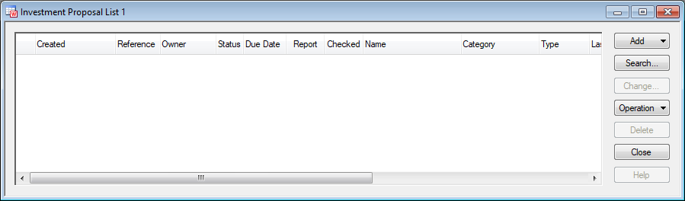

Figure 1: Investment Proposal List

Both investment proposals and the templates can be viewed in this list. The desired objects can be displayed by providing the corresponding search parameters in the Search dialog.

### Search Investment Proposal

Pressing the Search button in the list opens the Search Investment Proposal dialog. The search parameters are organized under the two tabs described below:

#### General Tab

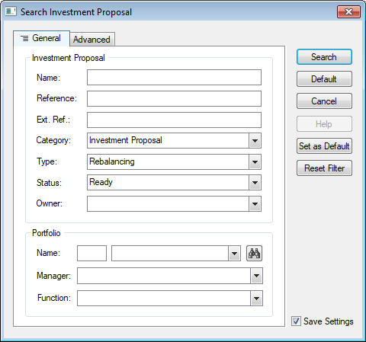

Figure 2: Search Investment Proposal - General Tab

Investment Proposal

This area contains several search parameters corresponding to the general investment proposal properties e.g. name, reference, category etc. For detailed descriptions, see section 1.3.1 Investment Proposal Editor.

Portfolio

This area contains a Name field, wherein a portfolio name can be specified to search for all investment proposals belonging to the portfolio. The portfolio can also be selected from a Portfolio Search via the adjacent button ().

The two fields Manager and Function allow for a more precise search for investment proposals belonging to the portfolios managed by a manager in a specific function.

#### Advanced Tab

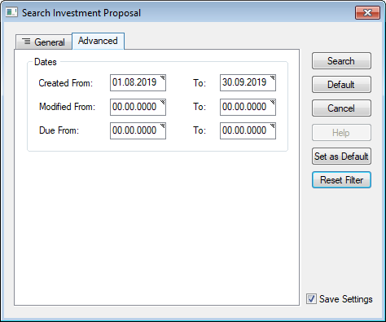

Figure 3: Search Investment Proposal - Advanced Tab

Dates

This area provides the options for searching objects created and / or modified on a certain date or within a range of dates. A search may also be performed using the due dates of proposals (specified in the General tab of the Investment Proposal editor).

Pressing, the Search button in the dialog shows the retrieved objects as per the search criteria:

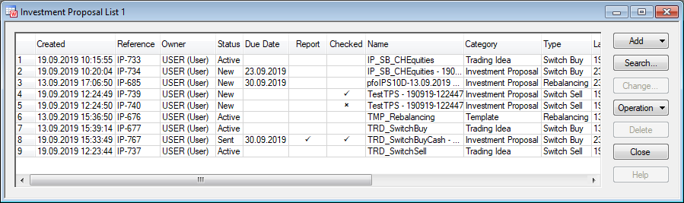

Figure 4: Investment Proposal List

### Other List Operations

For an investment proposal selected in the list, the following commands can be executed via the Operation button:

#### **Promote Investment Proposal**

Opens the Promote dialog to specify a new status for the investment proposal. The Current Status is shown and a New Status can be selected in the dialog:

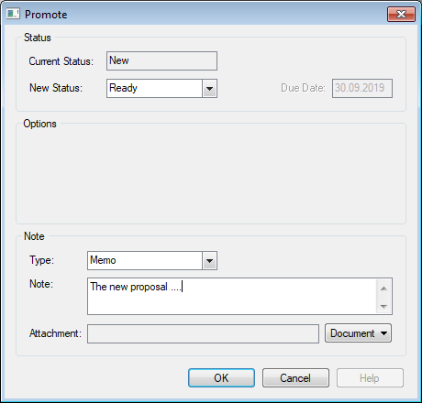

Figure 5: Promote Investment Proposal

Sent proposals can be saved in the Document Library. The Options area in the dialog shows the additional options when promoting to the status ‘Sent’:

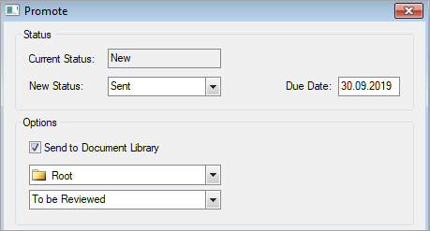

Figure 6: Send to Document Library

Furthermore, when promoting a proposal to the Closed status, a Closing Reason and comment can be entered in the respective options:

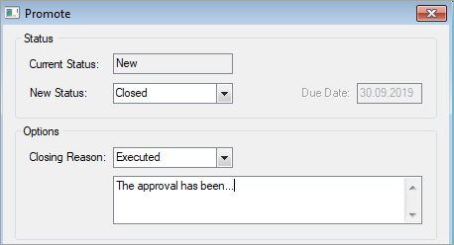

Figure 7: Closing Reason and Comments

The dialog also provides the fields for adding notes to a promote operation.

#### **Generate Investment Proposal Report**

Generates the report. The option may be unavailable if the proposal is not successfully checked yet. See the Report Tab section for details.

#### **View Investment Proposal Report**

Opens the report for viewing. The option may be unavailable if no report is generated yet for the selected proposal.

## Creating Investment Proposals

Investment proposals can be created using the Investment Proposal editor in the application. The editor may be opened in one of the following ways:

* From File menu, using the New│Investment Proposal command.
* From the investment proposal list, by pressing Create Investment Proposal from the Add button sub-menu.
* From the portfolio list, by right-clicking the required portfolio and selecting Order│Create Investment Proposal from the context menu.

Proposals can also be created with pre-defined templates as described in section 1.4.1 Creating an Investment Proposal from Template.

### Investment Proposal Editor

Investment proposal properties are organized under different tabs in the editor. Users may switch between tabs if necessary, however it is recommended for beginners to use the Next and Back buttons available along the right edge of the dialog. When using these buttons, the data entered in a current tab is checked for completion before moving on to the next tab.

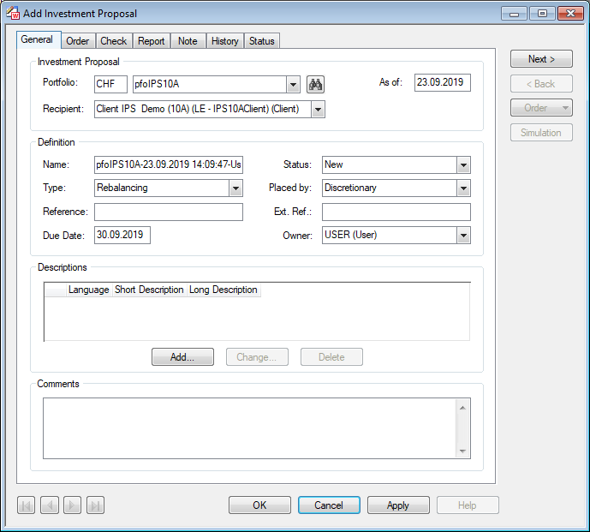

Figure 8: Investment Proposal Editor

#### General Tab

Investment Proposal

* Portfolio: Specifies the portfolio for which the investment proposal is being created.
* As of: Specifies the as of date for which the proposal is being created.
* Recipient: Specifies the recipient (legal entity) for the proposal. Legal entities linked to the selected portfolio are available for selection in the dropdown.

Definition

* **Name:** Specifies the name of the investment proposal. The name is generated automatically using the portfolio name, the current date and time and the active username. Users may change this name, however it must be unique.
* **Status:** Specifies the status for the investment proposal, which can be set to either ‘New’ or ‘Ready’ for a newly created proposal. Once a proposal is created, another status can be given to it using the promote command (see Promote Investment Proposal).
* **Type:** Specifies a type depending on the main purpose guiding the proposal. One of the following can be selected:
* Money Outflow: The proposal provides investment advice that will result in movement of money out of the portfolio. Such advice is generally prepared as a response to client request.
* New Money: The proposal provides investment advice that will result in movement of money in to the portfolio (i.e. more money added to the portfolio). Such advice is generally prepared as a response to client request.
* Rebalancing: The proposal advices on realigning the weightage of certain investment(s) by buying or selling investments to achieve a desired level of asset allocation or risk.
* Placed by: The value selected in this field is specified as the ‘Placed By’ property of orders generated via the proposal.
* Reference / Ext. Ref: Users may provide an internal and external reference to the proposal.
* Due Date: Specifies the date of next required action (e.g. a reminder to contact the client). This date can be used to track orders with approaching deadlines.
* Owner: Specifies the username of the proposal owner. By default, it is the current user.

Descriptions

Descriptions can be added to the proposal in several languages.

Comments

Any textual remarks regarding the proposal may be entered in this field.

#### Order Tab

The intended investment advice is defined as simulated orders in the Order tab of the editor:

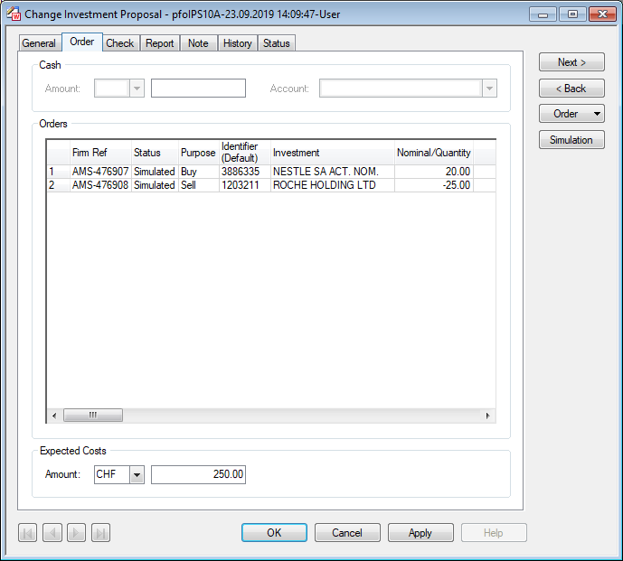

Figure 9: Investment Proposal Editor - Order Tab (for Rebalancing)

Note: The Order tab may slightly vary depending on the type of the proposal. As cash is not relevant for a rebalancing proposal. The field is therefore inactive in the image above. It is described later within this section.

Orders

Orders can be added by opening an order editor from the Order button in the dialog. Orders already defined are listed in the tab. Pressing the Simulation button opens the portfolio in the Analysis Tree with a simulation of the orders just added. The following image shows the orders from the Order tab in the tree:

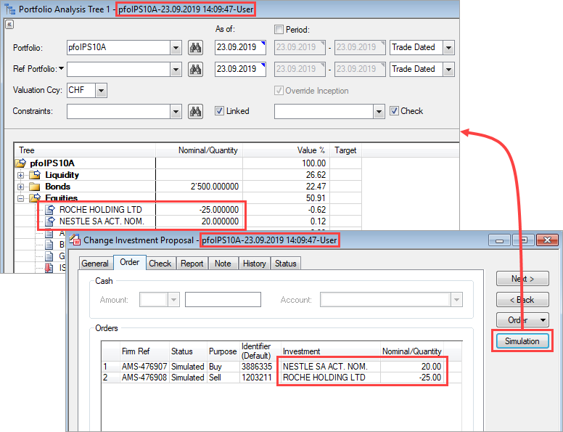

Figure 10: Simulated Orders in Analysis Tree

It is important to note that while the Analysis Tree is open for simulation, operations in the Investment Proposal editor become inactive.

Expected Costs

The expected cost of the proposed investments if executed can be entered here. This can be an important information for the recipient of the proposal and is also shown on the report.

Cash

The Order tab may slightly vary depending on the type of the proposal. Following is a snapshot of the Order tab for the ‘New Money’ proposal type, where the incoming amount of the cash must be specified. Similarly, the Cash settings are also relevant for ‘Money Outflow’.

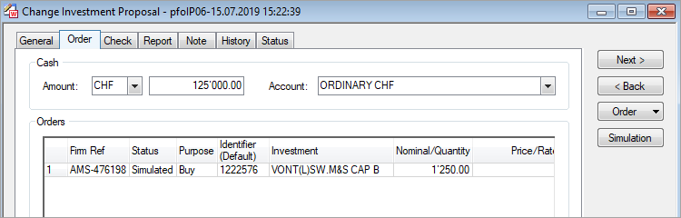

Figure 11: Investment Proposal Editor - Order Tab (for New Money)

* Amount: Specifies the amount of cash that will be added (as New Money) or removed (as Money Outflow) from the portfolio.
* Account: Specifies the account to which this amount belongs.

#### Check Tab

The Check tab allows performing a validation check on the proposed orders as per the applicable order validation rules and the constraints linked to the portfolio. Pressing the Check button initiates the check.

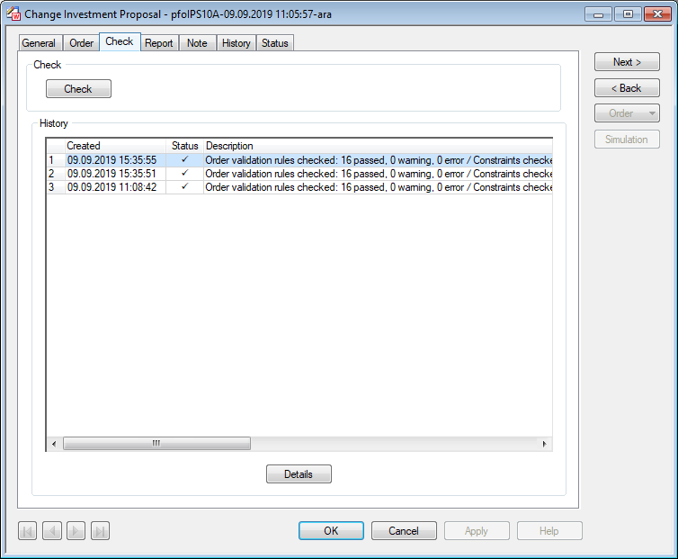

Figure 12: Investment Proposal Editor - Check Tab

A history of the executed checks is also shown in the tab.

If an error is encountered in the linked constraints, the Constraint Monitor is displayed with the details. The error(s) must be rectified, or accepted with reasoning, before a report could be generated. The following image shows the Confirmation dialog for entering comments and skipping an error:

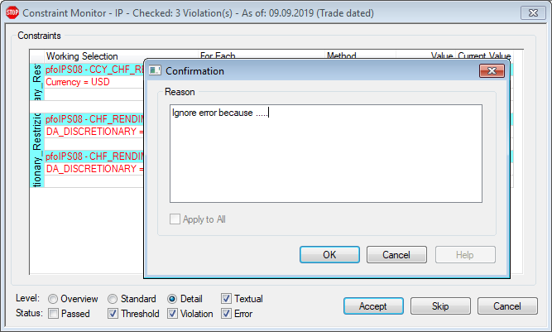

Figure 13: Constraint Monitor Displays When Error(s) Encountered

If an error is encountered in order validation, it must be corrected. Validation errors cannot be skipped!

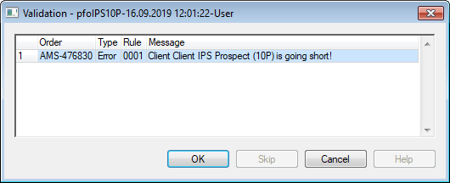

Figure 14: Order Validation Error

#### Report Tab

Once the check is successful, the investment proposal report can be generated in the Report Tab. Multiple report definitions are available to suit different preferences:

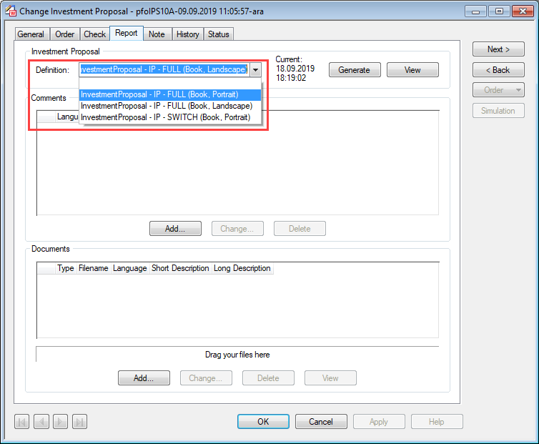

Figure 15: Investment Proposal Editor - Report Tab

Investment Proposal

* Definition: Specifies the report definition to use for report generation.
* Generate: Starts the report generation.
* View: Available, when a report has been generated in the current session. Opens the report for viewing. Reports generated previously can be viewed from the History tab.

Comments and Documents added in the respective areas may also be included in the report (depending on the report definition).

#### Note Tab

Any notes or activities relevant to the proposal (client responses and other communication) can be recorded in the Note tab:

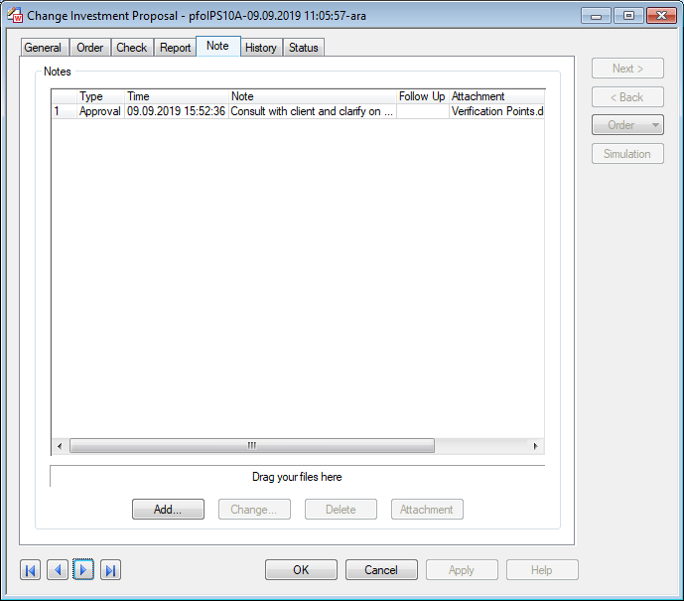

Figure 16: Investment Proposal Editor - Note Tab

Pressing Add opens the Add Note dialog to enter the information:

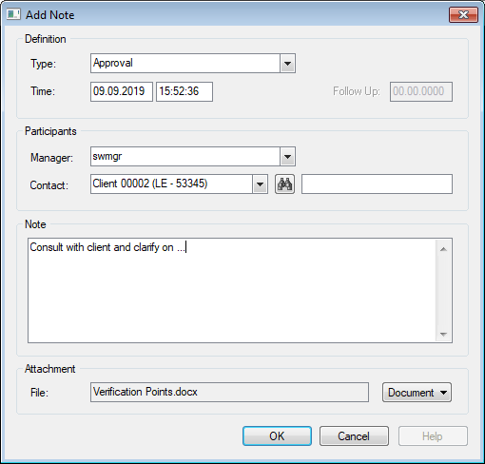

Figure 17: Adding Notes

#### History Tab

The History tab shows the changes made to the Investment Proposal.

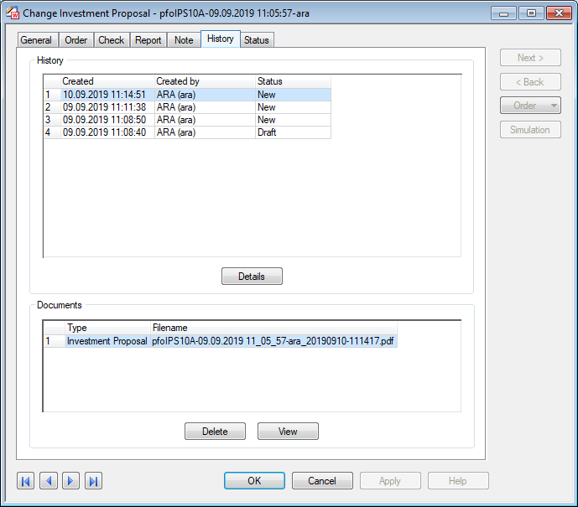

Figure 18: Investment Proposal Editor - History Tab

Further details on a history item can be viewed by pressing the Details button.

Investment Proposal reports generated in the past are available in the Documents area of the tab. These can be viewed using the View button.

#### Status Tab

Shows the audit and identification information.

Pressing OK saves the proposal.

Note: If a check is initiated (in the Check tab) or a report is generated (in the Report tab) without saving the investment proposal, an automatic save will be applied.

## Creating Investment Proposal Templates

Investment Proposals may also be created with certain fields predefined in an Investment Proposal Template. Pressing the Add│Template option in the investment proposal list opens the editor to create a template.

#### General Tab

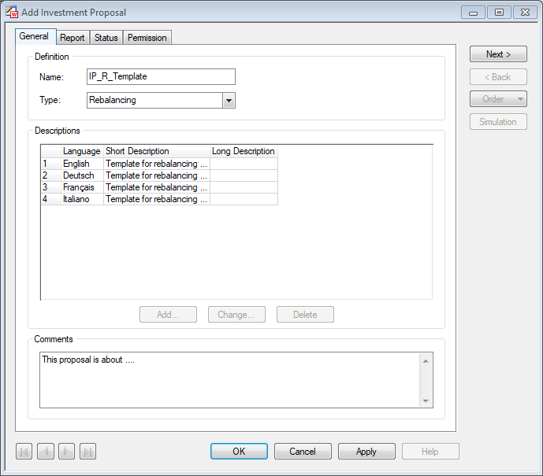

Figure 19: Investment Proposal Template - General Tab

#### Report Tab

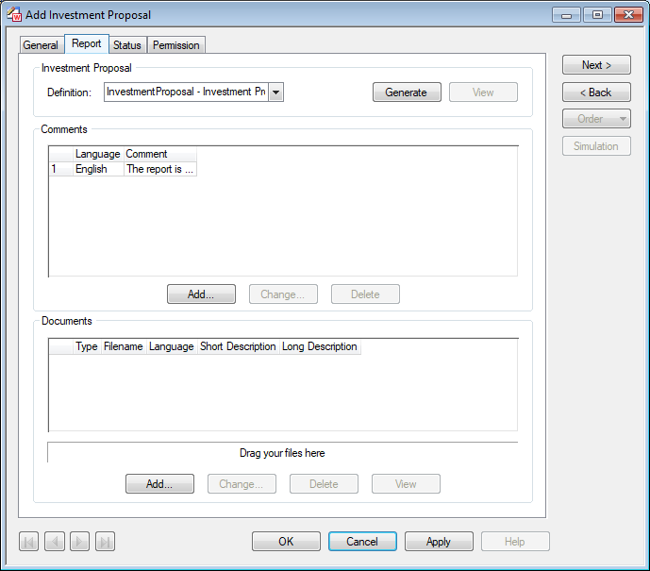

Figure 20: Investment Proposal Template - Report Tab

#### Permission Tab

Permission settings to control access to the template.

### Creating an Investment Proposal from Template

To create an investment proposal from a predefined template, first, the template is selected in the investment proposal list, and then Add│Investment Proposal from Template option is pressed. Alternatively, on right-clicking the template in the list, the context-menu also shows this option in the Add.

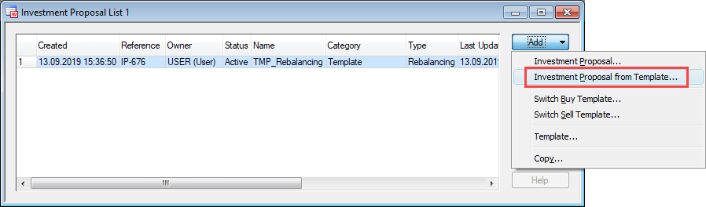

Figure 21: Creating an Investment Proposal from Template

For creating a proposal from the portfolio list, the context-menu shows the Order│Create Investment Proposal sub-menu that lists the templates available to the current user for selection.

## Creating a Trading Idea

Portfolio managers may foresee a certain investment performing well and would want to include it in their portfolios. A consideration may be replacing an existing investment (or cash) in their portfolios with the new better performing investment. Such a recommendation of acquiring new investments can be defined using the Switch Buy Template.

On the contrary, to propose selling of a possibly less beneficial investment in a portfolio the Switch Sell Template can be used. The proposal involves a recommendation on utilizing the amount obtained from the sale (i.e. cash or investment).

Separate editors are available to define both templates. These can be opened from the Add button in the investment proposal list by selecting the appropriate option:

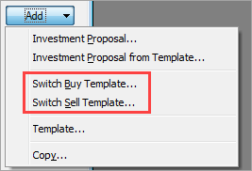

Figure 22: Add Button Options in the Investment Proposal List

The General tab of both editors contains the settings for specifying the template name, descriptions and comments. The template type i.e. Switch Buy or Switch Sell is a read-only field. The Investment tab however varies for the two types owing to the difference in the trading idea, and is explained in the following sections:

### Switch Buy Template

The purpose of a Switch Buy is to buy new investment(s). The proposal also recommends either to use existing cash or investment to make the purchase. The investments are defined respectively in the Old and New areas of the Investment tab:

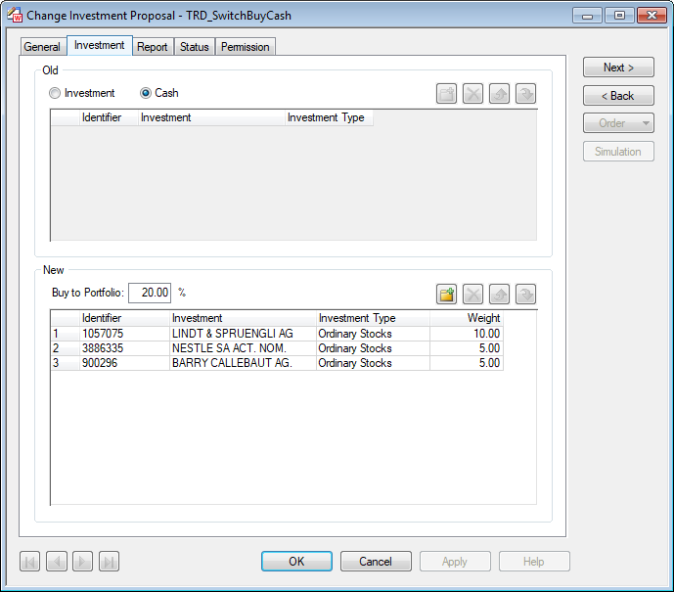

Figure 23: Switch Buy Template - Specifying the Investments

Old

The Investment / Cash option specifies whether to use available cash for buying the new investment(s), or to sell old investment(s) to obtain the cash.

When Investment is selected, pressing  opens the Search Investment dialog to select an investment. More than one investment can also be added.

Note that the old investments are sold depending on the total price of the investments to be bought. For example, if selling only first investment is sufficient for the new buy, the second will not be sold.

It is possible to delete investments () or change the list order ( ).

New

This area defines the new investments to be bought. A desired percentage can be entered in the Buy to Portfolio field. The investments specified underneath will be bought so that they make up this percentage of the entire portfolio.

Pressing  opens the Search Investment dialog to select an investment. More than one investment can also be added. A desired Weight (in percentage) can be specified for each investment. The sum of all weights must equal the Buy to Portfolio percentage.

### Switch Sell Template

A recommendation to sell an investment can be defined via the Switch Sell Template. The proposal also includes information on a possible use of the money obtained from the investment i.e. either to invest in other investments or keep as cash. The investments are defined respectively in the Old and New areas of the Investment tab:

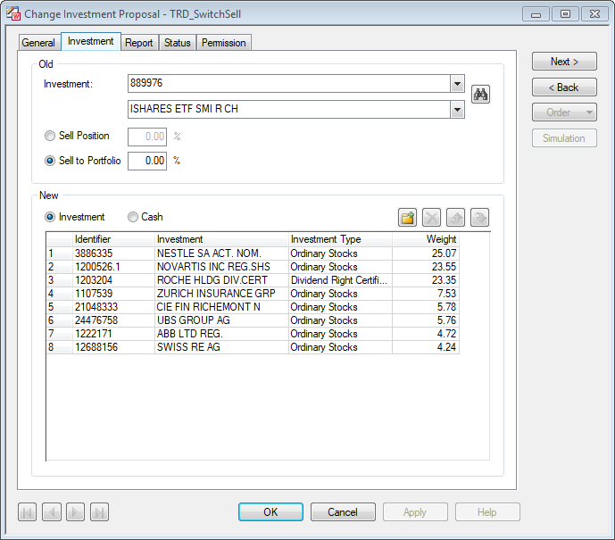

Figure 24: Switch Sell Template - Specifying the Investments

Old

The investment for sale is specified in the Investment field. The  button can be used to select the investment. One of the following percentages can be specified to define the quantity to be sold:

* Sell Position: Sells the defined percentage of total positions of this investment in portfolio.
* Sell to Portfolio: Sells a quantity such that the investment remains at the defined percentage of total portfolio.

New

It can be specified whether to utilize the sale money in other investment(s) or keep cash by selecting Investment or Cash. When Investment is selected, pressing  opens the Search Investment dialog to select an investment to buy. More than one investment can also be added.

It is possible to delete investments () or change the list order ( ).

## Screening Portfolios

Multiple portfolios can be screened for investments defined in the Switch Buy and Switch Sell templates, such that for all portfolios where investments are found and the trading idea is applicable, the corresponding proposals will be created.

The portfolios for screening can be selected in the portfolio list and right-clicked to access the Screen Portfolios option in the context-menu:

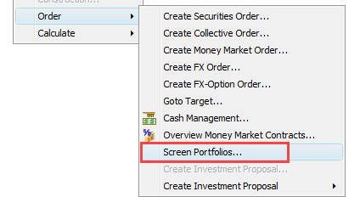

Figure 25: Screen Portfolios (Order Sub-Menu in the Portfolio List Context Menu)

Note: In case of a switch sell template, it is possible to use Inventory Inquiry to retrieve only the portfolios with investment(s) to be sold.

The Create Investment Proposals dialog displays:

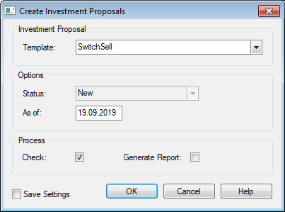

Figure 26: Template selection for screening portfolios (with only Check selected)

Following fields can be specified:

Investment Proposal

* Template: Specifies the Switch Buy or Switch Sell template to use for screening.

Options

* Status: Specifies the status for proposals to be generated. Read-only field set to ‘New’.
* As of: Specifies the as-of date for proposals to be generated.

Process

* Check: When marked, the validation rules and the linked portfolio constraints will be checked.
* Generate Report: When marked, the investment proposal reports will be generated (provided the check is successful.

Pressing OK begins the process. Upon screening, portfolios are checked for the investments defined in the selected template. An investment proposal is created for each portfolio that contains these investments. The investment proposal(s) are shown in a new investment proposal list:

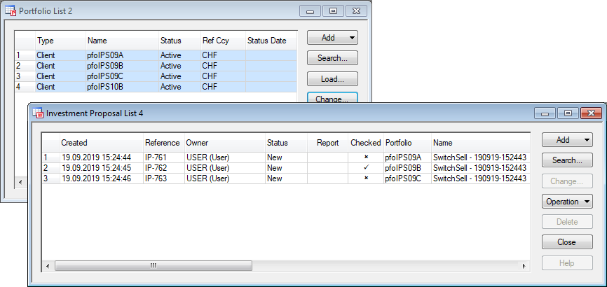

Figure 27: Investment proposal list generated by portfolio screening

In the above figure, investment proposals were created for three portfolios out of the four selected for screening in the portfolio list. The investment proposals, thus generated, can be opened in the editor for detailed viewing. The Order tab will show the orders generated:

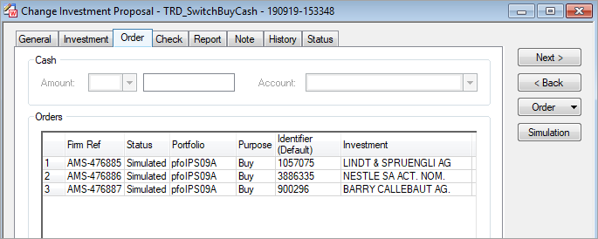

Figure 28: Orders Generated by Screening (Order Tab)

Further operations (e.g. report generation) can be performed on the proposal via the editor.

Note that proposals may not be generated in certain cases. E.g. if investments in the template do not match any investment in the selected portfolio(s):

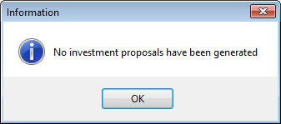

Figure 29: Information Box for No Proposal Generated

## User Rights and Permissions

Following are the rights available for investment proposal templates:

|  |  |
| --- | --- |
| Rights | Description |
| Read Template | Authorisation to read investment proposal templates |
| Modify Template | Authorisation to create, update and delete investment proposal templates |

Following are the rights available for investment proposals:

|  |  |
| --- | --- |
| Rights | Description |
| Read (New) | Authorisation to read IP in status New |
| Read (Ready) | Authorisation to read IP in status Ready |
| Read (Sent) | Authorisation to read IP in status Sent |
| Read (Reworking) | Authorisation to read IP in status Reworking |
| Read (Active) | Authorisation to read IP in status Active |
| Read (Closed) | Authorisation to read IP in status Closed |
| Modify (New) | Authorisation to create, update and delete IP in status New |
| Update (Reworking) | Authorisation to update IP in status Reworking |
| Modify Notes (New) | Authorisation to create, update, delete notes on IP in status New |
| Modify Notes (Ready) | Authorisation to create, update, delete notes on IP in status Ready |
| Modify Notes (Sent) | Authorisation to create, update, delete notes on IP in status Sent |
| Modify Notes (Reworking) | Authorisation to create, update, delete notes on IP in status Reworking |
| Modify Notes (Active) | Authorisation to create, update, delete notes on IP in status Active |
| Modify Notes (Closed) | Authorisation to create, update, delete notes on IP in status Closed |
| Delete (Closed) | Authorisation to delete IP in status Closed |

Following are the rights for managing investment proposal statuses:

|  |  |
| --- | --- |
| Rights | Description |
| Status: New To Ready | Authorisation to promote IP from status New to Ready |
| Status: Ready To New | Authorisation to promote IP from status Ready to New |
| Status: Ready To Sent | Authorisation to promote IP from status Ready to Sent |
| Status: Sent To Active | Authorisation to promote IP from status Sent to Active |
| Status: Active To Sent | Authorisation to promote IP from status Active to Sent |
| Status: Sent To Reworking | Authorisation to promote IP from status Sent to Reworking |
| Status: Reworking To Ready | Authorisation to promote IP from status Reworking to Ready |
| Status: Ready To Reworking | Authorisation to promote IP from status Ready to Reworking |
| Status: New To Closed | Authorisation to promote IP from status New to Closed |
| Status: Ready To Closed | Authorisation to promote IP from status Ready to Closed |
| Status: Sent To Closed | Authorisation to promote IP from status Sent to Closed |
| Status: Reworking To Closed | Authorisation to promote IP from status Reworking to Closed |
| Status: Active To Closed | Authorisation to promote IP from status Active to Closed |
| Status: Closed To Active | Authorisation to promote IP from status Closed to Active |
| Status: Closed To New | Authorisation to promote IP from status Closed to New |
| Status: Closed To Reworking | Authorisation to promote IP from status Closed to Reworking |
| Status: Closed To Closed | Authorisation to promote IP from status Closed to Closed |