*************************************************************************************

* Electronic Realization L.L.C. *

* Design: Battery charger 4 Li coin cells 24.5mm, maximum 800 mA charge current *

* Engineer: Cy Drollinger *

* Date: 5/18 *

* Email: cy@elec-real.com *

* Address: 2023 Stadium Dr Suite 2B #210 Bozeman, MT 59715 *

* Phone: 406-539-8117 *

*************************************************************************************

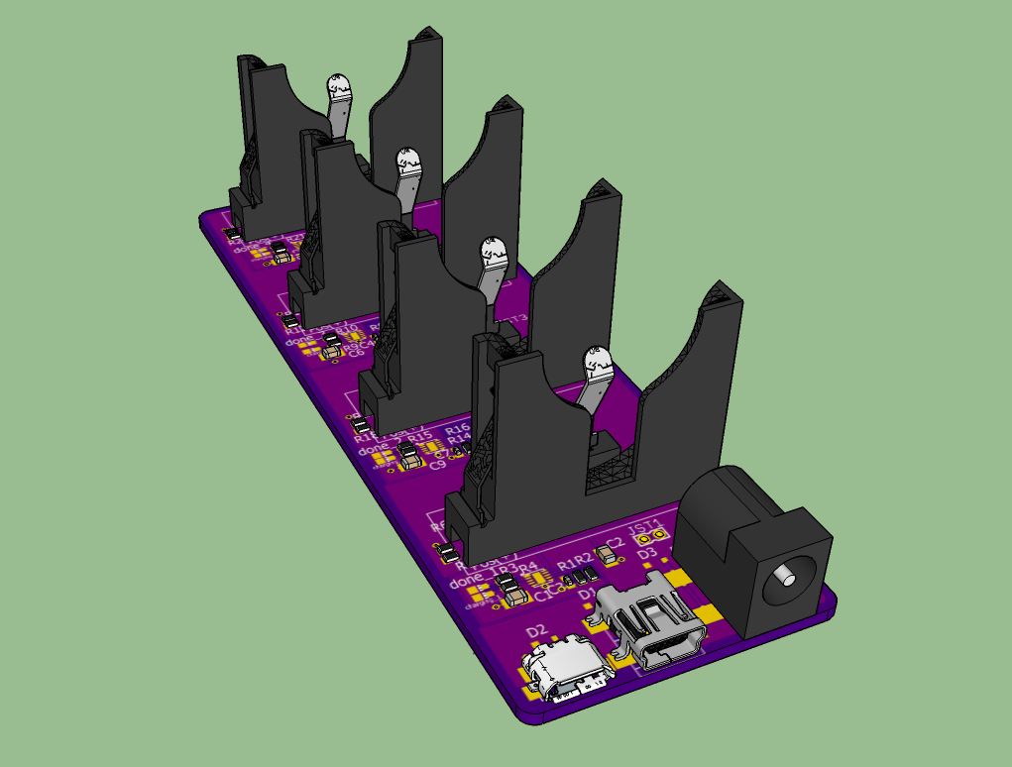

*******NOTE*************************************************************************

* This design is not perfect but is provdided gratis. Please think critically while using or redesigning * * for your success. Conversation is welcome, but be advised monetary compensation is required for * * work toward this design for your success. *

*************************************************************************************

*******************************************

*File Arcitecture with a terse description *

*******************************************

FOLDERS:

docs : datasheets charging IC and battery holder

hardware : eagle cadsoft(v7.7) hardware design files

eagleup : 3D files

library : eagle part files

manufacturing : files required to produce the desing

bom : files created to order the parts

batteryCharger.txt :

batteryv1.1.csv : digikey order

hundredUnits.txt

gerber : files generated to manufacture the board

: https://oshpark.com/shared_projects/4os8OxLZ

Readme.txt : this file