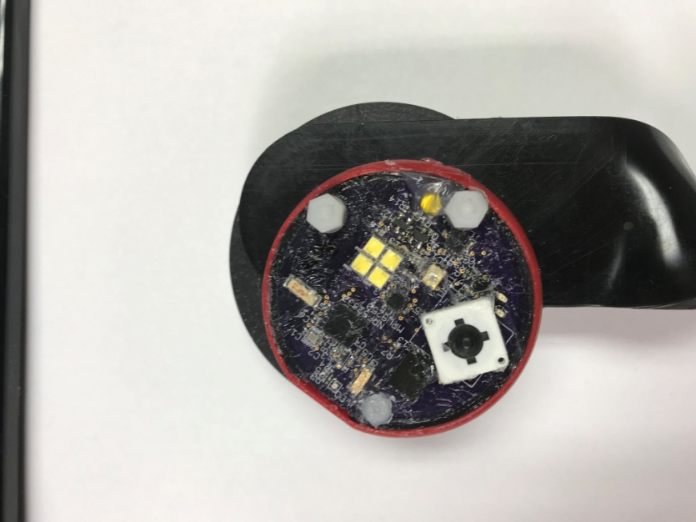

Power on/off

Press firm the little yellow button above the bottom attaching nut you should feel and here a click.

An LED will lit near the micro USB port and blink blue

HighBeamz

Once powered bush the big black button with the white housing, press again to turn off HighBeamz.