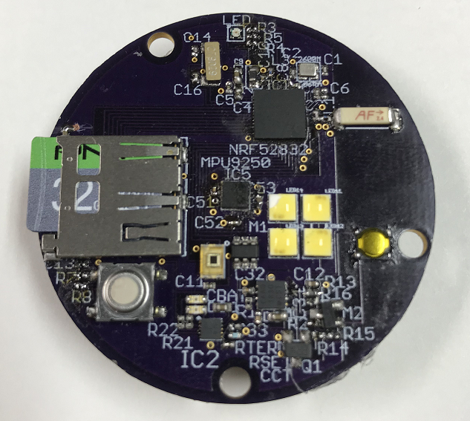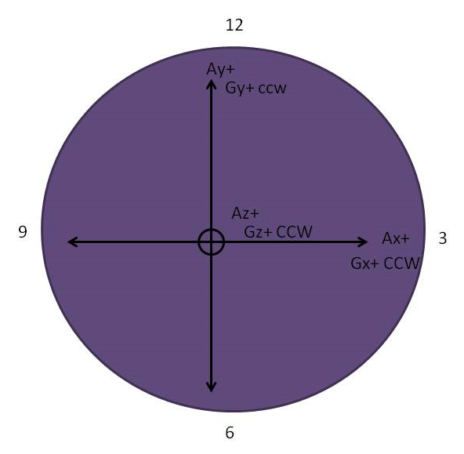

1. LED at the top of the board (12 o’clock), solid green LED powered on, solid blue LED recording, LED off the device is either asleep or it is powered off.
   1. The device can go from asleep to recording with the touch of the button, located under the micro SD card, (9 o’clock).
2. Power button is the flat yellow button to the right edge of the board, (approximately 3 o’clock)
   1. Hard press with a slight audible and tactile click, will lit the LED solid green.
   2. The device will create/open a file, NORDIC.TXT, on the micro SD card and write the text: SD CARD EXAMPLE. The phrase will indicate how many power cycles the device has undergone before reading the data off the micro SD card.
   3. The device either creates or appends a file, if the device has been power cycled an existing file will be appended. So if DATA0.CSV already exists data will be appended at the end of the file and therefore DATA0.csv could be several data sets with different events and meaning.
3. Recording data sets on the device requires the device to be powered on and the button under the micro SD card (3 o’clock) pressed solid blue LED indication. Sample rate is 1 kHz.