Date: 2/19/14

TEMPERATURE SENSOR WIRELESS NETWORK: FOUR NODES

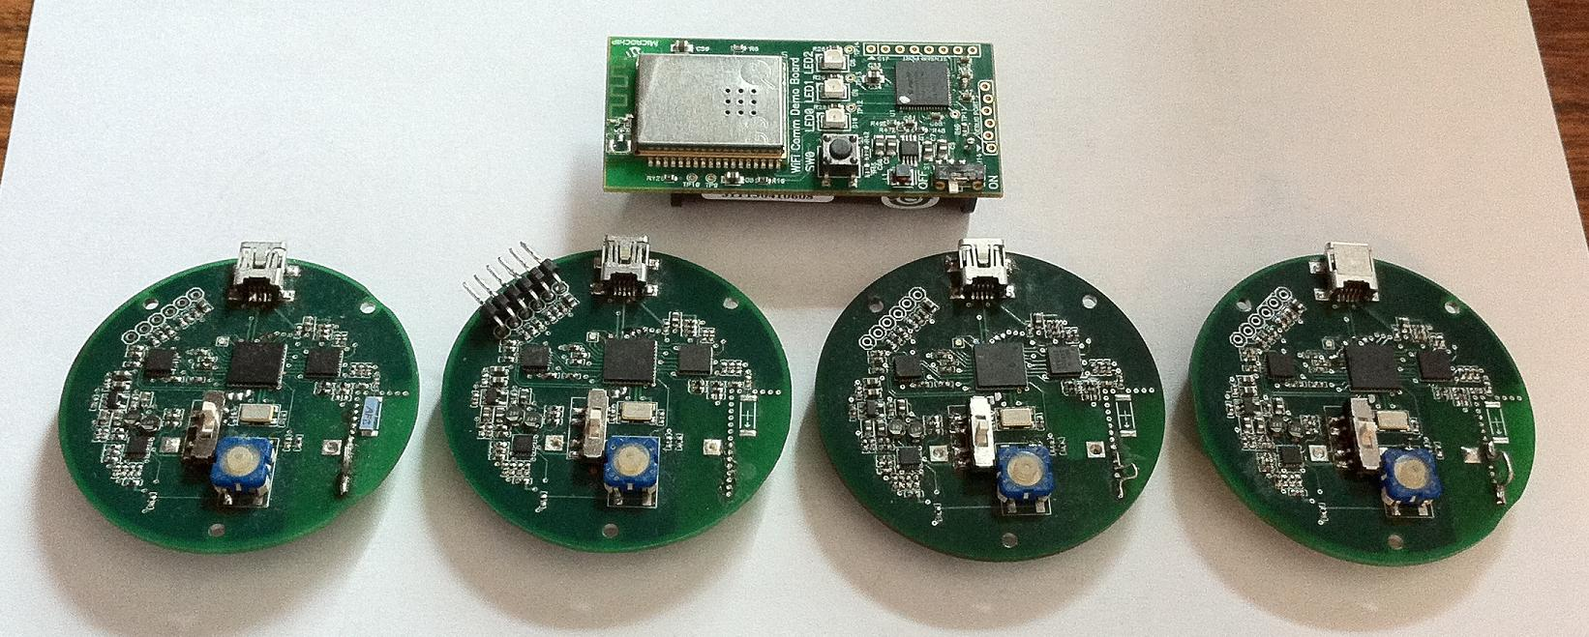

Nodes – Ant+ Slave ($50?)

Freezer/Cooler monitoring (designed, built, must be programmed)

Microchip 16 bit processor

Microchip Temperature sensor(design and build)

Nordic nRF24AP2 Ant + wireless communication

Note: nodes must reside within a WiFi network

Communication Hub – Ant+ Master(one maybe two – depends on the environment)

Microchip WiFi Comm Demo board(off the shelf, must be programmed) $50

WiFi built in (MRF24WB0MA)

Daughter Board(designed, must be built, must be programmed)($?)

Nordic nRF24AP2 Ant+ communication

Sensor port of the Demo Board

Reset

+3.3V

GND

Ant+ TX

Ant+ RX

Ant+ Sleep

Ant+ Suspend

Ant+ request to send