Stress Test 2019 - Model ST_19001

Brian Perdomo

June 07, 2019

Table of Contents

# Executive Summary

Operational Risk Expenses was aggregated quarterly at the portfolio level. A predictive model was developed integrating CHIMPS macroeconomic variables as predictors. Model characteristics and performance diagnostics were reviewed, and forecasts were made for each of the Federal Reserve provided scenarios.

# Model Name: Operational Risk Expenses

|  |  |
| --- | --- |
| Model Id: | ST_19001 |
| Model Use: | Stress Testing (regulatory), Capital Planning |
| Model Owner: | Finance |
| Owner POC: | Kevin Brown ([kevinbrown@synovus.com](mailto:kevinbrown@synovus.com)) |
| Category: | Corporate Finance |
| Model Type: | Portfolio Level (Quarterly) |
| Purpose: | The purpose of this project is to forecast quarterly values for Operational Risk Expenses for each CHIMPS economic scenario. |
| Development Date: | 06/07/2019 |

## Purpose and Relevance

*Purpose (CS1.1), Deployment intention (CS1.2), Internal data relevance (CS2.1)*

This model was developed with the purpose of forecasting Operational Risk Expenses for this segment for each of the three macroeconomic scenarios. Model forecasts are intended to assist Strategic Finance in anticipating changes in losses resulting from economic fluctuations in support of Stress Testing and Capital Planning efforts.

## Modeling Approach

### Design, Theory, and Methods

*Design and theory(CS1.3), Methodology (CS1.4)*

Series data was available in quarterly periods at the portfolio level, resulting in a time-series approach to model development. All domestic macroeconomic variables provided in the 2019 CHIMPS scenario set were considered for inclusion in the development of this model.

## Model Development Process

Model Development Group (MDG) followed internal standards of time-series modeling in the development of this model. Series and macroeconomic data were evaluated as time-series with lags and differencing used in model structures. Special emphasis was placed upon model stationarity and time-based structure in model residuals during all points of evaluation. Final models were evaluated for retention while considering model diagnostics, in-time and out-of-time forecast performance, and quality of scenario forecasts.

### Out-of-Time/Out-of-Sample Testing (Holdout Procedures)

*Out-of-sample testing (CS3.2), Out-of-time testing (CS3.3), (CS3.7), Backtesting used as form of outcomes analysis (OA2.Q2), Documentation of backtesting (OA2.2), Backtesting encompasses intended use (OA2.3), Backtesting conducted over varying periods and conditions (OA2.4), Development of confidence intervals around model forecasts (OA2.5), Backtesting results interpreted (OA2.6), Accounting for results following outside acceptable thresholds (OA2.7)*

In order to evaluate all developed models with regards to in-time and out-of-time forecast accuracy, a group of holdout data was withheld from the data used to train the model. The last four observations were withheld constituting the holdout data. The model was trained on all available observations up until the holdout period. The model was then used to generate in-time forecasts for all observations in the initial training set and out-of-time forecasts for all periods in the holdout data set. Each model was developed using this approach to allow the comparison of in-time and out-of-time forecast performance across candidate models.

### Scenario Forecasting

CHIMPS modeling requires that three scenarios be used to generate separate forecasts for each developed model. Each economic scenario includes quarterly macroeconomic variable values to be used in forecast generation. Each scenario begins using forecasted macroeconomic values as of 2019 Q1 which continue through 2021 Q4 resulting in a 12 quarter forecast window.

A base scenario is provided that represents continued gradual economic recovery.

An adverse scenario is provided that represents mild economic slowing.

A severely adverse scenario is provided that represents the rapid onset of a severely recessed economic environment.

# Dependent Value Processing

*Internal data quality(CS2.2), Assessment of internal data (OM2.1), Assessment of internal data and information quality (OM2.2)*

All values represent series rates for quarters from 1950 Q1 through 2023 Q4 for a total of 296 observations.

The data was delivered to MDG via flat file. The DV data was then formatted and made ready to join with CHIMPS macroeconomic variables.

## Assumptions

*Qualitative assumptions (OM5.3), List of assumptions (OM5.Q2), Evidence supporting assumptions (OM5.4)*

There were no model-specific qualitative assumptions.

### Testing, Use, and Considerations

*Testing encompasses model intended use (OM6.8), Consideration of model issues (OM6.9)*

The testing was performed on the product segments that are defined within the scope of the model group.

### Impact on Other Models

*Impact on other (endogenous) models relying on results (OM6.10)*

The portfolio level models do not impact any other model group.The relationship is quantitative for adverse scenarios and more qualitative for the Base scenario since the Base scenario incorporates projection methods consistent with budgeting and capital planning processes rather than a single model or calculation.

### Supervisory Concerns/Guidance

*Supervisory concerns/guidance (CS1.8)*

There are no supervisory concerns or guidance specifically related to this model.

### Data Adjustments

*Internal data adjustments, recoding, outlier removal, etc. (CS2.3), Internal data proxies (CS2.4)*

No proxies were associated or used with modeled series values. There were no adjustments made to this series.

## Series Structure and Stationarity

Visual inspection of the series suggested non-stationarity.

Figure 1: Univariate DV Evaluation

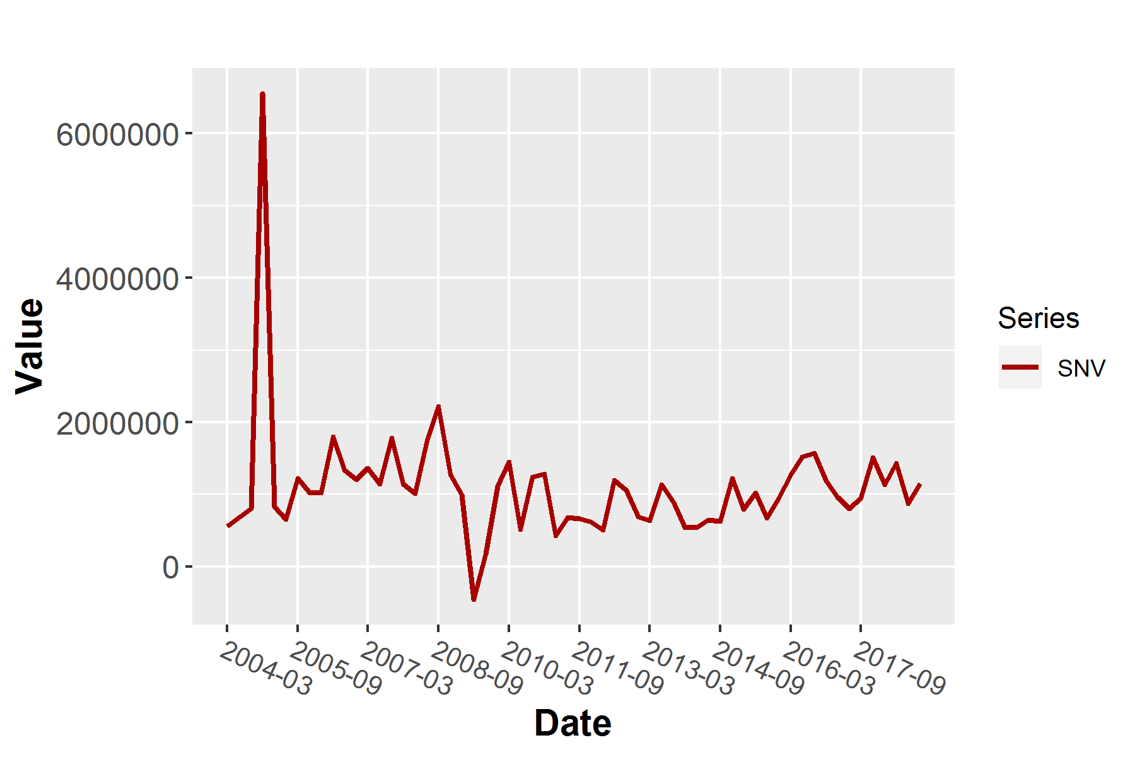

Augmented Dickey-Fuller (ADF) tests were conducted on the undifferenced series. ADF tests indicated nonstationarity.

Table 1: Univariate DV Evaluation - Augmented Dickey-Fuller Test

| Type | Lags | Tau | p |
| --- | --- | --- | --- |
| Zero Mean | 0.000 | -3.467 | 0.001 |
|  | 1.000 | -2.225 | 0.030 |
|  | 2.000 | -1.544 | 0.128 |
| Single Mean | 0.000 | -7.246 | 0.000 |
|  | 1.000 | -5.647 | 0.000 |
|  | 2.000 | -4.631 | 0.000 |
| Trend | 0.000 | -7.456 | 0.000 |
|  | 1.000 | -6.007 | 0.000 |
|  | 2.000 | -5.168 | 0.000 |

Autocorrelation function (ACF) and partial autocorrelation function (PACF) plots were generated. ACF plots of the undifferenced series suggest nonstationarity with one or more autoregressive terms through the presence of multiple significant values starting at lag one with a nearly linear decay.

Figure 2: Univariate DV Evaluation - ACF and PACF

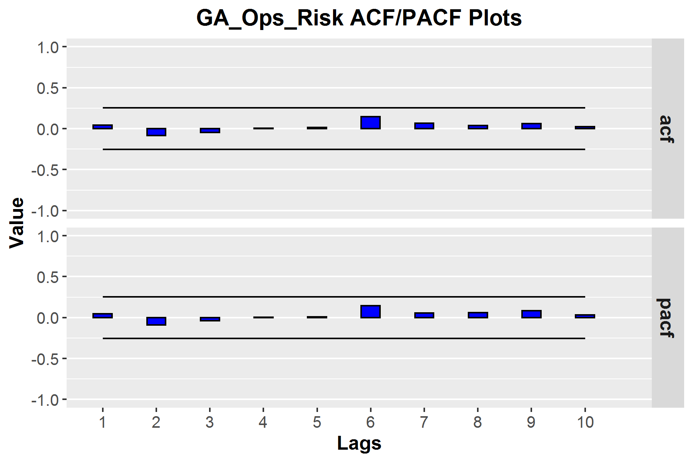

Collectively, diagnostics indicated the need for differencing the series. The series was differenced and evaluated. Visual inspection of the differenced series gave no clear indication of nonstationarity.

Figure 3: Univariate DV Evaluation - Order of Difference = 1

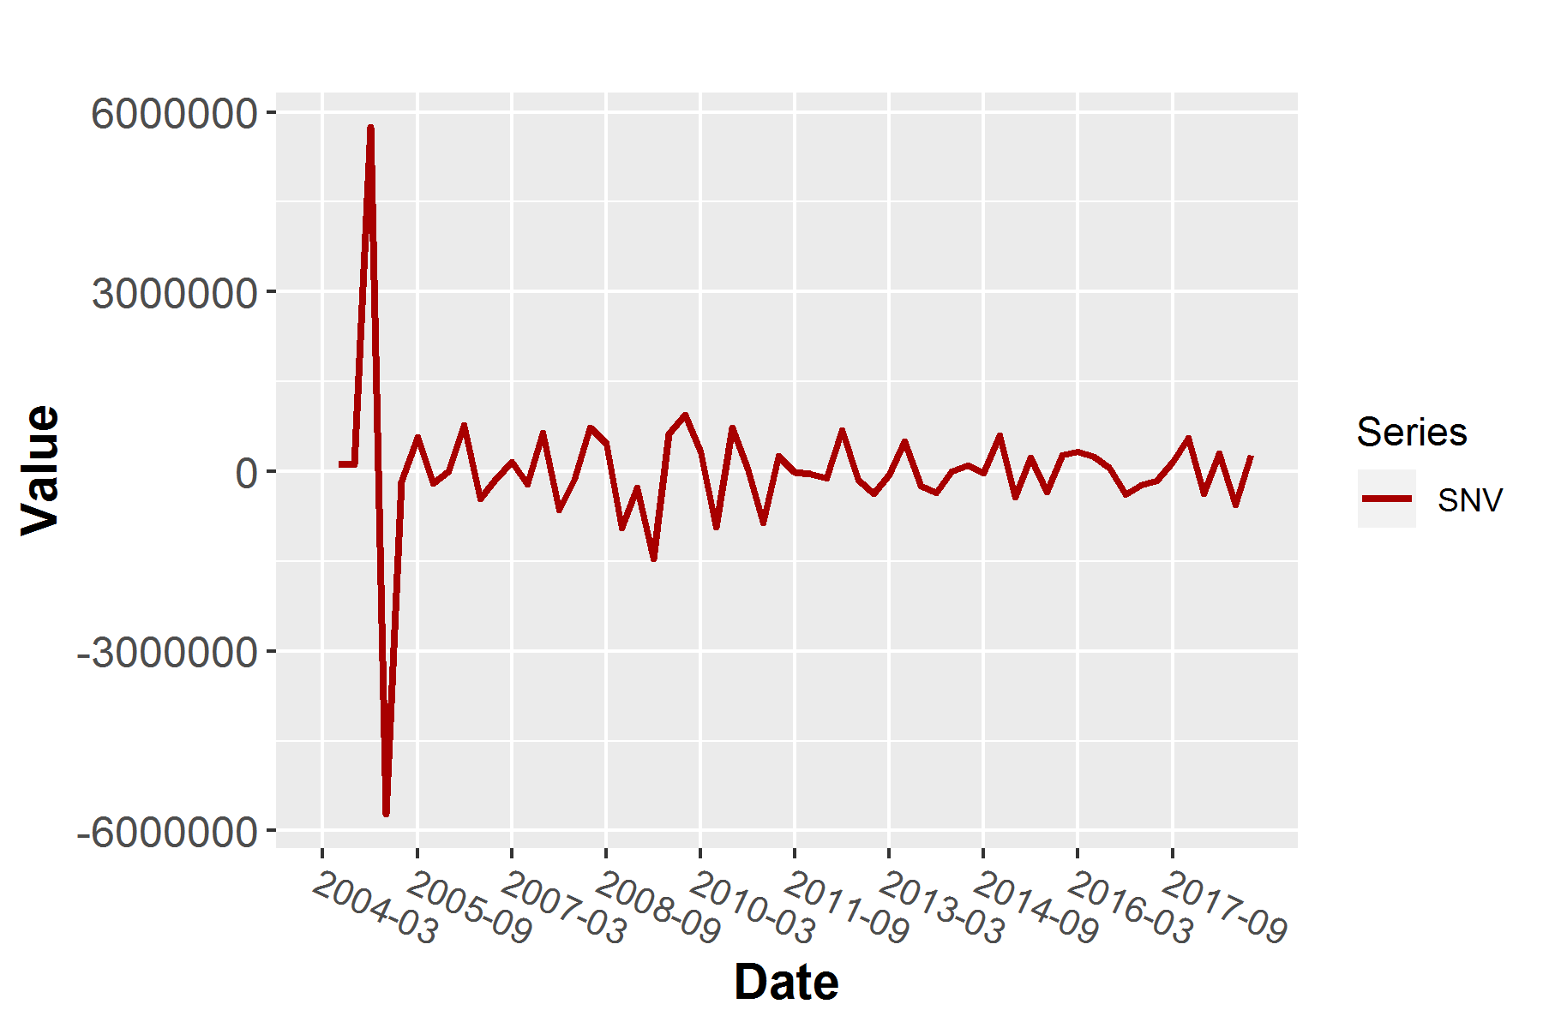

ADF tests were conducted on the differenced series. Most tested values reached significance at the .05 level, and some reached significance at the .01 level.

Table 2: Univariate DV Evaluation - Order of Difference = 1 - Augmented Dickey-Fuller Test

| Type | Lags | Tau | p |
| --- | --- | --- | --- |
| Zero Mean | 0.000 | -11.991 | 0.000 |
|  | 1.000 | -8.924 | 0.000 |
|  | 2.000 | -12.228 | 0.000 |
| Single Mean | 0.000 | -11.886 | 0.000 |
|  | 1.000 | -8.844 | 0.000 |
|  | 2.000 | -12.223 | 0.000 |
| Trend | 0.000 | -11.783 | 0.000 |
|  | 1.000 | -8.765 | 0.000 |
|  | 2.000 | -12.518 | 0.000 |

ACF and PACF plots of the differenced series exhibited no clear indication of nonstationarity.

Figure 4: Univariate DV Evaluation - Order of Difference = 1 - ACF and PACF

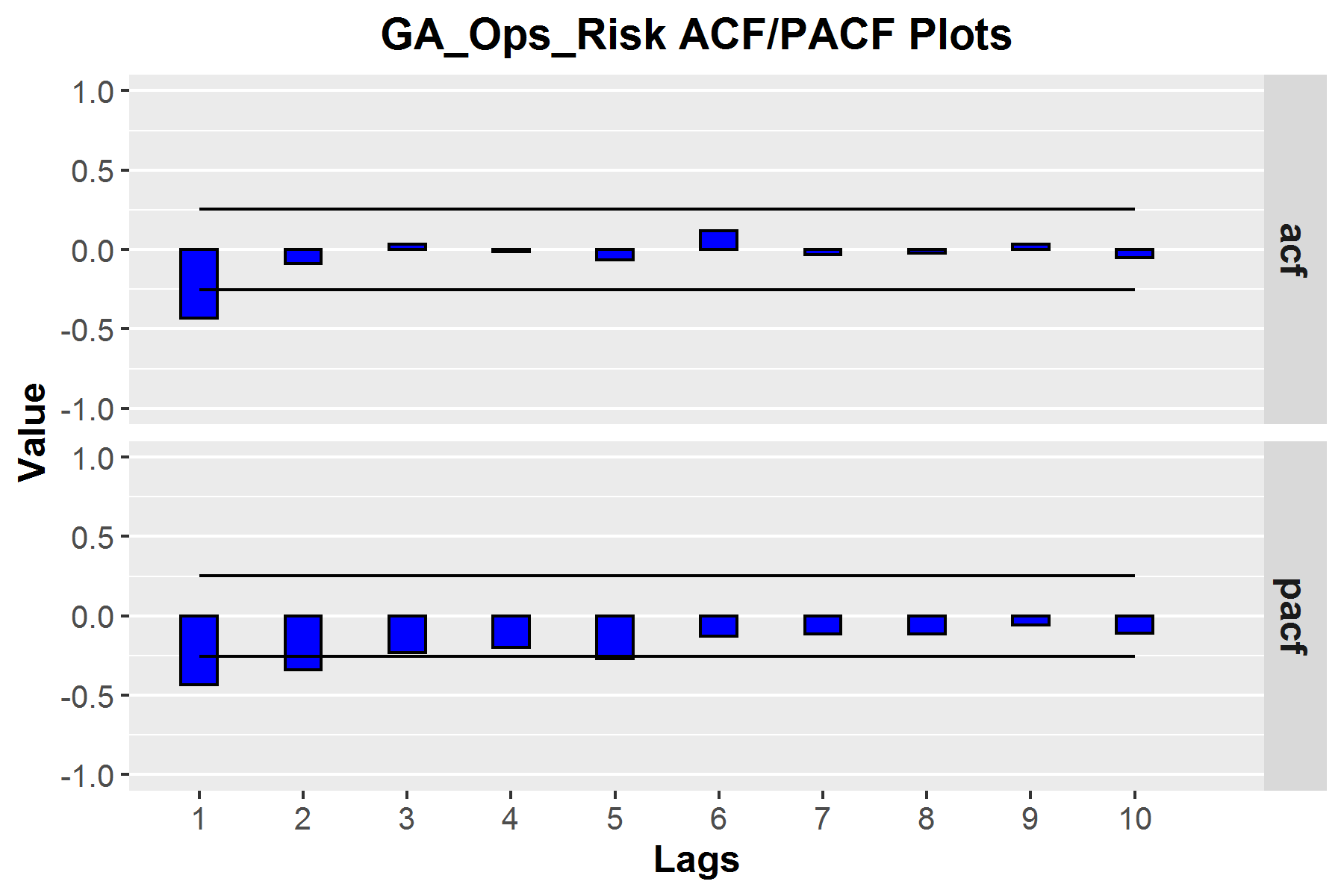

# Covariate Data Processing

## Scenario Data

The scenario data was loaded into the modeling environment using the MDG developed automated function and joined to the dependent variable. All independent variables were included already-differenced as reflected in the documentation CHIMPS Documentation.

# Modeling With Covariates

## Identifying Covariate Candidates

An automated process was used to evaluate all potential macroeconomic variable relationships provided by CHIMPs as described in Ariminator Process Documentation. The seven best covariate candidates identified were the following:

* civpart
* hpi
* imports
* libor_1y
* lumber
* mort_30y
* net_exports

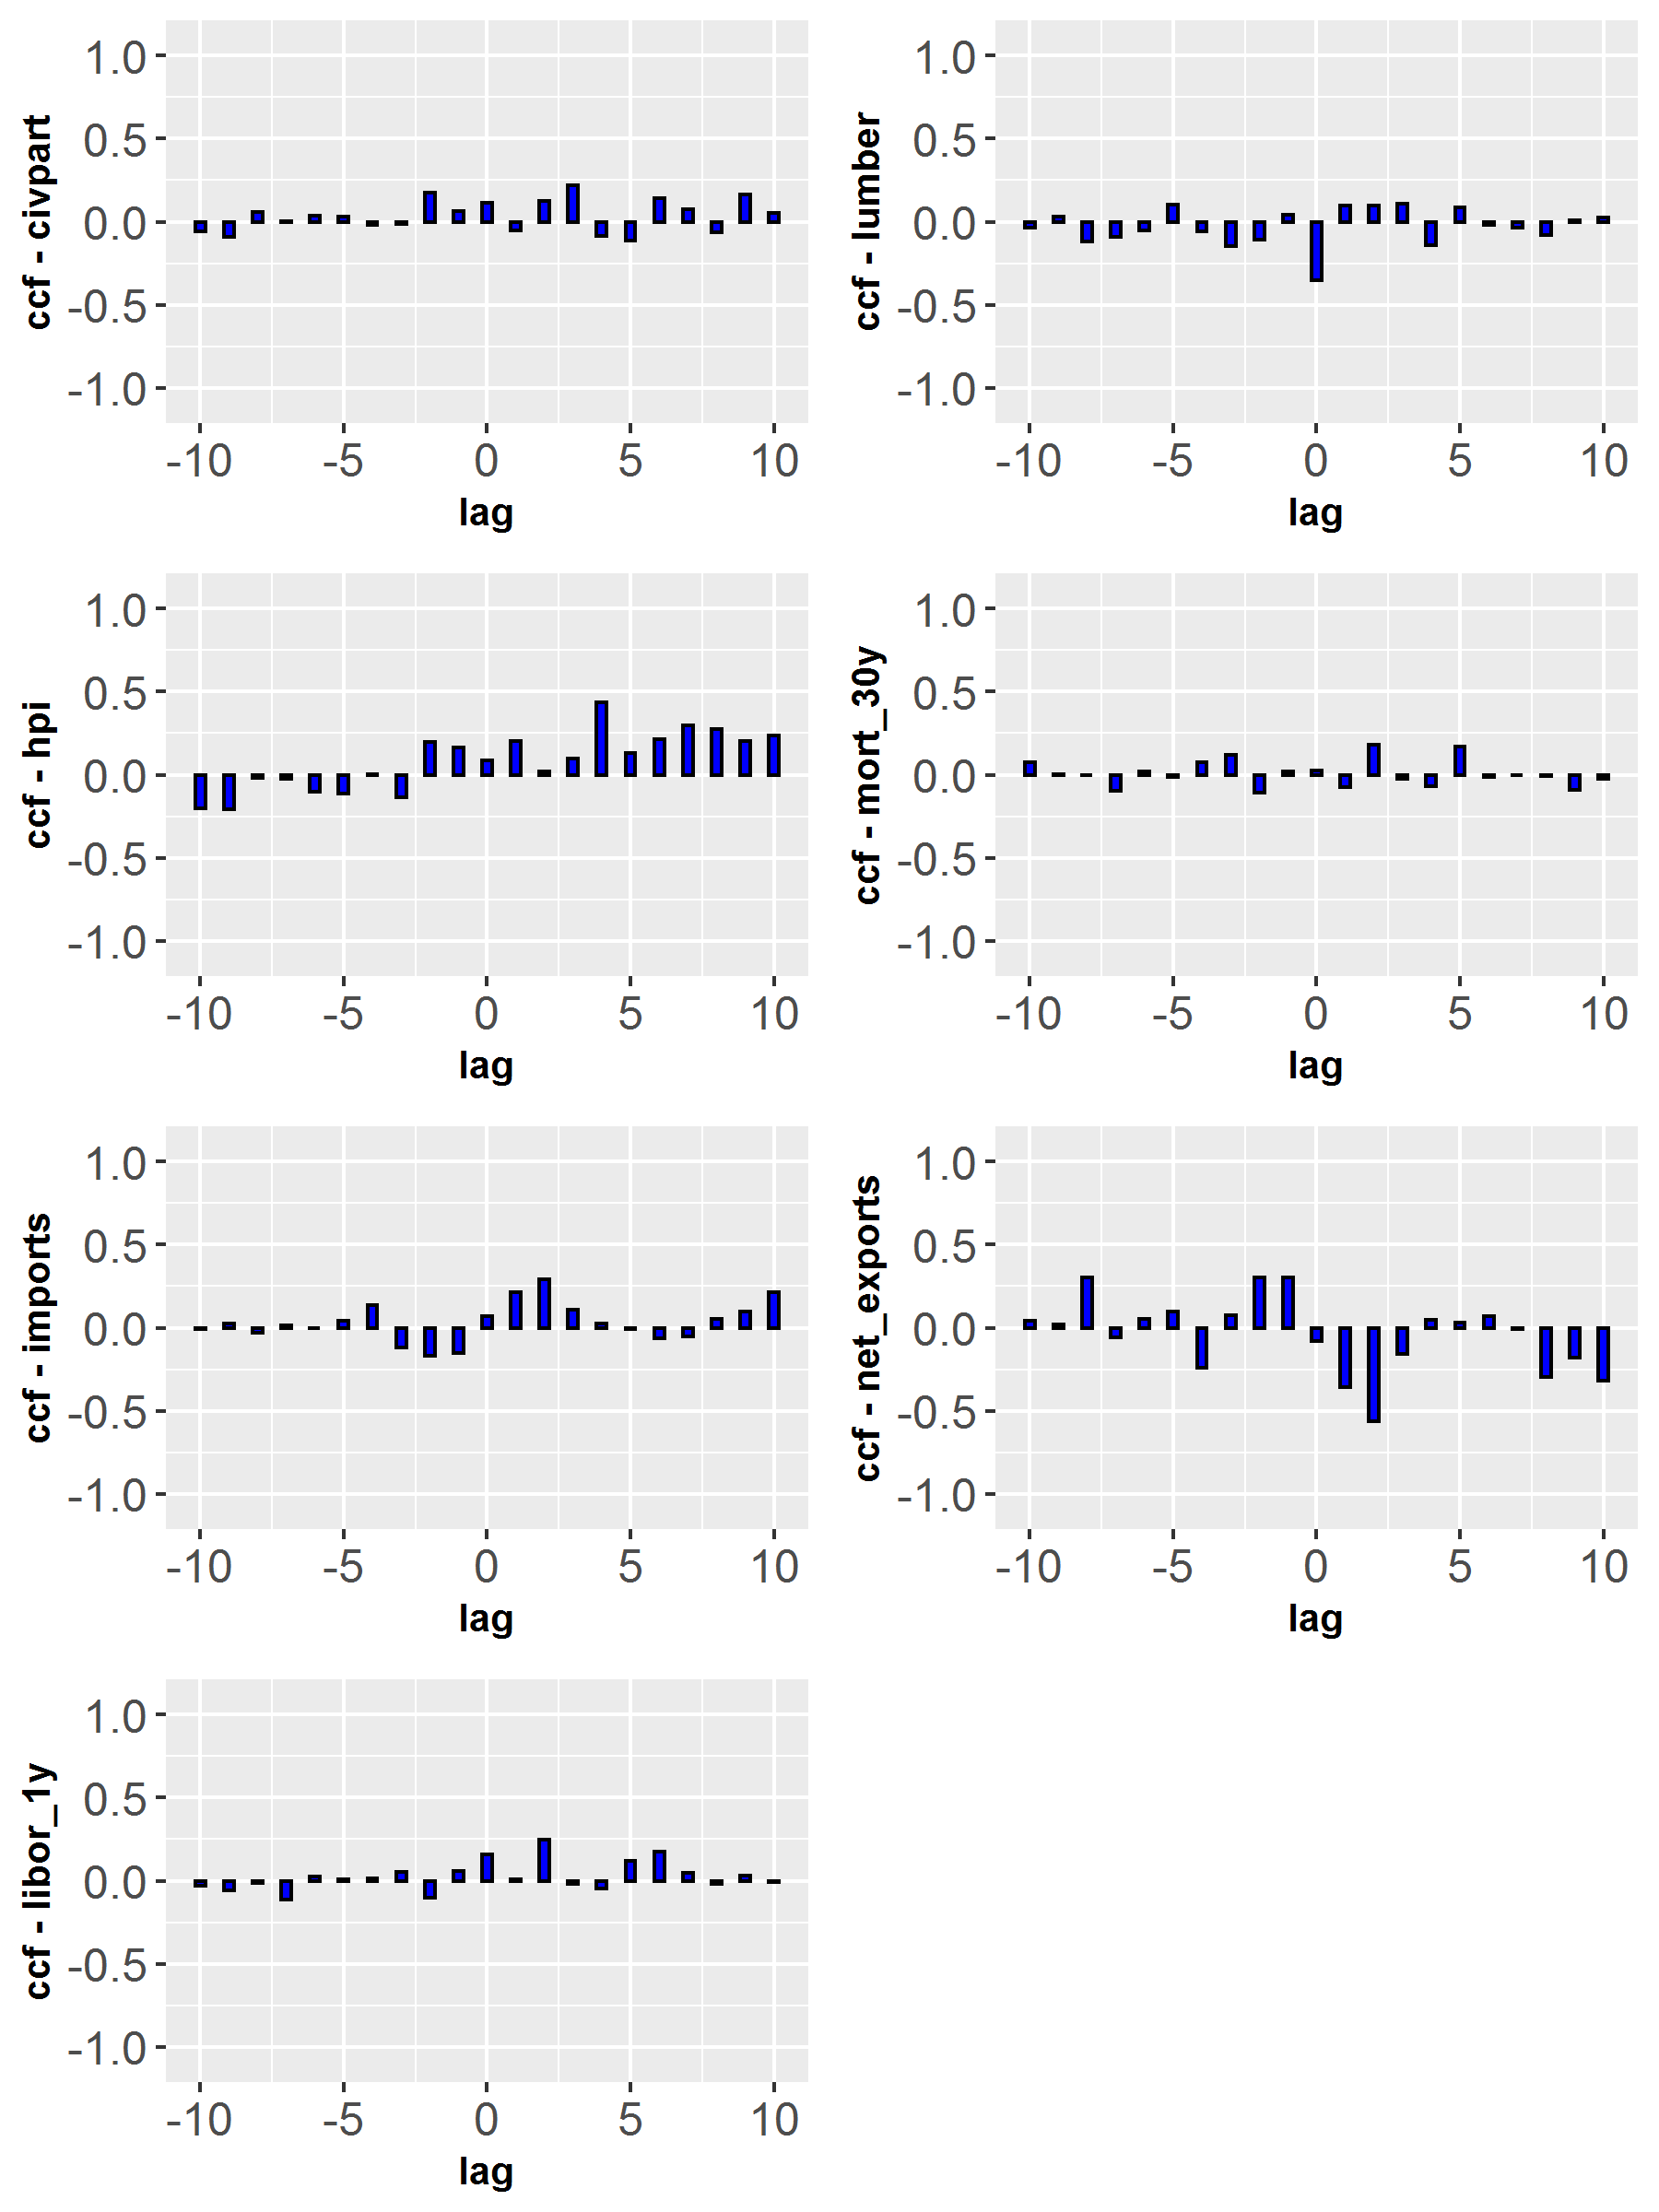

The resulting models were evaluated by both the analyst and SME to determine the set of parameters that optimized the model fit from a statistical and intuitiveness perspective, respectively.

The final tested model retained Disposable Income Real Lag 3 and AR3 as the sole parameters. Unemployment, Treasury 5 year rate, and Treasury 10 year 3 month rate terms were entered into the initial model structures, however in the presence of other predictors only Disposable Income Real Lag 3 was significantly related to the modeled series.

## Model Evaluation

The AR3 parameter was positively significant in the model at the .05 level and the Disposable Income Real lagged three quarters was significant at the .05 level. Disposable Income Real was positively related to balances, with increases in Disposable Income Real corresponding to three-quarters-later increases in deposit balances.

Table 6: Holdout Multivariate ARIMA - Parameter Significance

| Parameter | Estimate | Std. Error | t | p |
| --- | --- | --- | --- | --- |
| intercept | 1144244.989 | 94864.219 | 12.062 | 0.000 |
| civpart_lag3 | 1171789.019 | 436852.362 | 2.682 | 0.010 |
| lumber | -46385.787 | 9284.106 | -4.996 | 0.000 |

ADF tests of the residuals were calculated and exhibited that all tested periods achieved significance at the .01 level, indicating that the model had achieved stationarity.

Table 7: Holdout Multivariate ARIMA - Augmented Dickey-Fuller Test

| Type | Lags | Tau | p |
| --- | --- | --- | --- |
| Zero Mean | 0.000 | -5.681 | 0.000 |
|  | 1.000 | -4.808 | 0.000 |
|  | 2.000 | -4.733 | 0.000 |
| Single Mean | 0.000 | -5.629 | 0.000 |
|  | 1.000 | -4.764 | 0.000 |
|  | 2.000 | -4.690 | 0.000 |
| Trend | 0.000 | -5.656 | 0.000 |
|  | 1.000 | -4.785 | 0.000 |
|  | 2.000 | -4.734 | 0.000 |

Evaluation of ACF and PACF plots of the residuals provided no indication of unaddressed time-based structure in the model.

Figure 6: ARIMA - Holdout - ACF and PACF Plots

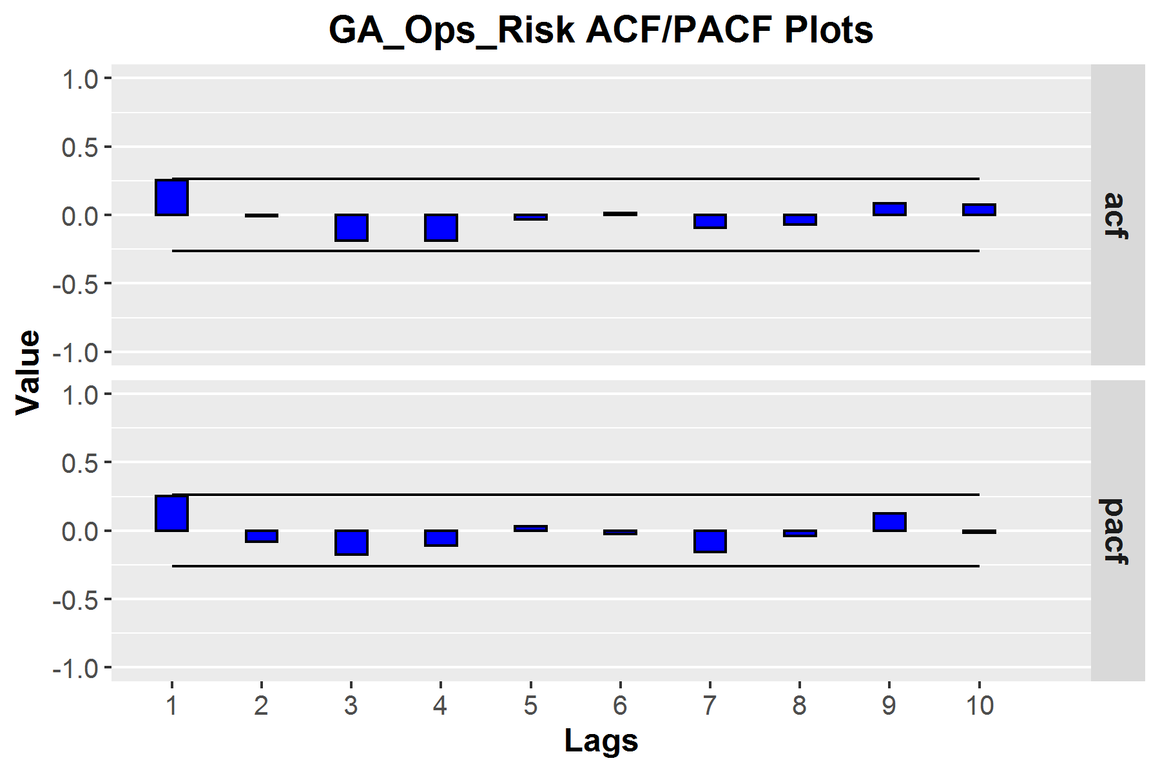

The QQ plot and Histogram plot of the residual values indicated acceptable normality of the distribution of the residuals.

Figure 7: ARIMA - Holdout - Normality of Residuals

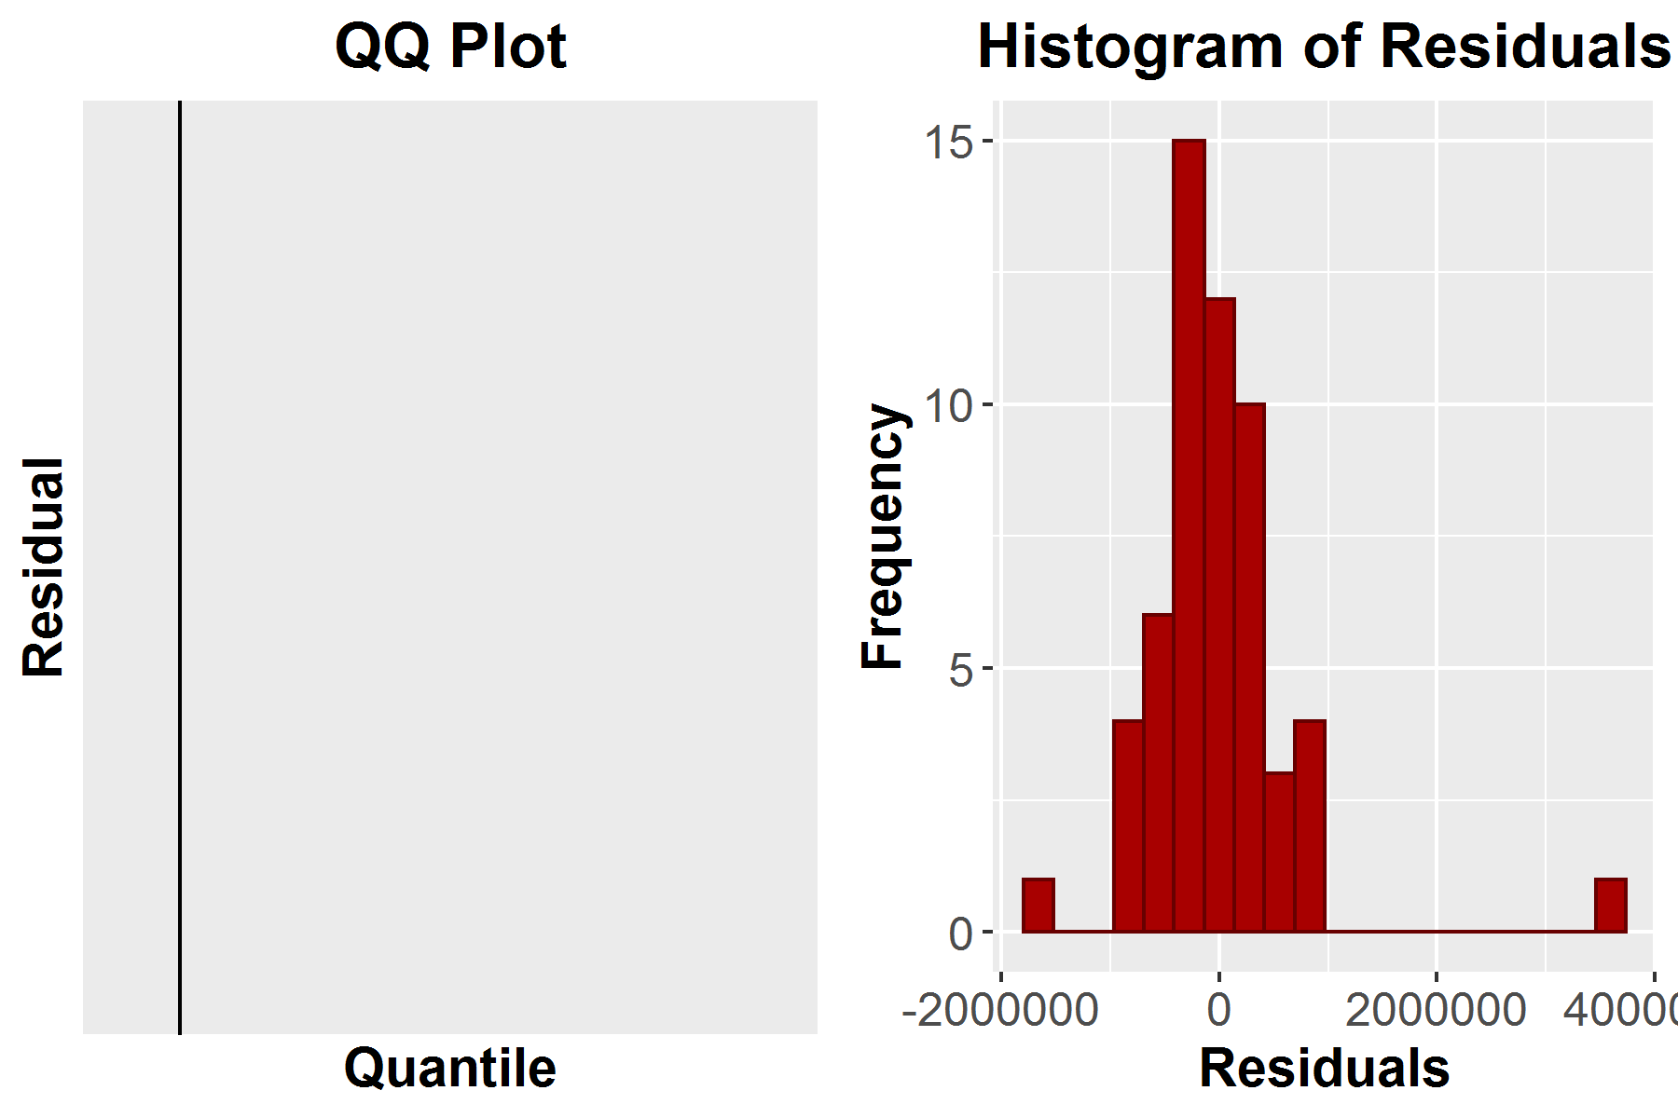

Box-Ljung tests of residuals were conducted at periods of 6, 12, 18, and 24 lags. There were no significant test statistics.

Table 8: Holdout Multivariate ARIMA - Box-Ljung Test

| Lag | ChiSq | df | p | acf1 | acf2 | acf3 | acf4 | acf5 | acf6 |
| --- | --- | --- | --- | --- | --- | --- | --- | --- | --- |
| 6.000 | 8.216 | 6.000 | 0.223 | 0.252 | -0.010 | -0.187 | -0.189 | -0.034 | 0.012 |
| 12.000 | 10.233 | 12.000 | 0.596 | -0.093 | -0.070 | 0.084 | 0.073 | -0.005 | -0.058 |
| 18.000 | 20.721 | 18.000 | 0.294 | -0.035 | 0.152 | 0.155 | 0.056 | -0.112 | -0.252 |
| 24.000 | 25.602 | 24.000 | 0.374 | -0.118 | -0.036 | 0.108 | 0.091 | 0.102 | 0.079 |

The model was judged to be appropriately specified and was retained for forecast diagnostic procedures.

### In-Time and Out-of-Time Forecast Evaluation

The model with covariates was evaluated for in-time and out-of-time forecast performance using both visual inspection and calculated performance metrics. Performance metrics for in-time and out-of-time forecast accuracy are displayed below, though offer little interpretable insight in the absence of model comparison.

Table 9: Holdout Multivariate ARIMA - Forecast Accuracy

| Model | Type | MAE | MAPE | MSE | RMSE |
| --- | --- | --- | --- | --- | --- |
| GA_Ops_Risk | In-Time | 437576.191 | 46.902 | 463946781444.619 | 681136.390 |
| GA_Ops_Risk | Out-of-Time | 853442.028 | 79.544 | 770914587875.924 | 878017.419 |

In-time forecasts were visually inspected and indicated an appropriate fit of the model to the data. All in-time observations were reasonably close to forecasts, and fit was generally consistent throughout the scope of observations.

Figure 8: ARIMA - Holdout - In-Time Forecasts

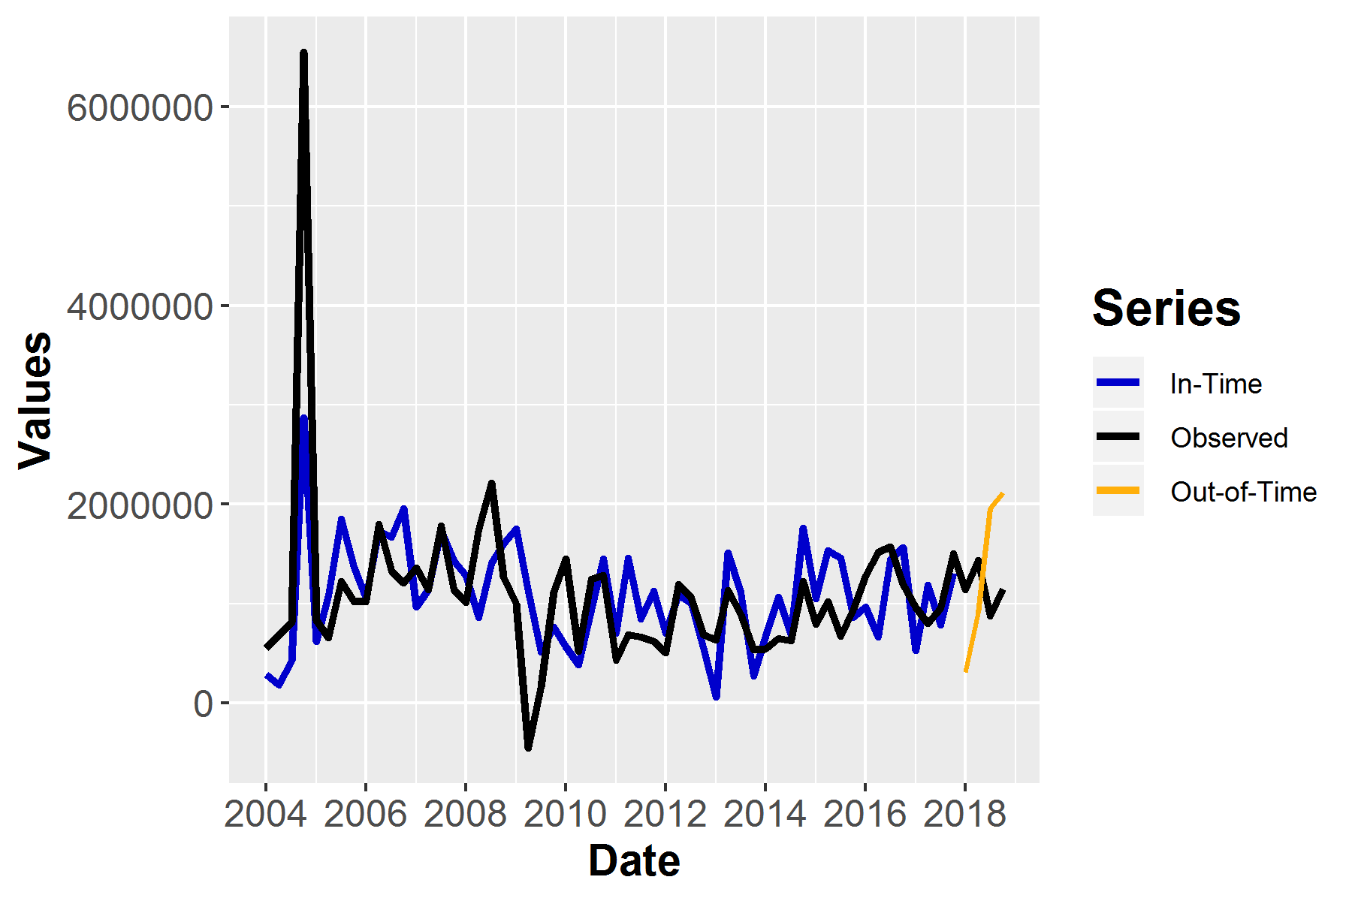

Evaluation of holdout forecasts indicated an acceptable fit of the model to the data. All observations fell within the 80 and 95 percent prediction intervals. The model was retained and moved into preliminary scenario forecast generation.

Figure 9: ARIMA - Holdout - Out-of-Time Forecasts

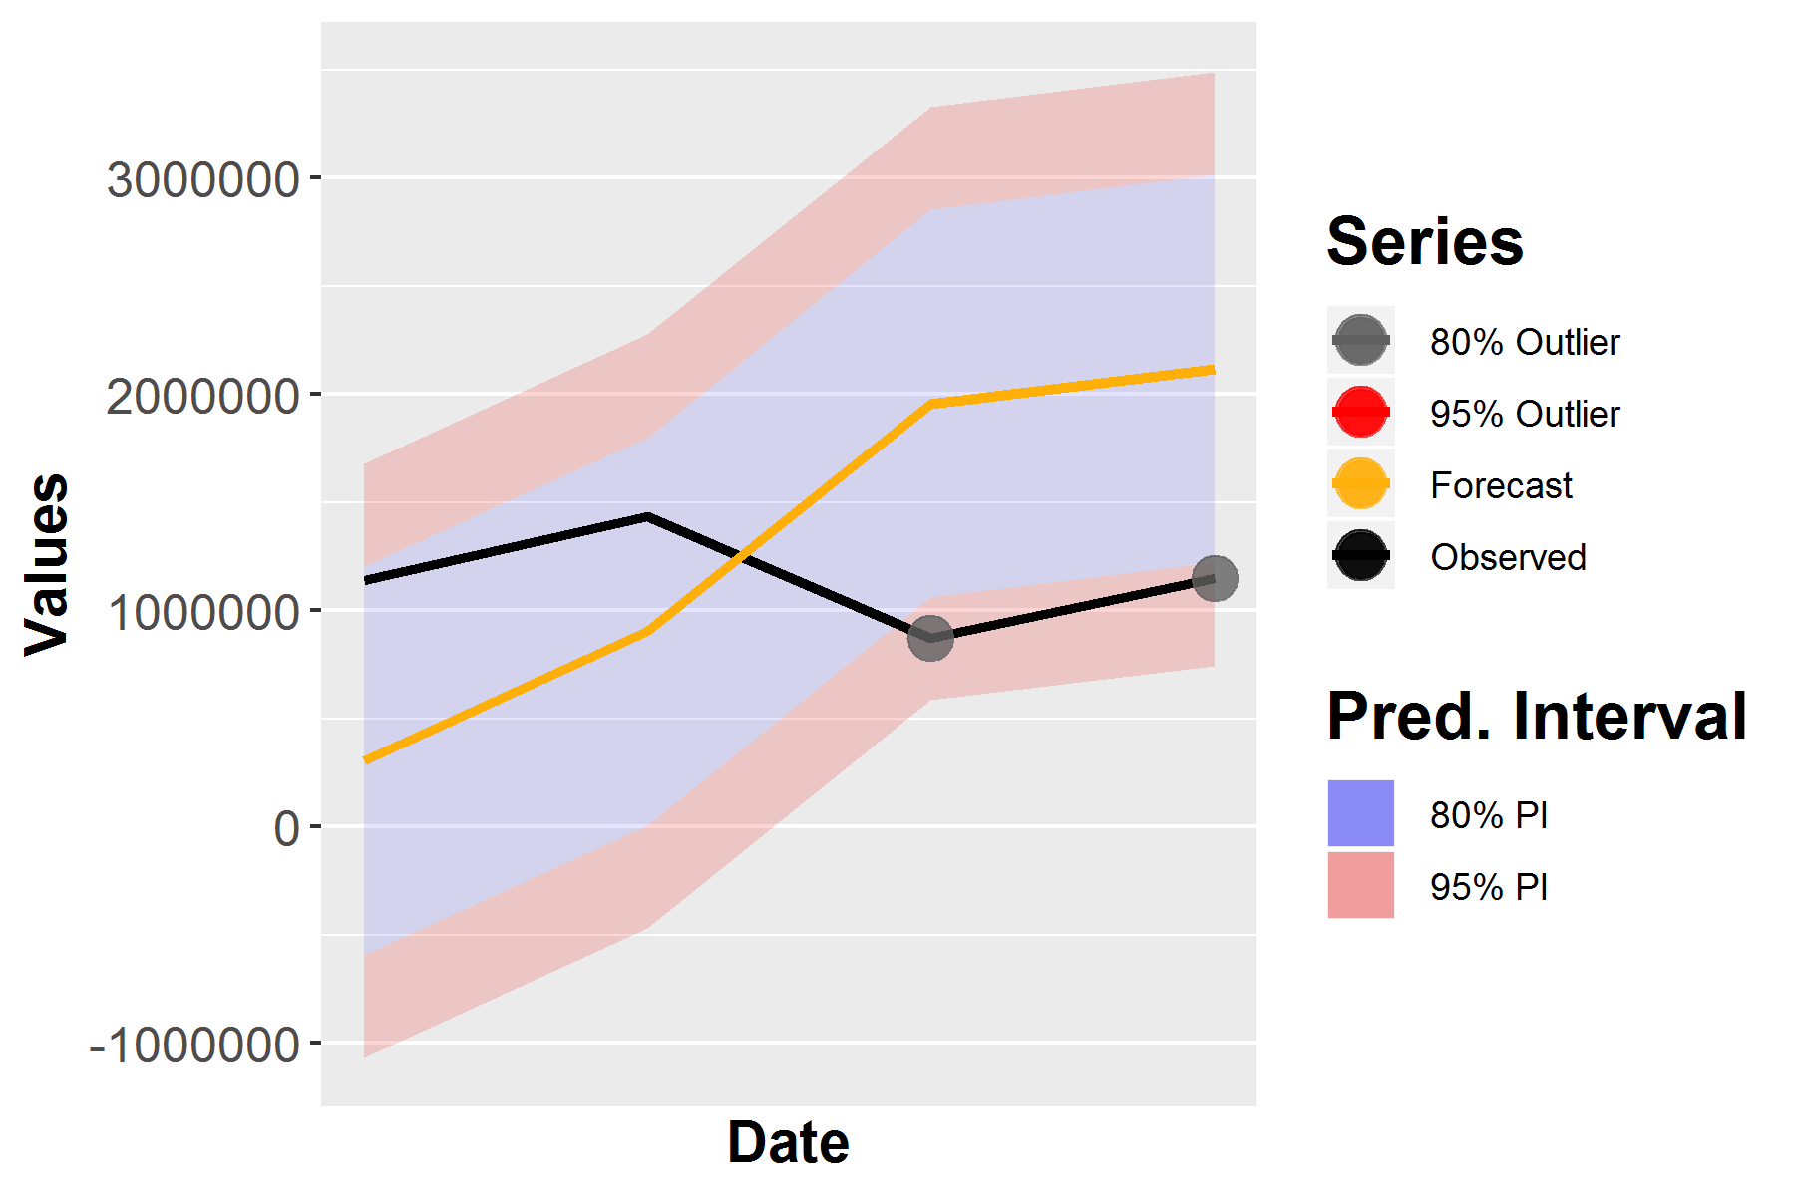

### Holdout Scenario Forecasts

Scenario forecasts were generated using the ARIMA model, forecasting starting at the observation just past the holdout period. Preliminary scenario forecasts exhibited favorable characteristics. There was acceptable stratification: the base scenario forecasts exhibited the highest values and the severe scenario values exhibited the lowest projected values. The base scenario exhibited continued increases. The adverse and severe scenarios both exhibited decrease followed by slow recoveries.

The preliminary model was determined to be acceptable and was refit to all available observations prior to conducting further diagnostics.

Figure 10: ARIMA - Holdout Forecasts

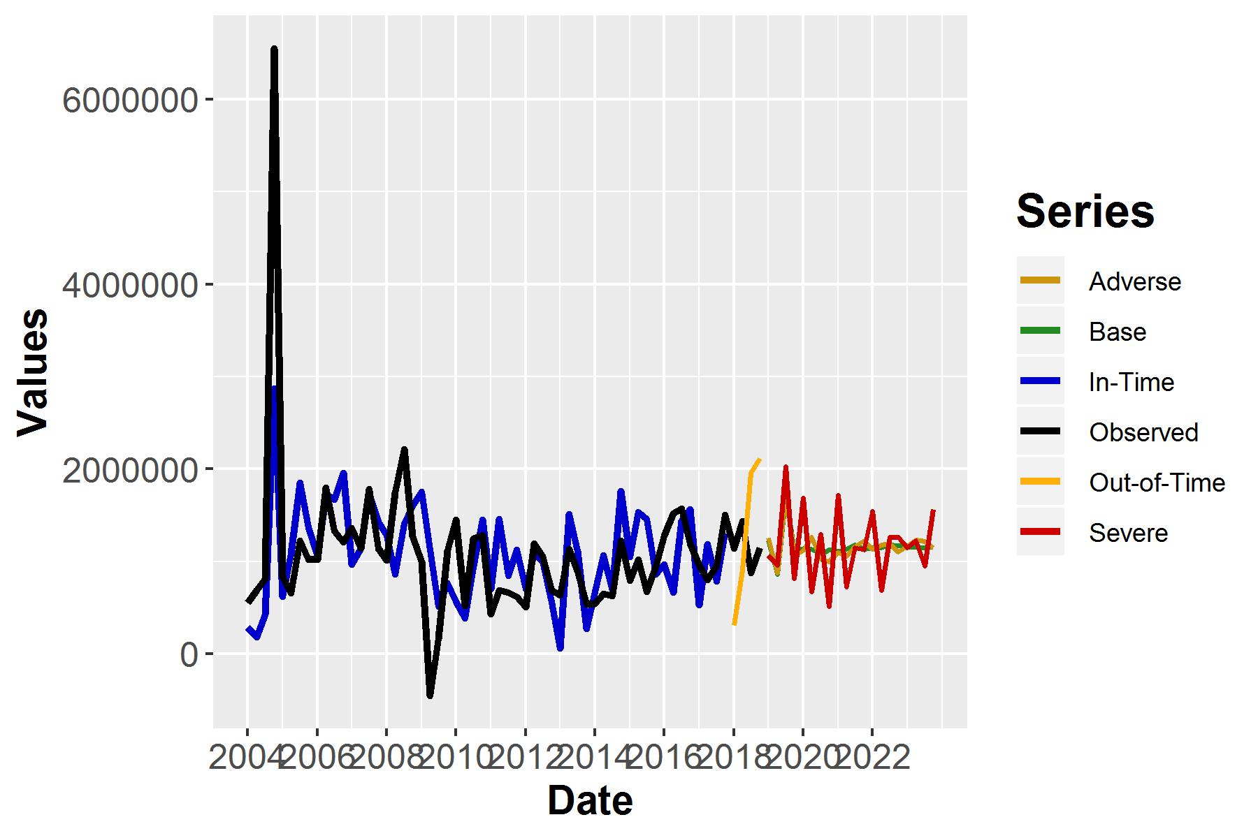

# Final Model

The ARIMA model was retained for production scoring. The model exhibited acceptable diagnostics and superior scenario forecast characteristics as judged by Finance SME. The ARIMA model was retained for further evaluation.

## Re-fitting - Final ARIMA model

*In-sample testing (CS3.1), product variety (CS3.10), Model accuracy, stability, and robustness (OM2.10), Evaluation of various model components (OM6.5)*

The ARIMA model was refit to all available observations prior to evaluation. The refit was conducted in order to maximize the number of observations in the training set, and as a means of increasing the forecast accuracy of short term forecasts.

### Evaluation of Model Components

*Evaluation of various model components (CS3.6), Evidence supporting assumptions (CS4.4)*

The AR term continued to exhibit significance at the .05 level, with slight p-value reductions observed in the refit final model. The Disposable Income Real Lag 3 parameter continued to exhibit significance at the .05 level.

Table 10: Final Multivariate ARIMA - Parameter Significance

| Parameter | Estimate | Std. Error | t | p |
| --- | --- | --- | --- | --- |
| intercept | 1142377.247 | 91991.038 | 12.418 | 0.000 |
| civpart_lag3 | 1247397.736 | 415946.250 | 2.999 | 0.004 |
| lumber | -36948.596 | 8363.042 | -4.418 | 0.000 |

The refit model retained stationarity for all tested periods.

Table 11: Final Multivariate ARIMA - Augmented Dickey-Fuller Test

| Type | Lags | Tau | p |
| --- | --- | --- | --- |
| Zero Mean | 0.000 | -6.068 | 0.000 |
|  | 1.000 | -4.934 | 0.000 |
|  | 2.000 | -5.020 | 0.000 |
| Single Mean | 0.000 | -6.013 | 0.000 |
|  | 1.000 | -4.882 | 0.000 |
|  | 2.000 | -4.966 | 0.000 |
| Trend | 0.000 | -6.129 | 0.000 |
|  | 1.000 | -4.994 | 0.000 |
|  | 2.000 | -5.130 | 0.000 |

The ACF and PACF plots of the residual values of the refit model were judged acceptable. They exhibited characteristics very similar to that of the holdout ARIMA model.

Figure 11: Final ARIMA Model - ACF and PACF Plots

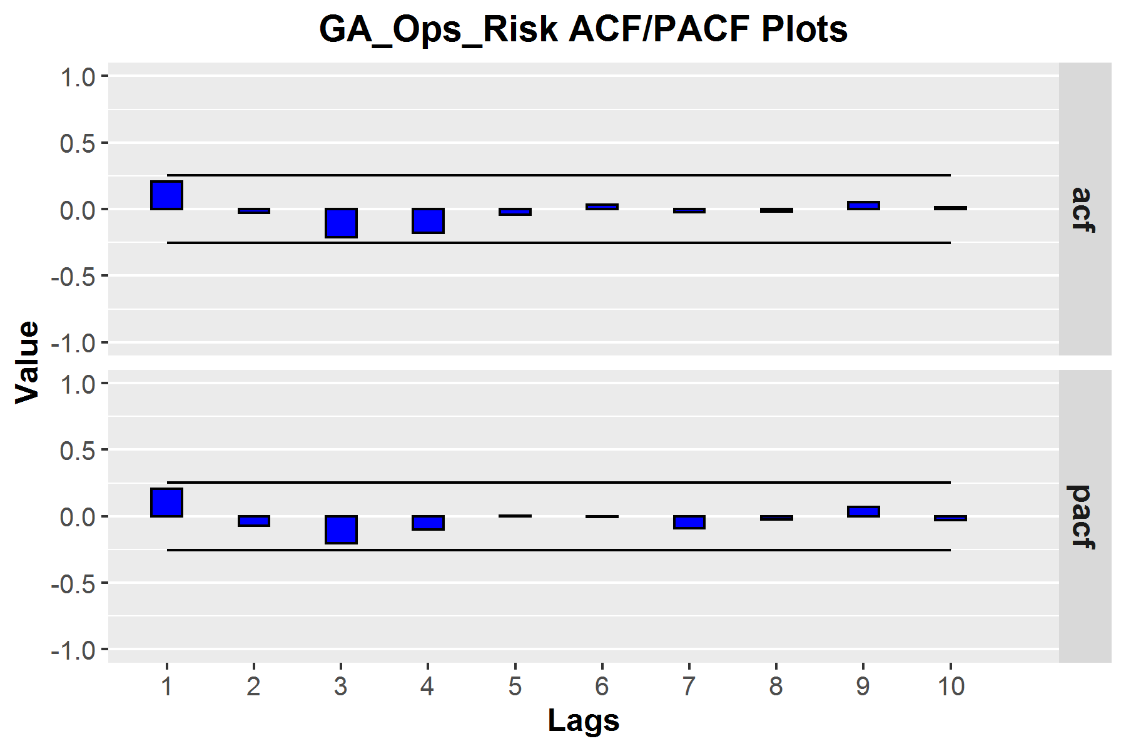

The QQ plot and Histogram plot of the residual values supported normality of the distribution of the residuals.

Figure 12: Final ARIMA Model - Normality of Residuals

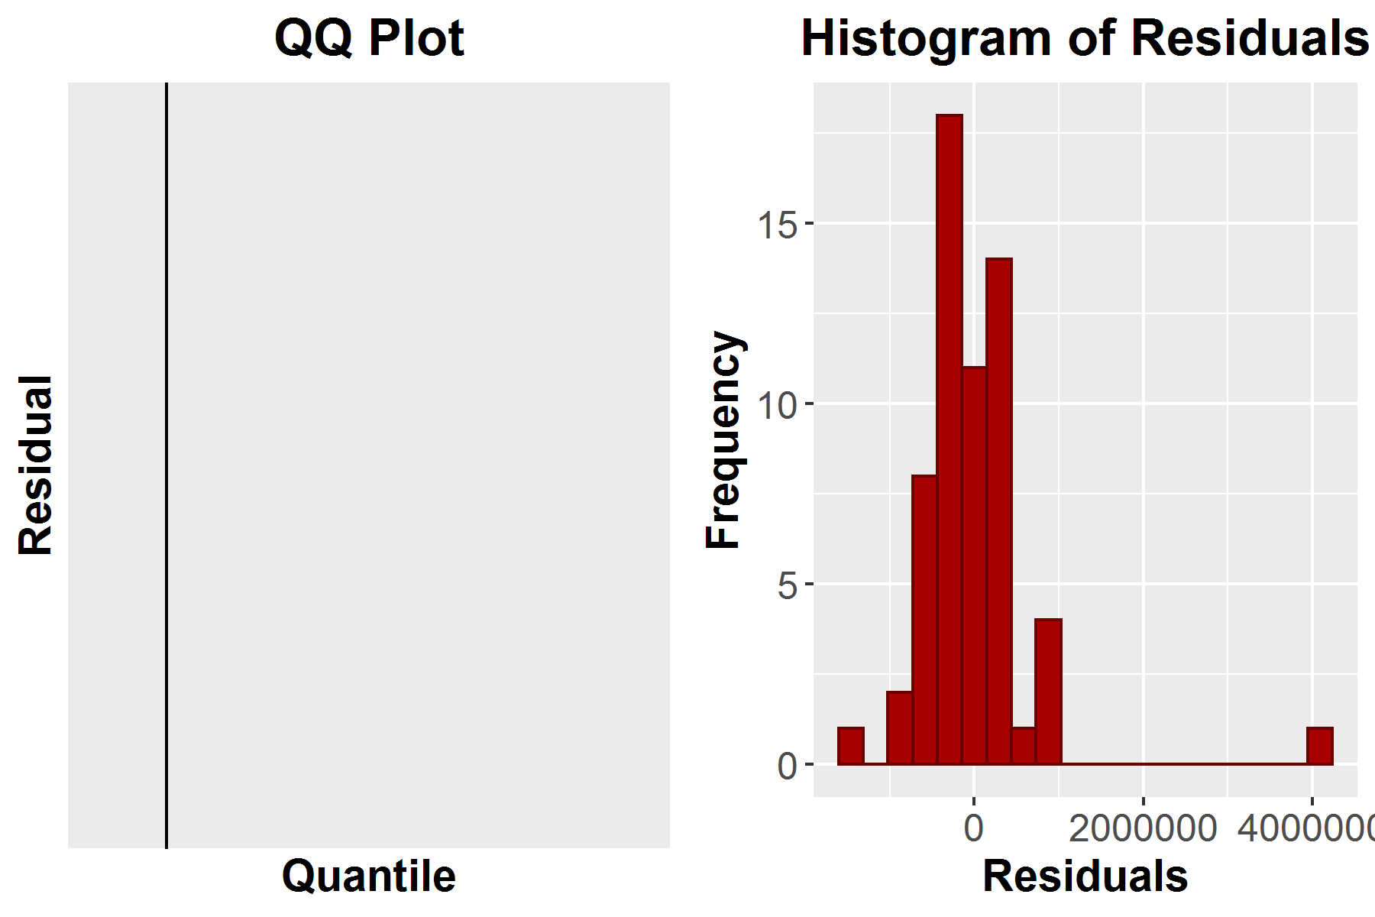

Box-Ljung ACF tests of residuals exhibited no test statistics with p values nearing significance thresholds and were judged acceptable.

Table 12: Final Multivariate ARIMA - Box-Ljung Test

| Lag | ChiSq | df | p | acf1 | acf2 | acf3 | acf4 | acf5 | acf6 |
| --- | --- | --- | --- | --- | --- | --- | --- | --- | --- |
| 6.000 | 7.930 | 6.000 | 0.243 | 0.206 | -0.026 | -0.213 | -0.176 | -0.040 | 0.032 |
| 12.000 | 8.386 | 12.000 | 0.754 | -0.024 | -0.018 | 0.053 | 0.014 | -0.023 | -0.042 |
| 18.000 | 17.424 | 18.000 | 0.494 | -0.002 | 0.141 | 0.161 | 0.037 | -0.075 | -0.230 |
| 24.000 | 21.478 | 24.000 | 0.610 | -0.112 | -0.012 | 0.123 | 0.075 | 0.086 | 0.040 |

Diagnostics of the re-fit model indicated acceptable fit of the model to the data.

### Parameter Changes

Parameter changes observed after inclusion of the holdout observations in the training set were considered acceptable and indicative of stability of parameter estimates. The model was retained for further evaluation.

Table 13: Parameter Changes

| Model | civpart_lag3 | intercept | lumber |
| --- | --- | --- | --- |
| Short Model | 1171789.019 | 1144244.989 | -46385.787 |
| Full Model | 1247397.736 | 1142377.247 | -36948.596 |
| Change PCT | 6.061 | -0.163 | -25.541 |

### In-Time Forecasts

The in-time forecasts for the refit model were evaluated. Inspection of in-time forecasts revealed no notable reduction in fit of the observations when the model was fit to all available observations.

Figure 13: Final ARIMA Model - In-time Forecasts

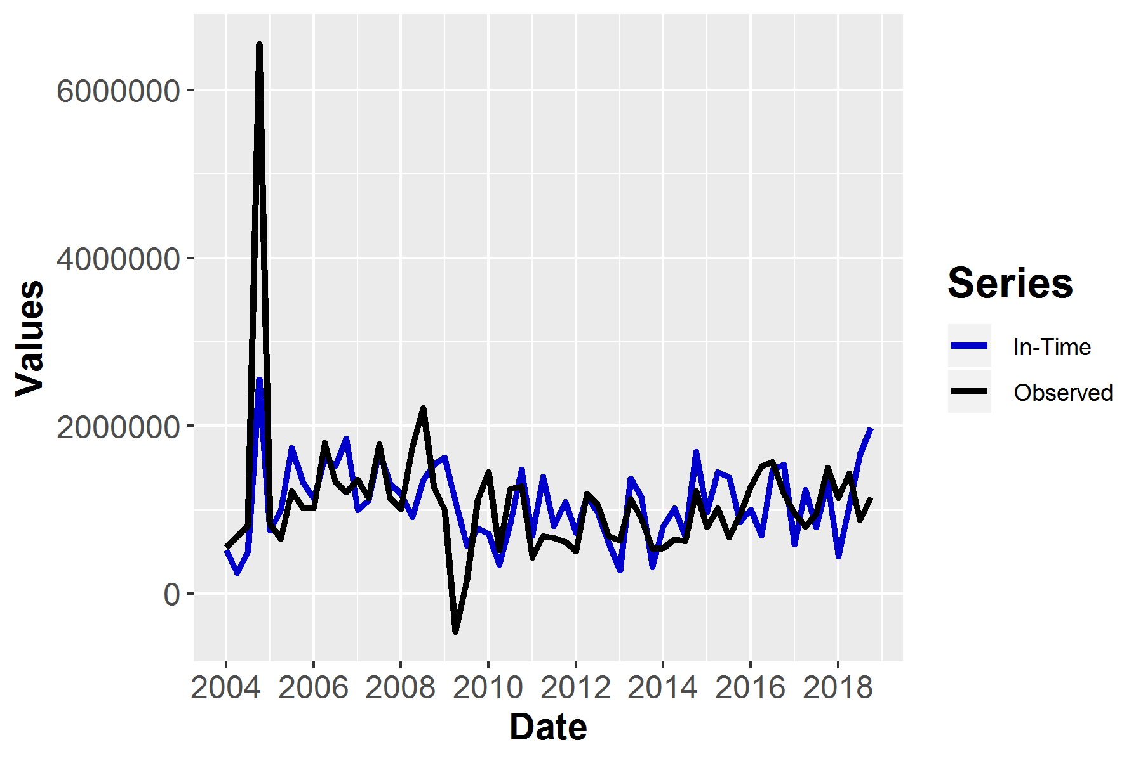

### Evaluation of Model Outcomes - Scenario Forecasts

*Evaluation of model outcomes (CS3.12)*

Scenario forecasts were generated using the refit model. Forecast values and scenario distributions changed very little, and remained acceptable. The refit model was retained for deployment and production scoring.

Figure 14: Final ARIMA Model - Forecasts

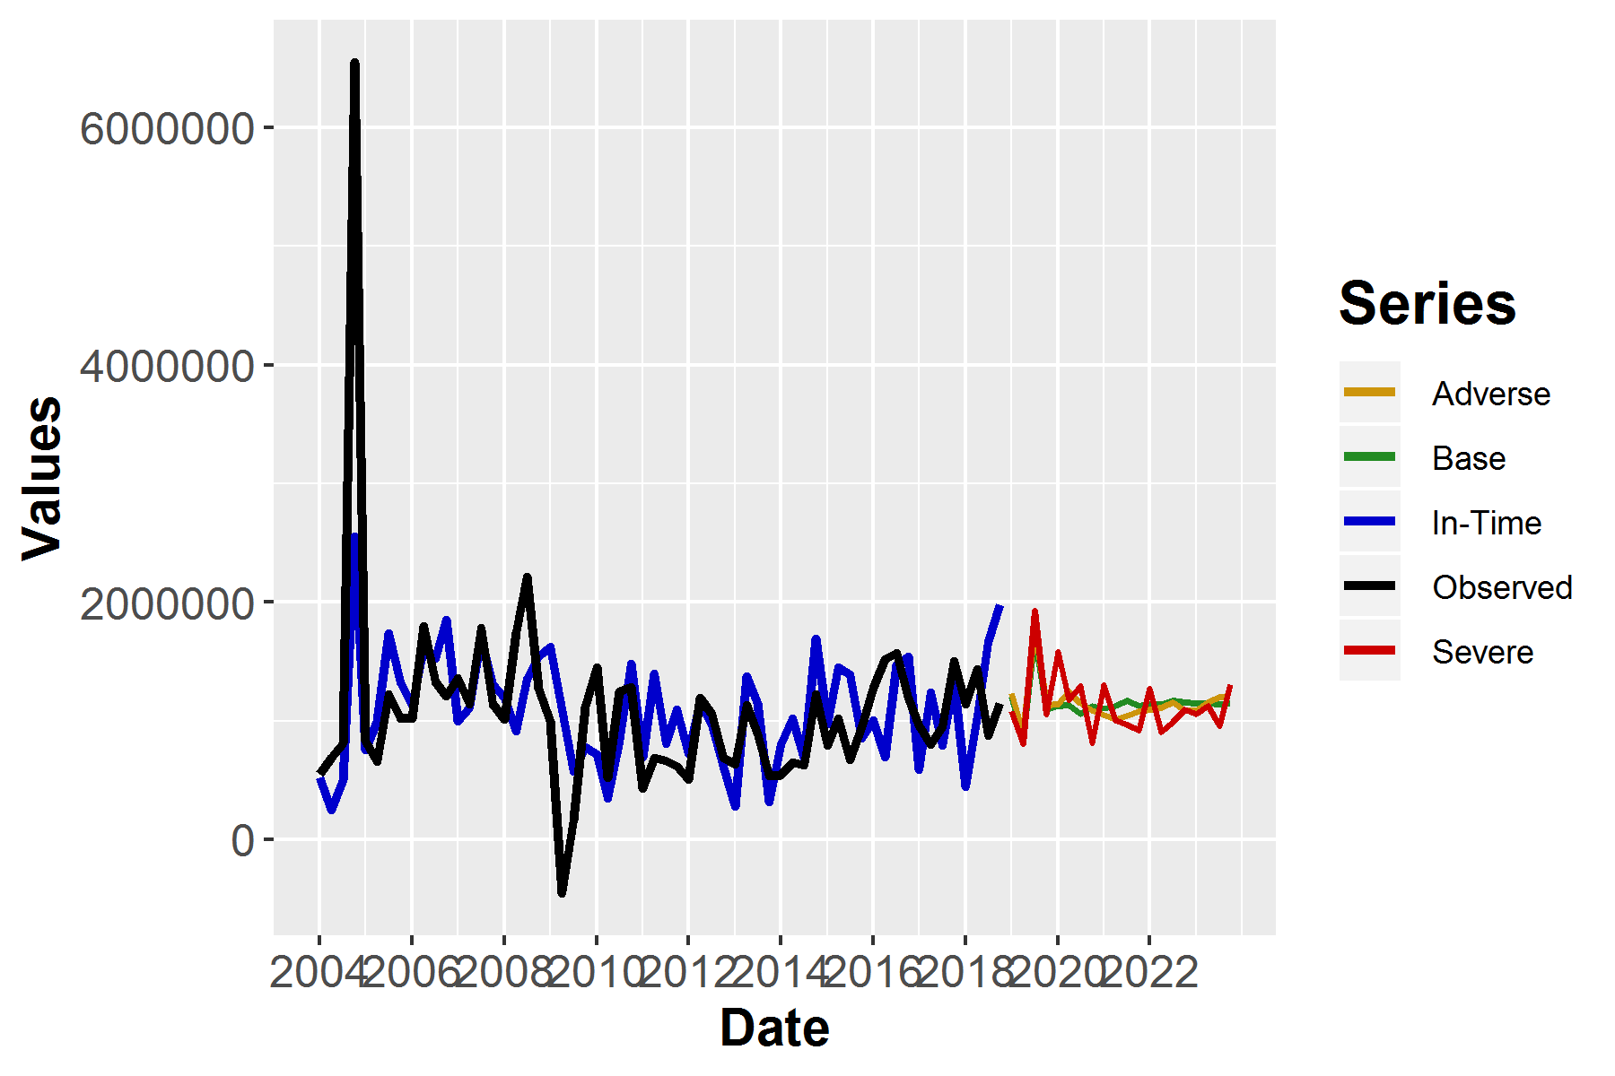

## Sensitivity Testing

*Model stability: univariate sensitivity testing (CS3.4), (OM6.3)*

In order to facilitate sensitivity testing, a series of shocks were applied to the base-scenario values of each macroeconomic CHIMPS predictor throughout the span of the forecasts. For univariate sensitivity testing, forecasts were generated replacing the base-scenario values with the shocked values one at a time when creating forecasts. For multivariate sensitivity testing, all shocked values simultaneously replaced all base-scenario values when generating the forecast.

The shocked values were produced by multiplying the base scenario values by either 1.10 or 0.90 depending on the direction of the shock.

The following variables use the 0.90 shock value: gdp_real, gdp_nom, dispinc_real, dispinc_nom, cpi_inf, treas_3month, treas_5year, treas_10year, mort, prime, dji, hpi, and cri.

The following variables use the 1.10 shock value: unem, bbb, volatility, bbb_cs, mort_cs, and treas_10y_3m.

### Univariate Shocks

The univariate shock of the individual predictor indicated an appropriate level of sensitivity of the model forecasts to changes in Disposable Income Real. Increases in forecasted values were notable, but not so severe as observed in the adverse scenario. The model was judged by the analyst to exhibit appropriate sensitivity to changes in predictor values.

Figure 15: Final ARIMA Model - Forecasts

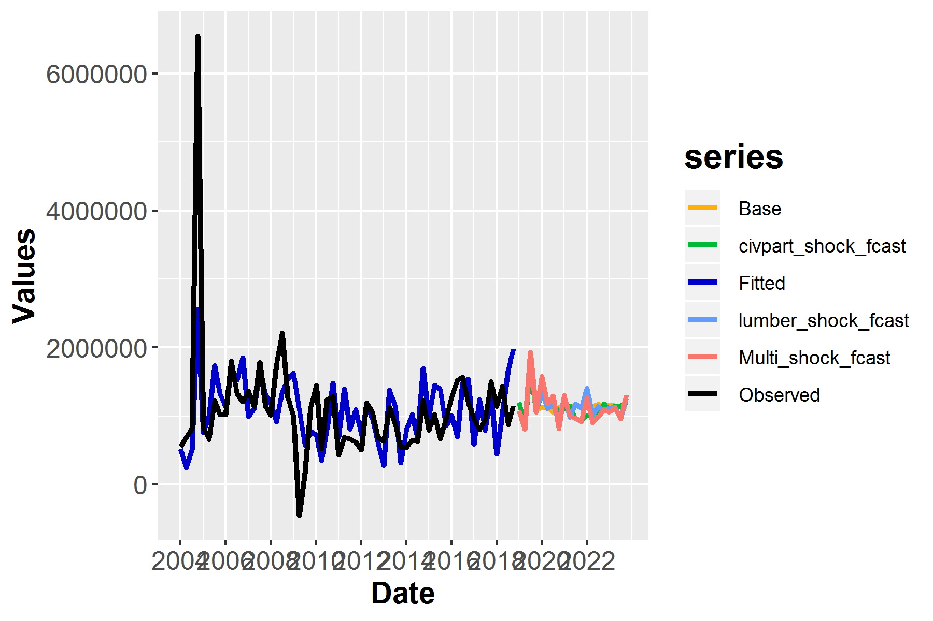

### Multivariate Shock

*Multivariate sensitivity testing (CS3.5), (OM6.4)*

Whereas additional univariate and multivariate sensitivity testing was conducted, it is noted that generation of scenario forecasts with this model provides evidence of model stability and appropriate sensitivity. The CHIMPS scenarios cover the full range of expected economic conditions for the forecast period, from serious recession to continued economic recovery. For each scenario, each predictor varies over time as a reflection of the complex time-base macroeconomic environment associated with that particular scenario. The retained model generated reasonable and appropriate forecasted values as judged by the Capital Management SME and analyst when simultaneously evaluating all three scenario forecasts. The reasonableness of these forecasts offers substantial evidence supporting the ability of the retained model to generate reasonable forecasts across a wide variety of economic scenarios.

Multivariate sensitivity testing was not conducted as a single macroeconomic predictor was included in the model.

### Sensitivity Testing of Assumptions

*Sensitivity testing of assumptions (CS4.4)*

Not applicable for this model as no quantitative assumptions were used in model development or forecast generation.

## Model Uncertainty

*Model uncertainty, inaccuracy, or instability (CS3.11), Quantifying model uncertainty (CS6.1)*

When considered collectively, the model diagnostics, out-of-time testing, and generation of forecast values over multiple ranges indicate that this is a model of acceptable accuracy with uncertainty within that deemed acceptably by SNV model management policy. In order to quantify model uncertainty, the model out-of-time mean absolute error (MAE) value will be used as an estimate of expected uncertainty for any given forecast generated using this model. The MAE is determined to be a ‘most-likely’ error estimator and, when applied universally to every forecasted value to decrease forecasted index values, a method that will remain conservative while not generating unreasonable inflation of error estimates.

The MAE defined uncertainty for this model was observed at **853,442.028**.

## Benchmark Comparison

*Benchmarking (OM1.4), Benchmark model used, quality of benchmark model (CS5.1), Discussion of differences from benchmark (CS5.Q2), Range of differences (CS5.2), Is the benchmark used (OM4.Q1), Quality of benchmark (OM4.1), Benchmark differs but not in error (OM4.Q2), Differences within appropriate range (OM4.2)*

There was no comparison of the forecasts generated by the retained model against a less granular benchmark model developed for the same portfolio. This model was developed at the least granular level possible, and as such forecasts from this scenario represent the smallest level of portfolio values appropriate to collectively model.

## Strengths and Limitations

*Model merits (CS1.6), Model limitations (CS1.7), (OM6.6), Assessment of potential limitations (CS3.8), Model robustness (CS3.9), (OM6.7)*

### Model Strengths

* Final model exhibited stationarity and inclusion of expected covariates
* Model structure exhibited within interval fit to holdout periods
* Final model exhibited acceptable in-time fit
* Final model parameter estimates changed little when fit to all data from those of the model fit to observations minus holdout, indicating model stability
* Final model scenario forecasts exhibited expected and intuitive stratification between scenarios
* Final model exhibited scenario forecasts values consistent with analyst and Strategic Finance SME expectations

### Model Limitations

* This model has a complete lack of backtesting after refitting, following the holdout test. As newly developed models cannot be tested for post-deployment performance, this is a limitation common to all newly developed models, and backtesting of the model structure partially mitigates this risk
* The available data does not cover the full conceivable range of values for those variables included in the model. This risk is minimal, however, as the range of values covered for either predictor or outcome variables are unlikely to be exceeded in the forecasted period

## Long Forecast Horizon

*Long forecast horizon (OA2.Q3), Backtesting of long forecast horizon (OA2.9), Early warning metrics (OA2.10)*

The 12 quarter forecast horizon generated is a standard forecast horizon for Stress Testing. The forecast horizon does not extend beyond five years, which has been determined by SNV Treasury to be a long forecast horizon. All model forecasts will be re-generated at a not-less-than annual schedule. Re-development of this model will be conducted on a schedule as outlined in SNV model management policy. At each instance of consideration for redevelopment, backtesting will be conducted.

## Supervisory Concerns/Guidance

*Supervisory concerns/guidance (CS1.8)*

There are no specific regulatory concerns or guidance related to the use of this model.

#### Overrides and Ongoing Monitoring Practices

There are no explicit overrides associated with this model. Ongoing monitoring practices can be found in SNV Model Management policy documentation.

## Model Uncertainty

*Accounting for model uncertainty: adjustments, restrictions, etc. (CS6.3), Ongoing Monitoring Plan/Policy (OM1.1), Management of model overrides (OM1.3), Benchmarking (OM1.4), Qualitative adjustments and model assumptions (OM1.5), OM tests (OM1.6), Use of overrides (OM3.Q1), Overrides due to model limitations (OM3.Q2), Reasons for overrides (OM3.1), Tracking of override performance (OM3.2), Is rate of overrides high or is override process improvement to model performance (OM3.Q3), Efforts in model redevelopment relevant to override use (OM3.3), Qualitative judgments applied (OM5.Q1), Review of qualitative adjustments (OM5.1), Qualitative adjustments sensitivity testing (OM5.2), Sensitivity testing of assumptions (OM5.5)*

Model uncertainty is quantified by using the final model MAE value calculated for the holdout forecast period. All other items already addressed earlier in this document.

## Model Reporting

*Model reporting (OM1.2)*

The modeling process and technical documentation for this model, contained in this document, provides an exhaustive description of each process, content, data, and diagnostic model related materials and results. All non-technical documentation and application of this model currently and will continue to refer to the most recent technical documentation.

## Model Use and Documentation Availability

*Model reports used for business decision making (OM2.Q3), Model reports clear (OM2.9), Availability of reports regarding model accuracy, stability, and robustness (OM2.10), Availability of reports regarding key assumptions (OM2.11)*

The model will be used in Stress Testing and for regulatory purposes and as a source of information in Capital Planning procedures. All documentation, code, and output are made readily available to the MDG, Treasury, MRMG, model owner, and any other concerned parties within the parent organization.

## Qualitative Adjustments

There were no qualitative adjustments made to model forecasts.

# Appendix

The following command lists the version of R and packages used to build this document.

## R version 3.6.1 (2019-07-05)  
## Platform: x86_64-w64-mingw32/x64 (64-bit)  
## Running under: Windows Server 2012 R2 x64 (build 9600)  
##   
## Matrix products: default  
##   
## locale:  
## [1] LC_COLLATE=English_United States.1252   
## [2] LC_CTYPE=English_United States.1252   
## [3] LC_MONETARY=English_United States.1252  
## [4] LC_NUMERIC=C   
## [5] LC_TIME=English_United States.1252   
##   
## attached base packages:  
## [1] stats graphics grDevices utils datasets methods base   
##   
## other attached packages:  
## [1] knitr_1.24 captioner_2.2.3 devEMF_3.6-3   
## [4] flextable_0.5.5 mschart_0.2.4 officer_0.3.5   
## [7] rmarkdown_1.15 zoo_1.8-6 forecast_8.9   
## [10] lubridate_1.7.4 forcats_0.4.0 stringr_1.4.0   
## [13] dplyr_0.8.3 purrr_0.3.2 readr_1.3.1   
## [16] tidyr_0.8.3 tibble_2.1.3 ggplot2_3.2.1   
## [19] tidyverse_1.2.1 gridExtra_2.3 SNVRegulatory1.5_1.6  
##   
## loaded via a namespace (and not attached):  
## [1] tseries_0.10-47 httr_1.4.1 jsonlite_1.6   
## [4] modelr_0.1.5 assertthat_0.2.1 TTR_0.23-4   
## [7] cellranger_1.1.0 yaml_2.2.0 gdtools_0.2.0   
## [10] pillar_1.4.2 backports_1.1.4 lattice_0.20-38   
## [13] glue_1.3.1 quadprog_1.5-7 uuid_0.1-2   
## [16] digest_0.6.20 rvest_0.3.4 colorspace_1.4-1   
## [19] htmltools_0.3.6 timeDate_3043.102 pkgconfig_2.0.2   
## [22] broom_0.5.2 haven_2.1.1 scales_1.0.0   
## [25] generics_0.0.2 withr_2.1.2 urca_1.3-0   
## [28] nnet_7.3-12 lazyeval_0.2.2 cli_1.1.0   
## [31] quantmod_0.4-15 magrittr_1.5 crayon_1.3.4   
## [34] readxl_1.3.1 evaluate_0.14 nlme_3.1-141   
## [37] xts_0.11-2 xml2_1.2.2 tools_3.6.1   
## [40] data.table_1.12.2 hms_0.5.1 munsell_0.5.0   
## [43] zip_2.0.3 writexl_1.1 RODBC_1.3-15   
## [46] compiler_3.6.1 systemfonts_0.1.1 rlang_0.4.0   
## [49] grid_3.6.1 rstudioapi_0.10 base64enc_0.1-3   
## [52] gtable_0.3.0 fracdiff_1.4-2 curl_4.0   
## [55] R6_2.4.0 zeallot_0.1.0 stringi_1.4.3   
## [58] parallel_3.6.1 Rcpp_1.0.2 vctrs_0.2.0   
## [61] tidyselect_0.2.5 xfun_0.9 lmtest_0.9-37