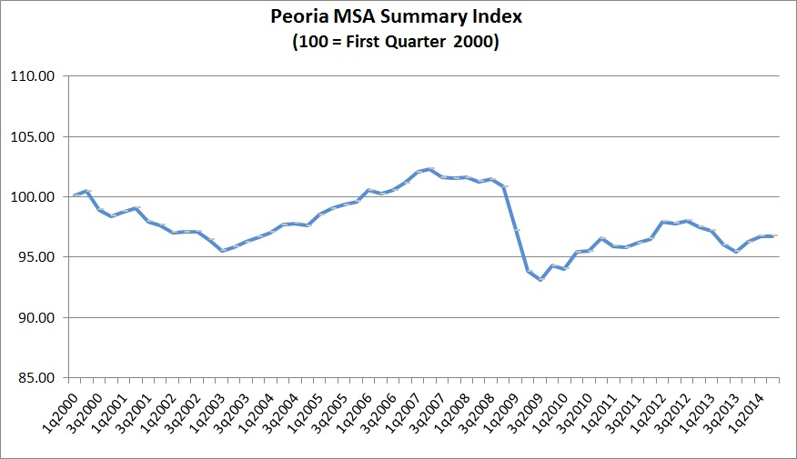
Peoria-Pekin MSA Business Index Stable for
Second Quarter 2014
The second quarter 2014 business and economic indicator Summary Index for the Peoria-Pekin Metropolitan Statistical Area (MSA; Peoria, Tazewell, Woodford, Stark and Marshall counties) was unchanged from the previous quarter’s 96.7 level maintaining earlier gains to remain 0.7 percent above the previous year’s 96.0

The Center for Business and Economic Research (CBER) reviews over 30 diverse business indicators in its quarterly assessments. The CBER computes its quarterly Summary Index of key local business and economic indicators for the Peoria-Pekin MSA to reflect business activity in the MSA on a seasonally adjusted basis, with an index score of 100 corresponding to the business conditions found locally in the first quarter of 2000, following the national economic expansion of the previous decade. The present national economic expansion began after the national recession of December 2007- June 2009: the local Summary Index grew after reaching its cyclical low of 93.1 during the third quarter of 2009.

The CBER is housed in the Foster College of Business of Bradley University and has compiled a local business and economic data base since 1991. The Peoria Journal Star funds maintenance of this business indicator database. A detailed analysis of these data appears below. Data reported are adjusted for normal seasonal variation, other than sales figures of Peoria-Pekin MSA retail sales, Hospital Revenue Index and the number of homes sold in the Peoria-Pekin MSA.
Labor Markets

The number of working Peoria-Pekin MSA residents rose for a second consecutive quarter in 2014, reversing the trend of declines in the number of working residents of the second half of last year.

The number of working Peoria-Pekin MSA residents rose 1.5% from the previous quarter, for an average of 180,605 working residents during the quarter. Second quarter growth in the number of working Peoria-Pekin MSA residents pushed the local unemployment rate down to 8.0% in the second quarter from 9.1% in the first quarter. Declining unemployment is found also for the state, with a 1.1 percentage point decline in the second quarter Illinois unemployment rate.

Manufacturing, reduced the number of people on their payrolls 1.6% from the previous quarter. At the
same time, national data for durable goods manufacturers show that they boosted second quarter
employee hours worked, with average factory overtime up 5.2% from the previous quarter.

Retail and Wholesale Trade employers reduced the number of persons on their payrolls by 1.4% from the previous quarter, Hospitality/Entertainment (a category dominated by restaurants) employers reduced the number of persons on their payrolls 0.6% in the quarter. The estimated second quarter 2014 area retail sales were up 1.9% from the year before, slightly above inflation for the period The CBER’s Retail Sales Index shows stable inflation adjusted sales, with little change from the previous quarter. These retail revenues should help support employment in the sector

Heath Care maintained the number of people on its payrolls, with the CBER estimate of the number of jobs in the industry little changed from the previous quarter and year. The 2.2% increase over last year in estimated second quarter 2014 Hospital Revenue Index should help support this sector.

The 2014 increases in the number of people working (which includes both people working on employer
payrolls and those self employed) should continue. Local employers are looking to increase hiring in
the months ahead, as indicated by their increasing postings of job openings by 9.1% in the second
quarter. Increases in the numbers of local self employed should be supported by their improved access
to health insurance from Illinois health insurance exchanges.

Homes

The number of homes sold in the second quarter in the Peoria-Pekin MSA was 5.3% higher than the year before. A separate analysis showed that the increase in the number of homes sold was largely a result of increases since the first quarter, increases that exceeded those expected from normal seasonal variation. The number of homes available for sale in the second quarter rose 8.1% from the previous quarter, reversing earlier declines, to put the number of homes for sale up 6.9% from the year before.

Similar trends were found for the prices of homes sold during the second quarter: Prices paid rose 7.2% from the previous quarter, reversing earlier declines to put these prices 6.6% above the year before. At the same time, second quarter mortgage interest rates fell 0.21 percentage points from the first quarter, leaving these rates 0.11 percentage points above the rates of the same time last year.

Review and Outlook

The Summary Index for the Peoria-Pekin MSA during the quarter and the growth in the number of working residents are positive, broad-based indicators of present business conditions.

Looking ahead, a key local leading indicator for the labor market improved in the second quarter, with
layoffs down for a third consecutive quarter, so that the number of persons who submitted new
unemployment claims in the second quarter of 2014 were less than half the numbers of the year
before, when rotating layoffs and furloughs were common.

The improvements in three of the four local leading indicators monitored by the CBER point to growth in the Summary Index for the Peoria-Pekin MSA in the months ahead

Bernard Goitein, PhD
Director
Center for Business and Economic Research

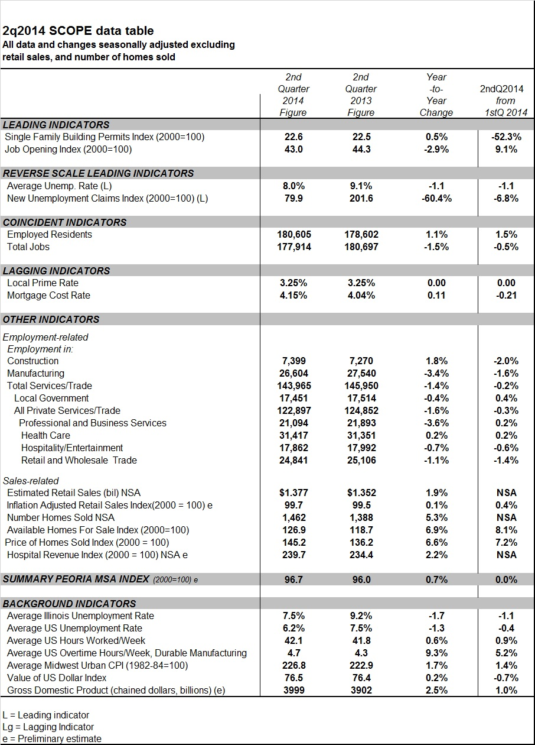Background

All business indicator data reported are adjusted for normal seasonal variation, other than quarterly

retail sales and number of homes sold. The CBER relies on SPSS for seasonal adjustment. The seasonal adjustment procedure removes the impact of seasonal components, i.e., the predictable seasonal variations of the data, so that any underlying trend in the data series can be discerned.

The "Summary Peoria-Pekin MSA Index" consists of the average of 14 key standardized, seasonally adjusted economic indicators. Indicators are standardized using a z transformation. A value of 100 corresponds to the Index value in the first quarter of 2000.

The "Single Family Building Permits" Index includes seasonally adjusted activity authorized by local building permits issued by the City of Peoria, Marshall County, Peoria County, Stark County, Tazewell County and Woodford County. The building permit activity authorized by these six governments in 2000 reflected over 80% of the nearly 1000 single family building permits issued by all governments in the five county MSA during the base year of 2000.
The "Job Opening Index" reflects help wanted postings, with an Index value of 100 corresponding to the average quarter's number of five-county help wanted postings in 2000.
The "New Unemployment Claims Index" refers to the seasonally adjusted number of new weekly unemployment claims in the five-county Peoria-Pekin MSA, with an Index value of 100 reflecting the average weekly number of new unemployment claims in 2000.
The Inflation Adjusted Retail Sales Index reflects retail spending in the Peoria-Pekin MSA, adjusted for inflation and for normal seasonal variation in retail sales. A score of 100 represents the inflation adjusted, seasonally adjusted retail sales during the first quarter of 2000.
The CBER’s five-county seasonally adjusted Index of available homes for sale is computed relative to the score of 100 in the base year of 2000. The CBER’s estimate of the seasonally adjusted Index of Price of Homes Sold is computed relative to a score of 100 in the base year of 2000.
The "Hospital Revenue Index” reflects area hospital revenues, with an Index value of 100 corresponding to the average quarter’s revenue in the base year of 2000.

The CBER uses regression models to estimates the number of jobs in area health care and to estimate the most recent quarter’s retail sales.

US government statistics compiled with seasonal adjustment include Illinois and US unemployment rates, the average number of hours worked/week by production and non-supervisory workers, average number of hours of overtime worked/week in durable manufacturing, the Midwest Urban Consumer Price Index (CPI; computed monthly for the Midwest region by the Bureau of Labor Statistics), the "Value of U.S. Dollar Index," and the Gross Domestic Product.

