First Quarter 2018 Business and Economic Indicators
Peoria-Pekin Metropolitan Statistical Area

The Composite Index of Business and Economic Indicators of the Peoria-Pekin Metropolitan Statistical Area (MSA; Peoria, Tazewell, Woodford, Stark and Marshall counties) retained its 2017 growth in the first quarter of 2018, with an Index score for the quarter of 101.8, up 0.4% from the year before, and 1.8% above the base period of the first quarter of 2010.

The Composite Index for the Peoria-Pekin MSA reflects local business and economic activity on a seasonally adjusted basis, with an Index score of 100 corresponding to the local business conditions in the first quarter of 2010. Faculty and staff of the Departments of Economics and of Management and Leadership of the Foster College of Business of Bradley University review over 30 diverse business indicators in the preparation of these quarterly assessments. A detailed analysis of these data appears below. Data reported are adjusted for normal seasonal variation, unless specified otherwise.
Labor and Job Markets

The number of area residents who are working provides a broad measure of labor market strength. Rising employment by area residents was found during the first quarter, with a 0.9% increase in the number of area residents who were working from the year before. At the same time, continued declines in area layoffs helped reduce the number of new unemployment claims filed by 14.0% from the year before. Fewer layoffs combined with increased employment have reduced the area’s first quarter unemployment rate to 4.6%, from 6.1% one year ago.

The total number of first quarter 2018 jobs on area employer payrolls was 0.7% above the first quarter of 2017. The majority of that growth was recorded at firms in the Professional and Business Services sector, with 3.1% more jobs in the first quarter of 2018 than one year before. Little change from the previous year was found in the number of jobs at two other area industries monitored: Education and Health Services (dominated by medical services), and Manufacturing.

Retail and related services

Estimated first quarter 2018 taxable retail sales of $1.25 billion were little changed from the year before. Taxable retail sales include spending on products of the retail sector and from the restaurants and related establishments of the hospitality/entertainment sector. Declines in employment from one year earlier were found for both sectors, with 1.7% fewer jobs recorded on local Retail/Wholesale trade firms’ payrolls, and 0.9% fewer jobs on area Hospitality/Entertainment firms’ payrolls. These payroll declines are consistent with the elevated Midwest employee “quit rate” of 2.0%.

Home Sales/Construction

A 2.0% reduction in the supply of homes for sale in the first quarter relative to the year before left the number of homes sold little changed from year earlier levels, with the prices of homes sold up 2.7% from the year before. Area builders continue to take out few new single family building permits, with the New Single Family Building Permits Index less than one fourth of that recorded in the base year of 2010. Employment at construction firms also fell, with 3.6% fewer jobs on local construction firms’ payrolls than the year before.
.

Review and Outlook

Long term growth trends are associated with the increased retirements of members of the large post-World War II “baby boom” cohort, as they reach their late 50’s, 60’s and 70’s. These retirements help to open opportunities for younger job seekers, and to reduce local unemployment rates (See Reinhold, 2018 for related research on age, retirement and Illinois labor force participation).

Shorter term, the increases found for local area “leading indicators”(that signal future levels of economic performance) are consistent with the longer term growth trends, and point to growth in the next few months.

Bernard Goitein, PhD
Professor of Management and Leadership
Foster College of Business

Kevin O’Brien, PhD
Professor of Economics
Foster College of Business

Richard Smilnak
MBA student,
Foster College of Business

© Bradley University

Reinhold, Rich, “Declining Labor Force Participation in Illinois: Why Have More People Stopped Working or Looking for Work” Illinois Department of Employment Security | Economic Information and Analysis Division | January 2018http://www.ides.illinois.gov/lmi/ILMR/DecliningLaborForce.pdf

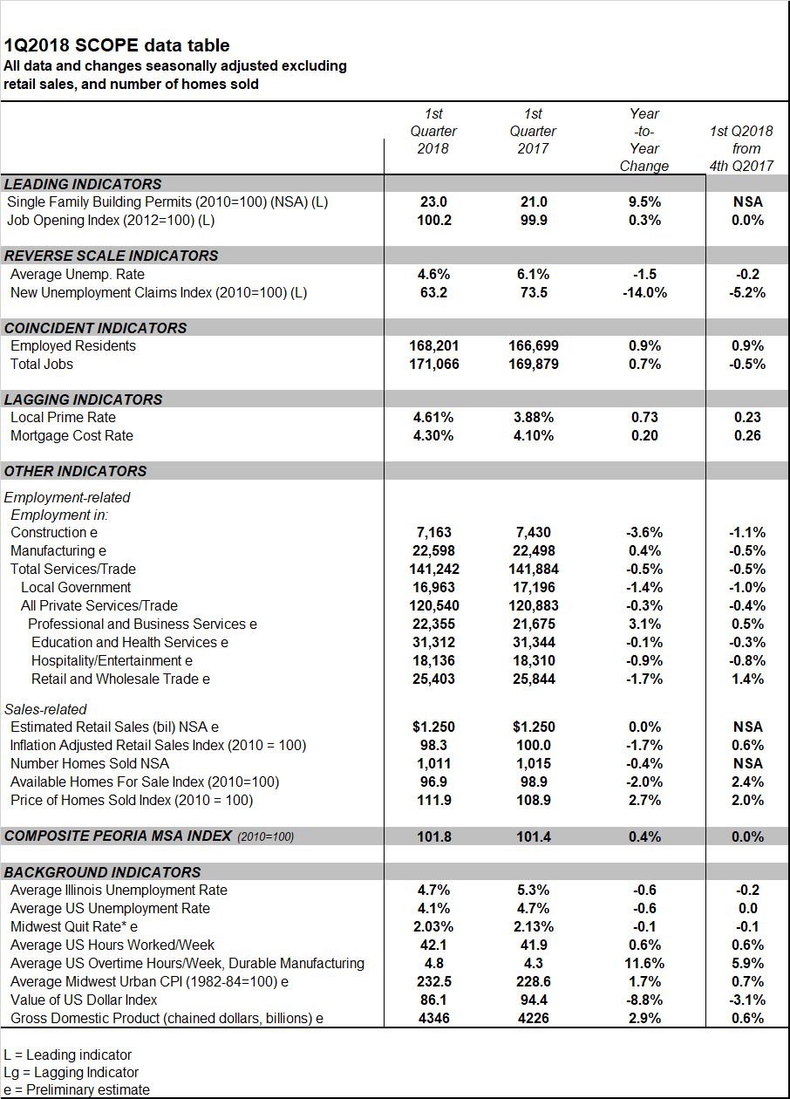

Background

Business indicator data reported are adjusted for normal seasonal variation, except where indicated otherwise.
We rely on SPSS for seasonal adjustment.The seasonal adjustment procedure removes the impact of seasonal components, i.e., the predictable seasonal variations of the data, so that any underlying trend in the data series can be discerned.

The "Composite Peoria-Pekin MSA Index" consists of the average of 14 key standardized, seasonally adjusted economic indicators. Indicators are standardized using a z transformation. A value of 100 corresponds to the Index value in the first quarter of 2010.

The "Single Family Building Permits" Index includes activity authorized by local building permits issued by the City of Peoria, Peoria County, Tazewell County and Woodford County.

The "Job Opening Index" reflects an a weighted average of new help wanted postings for the Peoria MSA, with an Index value of 100 corresponding to the average quarter's five-county help wanted postings in 2012.

The "New Unemployment Claims Index" refers to the seasonally adjusted number of new weekly unemployment claims in the five-county Peoria-Pekin MSA, with an Index value of 100 reflecting the average weekly number of new unemployment claims in 2010.

A regression model is used to estimate the most recent quarter’s taxable retail sales.The Inflation Adjusted Retail Sales Index reflects estimated taxable retail spending in the Peoria-Pekin MSA, adjusted for inflation and for normal seasonal variation in retail sales. A score of 100 represents the inflation adjusted, seasonally adjusted retail sales during the first quarter of 2010.

The five-county seasonally adjusted Index of available homes for sale is computed relative to the score of 100 in the base year of 2010.The estimate of the seasonally adjusted Index of Price of Homes Sold is computed relative to a score of 100 in the base year of 2010.

US government statistics compiled with seasonal adjustment include Illinois and US unemployment rates, the average number of hours worked/week by production and non-supervisory workers, average number of hours of overtime worked/week in durable goods manufacturing, the Midwest Urban Consumer Price Index (CPI; computed monthly for the Midwest region by the Bureau of Labor Statistics), the Midwest quit rate, Value of U.S. Dollar Index," and the Gross Domestic Product.

The Quit Rate is the number of quits during the month, divided by the number of employees who worked at that time.

