**Assignment-2**

**SG-8**

As part assignment-2 and for our project, we have implemented [**http://www.datasciencetoolkit.org/street2coordinates/**](http://www.datasciencetoolkit.org/street2coordinates/)api to get co-ordinates for given place.

Our project is university guider, which will take students to university tour for this robot should know the destination co-ordinates in order to go there so this api will be useful in our project.

We have also implemented to get current position of robot co-ordinates also.

Screenshots:

Given input as Student Union, umkc, Kansas city.

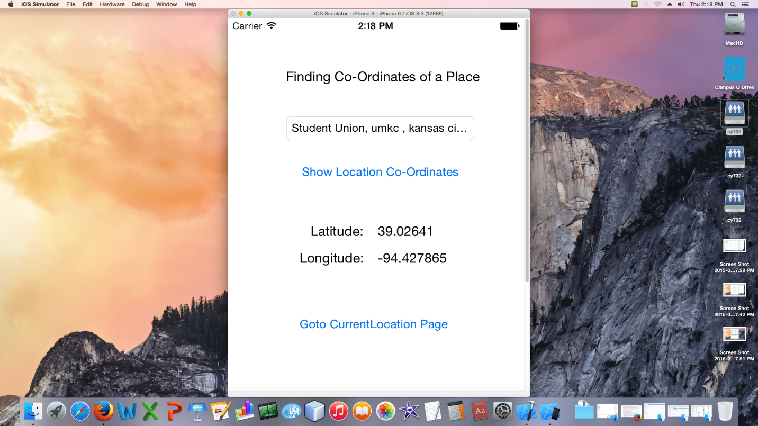

I/P: Haag Hall, Umkc, Kansas city

