**Airfoil: NACA 0018**

**Betz**

The airfoil that was picked after assignment 3 was the NACA 0018 symmetrical airfoil. The Betz analysis was started with a Reynolds number of 1e5 and from that, a design angle of attack and design coefficient of lift were obtained the C­L vs. alpha graph from XFOIL. The design angle of attack was picked because it is the highest lift achieved by the airfoil without going into the stall range. The design angle of attack is 10 degrees and design coefficient of lift is 1.0479. The table below summarizes the Betz analysis:



Figure



Figure

**MATLAB Program**

The MATLAB program consists of three main functions called “betz.m”, “bem.m”, and “cpcalc.m”. The “betz” function takes in the given variables to calculate the required unknowns which will be fed into the “bem” function. The “bem” function then calculates the required inputs for the “cpcalc” function, which ultimately has an ouput of the power coefficient for that particular scenario.

The program itself includes several parameters which have to be varied as the user sees problems with the root finding (which uses “interp1”, more error prone but does not require a curve fit, just data points). The root finding by interpolation will choose any root if the two CL vs. alpha curves insect at different points, therefore the user must constrain the “alpha sweep angle” for the BEM analysis to force the CL vs. alpha curve to hit the XFOIL data only at one point.

Another hurdle to overcome was to format the XFOIL data to not have any missing data points. Since interpolation was used to find where the two curves intersect, it was important to match the number of points that XFOIL provides to the number of points generated with the BEM analysis. Specifically, XFOIL would sometimes omit certain angles of attack because that particular did not converge to a result. The data were manually interpolated to create a data point so that the interpolation could work to find the points of intersection.

Finally, once all the functions have been tied together to generate a power coefficient, the lambda can be altered either automatically or manually (programmed in or changed by user). Once several data points have been obtained from the function, a graph of Cp vs. lambda can be generated to determine the optimum lambda for the rotor.

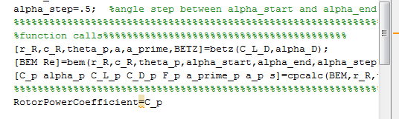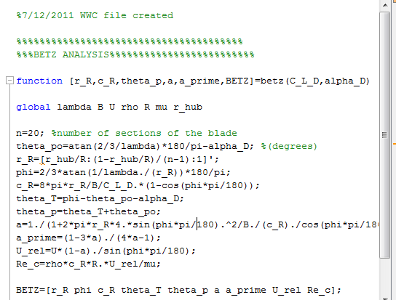

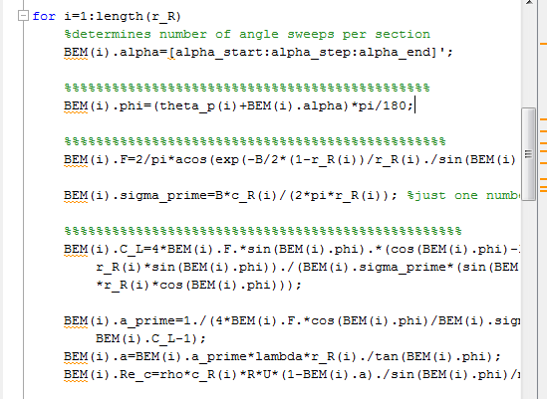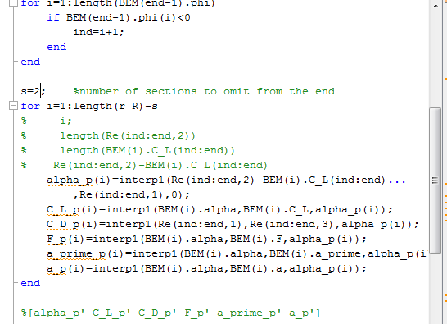

**Plots Generated by MATLAB**



Figure

The left graph of figure 3 shows the XFOIL data plotted with the CL vs. alpha from the BEM analysis for 20 sections. Note the line CL = 0 which is the coefficient of lift for the last section. It is 0 for all angles of attack because the correction factor is 0 in all cases at the end of the rotor blade. The plots from the BEM analysis are cut off at 5 degrees of angle of attack because the curves intersect twice at some sections. This eliminates two possible roots for the interpolation to find.

The right graph shows the predicted alpha obtained from the intersection of the BEM analysis plot and XFOIL data. The results show that the angle of attack trails off to about 8.3 at the end of the blades and is consistent with the plot on the left.



Figure

Figure 4 shows the axial and angular induction factors from the Betz and BEM analysis together on the same graph, versus relative radius.



Figure

Figure 5 shows the predicted CL and predicted CD versus relative radius (top two graphs) and the relative chord and section twist also versus relative radius (bottom two graphs).



Figure 6

Figure 6 shows the predicted Cp versus lambda curve. Aside from the unexpected local maximum at lambda equal to 9, the overall power coefficient curve looks similar to other power coefficient versus lambda curves. From this data, it is predicted that the rotor (with specifications of R=0.5m and r_hub=0.0762m) will perform at its best at a tip speed ratio of 4, given 3 blades and free stream air moving at 7 m/s.