建筑物采集接口及数据JSON格式
字段 | 数据类型 | 含义 | 是否必须
jzwid | VARCHAR2(36) | 建筑物ID | 必须
lcs | NUMBER(3) | 楼层数 | 必须
dys | NUMBER(3) | 单元数/行数 | 必须
mdyms | NUMBER(3) | 每层门数/房间数 | 必须
sflcxt | CHAR(1) | 是否单元楼层相同 | 必须
sfmsxt | CHAR(1) | 是否门数相同 | 必须
dxcs | NUMBER(3) | 地下层数 | 地下房间按单元分布时  dxmcms等于mdyms
dxmcms | NUMBER(3) | 地下每层门数/房间数 | 地下房间按单元分布时  dxmcms等于mdyms
postfix_dy | VARCHAR2 | 单元后缀 | 必须
postfix_lc | VARCHAR2 | 楼层后缀 | 必须
postfix_lc | VARCHAR2 | 楼层后缀 | 必须
width_dy | NUMBER(3) | 单元号位数 | 必须
width_lc | NUMBER(3) | 楼层号位数 | 必须
width_fj | NUMBER(3) | 房间号位数 | 必须
from | NUMBER(3) | 起始楼层数 | 必须
to | NUMBER(3) | 结束楼层 | 必须
value | VARCHAR2 | 房间号前缀值 | 必须
dxlcs |  | 地下楼层数 | 地下房间不按单元分布时
mcms |  | 地下每层门数 | 地下房间不按单元分布时

1.地下放房间不按单元分布
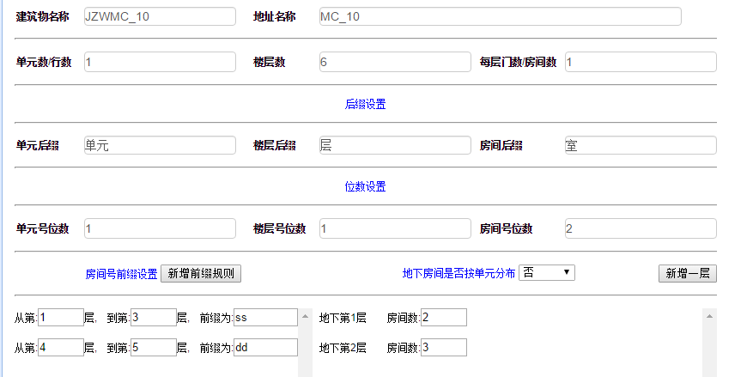
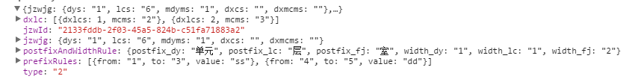

{postfixAndWidthRule=
{"width_lc":"1","postfix_lc":"层",
"postfix_dy":"单元","postfix_fj":"室","width_dy":"1","width_fj":"2"}, dxlc=[{"dxlcs":1,"mcms":"2"},{"dxlcs":2,"mcms":"3"}], jzwjg={"dxmcms":"","mdyms":"1","dxcs":"","lcs":"6","dys":"1"}, jzwId=2133fddb-2f03-45a5-824b-c51fa71883a2, type=2, prefixRules=[{"from":"1","to":"3","value":"ss"},{"from":"4","to":"5","value":"dd"}]}

2. 地下房间按照单元分布
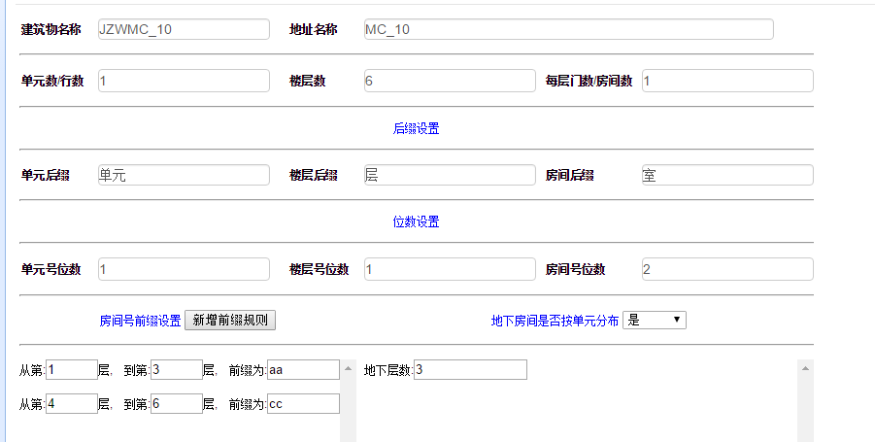
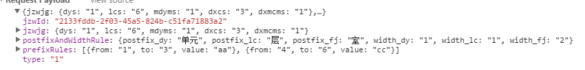

{postfixAndWidthRule={"width_lc":"1","postfix_lc":"层","postfix_dy":"单元","postfix_fj":"室","width_dy":"1","width_fj":"2"}, jzwjg={"dxmcms":"1","mdyms":"1","dxcs":"3","lcs":"6","dys":"1"}, jzwId=2133fddb-2f03-45a5-824b-c51fa71883a2, type=1, prefixRules=[{"from":"1","to":"3","value":"aa"},{"from":"4","to":"6","value":"cc"}]}

