# 1常住人口采集

## 1.1：业务逻辑说明

（1）进入信息采集页面

（2）根据房间加载加载部分采集信息

（3）根据身份证号加载采集信息

输入身份证号后：系统会先根据身份证号在常住人口管理表中查询是否有该人的信息，如果有直接把该人的信息带回，如果没有去人口库里面去查询，如果人口库里面有，把人口库里面的信息带回（信息不全，需手动填一部分）如果没有手动填写。

进入常住人口信息采集页面

根据身份证号需要加载图片信息，在照片表里面查询

（4）填写表单并提交

## 1.2：接口的具体说明

### 1.2.1：进入信息采集页面

URL: device/ enterSyFwCzrkAccInfo method=get

所需要参数： jzwfjid 建筑物房间Id

类型： String varchar2(36)

其中地址信息中的信息不需要手动填写，

调用 ISyFwCzrkService中loadFwCzrkAccInfo(String jzwfjid)

参数jzwfjid 建筑物房间Id

类型： String varchar2(36)

返回值为一个常住人口的实体czrk:

其中包括字段：ssxq（所属县区代码：数据库字段）

ssxq_mc （所属县区名称，业务逻辑显示用，非数据库字段）

jlxc （街路巷村代码：数据库字段）

jlxc_mc（街路巷村名称：业务逻辑显示用，非数据库字段）

mlph (门楼牌号:数据库字段，必填项)

mlxz（门楼详址：数据库字段）

sspcs（所属派出所Id:数据库字段）

pcs_mc（所属派出所名称：业务逻辑显示用，非数据库字段）

jwzrqdm（警务责任区Id,数据库字段）

jwzrq_mc（警务责任区名称, 业务逻辑显示用，非数据库字段）

服务器端效果图如下：

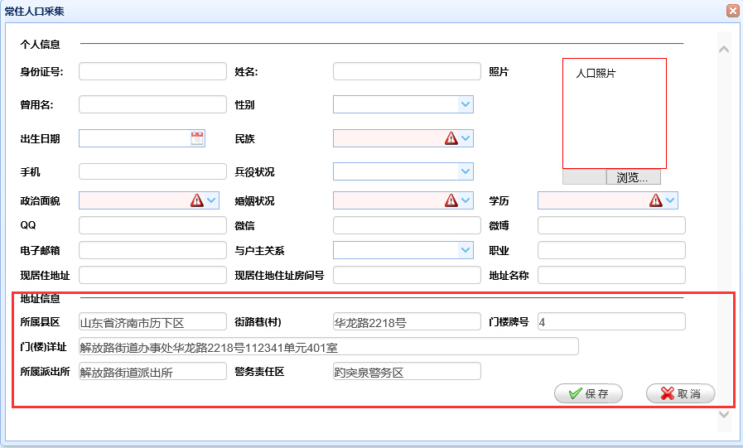

### 1.2.2：根据身份证号加载采集信息

输入身份证号后，系统根据身份证号查询调用接口：

url: device / loadCzrkInfo method:Post

返回数据格式如下

{"confirmMsg":"","data":{"byzk":"2","bz":"","csdgj":"","csdssx":"","csrq":"2016-01-05","cssj":"","czhkszd":"","czhkszdzz":"","czhkszdzzfjh":"","deltag":"0","deltime":null,"djdw":"370102001000","djdwmc":"解放路街道派出所","djr":"user_test_05","djrmc":"user_test_05","djsj":"2016-01-04 20:22:05","dzbm":"19b861b3-a467-4809-8572-f12fd79dff30","dzmc":"as","fqgmsfhm":"","fqxm":"","fwcs":"","gmsfhm":"372626188990312456","gxsj":"2016-01-07 21:46:07","hid":"aa69e700-51cb-4318-831b-cecb35d5a3ae","hjdxz":"","hyzk":"10","jggj":"","jgssx":"","jhregmsfhm":"","jhregx":"","jhrexm":"","jhrxm":"","jhrygx":"","jkrgmsfhm":"","jlxc":"03C5FA5F-9F8A-2EE1-7B8E-F23F3E044218","jlxc_mc":"","jwh":"","jwzrq_mc":"","jwzrqdm":"370102001015","jzwfjid":"1a921374-2311-4e0b-a5a8-ae2fa066b585","jzwid":"","lrfs":"0","lrjs":"","lrwl":"","lxfsgh":"","lxfsqt":"","lxfssj":"15624585978","mlph":"4","mlxz":"解放路街道办事处华龙路2218号112341单元303室","movesign":"","mqgmsfhm":"","mqxm":"","mz":"97","pcs":"","pcs_mc":"","pogmsfhm":"","poxm":"","rkbh":"aa69e700-51cb-4318-831b-cecb35d5a3ae","rkid":"aa69e700-51cb-4318-831b-cecb35d5a3ae","sbid":"","sg":null,"sspcs":"370102001000","ssxq":"1703ba8f-300a-44a4-bf35-c72d4b6f32a8","ssxq_mc":"","whcd":"","xb":"1","xgdw":"370102001000","xgdwmc":"解放路街道派出所","xgr":"user_test_05","xgrmc":"user_test_05","xjzd":"","xjzdzz":"123","xjzdzzfjh":"412","xl":"10","xm":"小马","xx":"","xxbcCyzk":"","xxbcDzyx":"642833413@qq.com","xxbcFwcs":"","xxbcFwcsxz":"","xxbcJjzk":"","xxbcJtgj":"","xxbcLxdh":"","xxbcMsn":"","xxbcQq":"642833413","xxbcRklb":"","xxbcSfrhfl":"","xxbcSfzdbd":"","xxbcWb":"weibo","xxbcWx":"1222","xxbcXzdxz":"","xxbcZzmm":"","xzjd":"","xzjd_mc":"","yhzgx":"111","zbx":null,"zby":null,"zjxy":"","zrr":"","zxrq":null,"zxzt":"0","zy":"as","zym":"xiaoma","zzmm":"3"},"forwardUrl":"","message":"数据加载成功","statusCode":200,"token":""}

所需参数：

1. jzwfjid 建筑物房间Id, 类型： String varchar2(36)
2. sfzh 身份证号,类型：String

返回值：（1）状态码为200 ，返回Json对象

包括：个人的所有信息

身份证号：gmsfhm 非空 length[15,18]

姓名： xm 非空 length[1,50]

曾用名： zym length[0,50]

性别： xb 数据字典项 性别-CHAR(1)

出生日期：csrq VARCHAR2(10)

民族： mz 数据字典项 CHAR(2)

手机： lxfssj VARCHAR2(50)

兵役状况： byzk VARCHAR2(36)

政治面貌zzmm 数据字典项 VARCHAR2(36)

婚姻状况：hyzk 数据字典项 VARCHAR2(10)

学历：xl 数据字典项 VARCHAR2(36)

QQ: xxbcQq VARCHAR2(36)

微信：xxbcWx VARCHAR2(36)

微博：xxbcWb VARCHAR2(36)

电子邮箱：xxbcDzyx VARCHAR2(36)

与户主关系：yhzgx 数据字典项 VARCHAR2(36)

职业：zy VARCHAR2(36)

现居住地址：xjzdzz VARCHAR2(500)

现居住地址房间号：xjzdzzfjh VARCHAR2(50)

地址名称：dzmc VARCHAR2(200)

相片 xp byte[]

(2)状态码为202，返回Josn对象

其中包括：

性别：xb

曾用名：CYM

兵役状况：BYZK

婚姻状况：HYZK

学历：WHCD

民族：MZ

姓名：XM

出生日期：CSRQ

相片 xp

(3)状态码为300，提示："该采集信息已经存在"

（4）状态码为201 ：需要手动填写

## 1.2.3表单的填写和提交

表单填写完成，需要填写的项如1.2.2状态码为200时所介绍的

表单提交：

请求 URL: device/savefwCzrkAccInfo

请求方法: POST

参数：Json 串

返回值：

{"confirmMsg":"","data":null,"forwardUrl":"","message":"操作成功","statusCode":200,"token":""}

状态码：200 操作成功

状态码：400 服务器错误

状态码：300 e.getMessage()

# 2：流动人口信息采集

## 2.1业务逻辑说明

（1）进入信息采集页面

（2）根据房间加载加载部分采集信息

（3）根据身份证号加载采集信息

输入身份证号后：系统会先根据身份证号在流动人口管理表中查询是否有该人的信息，如果有直接把该人的信息带回，如果没有去人口库里面去查询，如果人口库里面有，把人口库里面的信息带回（信息不全，需手动填一部分）如果没有手动填写。

进入流动人口信息采集页面

根据身份证号需要加载图片信息，在照片表里面查询

1. 填写表单并提交

## 2.2接口的具体说明

### 2.2.1进入流动人口信息采集页面

请求 URL:  [device /enterSyFwLdrkAccInfo](http://localhost:8081/psam/psam/sy/syfwLdrk/enterSyFwLdrkAccInfo)

请求方法: GET

所需要参数： jzwfjid 建筑物房间Id

类型： String varchar2(36)

其中地址信息中的信息不需要手动填写：

包括：

ssxqdm ：省市县（区）数据库字段

ssxqdm_mc：省市县（区）业务逻辑用-非数据库字段

ssjlxxqDzbm：所属街路巷(小区)_地址编码

ssjlxxqDzbm_mc：所属街路巷(小区)_地址名称--业务逻辑用-非数据库字段

fjh：房间号

xxdz：现居住地详细地址

sdpcs：属地派出所代码

sdpcs_mc：属地派出所名称 业务逻辑用-非数据库字段

jwzrq：警务责任区代码

jwzrq_mc：警务责任区名称 业务逻辑用-非数据库字段

服务器端效果图如下：

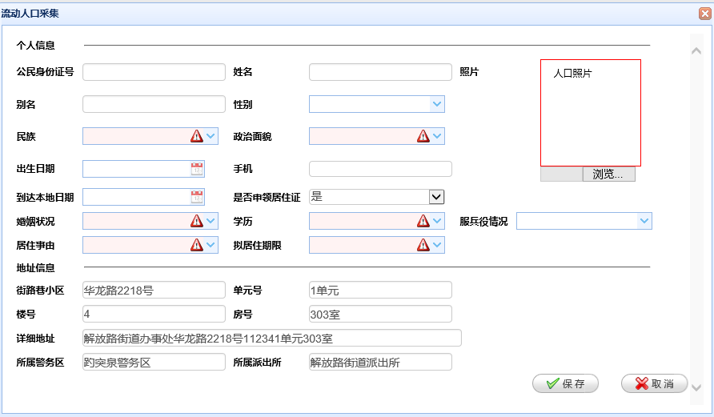

### 2.2.2根据身份证号加载流动人员信息

输入身份证号号根据身份证号查询

请求 URL:  [device /loadLdrkInfo](http://localhost:8081/psam/psam/sy/syfwLdrk/loadLdrkInfo)

参数：

（1）sfzh 类型：String

（2）jzwfjid 类型：String

返回数据格式如下：

{"confirmMsg":"","data":{"bdsjQk":null,"bdsjSd":null,"bdsjZt":null,"bm":"xiaoma","bz":"","bzdz":null,"cbqk":"","csrq":"2016-01-07 00:00:00","cszy":"","czfwId":"","czhkszd":"","czhkszdzz":"","czhkszdzzfjh":"","czlx":"","ddbdrq":"2016-01-13 00:00:00","deltag":"0","deltime":null,"djdw":"370102001000","djdwmc":"解放路街道派出所","djr":"user_test_05","djrmc":"user_test_05","djsj":"2016-01-04 20:24:55","drbz":"","dsdm":"","dsdr":"","dszj":"","dwdz":"","dwfzr":"","dwlxdh":"","dwpcs":"","dwssfj":"","dwsspcs":"","dyh":"1单元","dzSsxq":"","dzSsxq_mc":"","dzXzjd":"","dzbm":"3e39f307-ad9c-4460-83be-996953b83940","dzxqCzlx":"","dzxqSpzt":"","etsfyfjz":"","fbyqk":"1","fh":"401室","fjbm":"e3886962-5598-4330-a224-c9df9b91c526","fz":"","fzSfzh":"","fzsj":null,"gajgdm":"","gxsj":null,"gzdw":"","gzdwszfj":"","hjdxzqh":"","hsbz":"","hsrsfzh":"","hssj":null,"hyzk":"10","hyzmbh":"","id":"4bfc7533-1d0e-4f80-a381-774019241116","jlxxq":"华龙路2218号","jzdywgzdw":"","jzsy":"01","jzwid":"","jzzyxq":null,"ldhtqdqk":"","ldid":"4bfc7533-1d0e-4f80-a381-774019241116","lh":"4","lrfs":"0","lrjs":"","lrwl":"","lsh":"","lxfsGh":"","lxfsSj":"15698745698","lxfsXlt":"","movesign":"","mph":"","mz":"01","njzqx":"1","objectid":"","qfbz":"","qfr":"","qfsj":null,"qt":"","qtlxfsEmail":"","qtlxfsQq":"","sbid":"","sfbdQk":"","sfbdSd":"","sfbdZt":"","sfbhb":"","sfcjgz":"","sfcqjycs":"","sfedtcq":"","sfedzdq":"","sfjzcq":"","sfls":"","sfsljzz":"1","sfsy":"","sfyxzz":"","sfzh":"369878255660144536","shdwdm":"","shrsfzh":"","shrxm":"","shsj":null,"sjly":"","sjyxx":"","sjyxxYzsj":null,"slsj":null,"spzt":"","sqjcwh":"","ssjwq":"370102001015","ssjwq_mc":"","sspcs":"370102001000","sspcs_mc":"","syznNan":null,"syznNv":null,"tbdwdm":"","tbrsfzh":"","tbrxm":"","tbsj":null,"xb":"1","xgdw":"","xgdwmc":"","xgr":"","xgrmc":"","xjzd":"","xjzdzz":"","xjzdzzfjh":"","xl":"10","xlh":"4bfc7533-1d0e-4f80-a381-774019241116","xm":"小马","xxdz":"解放路街道办事处华龙路2218号112341单元401室","xzdxzqh":"","xzjd":"","ygznx":"","zbx":null,"zbxGps":null,"zbxTdt":null,"zby":null,"zbyGps":null,"zbyTdt":null,"zhxgsj":null,"zp":[],"zslb":"","zxbz":"0","zxrq":null,"zxsj":null,"zxzt":"0","zyjszw":"","zyzg":"","zzbz":"","zzmm":"3","zzsj":null,"zzzt":""},"forwardUrl":"","message":"数据加载成功","statusCode":200,"token":""}

返回值：

状态码为200时

|  |  |  |  |  |  |
| --- | --- | --- | --- | --- | --- |
| 字段 | 说明 | 数据字典项 | 类型 | 长度 | 是否必填 |
| sfzh | 身份证号 | 否 | String | VARCHAR2(20) | 是 |
| xm | 姓名 | 否 | String | VARCHAR2(50) | 是 |
| bm | 别名 | 否 | String | VARCHAR2(50) |  |
| xb | 性别 | 是 | String | VARCHAR2(10) |  |
| mz | 民族 | 是 | String | VARCHAR2(10) | 是 |
| zzmm | 政治面貌 | 是 | String | VARCHAR2(10) | 是 |
| csrq | 出生日期 | 否 | DATE |  |  |
| lxfsSj | 手机 |  | String | VARCHAR2(50) |  |
| ddbdrq | 到达本地日期 |  | DATE |  |  |
| sfsljzz | 是否申领居住证 |  | String | （0否1是）-CHAR(1) |  |
| hyzk | 婚姻状况 | 是 | String | VARCHAR2(10) | 是 |
| xl | 学历 | 是 | String | VARCHAR2(10) | 是 |
| fbyqk | 服兵役情况 | 是 | String | CHAR(1) |  |
| jzsy | 居住事由 | 是 | String | VARCHAR2(10) | 是 |
| njzqx | 拟居住期限 | 是 | String | VARCHAR2(20) | 是 |
| xp | 相片 |  | Byte[] |  | 是 |
|  |  |  |  |  |  |
|  |  |  |  |  |  |
|  |  |  |  |  |  |

状态码为202时：

|  |  |  |  |  |
| --- | --- | --- | --- | --- |
| 字段 | 说明 | 数据字典项 | 类型 | 长度 |
| xb | 性别 |  |  |  |
| cym | 别名 |  |  |  |
| byzk | 服兵役情况 |  |  |  |
| hyzk | 婚姻状况 |  |  |  |
| whcd | 学历 |  |  |  |
| mz | 民族 |  |  |  |
| xm | 姓名 |  |  |  |
| csrq | 出生日期 |  |  |  |
| xp | 相片 |  |  |  |

状态码为300 ：该采集信息已经存在

状态码为201 ：未查询到数据

### 2.2.3表单的填写和提交

请求 URL: device/saveSyFwLdrkAccInfo

请求方法: POST

参数：Json

返回值：

{"confirmMsg":"","data":null,"forwardUrl":"","message":"操作成功","statusCode":200,"token":""}

状态码：200 操作成功

状态码：400 服务器错误

状态码：300 e.getMessage()

# 3.境外人员信息采集

## 3．1业务逻辑说明

（1）进入信息采集页面

（2）根据房间加载加载部分采集信息

（3）根据身份证号加载采集信息

输入身份证号后：系统会先根据身份证号在常住人口管理表中查询是否有该人的信息，如果有直接把该人的信息带回，如果没有去人口库里面去查询，如果人口库里面有，把人口库里面的信息带回（信息不全，需手动填一部分）如果没有手动填写。

进入境外人口信息采集页面

根据身份证号需要加载图片信息，在照片表里面查询

（4）填写表单并提交

## 3.2接口的具体说明

进入境外人员信息采集页面：

URL:  [device /enterSyFwJwryAccInfo](http://localhost:8081/psam/psam/sy/syFwJwry/enterSyFwJwryAccInfo)

请求方法: GET

所需要参数： jzwfjid 建筑物房间Id

类型： String varchar2(36)

其中地址信息中的信息不需要手动填写：

包括：

ssxqdm ：省市县（区）数据库字段

ssxqdm_mc：省市县（区）业务逻辑用-非数据库字段

ssjlxxqDzbm：所属街路巷(小区)_地址编码

ssjlxxqDzbm_mc：所属街路巷(小区)_地址名称--业务逻辑用-非数据库字段

fjh：房间号

xxdz：现居住地详细地址

sdpcs：属地派出所代码

sdpcs_mc：属地派出所名称 业务逻辑用-非数据库字段

jwzrq：警务责任区代码

jwzrq_mc：警务责任区名称 业务逻辑用-非数据库字段

服务器端效果图：

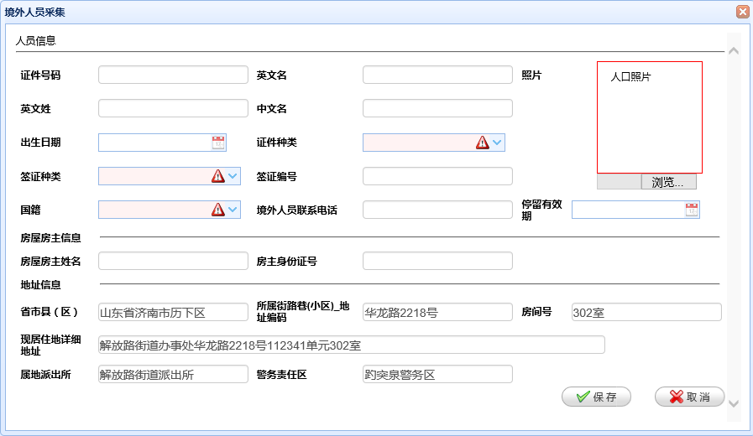

### 3.2.1根据证件号码加载采集信息

请求 URL: device /loadJwryInfo

参数：

（1）sfzh 类型：String

（2）jzwfjid 类型：String

返回数据格式如下：

{"confirmMsg":"","data":{"bz":"","cjry":"","cjrylxdh":"","cjsj":null,"csrq":"2016-01-06 00:00:00","deltag":"0","deltime":null,"djdw":"370102001000","djdwmc":"解放路街道派出所","djr":"user_test_05","djrmc":"user_test_05","djsj":"2016-01-04 20:26:16","dzbm":"dc4fb4fd-2db1-49fa-b283-c4dfaf850558","fjbm":"e3886962-5598-4330-a224-c9df9b91c526","fjh":"401室","fwfzxm":"xizo,a","fzsfzh":"369874566332144535","gj":"CN","gjdm":"","gxsj":null,"gzxxsf":"","jlqk":"","jlsy":"","jlxkhm":"","jwryid":"1766e137-be75-4fd3-9023-d9346f4f3b61","jwrylkrq":null,"jwrylxdh":"wewe","jwryzp":[],"jwzrq":"370102001015","jwzrq_mc":"","jzdxz":"","jzwid":"","lhsf":"","lrfs":"0","lrjs":"","lrwl":"","lzrq":null,"movesign":"","qfjg":"","qzbh":"weeee","qzcs":"","qzzl":"C","rjka":"","rjrq":null,"rkfl":"","rylb":"","rzfs":"","rzrq":null,"rzsj":null,"sbid":"","sdpcs":"370102001000","sdpcs_mc":"","ssjlxxqDzbm":"00035802218000000000000","ssjlxxqDzbm_mc":"","ssxqdm":"1703ba8f-300a-44a4-bf35-c72d4b6f32a8","ssxqdm_mc":"","sxrycsrq1":null,"sxrycsrq2":null,"sxrydwmc1":"","sxrydwmc2":"","sxryqsgx1":"","sxryqsgx2":"","sxryxb1":"","sxryxb2":"","sxryywxm1":"","sxryywxm2":"","sxryzwxm1":"","sxryzwxm2":"","tjflg":"","tlyxq":"2016-01-05 00:00:00","xgdw":"","xgdwmc":"","xgr":"","xgrmc":"","xxdz":"解放路街道办事处华龙路2218号112341单元401室","xzzhuid":"","xzzhuidgxsj":null,"xzzqh":"","xzzssfjdm":"","ywm":"wee","ywx":"qwewe","zhgzjgdm":"","zhgzjgmc":"","zjhm":"369874569874563215","zjzl":"1","zslxfs":"","zwm":"weee","zwsp":"","zxrq":null,"zxzt":"0","zy":""},"forwardUrl":"","message":"数据加载成功","statusCode":200,"token":""}

返回值：

状态码为200时

|  |  |  |  |  |  |
| --- | --- | --- | --- | --- | --- |
| 字段 | 说明 | 数据字典项 | 类型 | 长度 | 是否必填 |
| zjhm | 证件号码 |  | String | VARCHAR2(50) | 是 |
| ywm | 英文名 |  | String | VARCHAR2(50) | 是 |
| ywx | 英文姓 |  | String | VARCHAR2(50) | 是 |
| zwm | 中文名 |  | String | VARCHAR2(50) |  |
| csrq | 出生日期 |  | DATE |  |  |
| zjzl | 证件种类 | 是 | String | VARCHAR2(36) | 是 |
| qzzl | 签证种类 | 是 | String | VARCHAR2(36) | 是 |
| qzbh | 签证编号 |  | String | VARCHAR2(50) |  |
| gj | 国籍 | 是 | String | VARCHAR2(36) | 是 |
| jwrylxdh | 境外人员联系电话 |  | String | VARCHAR2(50) |  |
| tlyxq | 停留有效期 |  | Date |  |  |
| fwfzxm | 房屋房主姓名 |  | String | VARCHAR2(50) | 是 |
| fzsfzh | 房主身份证号 |  | String | VARCHAR2(20) | 是 |
| xp | 相片 |  |  |  |  |
|  |  |  |  |  |  |
|  |  |  |  |  |  |
|  |  |  |  |  |  |
|  |  |  |  |  |  |
|  |  |  |  |  |  |

状态码为202

csrq ：出生日期

状态码：400服务器错误

状态码：300 e.getMessage()

### 3.3.3：表单的填写和提交

请求 URL: device.saveSyFwJwryAccInfo

请求方法: POST

参数：Json 串

返回值：

{"confirmMsg":"","data":null,"forwardUrl":"","message":"操作成功","statusCode":200,"token":""}

状态码：200 操作成功

状态码：400 服务器错误

状态码：300 e.getMessage()

# 4.房屋信息采集

## 4.1：业务逻辑说明

（1）进入信息采集页面

（2）根据房间加载加载部分采集信息

（3）填写表单并提交

## 4.2：接口的具体说明

进入采集页面

device /loadFwjbxxAccInfo

请求方法: GET

所需要参数： jzwfjid 建筑物房间Id

类型： String varchar2(36)

根据房间带回信息：

|  |  |  |  |  |
| --- | --- | --- | --- | --- |
| 字段 | 说明 | 是否为数据库字段 | 长度 | 类型 |
| ssxqdm | 省市县（区） | 是 |  |  |
| ssjlxxq_mc | 省市县（区名称 | 否 |  |  |
| fjbm | 房间编码 | 是 |  |  |
| fjh | 房间号 | 是 |  |  |
| fwdz | 房屋地址详细地址 | 是 |  |  |
| sdpcs | 属地派出所 | 是 |  |  |
| sdpcs_mc | 属地派出所名称 | 否 |  |  |
| jwzrq | 警务责任区 | 是 |  |  |
| jwzrq_mc | 警务责任区名称 | 否 |  |  |

手动填写项：

|  |  |  |  |  |  |
| --- | --- | --- | --- | --- | --- |
| 字段 | 说明 | 是否必填 | 类型 | 长度 | 数据字典项 |
| fwlb | 房屋类别 | 是 | String | VARCHAR2(2) | 是 |
| fwxz | 房屋性质 | 是 | String | VARCHAR2(2) | 是 |
| fwyt | 房屋用途 | 是 |  |  | 是 |
| fwlx | 房屋类型 | 是 |  |  | 是 |
| fwcqzh | 房屋产权证号 | 是 | String | VARCHAR2(50) |  |
| sfczfw | 是否出租房屋 |  | String | VARCHAR2(1)  0：否1：是 |  |
| hx | 户型（*室*厅） | 是 | String | VARCHAR2(36) |  |
| fwjs | 房屋间数 |  | Integer | NUMBER(8) |  |
| fwmj | 房屋面积 |  | BigDecimal | NUMBER(12,2) |  |
| fzxm | 房主姓名 | 是 | String | VARCHAR2(50) |  |
| fzsfzhm | 房主身份证号码 | 是 | String | VARCHAR2(20) |  |
| fzlxdh | 房主联系电话 |  | String | VARCHAR2(50) |  |
| tgrxm | 托管人姓名 |  | String | VARCHAR2(50) |  |
| tgrsfzhm | 托管人身份证号码 |  | String | VARCHAR2(20) |  |
| tgrlxdh | 托管人联系电话 |  | String | VARCHAR2(50) |  |
| yfzgx | 与房主关系 |  | String | VARCHAR2(36) |  |
| fwssdwbm | 房屋所属单位编码 | 是 | String | VARCHAR2(36) |  |
| fwssdwmc | 房屋所属单位名称 | 是 | String | VARCHAR2(200) |  |
|  |  |  |  |  |  |

## 4.3提交表单

请求 URL: device.saveFwjbxxAccInfo

参数：json串

返回值：{"confirmMsg":"","data":null,"forwardUrl":"","message":"操作成功","statusCode":200,"token":""}