# 1常住人口采集

## 1.1：业务逻辑说明

（1）进入信息采集页面

（2）根据房间加载加载部分采集信息

（3）根据身份证号加载采集信息

输入身份证号后：系统会先根据身份证号在常住人口管理表中查询是否有该人的信息，如果有直接把该人的信息带回，如果没有去人口库里面去查询，如果人口库里面有，把人口库里面的信息带回（信息不全，需手动填一部分）如果没有手动填写。

进入常住人口信息采集页面

根据身份证号需要加载图片信息，在照片表里面查询

（4）填写表单并提交

## 1.2：接口的具体说明

### 1.2.1：进入信息采集页面

URL: <http://localhost:8081/psam/psam/sy/syfwCzrk/enterSyFwCzrkAccInfo> method=get

所需要参数： jzwfjid 建筑物房间Id

类型： String varchar2(36)

其中地址信息中的信息不需要手动填写，

调用 ISyFwCzrkService中loadFwCzrkAccInfo(String jzwfjid)

参数jzwfjid 建筑物房间Id

类型： String varchar2(36)

返回值为一个常住人口的实体czrk:

其中包括字段：ssxq（所属县区代码：数据库字段）

ssxq_mc （所属县区名称，业务逻辑显示用，非数据库字段）

jlxc （街路巷村代码：数据库字段）

jlxc_mc（街路巷村名称：业务逻辑显示用，非数据库字段）

mlph (门楼牌号:数据库字段，必填项)

mlxz（门楼详址：数据库字段）

sspcs（所属派出所Id:数据库字段）

pcs_mc（所属派出所名称：业务逻辑显示用，非数据库字段）

jwzrqdm（警务责任区Id,数据库字段）

jwzrq_mc（警务责任区名称, 业务逻辑显示用，非数据库字段）

服务器端效果图如下：

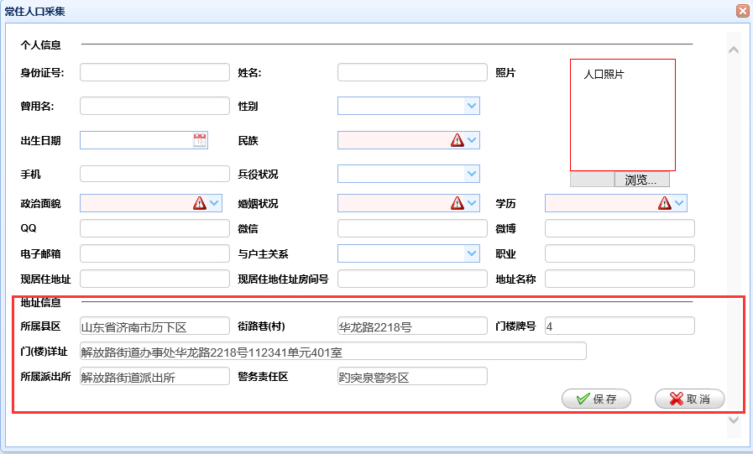

### 1.2.2：根据身份证号加载采集信息

输入身份证号后，系统根据身份证号查询调用接口：

url: http://localhost:8081/psam/psam/sy/syfwCzrk/ loadCzrkInfo method:Post

返回数据格式如下

{"confirmMsg":"","data":{"byzk":"2","bz":"","csdgj":"","csdssx":"","csrq":"2016-01-05","cssj":"","czhkszd":"","czhkszdzz":"","czhkszdzzfjh":"","deltag":"0","deltime":null,"djdw":"370102001000","djdwmc":"解放路街道派出所","djr":"user_test_05","djrmc":"user_test_05","djsj":"2016-01-04 20:22:05","dzbm":"19b861b3-a467-4809-8572-f12fd79dff30","dzmc":"as","fqgmsfhm":"","fqxm":"","fwcs":"","gmsfhm":"372626188990312456","gxsj":"2016-01-07 21:46:07","hid":"aa69e700-51cb-4318-831b-cecb35d5a3ae","hjdxz":"","hyzk":"10","jggj":"","jgssx":"","jhregmsfhm":"","jhregx":"","jhrexm":"","jhrxm":"","jhrygx":"","jkrgmsfhm":"","jlxc":"03C5FA5F-9F8A-2EE1-7B8E-F23F3E044218","jlxc_mc":"","jwh":"","jwzrq_mc":"","jwzrqdm":"370102001015","jzwfjid":"1a921374-2311-4e0b-a5a8-ae2fa066b585","jzwid":"","lrfs":"0","lrjs":"","lrwl":"","lxfsgh":"","lxfsqt":"","lxfssj":"15624585978","mlph":"4","mlxz":"解放路街道办事处华龙路2218号112341单元303室","movesign":"","mqgmsfhm":"","mqxm":"","mz":"97","pcs":"","pcs_mc":"","pogmsfhm":"","poxm":"","rkbh":"aa69e700-51cb-4318-831b-cecb35d5a3ae","rkid":"aa69e700-51cb-4318-831b-cecb35d5a3ae","sbid":"","sg":null,"sspcs":"370102001000","ssxq":"1703ba8f-300a-44a4-bf35-c72d4b6f32a8","ssxq_mc":"","whcd":"","xb":"1","xgdw":"370102001000","xgdwmc":"解放路街道派出所","xgr":"user_test_05","xgrmc":"user_test_05","xjzd":"","xjzdzz":"123","xjzdzzfjh":"412","xl":"10","xm":"小马","xx":"","xxbcCyzk":"","xxbcDzyx":"642833413@qq.com","xxbcFwcs":"","xxbcFwcsxz":"","xxbcJjzk":"","xxbcJtgj":"","xxbcLxdh":"","xxbcMsn":"","xxbcQq":"642833413","xxbcRklb":"","xxbcSfrhfl":"","xxbcSfzdbd":"","xxbcWb":"weibo","xxbcWx":"1222","xxbcXzdxz":"","xxbcZzmm":"","xzjd":"","xzjd_mc":"","yhzgx":"111","zbx":null,"zby":null,"zjxy":"","zrr":"","zxrq":null,"zxzt":"0","zy":"as","zym":"xiaoma","zzmm":"3"},"forwardUrl":"","message":"数据加载成功","statusCode":200,"token":""}

所需参数：

1. jzwfjid 建筑物房间Id, 类型： String varchar2(36)
2. sfzh 身份证号,类型：String

返回值：（1）状态码为200 ，返回Json对象

包括：个人的所有信息

身份证号：gmsfhm 非空 length[15,18]

姓名： xm 非空 length[1,50]

曾用名： zym length[0,50]

性别： xb 数据字典项 性别-CHAR(1)

出生日期：csrq VARCHAR2(10)

民族： mz 数据字典项 CHAR(2)

手机： lxfssj VARCHAR2(50)

兵役状况： byzk VARCHAR2(36)

政治面貌zzmm 数据字典项 VARCHAR2(36)

婚姻状况：hyzk 数据字典项 VARCHAR2(10)

学历：xl 数据字典项 VARCHAR2(36)

QQ: xxbcQq VARCHAR2(36)

微信：xxbcWx VARCHAR2(36)

微博：xxbcWb VARCHAR2(36)

电子邮箱：xxbcDzyx VARCHAR2(36)

与户主关系：yhzgx 数据字典项 VARCHAR2(36)

职业：zy VARCHAR2(36)

现居住地址：xjzdzz VARCHAR2(500)

现居住地址房间号：xjzdzzfjh VARCHAR2(50)

地址名称：dzmc VARCHAR2(200)

(2)状态码为202，返回Josn对象

其中包括：

性别：XB

曾用名：CYM

兵役状况：BYZK

婚姻状况：HYZK

学历：WHCD

民族：MZ

姓名：XM

出生日期：CSRQ

(3)状态码为300，提示："该采集信息已经存在"

（4）状态码为201 ：需要手动填写

## 1.2.3 根据身份证号加载照片信息

url: ${ctx}/psam/sy/syRkglPic/loadRkglPic

参数：

HttpServletResponse response

,String zjhm 类型（String） varchar2(40)

## 1.2.4表单的填写和提交

表单填写完成，需要填写的项如1.2.2状态码为200时所介绍的

表单提交：

请求 URL: <http://localhost:8081/psam/psam/sy/syfwCzrk/savefwCzrkAccInfo>

请求方法: POST

参数：（1）MultipartFile file （2）SyRkglCzrk czrk

返回值：

{"confirmMsg":"","data":null,"forwardUrl":"","message":"操作成功","statusCode":200,"token":""}

状态码：200 操作成功

状态码：400 服务器错误

状态码：300 e.getMessage()

# 2：流动人口信息采集

## 2.1业务逻辑说明

（1）进入信息采集页面

（2）根据房间加载加载部分采集信息

（3）根据身份证号加载采集信息

输入身份证号后：系统会先根据身份证号在流动人口管理表中查询是否有该人的信息，如果有直接把该人的信息带回，如果没有去人口库里面去查询，如果人口库里面有，把人口库里面的信息带回（信息不全，需手动填一部分）如果没有手动填写。

进入流动人口信息采集页面

根据身份证号需要加载图片信息，在照片表里面查询

1. 填写表单并提交

## 2.2接口的具体说明

### 2.2.1进入流动人口信息采集页面

请求 URL: <http://localhost:8081/psam/psam/sy/syfwLdrk/enterSyFwLdrkAccInfo>

请求方法: GET

所需要参数： jzwfjid 建筑物房间Id

类型： String varchar2(36)

其中地址信息中的信息不需要手动填写：

包括：

ssxqdm ：省市县（区）数据库字段

ssxqdm_mc：省市县（区）业务逻辑用-非数据库字段

ssjlxxqDzbm：所属街路巷(小区)_地址编码

ssjlxxqDzbm_mc：所属街路巷(小区)_地址名称--业务逻辑用-非数据库字段

fjh：房间号

xxdz：现居住地详细地址

sdpcs：属地派出所代码

sdpcs_mc：属地派出所名称 业务逻辑用-非数据库字段

jwzrq：警务责任区代码

jwzrq_mc：警务责任区名称 业务逻辑用-非数据库字段

服务器端效果图如下：

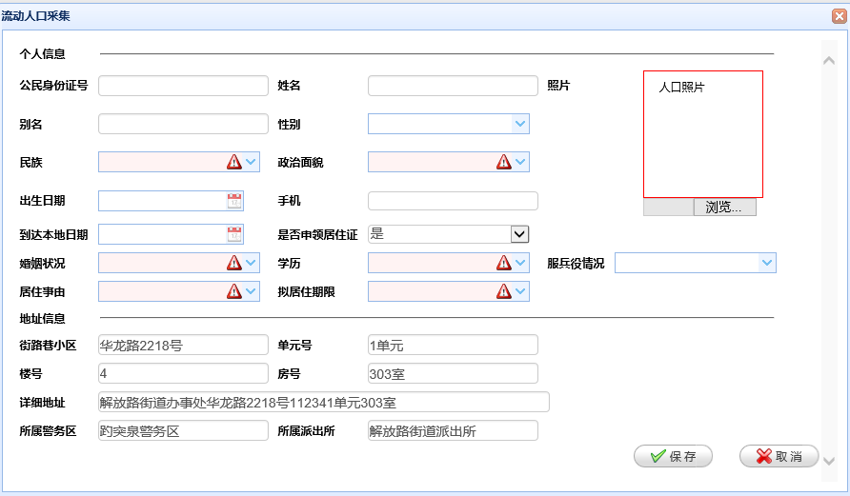

### 2.2.2根据身份证号加载流动人员信息

输入身份证号号根据身份证号查询

请求 URL: <http://localhost:8081/psam/psam/sy/syfwLdrk/loadLdrkInfo>

参数：

（1）sfzh 类型：String

（2）jzwfjid 类型：String

返回数据格式如下：

{"confirmMsg":"","data":{"bdsjQk":null,"bdsjSd":null,"bdsjZt":null,"bm":"xiaoma","bz":"","bzdz":null,"cbqk":"","csrq":"2016-01-07 00:00:00","cszy":"","czfwId":"","czhkszd":"","czhkszdzz":"","czhkszdzzfjh":"","czlx":"","ddbdrq":"2016-01-13 00:00:00","deltag":"0","deltime":null,"djdw":"370102001000","djdwmc":"解放路街道派出所","djr":"user_test_05","djrmc":"user_test_05","djsj":"2016-01-04 20:24:55","drbz":"","dsdm":"","dsdr":"","dszj":"","dwdz":"","dwfzr":"","dwlxdh":"","dwpcs":"","dwssfj":"","dwsspcs":"","dyh":"1单元","dzSsxq":"","dzSsxq_mc":"","dzXzjd":"","dzbm":"3e39f307-ad9c-4460-83be-996953b83940","dzxqCzlx":"","dzxqSpzt":"","etsfyfjz":"","fbyqk":"1","fh":"401室","fjbm":"e3886962-5598-4330-a224-c9df9b91c526","fz":"","fzSfzh":"","fzsj":null,"gajgdm":"","gxsj":null,"gzdw":"","gzdwszfj":"","hjdxzqh":"","hsbz":"","hsrsfzh":"","hssj":null,"hyzk":"10","hyzmbh":"","id":"4bfc7533-1d0e-4f80-a381-774019241116","jlxxq":"华龙路2218号","jzdywgzdw":"","jzsy":"01","jzwid":"","jzzyxq":null,"ldhtqdqk":"","ldid":"4bfc7533-1d0e-4f80-a381-774019241116","lh":"4","lrfs":"0","lrjs":"","lrwl":"","lsh":"","lxfsGh":"","lxfsSj":"15698745698","lxfsXlt":"","movesign":"","mph":"","mz":"01","njzqx":"1","objectid":"","qfbz":"","qfr":"","qfsj":null,"qt":"","qtlxfsEmail":"","qtlxfsQq":"","sbid":"","sfbdQk":"","sfbdSd":"","sfbdZt":"","sfbhb":"","sfcjgz":"","sfcqjycs":"","sfedtcq":"","sfedzdq":"","sfjzcq":"","sfls":"","sfsljzz":"1","sfsy":"","sfyxzz":"","sfzh":"369878255660144536","shdwdm":"","shrsfzh":"","shrxm":"","shsj":null,"sjly":"","sjyxx":"","sjyxxYzsj":null,"slsj":null,"spzt":"","sqjcwh":"","ssjwq":"370102001015","ssjwq_mc":"","sspcs":"370102001000","sspcs_mc":"","syznNan":null,"syznNv":null,"tbdwdm":"","tbrsfzh":"","tbrxm":"","tbsj":null,"xb":"1","xgdw":"","xgdwmc":"","xgr":"","xgrmc":"","xjzd":"","xjzdzz":"","xjzdzzfjh":"","xl":"10","xlh":"4bfc7533-1d0e-4f80-a381-774019241116","xm":"小马","xxdz":"解放路街道办事处华龙路2218号112341单元401室","xzdxzqh":"","xzjd":"","ygznx":"","zbx":null,"zbxGps":null,"zbxTdt":null,"zby":null,"zbyGps":null,"zbyTdt":null,"zhxgsj":null,"zp":[],"zslb":"","zxbz":"0","zxrq":null,"zxsj":null,"zxzt":"0","zyjszw":"","zyzg":"","zzbz":"","zzmm":"3","zzsj":null,"zzzt":""},"forwardUrl":"","message":"数据加载成功","statusCode":200,"token":""}

返回值：

状态码为200时

|  |  |  |  |  |  |
| --- | --- | --- | --- | --- | --- |
| 字段 | 说明 | 数据字典项 | 类型 | 长度 | 是否必填 |
| sfzh | 身份证号 | 否 | String | VARCHAR2(20) | 是 |
| xm | 姓名 | 否 | String | VARCHAR2(50) | 是 |
| bm | 别名 | 否 | String | VARCHAR2(50) |  |
| xb | 性别 | 是 | String | VARCHAR2(10) |  |
| mz | 民族 | 是 | String | VARCHAR2(10) | 是 |
| zzmm | 政治面貌 | 是 | String | VARCHAR2(10) | 是 |
| csrq | 出生日期 | 否 | DATE |  |  |
| lxfsSj | 手机 |  | String | VARCHAR2(50) |  |
| ddbdrq | 到达本地日期 |  | DATE |  |  |
| sfsljzz | 是否申领居住证 |  | String | （0否1是）-CHAR(1) |  |
| hyzk | 婚姻状况 | 是 | String | VARCHAR2(10) | 是 |
| xl | 学历 | 是 | String | VARCHAR2(10) | 是 |
| fbyqk | 服兵役情况 | 是 | String | CHAR(1) |  |
| jzsy | 居住事由 | 是 | String | VARCHAR2(10) | 是 |
| njzqx | 拟居住期限 | 是 | String | VARCHAR2(20) | 是 |
|  |  |  |  |  |  |
|  |  |  |  |  |  |
|  |  |  |  |  |  |
|  |  |  |  |  |  |

状态码为202时：

|  |  |  |  |  |
| --- | --- | --- | --- | --- |
| 字段 | 说明 | 数据字典项 | 类型 | 长度 |
| XB | 性别 |  |  |  |
| CYM | 别名 |  |  |  |
| BYZK | 服兵役情况 |  |  |  |
| HYZK | 婚姻状况 |  |  |  |
| WHCD | 学历 |  |  |  |
| MZ | 民族 |  |  |  |
| XM | 姓名 |  |  |  |
| CSRQ | 出生日期 |  |  |  |
|  |  |  |  |  |

状态码为300 ：该采集信息已经存在

状态码为201 ：未查询到数据

### 2.2.3根据身份证号加载照片信息

url: ${ctx}/psam/sy/syRkglPic/loadRkglPic

参数：

HttpServletResponse response

,String zjhm 类型（String） varchar2(40)

### 2.2.4表单的填写和提交

请求 URL: http://localhost:8081/psam/psam/sy/syfwLdrk/saveSyFwLdrkAccInfo

请求方法: POST

参数：（1）MultipartFile file （2）SyRkglLdrkdjb ldrk

返回值：

{"confirmMsg":"","data":null,"forwardUrl":"","message":"操作成功","statusCode":200,"token":""}

状态码：200 操作成功

状态码：400 服务器错误

状态码：300 e.getMessage()

# 3.境外人员信息采集

## 3．1业务逻辑说明

（1）进入信息采集页面

（2）根据房间加载加载部分采集信息

（3）根据身份证号加载采集信息

输入身份证号后：系统会先根据身份证号在常住人口管理表中查询是否有该人的信息，如果有直接把该人的信息带回，如果没有去人口库里面去查询，如果人口库里面有，把人口库里面的信息带回（信息不全，需手动填一部分）如果没有手动填写。

进入境外人口信息采集页面

根据身份证号需要加载图片信息，在照片表里面查询

（4）填写表单并提交

## 3.2接口的具体说明

进入境外人员信息采集页面：

URL: <http://localhost:8081/psam/psam/sy/syFwJwry/enterSyFwJwryAccInfo>

请求方法: GET

所需要参数： jzwfjid 建筑物房间Id

类型： String varchar2(36)

其中地址信息中的信息不需要手动填写：

包括：

ssxqdm ：省市县（区）数据库字段

ssxqdm_mc：省市县（区）业务逻辑用-非数据库字段

ssjlxxqDzbm：所属街路巷(小区)_地址编码

ssjlxxqDzbm_mc：所属街路巷(小区)_地址名称--业务逻辑用-非数据库字段

fjh：房间号

xxdz：现居住地详细地址

sdpcs：属地派出所代码

sdpcs_mc：属地派出所名称 业务逻辑用-非数据库字段

jwzrq：警务责任区代码

jwzrq_mc：警务责任区名称 业务逻辑用-非数据库字段

服务器端效果图：

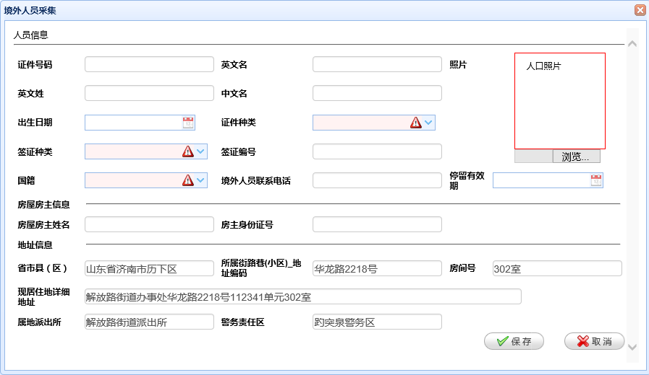

### 3.2.1根据证件号码加载采集信息

请求 URL: http://localhost:8081/psam/psam/sy/syFwJwry/loadJwryInfo

参数：

（1）sfzh 类型：String

（2）jzwfjid 类型：String

返回数据格式如下：

{"confirmMsg":"","data":{"bz":"","cjry":"","cjrylxdh":"","cjsj":null,"csrq":"2016-01-06 00:00:00","deltag":"0","deltime":null,"djdw":"370102001000","djdwmc":"解放路街道派出所","djr":"user_test_05","djrmc":"user_test_05","djsj":"2016-01-04 20:26:16","dzbm":"dc4fb4fd-2db1-49fa-b283-c4dfaf850558","fjbm":"e3886962-5598-4330-a224-c9df9b91c526","fjh":"401室","fwfzxm":"xizo,a","fzsfzh":"369874566332144535","gj":"CN","gjdm":"","gxsj":null,"gzxxsf":"","jlqk":"","jlsy":"","jlxkhm":"","jwryid":"1766e137-be75-4fd3-9023-d9346f4f3b61","jwrylkrq":null,"jwrylxdh":"wewe","jwryzp":[],"jwzrq":"370102001015","jwzrq_mc":"","jzdxz":"","jzwid":"","lhsf":"","lrfs":"0","lrjs":"","lrwl":"","lzrq":null,"movesign":"","qfjg":"","qzbh":"weeee","qzcs":"","qzzl":"C","rjka":"","rjrq":null,"rkfl":"","rylb":"","rzfs":"","rzrq":null,"rzsj":null,"sbid":"","sdpcs":"370102001000","sdpcs_mc":"","ssjlxxqDzbm":"00035802218000000000000","ssjlxxqDzbm_mc":"","ssxqdm":"1703ba8f-300a-44a4-bf35-c72d4b6f32a8","ssxqdm_mc":"","sxrycsrq1":null,"sxrycsrq2":null,"sxrydwmc1":"","sxrydwmc2":"","sxryqsgx1":"","sxryqsgx2":"","sxryxb1":"","sxryxb2":"","sxryywxm1":"","sxryywxm2":"","sxryzwxm1":"","sxryzwxm2":"","tjflg":"","tlyxq":"2016-01-05 00:00:00","xgdw":"","xgdwmc":"","xgr":"","xgrmc":"","xxdz":"解放路街道办事处华龙路2218号112341单元401室","xzzhuid":"","xzzhuidgxsj":null,"xzzqh":"","xzzssfjdm":"","ywm":"wee","ywx":"qwewe","zhgzjgdm":"","zhgzjgmc":"","zjhm":"369874569874563215","zjzl":"1","zslxfs":"","zwm":"weee","zwsp":"","zxrq":null,"zxzt":"0","zy":""},"forwardUrl":"","message":"数据加载成功","statusCode":200,"token":""}

返回值：

状态码为200时

|  |  |  |  |  |  |
| --- | --- | --- | --- | --- | --- |
| 字段 | 说明 | 数据字典项 | 类型 | 长度 | 是否必填 |
| zjhm | 证件号码 |  | String | VARCHAR2(50) | 是 |
| ywm | 英文名 |  | String | VARCHAR2(50) | 是 |
| ywx | 英文姓 |  | String | VARCHAR2(50) | 是 |
| zwm | 中文名 |  | String | VARCHAR2(50) |  |
| csrq | 出生日期 |  | DATE |  |  |
| zjzl | 证件种类 | 是 | String | VARCHAR2(36) | 是 |
| qzzl | 签证种类 | 是 | String | VARCHAR2(36) | 是 |
| qzbh | 签证编号 |  | String | VARCHAR2(50) |  |
| gj | 国籍 | 是 | String | VARCHAR2(36) | 是 |
| jwrylxdh | 境外人员联系电话 |  | String | VARCHAR2(50) |  |
| tlyxq | 停留有效期 |  | Date |  |  |
| fwfzxm | 房屋房主姓名 |  | String | VARCHAR2(50) | 是 |
| fzsfzh | 房主身份证号 |  | String | VARCHAR2(20) | 是 |
|  |  |  |  |  |  |
|  |  |  |  |  |  |
|  |  |  |  |  |  |
|  |  |  |  |  |  |
|  |  |  |  |  |  |
|  |  |  |  |  |  |

状态码为202

CSRQ ：出生日期

状态码：400服务器错误

状态码：300 e.getMessage()

### 3.2.2:根据证件号码加载照片信息

url: ${ctx}/psam/sy/syRkglPic/loadRkglPic

参数：

HttpServletResponse response

,String zjhm 类型（String） varchar2(40)

### 3.3.3：表单的填写和提交

请求 URL: http://localhost:8081/psam/psam/sy/syFwJwry/saveSyFwJwryAccInfo

请求方法: POST

参数：（1）MultipartFile file （2）Syjwry jwry

返回值：

{"confirmMsg":"","data":null,"forwardUrl":"","message":"操作成功","statusCode":200,"token":""}

状态码：200 操作成功

状态码：400 服务器错误

状态码：300 e.getMessage()

# 4.房屋信息采集

## 4.1：业务逻辑说明

（1）进入信息采集页面

（2）根据房间加载加载部分采集信息

（3）填写表单并提交

## 4.2：接口的具体说明

进入采集页面

http://localhost:8081/psam/psam/fw/loadFwjbxxAccInfo

请求方法: GET

所需要参数： jzwfjid 建筑物房间Id

类型： String varchar2(36)

根据房间带回信息：

|  |  |  |  |  |
| --- | --- | --- | --- | --- |
| 字段 | 说明 | 是否为数据库字段 | 长度 | 类型 |
| ssxqdm | 省市县（区） | 是 |  |  |
| ssjlxxq_mc | 省市县（区名称 | 否 |  |  |
| fjbm | 房间编码 | 是 |  |  |
| fjh | 房间号 | 是 |  |  |
| fwdz | 房屋地址详细地址 | 是 |  |  |
| sdpcs | 属地派出所 | 是 |  |  |
| sdpcs_mc | 属地派出所名称 | 否 |  |  |
| jwzrq | 警务责任区 | 是 |  |  |
| jwzrq_mc | 警务责任区名称 | 否 |  |  |

手动填写项：

|  |  |  |  |  |  |
| --- | --- | --- | --- | --- | --- |
| 字段 | 说明 | 是否必填 | 类型 | 长度 | 数据字典项 |
| fwlb | 房屋类别 | 是 | String | VARCHAR2(2) | 是 |
| fwxz | 房屋性质 | 是 | String | VARCHAR2(2) | 是 |
| fwyt | 房屋用途 | 是 |  |  | 是 |
| fwlx | 房屋类型 | 是 |  |  | 是 |
| fwcqzh | 房屋产权证号 | 是 | String | VARCHAR2(50) |  |
| sfczfw | 是否出租房屋 |  | String | VARCHAR2(1)  0：否1：是 |  |
| hx | 户型（*室*厅） | 是 | String | VARCHAR2(36) |  |
| fwjs | 房屋间数 |  | Integer | NUMBER(8) |  |
| fwmj | 房屋面积 |  | BigDecimal | NUMBER(12,2) |  |
| fzxm | 房主姓名 | 是 | String | VARCHAR2(50) |  |
| fzsfzhm | 房主身份证号码 | 是 | String | VARCHAR2(20) |  |
| fzlxdh | 房主联系电话 |  | String | VARCHAR2(50) |  |
| tgrxm | 托管人姓名 |  | String | VARCHAR2(50) |  |
| tgrsfzhm | 托管人身份证号码 |  | String | VARCHAR2(20) |  |
| tgrlxdh | 托管人联系电话 |  | String | VARCHAR2(50) |  |
| yfzgx | 与房主关系 |  | String | VARCHAR2(36) |  |
| fwssdwbm | 房屋所属单位编码 | 是 | String | VARCHAR2(36) |  |
| fwssdwmc | 房屋所属单位名称 | 是 | String | VARCHAR2(200) |  |
|  |  |  |  |  |  |

## 4.3提交表单

请求 URL: <http://localhost:8081/psam/psam/fw/saveFwjbxxAccInfo>

返回值：{"confirmMsg":"","data":null,"forwardUrl":"","message":"操作成功","statusCode":200,"token":""}