For this project, I immediately imagined a ‘fantasy’ like game where you are dropped into a dungeon of sorts and have to find your way out alive. I like choosing numbers, so I’m tentatively giving the player 9 steps to make it out. There will be 7 Spaces in the playing field. The three space derivatives will be; monster, treasure, and trap.
The space class will have a string variables to hold the space’s name, an enum to hold the space’s type, and pointers to four other spaces, top, right, bottom, left. A space will also hold a pointer to an item, but can also take on more items.
The space class will have functions to deal with entering the room, a bool, interacting with the room, that will take in the player and return a bool, pickUpItem will pickup the item in the room if able, placeItem will place an item and remove it from the player. moveTo another space that will also return a bool. These functions will return bools to represent whether or not the action could be completed.
I’ll make a simple player class that will hold the current space of the player and the player’s container, their two hands. I’ll also create an item class with a few derivatives. A key, a sword, a torch, and a shield. The player will only be able to hold two items at a time.
The player will drop into a treasure space, with a torch present. The player can pick up the torch or not. If the player picks up the torch, they’ll be able to tell that the top, left, and right doors are closed, while the bottom is opened with a shiny object.
If the player moves to the bottom space, another treasure space, the player can pick up the key. The only way out of the bottom space is to go back up to the original space. From the original space, the top is a blocked by a lock door and so is the left. The right one can’t be unlocked with a key.
If the player uses the key to go to the top space, they will enter a trap space and die instantly. If the player uses the key to go to the left room, they will enter a treasure space where the sword can be obtained.
If the player is holding the sword, the door to the right space will be open. Here the player will encounter the first monster space, full of bats, or snakes, or bees, some swarming entity. I’ll need to create some sort of ‘monster’ version of the player class and make sure both of some attack and defense and hitpoints… or if the player has the sword they kill the monsters? I’m not sure how I want to implement that just yet, I’m leaning towards a small battle function, I’m just not sure what to do about steps, unless I only count steps as moving from space to space.
When the player enters the first monster space, the door will close behind them. There is no space to the top or bottom in the first monster space, only to the left and right. The player won’t be able to return to the original room at this point until the monsters are defeated. When the monsters are defeated, the left and right doors will open. The player can then choose to go to either space. If the player enters the space to the right of the first monster space, the player will enter another treasure space. This is the final treasure space of the map. Here the player can pick up a shield. However, the player will also face a conundrum here, the player can put down the sword or the torch to pick up the shield, but cannot hold all three.
The space to the top is blocked by a bushy structure that requires the torch to destroy. Once this wall is opened, the player can drop the torch and pick up the shield in order to wild the shield and sword to defeat the final monster in the last space of the game.
This will be one monster space, and the monster inside will defeat the player instantly if the player isn’t wielding both the sword and the shield. If at any time the player reaches 9 steps before getting to the monster, the player dies. If the player makes it to the monster, the player will battle the monster.
If the player wins the battle, the player exits the dungeon by jumping on the back of the monster and out of the ceiling. If the player loses, the player dies and is asked to start over again. Figure 1 features the map layout.
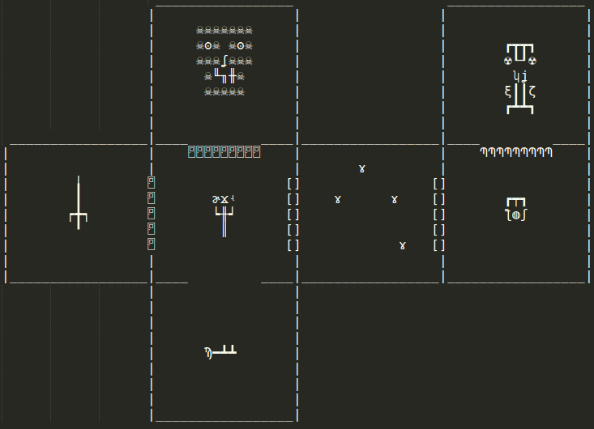

Figure 1.
Testing plan:
I’ll first test naming the Characters and pointing to other Characters.
Test 1
Barbarian→setName(“Barby”); HarryPotter→setName(“harry”); Barbarian→setNext(HarryPotter);
Barbarian→getNext()->getName(); | “Barby next is harry”

I’ll then test the recovery function.
Test 2
Barbarian->recover(); | 6
Barbarian->recover(); | 3

With the new Character functionality working, I’ll move on to creating the teams and testing the push and pop.
Test 3
TeamOne->pushTeamMate(barbarian);
TeamOne->printTeam(); | Team One:  Barbarian Barbarian
Delete teamOne→popFighter(); teamOne→printTeam(); | Team One:

I then set the popped fighters attack each other in the battle function. Which worked exactly as it did in Project 03, but I ran into some issues when I was pushing the winners or losers to the appropriate team. I’ll write more about this issue in the final section.
Test 4
Battle(); | Round 1: Team 1 Barbarian Barbarian vs. Team 2 Harry Potter Harry Potter
 | Harry Potter has been defeated
Losers→printTeam(); | segFault

After discovering the err in my ways, I got all the teams working correctly and moved on to displaying the score, and then asking to display the teams.
Test 5
TournamentResults(); | Team 1: 2 Team 2: -1  The winner is Team 1  Would you like to print the contents of the teams, including the losers?
TeamOne→printTeam();  teamTwo→printTeam();  losers->printTeam(); | Team 1:  Barbarian Barbarian  Team 2:  Losers:  Harry Potter Harry Potter

At this point, the program is working correctly! I ran countless iterations of the gameplay, and came across no errors after working through the rats nest I’d created for myself.
REFLECTION:

