The Capabilities of the GridSpace2 Experiment Workbench
Marian Bubak (1,2), Bartosz Baliś (1), Tomasz Bartyński (3), Eryk Ciepiela (3), Włodzimierz Funika (1), Tomasz Gubała (3), Daniel Harężlak (3), Marek Kasztelnik (3), Joanna Kocot (3), Maciej Malawski (1), Jan Meizner (1), Piotr Nowakowski (3), Katarzyna Rycerz (1)
(1) Institute of Computer Science AGH, Krakow, Poland
(2) Informatics Institute, University of Amsterdam, The Netherlands
(3) ACC CYFRONET AGH, Krakow, Poland

The emergence of cloud computing and other distributed computing frameworks calls for a novel approach to ensure that the capabilities offered by such platforms are actually exploited by their target groups. In the scope of scientific infrastructures, this primarily involves domain scientists who apply the e-science [1] approach in their research work. As the capabilities of high-performance and high-throughput computing systems increase, we are faced with the need for software solutions which would enable scientists to fully utilize their potential while at the same time avoiding the steep learning curve that has historically hampered wide take-up of Grid computing platforms.
The GridSpace2 Virtual Laboratory is an evolution of the computing and data access platform for viral disease research originally implemented in the ViroLab project [2,3]. Following extensive discussions with representatives of various fields of e-science we have reengineered our software to better suit the daily work habits of domain scientists. This group includes users who frequently conduct virtual experimentation, relying on applications which can easily be ported to distributed computing environments. We have also drawn upon the experience of to-date scientific computing projects and the issues which have emerged during the course of their implementation (see [4] for an insightful discussion of these issues).
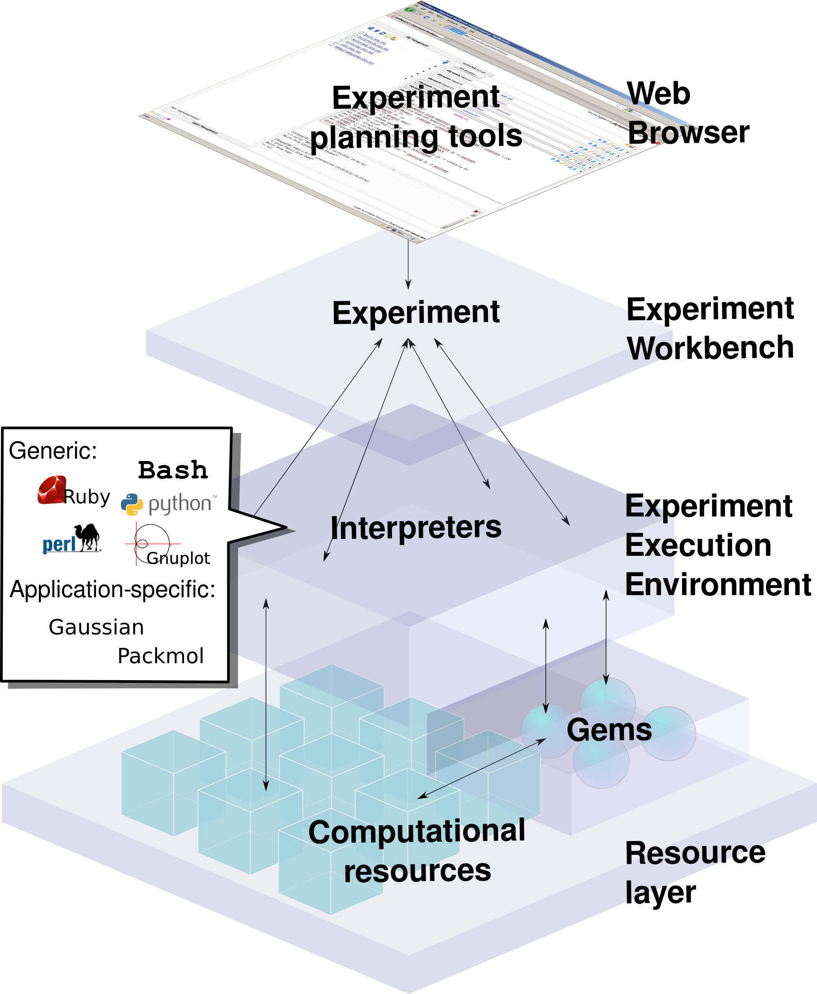
The GridSpace2 Experiment Workbench, a top-level user interface, is designed to suit the habits and requirements of such users and allow them to exploit of the potential of distributed computing platforms, including PL-Grid [5]. The Workbench GridSpace2 bases upon the notion of exploratory programming where each experiment can be decomposed into a number of so-called snippets. Each snippet may be written in a different programming language; moreover, the Workbench enables its user to execute entire experiments or just selected snippets. In this way, time-consuming experiments do not have to be started from scratch each time a modification is made during development.
The paper shows how the Experiment Workbench assists its users in iteratively developing virtual experiments with the use of scripting languages, including Ruby, Python and Perl. We also provide a description of additional tools available in the Workbench, along with examples of their use in specific experiments, provided by the domain scientists who participate in the PL-Grid project (in which GridSpace2 is being developed and deployed).
Figure 1: Architecture of the GridSpace2 Virtual Laboratory and the Experiment Workbench
Along with examples of use, we also discuss ongoing work on the platform, which focuses on managing secure storage of sensitive data via a wallet mechanism and enabling users to prepare custom graphical user interfaces (WebGUIs) for the experiments they create. Near-term plans also include extending the pool of scientific libraries (which we call gems) available to experiment developers.

Acknowledgements. The research presented in this paper has been partially supported by the European Union within the European Regional Development Fund program no. POIG.02.03.00-00-007/08-00 as part of the PL-Grid project (www.plgrid.pl).

References
- Tomasz Gubała, Marek Kasztelnik, Maciej Malawski, Marian Bubak, “Towards System-Level Science Support”. In: Bubak, M., Albada, G.D.v., Dongarra, J., Sloot, P.M.A. (eds.), Proceedings ICCS 2008, Kraków, Poland, June 23-25, 2008, LNCS 5101, pp. 56-65, Springer 2008
- M. Bubak et al., Virtual Laboratory for Collaborative Applications, In: M. Cannataro (Ed.) Handbook of Research on Computational Grid Technologies for Life Sciences, Biomedicine and Healthcare, Chapter 27, pp. 531-551, Information Science Reference, 2009, IGI Global
- M. Malawski, T. Bartyński, and M. Bubak, “Invocation of operations from script-based grid applications,” Future Generation Computer Systems, Volume 26, Issue 1, January 2010, Pages 138-146.
- Uwe Schwiegelshohn, Rosa M. Badia, Marian Bubak, Marco Danelutto, Schahram Dustdar, Fabrizio Gagliardi, Alfred Geiger, Ladislav Hluchy, Dieter Kranzlmüller, Erwin Laure, Thierry Priol, Alexander Reinefeld, Michael Resch, Andreas Reuter, Otto Rienhoff, Thomas Rüter, Peter Sloot, Domenico Talia, Klaus Ullmann, Ramin Yahyapour and Gabriele von Voigt, Perspectives on Grid Computing, Future Generation Computer Systems Volume 26, Issue 8, Elsevier B.V., October 2010, pp. 1104-1115.
- The PL-Grid project, www.plgrid.pl
- T. Gubala, M. Bubak, P.M.A. Sloot; Semantic Integration of Collaborative Research Environments, In: M. Cannataro (Ed.) Handbook of Research on Computational Grid Technologies for Life Sciences, Biomedicine and Healthcare, Chapter 26, pp. 514-530, Information Science Reference, 2009, IGI Global
- B. Balis, M. Bubak, M. Pelczar, J. Wach; Provenance Tracking and End-User Oriented Query Construction, In: M. Cannataro (Ed.) Handbook of Research on Computational Grid Technologies for Life Sciences, Biomedicine and Healthcare, Chapter 4, pp. 60-75, Information Science Reference, 2009, IGI Global

