成都信息工程大学

毕业设计英文翻译

展望物联网: 中国视角下的应用, 挑战与机遇

系 别 | 电子工程学院
姓 名 | 陈宇航
专 业 | 电子信息科学与技术
班 级 | 电信科学(航)181
学 号 | 2018022196

A Vision of Iot: Applications, challenges, and Opportunities With China Perspective

Abstract: Internet of Things (IoT), which will create a huge network of billions or trillions of “Things” communicating with one another, are facing many technical and application challenges. This paper introduces the status of IoT development in China, including policies, R&D plans, applications, and standardization. With China’s perspective, this paper depicts such challenges on technologies, applications, and standardization, and also proposes an open and general IoT architecture consisting of three platforms to meet the architecture challenge. Finally, this paper discusses the opportunity and prospect of IoT.
Index Terms—Internet of Things (IoT), IoT application, IoT architecture, IoT challenge, IoT standardization.
- INTRODUCTION
THE INTERNET of Things (IoT) is regarded as a technology and economic wave in the global information industry after the Internet. The IoT is an intelligent network which connects all things to the Internet for the purpose of exchanging information and communicating through the information sensing devices in accordance with agreed protocols. It achieves the goal of intelligent identifying, locating, tracking, monitoring, and managing things [1]. It is an extension and expansion of Internet-based network, which expands the communication from human and human to human and things or things and things. In the IoT paradigm, many objects surrounding us will be connected into networks in one form or another. RF identification (RFID), sensor technology, and other smart technologies will be embedded into a variety of applications.
Manuscript received October 30, 2013; revised March 31, 2014 and May 15, 2014; accepted June 29, 2014. Date of publication July 09, 2014; date of current version August 07, 2014. This work was supported in part by the Major National Science and Technology Special Project under Grant 2013ZX03001025-001 and by the National High-Technology Program (863) of China under Grant 2011AA01A101.
- Chen and H. Wang are with the State Key Laboratory of Wireless Mobile Communications, China Academy of Telecommunications Technology (CATT), Beijing 100191, China, and also with the State Key Laboratory of Networking and Switching Technology, Beijing University of Posts and Telecommunications, Beijing 100876, China (e-mail: chensz@datanggroup.cn; wanghucheng@catt.cn).
H. Xu is with the State Key Laboratory of Wireless Mobile Communications, China Academy of Telecommunications Technology (CATT), Beijing 100191, China, and also with the Datang Telecom Technology & Industry Group, Beijing, China (e-mail: xuhui@catt.cn).
D. Liu is with the Application Specific Instruction-Set Processor (ASIP) Laboratory, Beijing Institute of Technology (BIT), Beijing 100081, China (e-mail: dake@bit.edu.cn).
B. Hu is with the State Key Laboratory of Networking and Switching Technology, Beijing University of Posts and Telecommunications, Beijing 100876, China (e-mail: hubo@bupt.edu.cn).
As a burgeoning thing, there is not a common accepted definition on IoT. Specialists from different perspectives and organizations describe IoT on diverse preference. Typical definitions of IoT from different organizations are shown in Table I.
Following technology evolutions, more and more computing power, storage, and battery capacities become available at relatively low cost and low size. This trend is enabling the development of extreme small-scale electronic devices with identification/communication/computing capabilities, which could be embedded in other devices, systems, and facilities [1]. IoT should have the following three characteristics [6].
1) Comprehensive Perception: Using RFID, sensors, and two-dimensional barcode to obtain the object information at anytime and anywhere, it will be a new opportunity. Using it, information and communication systems can be invisibly embedded in the environment around us. Sensor network will enable people to interact with the real world remotely. Identification technologies mentioned here include objects and location identifications. Identification and recognition of the physical world is the foundation of implementing overall perception.
2) Reliable Transmission: Through a variety of available radio networks, telecommunication networks, and Internet, objects information can be available in any time. Communication technology here includes a variety of wired and wireless transmission technologies, switching technologies, networking technologies, and gateway technologies. IoT further creates the interaction among the physical world, the virtual world, the digital world, and the society. Machine to machine (M2M), furthermore, is the key implementation technology of the Network of Things, which represents the connections and communications between M2M and Human to Machine including Mobile to Machine.
3) Intelligent Processing: By collecting IoT data into databases, various intelligent computing technologies including cloud computing will be able to support IoT data applications. The network service providers can process tens of millions or even billion pieces of messages instantly through cloud computing. Cloud computing technology will thus be the promoter of IoT.
Currently, in China, there are at least 9 billion interconnected devices, and it is expected to reach 24 billion devices by 2020. According to the GSMA, this amount to $1.3 trillion revenue opportunities for mobile network operators alone spanning segments such as health, automotive, utilities, and consumer electronics. Many countries consider IoT as strategic industries and a new economic growth engine in the future. European Union (EU) has invested more than 100 million Euros in a series of projects through Seventh EU Framework Programme (FP7 for R&D), and these projects will be actively deployed in smart grid, intelligent transportation, smart cities, etc. South Korea invested 27.8 million U.S. dollars in IoT fundamental technology development, IoT test bed advancement, and IoT standardization, etc.
China is speeding up the development of IoT and defines it as a new engine for economic growth. The government released the 12th Five-Year Plan for IoT development. This plan is an outline program for developing IoT from 2011 to 2015. The plan gave the goal and objectives of future development, and the plan proposed several approaches reaching the goal. The plan also puts forward a list of methods to support and promote the development of IoT industry.
This paper is organized as follows. Section II introduces opportunities of IoT and summarizes its status and applications. Section III introduces the policy, R&D plans, and standardization of IoT in China. Based on the introduction of Sections II and III, in Section IV, the major problem hampering the development of IoT is analyzed, i.e., lack of interoperability among diverse IoT solutions. A general open IoT architecture developed in China is given. Section V introduces main application fields, examples of typical public applications, and examples of industry applications of IoT in China. Section VI analyzes further challenges on IoT, including technical challenge and standard challenge, and introduces the prospect of IoT. Section VII is the conclusion of this paper.

TABLE I
DEFINITIONS OF THE IOT FROM DIFFERENT ORGANIZATIONS
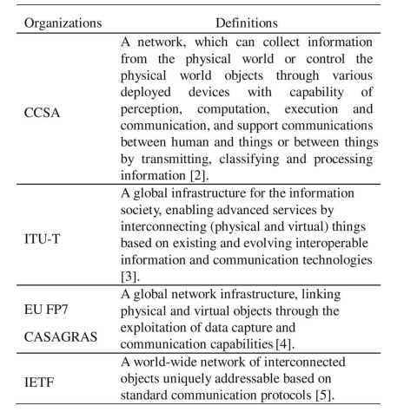

II. OPPORTUNITY, STATUS, AND CAPABILITY OF IOT
A. Opportunity of IoT
The IoT will create a huge network of billions or trillions of “Things” communicating each other. The IoT is not subversive revolution over the existing technologies, it is comprehensive utilizations of existing technologies, and it is the creation of the new communication modes. The IoT blends the virtual world and the physical world by bringing different concepts and technical components together: pervasive networks, miniaturization of devices, mobile communication, and new ecosystem. In IoT, applications, services, middleware components, networks, and end nodes will be structurally organized and used in entire new ways.
IoT offers a means to look into complex processes and relationships. The IoT implies a symbiotic interaction between the real/physical and the digital/virtual worlds: physical entities have digital counterparts and virtual representation; things become context aware and they can sense, communicate, interact, and exchange data, information, and knowledge. New opportunities will meet business requirements, and new services will be created based on real-time physical world data.
Everything from the physical or virtual world will possibly be connected by the IoT. Connectivity between the things shall be available to all with low cost and may not be owned by private entities. For IoT, intelligent learning, fast deployment, best information understanding and interpreting, against fraud and malicious attack, and privacy protection are essential requirements.
B. Status of IoT
The IoT can be regarded as an extension of existing interaction between people and applications through a new dimension of “Things” for communication and integration.
The IoT development process is a complex large-scale technological innovation process. The IoT is evolving from the vertical application to polymeric application.
At the early stage of IoT deployment, driving of domain-specific applications is the main development strategy. A domain-specific application might be a manufacturing control system with its own industry characteristics. The application can provide various enterprise management services being integrated with the industry production and business processes.
Polymeric applications are cross-industry applications based on public information service platforms. These applications support both home users and industry users. The application are provided and promoted by communication operators and solution providers with large scale. For example, a vehicle integrated with sensor networks, a global positioning system (GPS), and radio communication technology can provide comprehensive detection, navigation, entertainment, and other information services. By maintaining such information through the public service platform, consumers, original equipment manufacturers (OEMs), maintenance providers, and vehicle management agencies can share these information and share services to improve the vehicle, the vehicle component design, and the fabrication process through the vehicle lifecycle management.
C. Capability of the IoT Application
In summary, the IoT applications shall have the following capabilities.
1) Location Sensing and Sharing of Location Info: The IoT system can collect the location information of IoT terminals and end nodes, and then provide services based on the collected location information. The location information includes geographical position information got from the GPS, Cell- ID, RFID, etc., and absolute or relative position information between things. More typical IoT applications include at least the following.
a) Mobile asset tracking: This application can track and monitor the status of commodity using the position- sensing device and communication function installed on the commodity.
b) Fleet management: The manger of the fleet can schedule the vehicles and drivers based on the business requirements and the real-time position information collected by the vehicles.
c) Traffic information system: This application can get traffic information such as road traffic conditions and congested locations by tracking the location information of a large number of vehicles. The system thus assists the driver to choose the most efficient route.
2) Environment Sensing: The IoT system can collect and process all kinds of physical or chemical environmental parameters via the locally or widely deployed terminals. Typical environmental information includes temperature, humidity, noise, visibility, light intensity, spectrum, radiation, pollution (CO, CO2, etc.), images, and body indicators. Typical applications include at least the following.
a) Environment detection: IoT systems offer environmental and ecological, such as forest and glacier, monitoring; disaster, such as volcanoes and seismic, monitoring; and factory monitoring. All are with automatic alarm systems using environmental parameters collected by large number of sensors.
b) Remote medical monitoring: IoT can analyze the recurring indicator data collected from the device placed on patients’ body and provide the users with health trends and health advice.
3) Remote Controlling: IoT systems can control IoT terminals and execute functions based on application commands combined with information collected from things and service requirements.
a) Appliance control: People can remotely control operat-ing status of appliances through IoT system.
b) Disaster recovery: Users can remotely start disasters treatment facilities to minimize losses caused by disasters according to the monitoring mentioned before.
4) Ad Hoc Networking: IoT system shall have rapidly self-organized networking capability and can interoperate with the network/service layer to provide related services [7]. In the vehicle network, in order to transfer the data, the network between vehicles and/or road infrastructures can be rapidly self-organized.
5) Secure Communication: IoT system can further establish secure data transmission channel between the applicationor service platform and IoT terminals based on service requirements.
In practice, an IoT application consists of different types of capabilities and even applications based on the service requirement. Table II shows examples of different IoT applications

TABLE II SUMMARY OF IOT APPLICATIONS

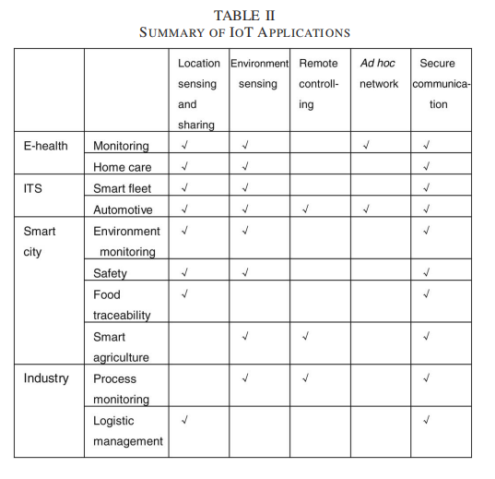
III. IOT IN CHINA
A. China Pushes Development of IoT
The IoT sensing network research started in China in 1999. IoT was positioned as one of the strategic emerging industries and written into the government work report in March 2010. The state council’s decision on speeding up the incubation and development of strategic emerging industries, which was promulgated in November 2010, clearly stated that the IoT research and application demonstrations will be promoted.
In 2012, the Ministry of Industry and Information of China explained the national 12th Five-Year Plan including IoT development (2011–2015) [8]. It was the first plan that China government released the development of IoT in detail. The plan clearly proposed the development goal of the IoT during the period of 2011–2015. By 2015, there should be significant achievements of IoT essential technologies, related applications, and standardizations.
The plan put forward eight main tasks and clearly clarified five key projects, including the Key Technology Innovation Project, Standardization acceleration Project, “10 Industrial sectors & 100 New Enterprises” Industry Development Pioneering Project, Application Demonstration Projects in Key Sectors, and Public Service Platform Construction Project.
In order to solve the popped-up problems and consider long-term development of IoT, the State Council issued the “guidance on tracking and ordering for promoting the development of IoT” [9] that determined the development goals and threads for IoT in February 2013. The 14 ministries of China established a joint meeting for IoT development in September 2013, and organized Expert Advisory Committee on the IoT development. The 10 Special Development Action Plans for IoT [10], including: 1) top-layer design; 2) standards development; 3) technology development; 4) application promotion; 5) industry support; 6) business models; 7) security; 8) government support; 9) laws and regulations guarantee; and 10) personnel training, was issued by the joint meeting. As a part of the Action Plans, the strategic alliance for industrial technology innovations of IoT was established in October 2013 [11]. Fig. 1 shows the summary of the Special Development Packet Plans.
B. R&D Plans
In China, the central government established the special funds for demonstration projects and research projects to support the development of IoT. In 2011, for supporting the development of IoT in China, around RMB 500 million special IoT fund was invested into IoT-related fields, 2/3 of the funds were put into R&D and applications; this fund has supported 381 related companies since 2011. China government has supported 22 National major IoT application demonstration projects since 2011, and an announcement was issued by China National Development and Reform Commission in October 2013. It was about organizing and carrying out the national IoT pilot major application demonstration projects during 2014– 2016 in special regions.
In Research and Development area, the China Ministry of Industry and Information Technology had set up a number of key technical research projects on architectures and applications such as intelligent transport system (ITS) and e-health under the packet of “a new generation of mobile broadband project.” China Ministry of Science and Technology also set up a series of fundamental researches for IoT on architecture, fundamental theory and design, etc., under the 973 project framework (National Key Fundamental Research and Development Plan).
The national level IoT R&D is distributed as: the enterprises such as operators and vendors provide the operation and system development of IoT. Universities and research institutions focus on the key technology research, and the standard organizations are responsible for the standardization of IoT. At present, IoT-related industry has basically formed, and mainly distributed over the Bohai bay area, the Yangtze River Delta zoon, the Pearl River Delta zoon, and the central and western regions. Fig. 2 shows the summary of national R&D plans in IoT.
C. Standardization
The IoT standard system contains the architecture standards, the application requirements standards, the communication protocol standards, the identification standards, the security standards, the application standards, the data standards, the information processing standards, and the public service platform standards.
The proposed IoT standard set is relatively complicated. In China, the standardization efforts started at 2010. The main standard organizations for IoT in China are China Communications Standards Association (CCSA), China Standardization Working Group on Sensor Networks (WGSN), electric tag standards technical committee, etc. These standard organizations are leading the standardization process of China IoT. As part of the Special IoT Action Plans, actions for the standardization of IoT include to build a standard system, to develop common standards, key technical standards, and urgent industry standards, to actively participate in the international standardization processes, to conduct standard validations and services, to improve the organizational structure.
In the course of standardization, many research institutions and enterprises in China have also been participating in international standardization work in M2M of International Organization for Standardization/International Electrotechnical Commission (ISO/IEC), ITU Telecommunication Standardization Sector (ITU-T), 3rd Generation Partnership Project (3GPP). China is one of the leading countries in ITU-T and ISO Wireless Sensor Network (WSN) Working Group. CCSA is one of the sponsoring organizations of the One M2M, and many enterprises are deeply participating in the MTC-related standard development in 3GPP.

Fig. 1. Summary of the Special Action Plans.

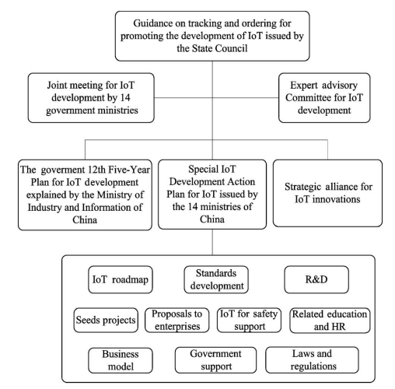

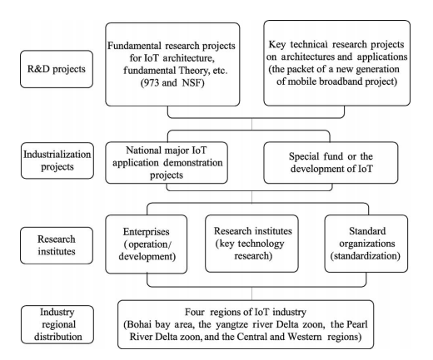
Fig. 2. Summary of National R&D plans in IOT in China

IV. OPEN AND GENERAL IOT ARCHITECTURE
A. Motivation and General Description
As seen in the previous introduction to the current IoT, most IoT applications in China were domain-specific or application-specific solutions. The architectures of these IoT systems are fragmented and cannot correlate and integrate the data from different silos; these isolated IoT solutions use private protocols and cause much problems in information sharing, technology multiplexing, network managements, and upgrading. All these problems are hindering the development of IoT.
In order to reduce the total IoT cost and share information, we need to integrate multiple functions and resources into a larger system. IoT thus needs to be designed with an open and generic IoT architecture with open interfaces and resources, considering different business scenarios, application-based requirements, and current technologies [12]. We have thus seen the motivation to formulate a standard for IoT integration in order to reduce the total cost of money and time from devices, developments, and deployments.
An open and generic IoT architecture is an integrated solution with interoperability [13], [14]. It will have the following characteristics.
1) Standard Interface and Protocol: By comparing various private IoT systems, a generic IoT infrastructure has the same hardware and software interfaces, and protocols.
2) Public and Operating: A general IoT architecture is deployed to take over public IoT applications with open- operating capability. A public IoT system can thus integrate multiple IoT applications into one architecture.
3) Open, Scalable, and Flexible: An open IoT architecture with open resources, open standards, and open interfaces can easily extend its functionality and the scale of performance. It can thus adapt to different requirements including technical developments flexibly.
B. Open and General IoT Architecture
China Communications Standards Association (CCSA) proposed a reference model for the IoT, which consists of sensing layer, network and business layers, and application layer. Complying with this reference model, Fig. 3 shows its open and general architecture, which is layered, open, and flexible. The architecture includes three functional platforms as follows.
1) Sensing and Gateway Platform: This platform connects sensors, controllers, RFID readers, and location sensing device (e.g., GPS) to IoT network layer. Modularization of hardware, data format, and software interface is proposed for IoT terminal, IoT Gateway, and tip node. IoT terminal, IoT gateway, and tip node can include flexible modules combined with control module, common interface module, and communication module. Common interface module collects physical interfaces of various sensors into a common interface. Common control module can connect sensors, controllers, GPS, and RFID readers with a common connection protocol. The software and application parameters of an IoT terminal and IoT gateway should be able to self-configure and self-adapt. Modularization, common interface, intelligent operation, self-adaption, and self-configuration are important characteristics of this platform.
2) Resource and Administration Platform: Network and service layer includes backbone networks and resource administration platforms. The backbone network includes 3G, 4G, internet, optical fiber network, Ethernet network, satellite networks, and private network. The resource and administration platform provides common capabilities which can be used by different IoT applications, such as data processing, data storage, security management, and application supporting. These capabilities may also be invoked by specific IoT application support capabilities, e.g., to build other specific IoT application support capabilities. This platform also provides relevant control functions of network connectivity, such as access and transport resource control functions, mobility management, or authentication, authorization, and accounting for IoT terminals, services, applications, users, and developers.
3) Open Application Platform: Modularization design in this application platform provides common function and open application programming interface (API). An IoT application provider can develop its application using these APIs. Meanwhile, this platform supports application managements. Various applications can be published to the application platform and users can get application information and subscribe applications through this platform. Convenient and easy deployment, distribution, and flexible application environment are the characteristics of this platform.

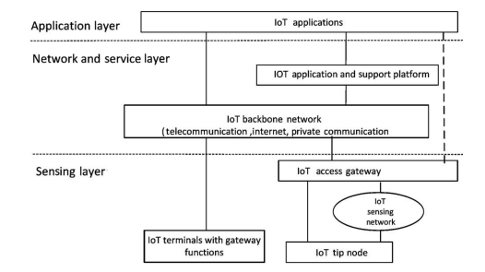

Fig. 3. CCSA proposed open and general architecture of IOT

V. TYPICAL APPLICATIONS AND DEPLOYMENT IN CHINA
A. Main Application Fields
In China, IoT applications will be developed in nine fields, including: 1) domain industry applications; 2) smart agriculture; 3) smart logistics; 4) intelligent transportation; 5) smart grid; 6) smart environmental protection; 7) smart safety; 8) smart medical care; and 9) smart home, as shown in Table III.
Three major operators: 1) China mobile; 2) China Telecom; and 3) China Unicom had announced their IoT development plans. The IoT has been an important part in the strategies of Chinese telecom operators.
China mobile plans to implement a centralized platform [China mobile IoT operation supporting platform (CMITS)], and the branch for IoT was established in Chongqing in 2012.
China Telecom plans to further enrich IoT services based on key industry requirements, to build an open platform for cooperation, and to promote IoT business model innovation. The branch for IoT was established in Wuxi in 2014.
China Unicom plans to build a management and control platform and an operation supporting system for IoT. They also planned to offer specific hardware communication modules.
The government planned to provide special phone numbers (1064xxxxxxxxx with billions of identities) dedicated for M2M. Table IV shows IoT development plans and actions from three major operators.
- Deployment of Typical Applications
1) Smart City: Smart city is a new development model of a city using new technologies, such as IoT, cloud computing, and big data analytics, to boost the information sharing and coordination within a city system. IoT is important means and tools of building smart city, and it is infrastructure- carrying smart city construction. Smart city construction depends on a lot of IoT applications for different industries [15], [16].
Smart city development plans are divided into three stages:
1) the stage for initial infrastructure construction;
2) the stage for data-processing facility construction; and
3) the stage for end-phase service platform construction. A large number of smart city projects provide huge opportunities for telecom OEM, systems integration enterprises, data aggregation and analysis/service enterprises, and telecom operators. In China, some cities are focusing on improving infrastructure for smart cities programs, and on developing regional smart e-commerce and logistics, while other cities are stepping up efforts to improve the management of local utilities. According to estimation, the smart city market will have a total value of more than RMB 2 Trillion during the 12th Five-Year Plan period (2011–2015).
2) Intelligent Transportation: China needs a solution to solve the problems of increased amount of traffic congestion in urban areas using new technologies such as IoT.
The Ministry of Transport in China has announced a plan that the development of ITS will be installed and in-use across the country by 2020. In the next 10 years, the government will invest about RMB 4 Trillion in intelligent transportation.
Intelligent Transportation System in China is developing and keeping a high growth rate. The growing speed of China’s urban intelligent transportation control system market is high, including electronic police, intelligent traffic signal control, traffic video monitoring, intelligent Taxi service management, urban public transport information technology, and ETC. Until the completion of the 12th Five-Year Plan, 60% of national highways in China will have ETC. The installation of IoT infrastructures in ITS of smart cities will be supporting fundamental technologies.
Connected vehicles and vehicular networks have been identified as a key technology for enhancing road safety and transport efficiency [17], [18]. In recent years, vehicular network infrastructure integration technology attracts a great amount of attentions; it also brings inestimable economic value, and will play an important role in the next generation of intelligent transportation systems and communication network development. Separately, built-in connectivity in vehicles is predicted to mandatory function for consumers in 2020, driven partly by the increasing global demand for availability of charging supply for electric vehicles. Government, University, automakers, and telecommunication vendors form alliances to develop this industry, such as China ITS Industry Alliance and Telematics Industry Application Alliance, to develop the connected vehicles industry. The related installation of IoT infrastructures of smart cities will be fundamental supporting technologies as well.
- Deployment of Typical Industry Applications
1) Intelligent Coal Mine: In 2011, The State Administration of work safety and State Coal Mine Safety Supervision Bureau in China regulated that all coal mines in china must complete the construction of “Mine Six-Hedge Safety Systems” until the end of 2013. The Six-Hedge underground systems include: 1) general monitoring and controlling system; 2) personnel positioning system; 3) emergent shelter systems; 4) oxygen provision monitoring system; 5) water supply and drainage monitoring system; and 6) mine cable and wireless communication system.
All the six systems mentioned above are based on pervasive sensing, sensing data collection, real-time use of data, and deep data post analyses, which is actually based on IoT. The IoT can be widely used in the “six system.” For example, it uses sensors to monitor miner position and leak of hazard gases. Fig. 4 shows a typical underground IoT system.
Built on underground industrial ring network and industrial field bus, the system is actually a comprehensive underground IoT platform, which transmits data of mining devices under industrial Ethernet protocols to dispatch center so as to monitor various devices and sensors inside the dispatch center. The overall design of the system consists of sensing and equipment layer, network and access layer, as well application and information management layer. The system collects real-time parameters of electromechanical devices and data of safety systems, which improves the system efficiency and safety. Finally, it highly guarantees the correct dispatching and decision-making of coal mines.
2) Intelligent Oil Field: Intelligent oil field (IOF) consists of a distributed system, holding frequently captured data. The data are evaluated and acted upon real-time information. IOF brings lower operational costs, lower capital investment, and increased yield of oil and gas.
Fig. 5 shows the IOF system based on the architecture mentioned in Section IV. It will collect parameters through its entire production process, such as sensing and monitoring parameters from oil well and gas well, metering house, oil station and gas station, and oil and gas pipe network. Sensed data will be collected and transmitted for further analysis between the service platform and gateway/terminal with a common connection protocol. Real-time production data and equipment condition information support the centralized management and control at production command center in production control center. IOF can increase the integrity, accuracy, timeliness, and standardization of the production decision-making for oil and gas fields.
The goal and objectives of the IOF system are to increase the accuracy and timeliness of product process, decision-making, improvement of the system management level, reducing the operation costs, and minimizing risk. As a subsystem in IOF, IoT system offers automatic production data collection, remote monitoring, and supporting for production prewarning by establishing a standardized general service platform, which covers all oil and gas wells and fields, metering house, collect and conveyance station, combination station, treatment plant. The platform also supports the process of production process management.

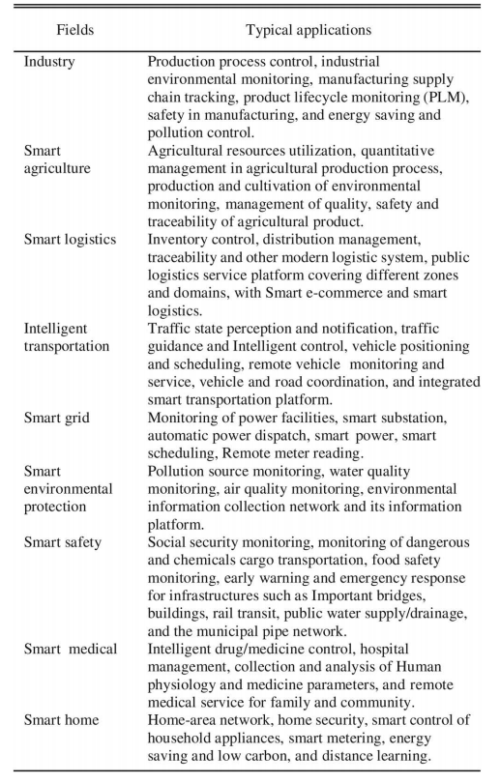
TABLE III MAIN APPLICATION FIELDS IN CHINA
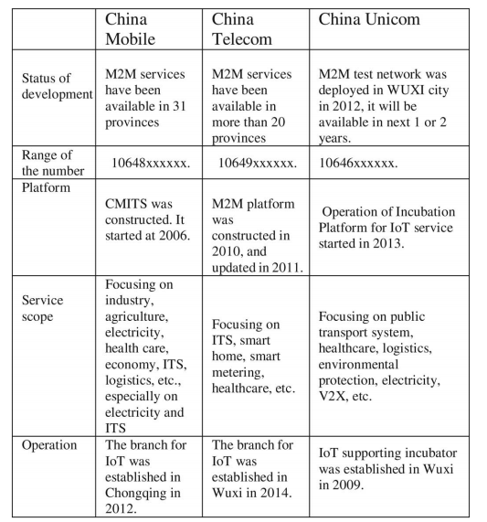
TABLE IV
IOT DEVELOPMENTS FROM THREE MAJOR OPERATORS
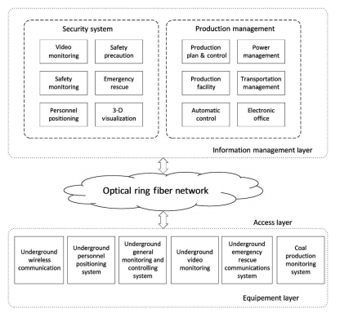
Fig. 4. IOT system structure for coal mine

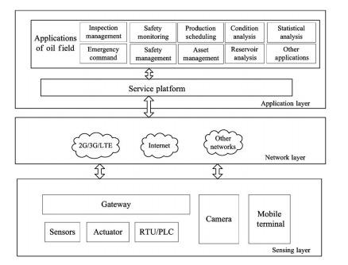
Fig. 5. IOF system.

VI. CHALLENGE AND PROSPECT OF IOT
IoT trends to be unified, seamless, and pervasive. Large-scale service deployment needs to be framed within a set of standards. However, IoT involves many manufacturers, spans multiple industries, and it differs widely in application scenarios and user requirements, which consequently gives impacts on large-scale commercial deployment of related services. The development of IoT is a step-by-step process. There are still many problems to be solved, such as low power nodes and computing, low cost and low latency communication, identification and positioning technologies, self-organized distributed systems technology, and distributed intelligence.
A. Challenge of IoT
The IoT provides many new opportunities to the industry and end user in many application fields. Currently, however, the IoT itself lacks theory, technology architecture, and standards that integrate the virtual world and the real physical world in a unified framework [19]. Following key challenges are thus listed.
1) Architecture Challenge: IoT encompasses an extreme wide range of technologies. IoT involves an increasing number of smart interconnected devices and sensors (e.g., cameras, biometric, physical, and chemical sensors) that are often nonintrusive, transparent, and invisible. As the communications among these devices are expected to happen anytime, anywhere for any related services, generally, these communications are in a wireless, autonomic, and ad hoc manner. In addition, the services become much more mobile, decentralized, and complex. In IoT, data integrations over different environments are thus tough and will be supported by modular interoperable components. Infrastructure solutions will require systems to combine volumes of data from various sources and determine relevant features, to interpret data and show their relationships, to compare data to historical useful information, and support decision-making. Single reference architecture thus cannot be a blueprint for all applications. Heterogeneous reference architectures have to coexist in IoT. Architectures should be open, and following standards, they should not restrict users to use fixed, end-to-end solutions. IoT architectures should be flexible to cater for cases such as identification (RFID, tags), intelligent devices, and smart objects (hardware and software solutions).
2) Technical Challenge: IoT technology can be complex for variety of reasons. First, there are legacy heterogeneous architectures in the existing networking technologies and applications, e.g., different applications and environments need different networking technologies, and the ranges as well as other characteristics of cellular, wireless local area network, and RFID technologies are much different from each other [20]. Second, communication technologies, including fixed and mobile communication systems, power line communications, wireless communication, and short-range wireless communication technologies, for both fixed and mobile devices, either simple or complicated, should be low cost and with reliable connectivity. At last, there are thousands of different applications; it is in natural to have different requirements on what parties need to communicate with each other, what kind of security solutions are appropriate, and so on.
To summarize, complexity and alternative technologies may introduce problems; unnecessary competition and deployment barriers in markets may also introduce problems; systems and communication mechanisms with unnecessary dependencies may block the migration of IoT systems to the most economic and efficient platforms. All the above may block IoT to connect as many “Things” as possible.
3) Hardware Challenge: Smart devices with enhanced inter-device communication will lead to smart systems with high degrees of intelligence. Its autonomy enables rapid deployment of IoT applications and creation of new services. Therefore, hardware researches are focusing on designing wireless identifiable systems with low size, low cost yet sufficient functionality.
As the bandwidth of IoT terminals could vary from kbps to mbps from sensing simple value to video stream, requirements on hardware are diverging. However, two requirements have been nevertheless the essentials: one is the extremely low power consumption in sleep mode and the other is ultra low cost. Suppose the sleeping time over active time is one million, the leakage power of an IoT terminal shall at least be one million time less than that of active. It is so far impossible when an IoT terminal is sleeping and receiving RF signals. It will be even difficult when using advanced CMOS silicon with relatively more leakage power. Hardware and protocol codesign for sleeping has been thus the first hardware challenge of IoT.
Billions of IoT terminals will be used; the cost of an IoT terminal must be ultra low. However, so far, there is no low cost positioning solution for IoT, especially the positioning precision of a short-range IoT terminal must be high.
Low active power is also a challenge for low-cost terminal [21]. Traditionally, low cost equals to lower performance or longer process latency. Longer processing latency ends up to higher energy consumption. As the spectrum resource is very limited at the lower part in L band, IoT may use higher RF such as the frequency bands higher than 5 GHz. The higher the RF, the more power consumption from RF PA will be.
In another way, not yet used very narrow spectrum band between two used bands may have to be used by future IoT. To use very narrow band with strong power neighbors, the cost of passive component will not be low and that will definitely be a potential challenge in the future.
4) Privacy and Security Challenge: Compared with traditional networks, security and privacy issues of IoT become more prominent [22]. Much information includes privacy of users, so that protection of privacy becomes an important security issues in IoT. Because of the combinations of things, services, and networks, security of IoT needs to cover more management objects and levels than traditional network security. Existing security architecture is designed from the perspective of human communication, may not be suitable and directly applied to IoT system. Using existed security mechanisms will block logical relationship between things in IoT.
IoT needs low-cost- and M2M-oriented technical solutions to guarantee the privacy and the security. In many use cases, the security of a system has been considered as a general feature. Related research shall focus on privacy control. Low cost, low latency, and energy-efficient cryptography algorithms and related flexible hardware will be essential for sensor or device.
5) Standard Challenge: Standards play an important role in forming IoT. A standard is essential to allow all actors to equally access and use. Developments and coordination of standards and proposals will promote efficient development of IoT infrastructures and applications, services, and devices. In general, standards developed by cooperated multiparties, and information models and protocols in the standards, shall be open. The standard development process shall also be open to all participants, and the resulting standards shall be publicly and freely available. In today’s network world, global standards are typically more relevant than any local agreements.
6) Business Challenge: For a mature application, its business model and application scenario are clear and easy to be mapped into technical requirements. So the developers do not need to spend much time on business-related aspects. But for IoT, there are too many possibilities and uncertainties in business models and application scenarios. It is thus inefficient in terms of business-technology alignment, and one solution will not fit possibilities for all. The IoT is a challenging traditional business model. Although small-scale applications have been profitable in some industries, it is unsustainable when extended to other industries. In the early stage of IoT development, business aspects should be considered to reduce the risk of failure.
B. Prospect of IoT
With the development and maturity of distributed intelligent information processing technologies, IoT systems will make intelligent sensing widely available through information sharing and collaboration. The gradual establishment and improvement of the standards system will inevitably bring IoT into our daily life. The IoT creates an opportunity for the web-based services, thus enhancing the commercial and social potential future of IoT [23].
The development of IoT keeps going forward along scale, collaborative, and intelligent. Promoted by technology, standardization, and application experiences, IoT applications will expand the scale in the different industries, and more enterprises will be attracted to come in
1) Interoperability: Information interoperability will take place among different things, different enterprises, different industries, and different regions or countries; application models will change from closed to open and the globalization of IoT application system serving different industries and fields will be constructed. Interoperability is the essential issue for crossing layers of physical, device, communication (protocol and spectrum utility), function and application. These levels traditionally are built with different languages and protocols. Level and domain transparent languages and protocols are, therefore, needed. A holistic approach is required in addressing and solving the interoperability of IoT devices and services at several layers.
2) Intelligent System: The IoT will bring seamless business and social networking over fast reliable and secure networks into our society. System intelligence will be important for the development of IoT and the key point will be context awareness and inter-things information exchange. Therefore, increasing and adapting the intelligence at the device level will be a focus of research, such as the integration of sensors and actuators, high efficiency, multistandard and adaptive communication subsystems, and adaptable antennae.
Intelligences can be introduced using micro control unit (MCU) on upper layers. However, physical layer so far has been far behind the required intelligent level, for example, to adapt IoT devices under different radio infrastructures. Four parts in physical layer must be further developed to adapt to and/or to form an intelligent IoT device, which are as follows.
Programmable baseband processor will be used to adapt to different modulation algorithms, different error correction algorithms, different channel bandwidths, and different channel scenarios.
Software-controlled RF will be essential for transceiver to adapt to the local radio frequency requirements.
Fully digital RF PA will be the indispensable device to consume less low power and offer programmability for PA to adapt radio transmission requirements.
Finally, controllable integrated passive components will be an essential glue to connect intelligent semiconductor components into a sensor node with low cost, low size, and low power.
3) Energy Sustainability: In the future, energy-efficient and self-sustainable systems will be key enhancing issues to the IoT. The ways to harvest energy from environments must be developed. Efficiency in processing and communication must also be increased through new circuits, new programming paradigms, and the further development of energy-efficient protocols and smart antennae. The development of new, efficient, and compact batteries, fuel cells, as well as new energy generation devices coupling energy transmission methods or energy harvesting will be the key factors for the roll-out of autonomous wireless smart systems.
Charging of global IoT terminals, power consumption of global IoT access points and gateways, as well as the power consumption of IoT data processing in IoT infrastructures will be one of the dominant power consumers in the future world.
Mechanical energy harvest will be sufficient for body network as a part of IoT
VII. CONCLUSION
The IoT encompasses several technologies such as information technology, cognitive sciences, communication technology, and low-power electronics. IoT creates a newer information society and knowledge economy. But the challenges from research, industries, and the government will keep pushing and investing. The development of IoT will depend on technological advances in silicon scaling and energy-efficient devices, in getting the information from heterogeneous sources, in reducing costs, and in improving efficiencies. The development of the IoT exposed many new challenges including the lack of fundamental theory supporting, unclear architecture, and immature standards. To meet these challenges, we give a three-layer architecture including three platforms. The proposed acting standard can hopefully balance desires from different parties, can open the door for future fundamental theory development, and can eventually stimulate/regulate IoT development. Recent years, Chinese government is pushing the development of the IoT. Following the Chinese 12th Five-Year Plan for IoT Development, China has accomplished a number of demonstration application projects such as the smart city and the intelligent transportation system in public IoT applications, intelligent coal mine, and the IOFs in industry applications. The future of IoT will be expected to be unified, seamless, and pervasive. Large-scale service deployment needs to be framed within a set of standards. Thus, the developments of IoT as an intelligent system can be proceeding with interoperability, energy sustainability, privacy, and security. IoT have become an inevitable trend of development of information industry, which bound to bring new changes to our lives.

展望物联网:中国视角下的应用、挑战与机遇
摘要: 物联网(IoT)是一个由数十亿或数万亿“物”相互通信的巨大网络，它面临着许多技术和应用挑战。介绍了物联网在中国的发展现状，包括政策、研发计划、应用和标准化。本文从中国的角度，描述了在技术、应用和标准化方面面临的挑战，并提出了一个由三个平台组成的开放通用的物联网体系结构来应对体系结构挑战。最后，本文讨论了物联网的机遇和前景。
物联网、物联网应用、物联网架构、物联网挑战、物联网标准化。
1.介绍
物联网(IoT)被认为是全球信息领域的一股技术和经济浪潮
互联网之后的产业。物联网是一种智能网络，它将所有事物连接到互联网上，通过信息感知设备按照约定的协议交换信息和通信。实现了对事物[1]的智能识别、定位、跟踪、监控和管理。它是基于互联网的网络的延伸和扩展，将人与人之间的交流扩展到人与物之间或物与物之间。在物联网范式中，我们周围的许多物体将以一种或另一种形式连接到网络中。射频识别(RFID)、传感器技术等智能技术将被嵌入到各种各样的应用中。
稿件收于2013年10月30日;修改2014年3月31日和2014年5月15日;2014年6月29日录用。2014年7月09日;当前版本日期为2014年8月07日。国家科技重大专项;国家高技术计划资助项目。
物联网作为一种新兴事物，目前还没有一个公认的定义。来自不同视角和组织的专家对物联网的描述有着不同的偏好。不同组织对物联网的典型定义如表I所示。
随着技术的发展，越来越多的计算能力、存储能力和电池容量将以相对较低的成本和尺寸获得。这种趋势使得具有识别/通信/计算能力的极小型电子设备的开发成为可能，这些设备可以嵌入到其他设备、系统和设施中。物联网应该具有以下三个特点[6]。
1)综合感知:利用RFID、传感器、二维条码，随时随地获取物体信息，将是一个新的机遇。利用它，信息和通信系统可以隐形地嵌入到我们周围的环境中。传感器网络将使人们能够与现实世界进行远程交互。这里提到的识别技术包括对象识别和位置识别。对物质世界的识别和认识是实现整体感知的基础。
2)可靠的传输:通过各种可用的无线网络、电信网络和互联网，可以在任何时间获得对象信息。这里的通信技术包括各种有线和无线传输技术、交换技术、网络技术和网关技术。物联网进一步创造了物理世界、虚拟世界、数字世界和社会之间的互动。机器对机器(Machine to Machine, M2M)是物联网的关键实现技术，它代表了M2M与人对机器(包括移动对机器)之间的连接和通信。
3)智能处理:通过将物联网数据收集到数据库中，包括云计算在内的各种智能计算技术将能够支持物联网数据应用。网络服务提供商可以通过云计算即时处理数千万甚至数十亿条消息。云计算技术将成为物联网的推动者。
目前，中国至少有90亿台互联设备，预计到2020年将达到240亿台。根据GSMA的数据，这一数字为1.3万亿美元。
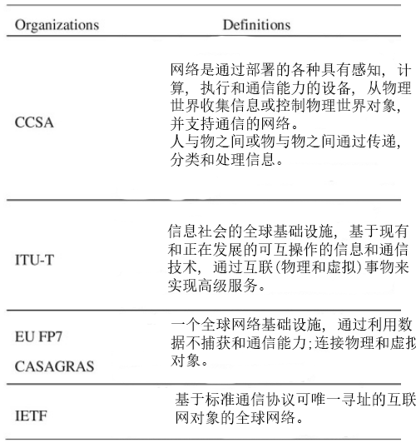
表1.1 不同组织对物联网的定义

仅移动网络运营商的收入机会就涵盖了医疗、汽车、公用事业和消费电子等领域。许多国家将物联网视为战略产业和未来新的经济增长引擎。欧盟已通过第七次欧盟框架计划(FP7 for R&D)对一系列项目投资超过1亿欧元，这些项目将积极部署在智能电网、智能交通、智慧城市等领域。韩国在物联网基础技术开发、物联网测试台的发展、物联网标准化等方面投入了2780万美元(约3800亿韩元)。
中国正在加快物联网的发展，并将其定义为经济增长的新引擎。政府发布了物联网发展“十二五”规划。该计划是2011年至2015年发展物联网的纲要计划。规划提出了未来发展的目标和目标，并提出了实现这一目标的几种途径。该计划还提出了一系列支持和促进物联网产业发展的方法。
本文的组织如下。第二部分介绍了物联网的机遇，总结了物联网的现状和应用。第三部分介绍了我国物联网的政策、研发计划和标准化。在第二节和第三节介绍的基础上，第四节分析了阻碍物联网发展的主要问题:不同物联网解决方案之间缺乏互操作性。给出了一种开放的物联网通用体系结构。第五部分介绍了物联网在中国的主要应用领域、典型公共应用实例和行业应用实例。第六节分析了物联网面临的进一步挑战，包括技术挑战和标准挑战，并介绍了物联网的前景。第七部分是本文的结论部分。
2.物联网的机遇、地位和能力
A.物联网的机遇
物联网将创造一个由数十亿或数万亿“事物”相互通信的巨大网络。物联网不是对现有技术的颠覆性革命，它是对现有技术的综合利用，是新通信模式的创造。物联网通过将不同的概念和技术组件结合在一起，将虚拟世界和物理世界混合在一起:普及网络、设备小型化、移动通信和新的生态系统。在物联网中，应用程序、服务、中间件组件、网络和终端节点将以全新的方式进行结构组织和使用。
物联网提供了一种研究复杂过程和关系的方法。物联网意味着真实/现实世界和数字/虚拟世界之间的共生互动:物理实体具有数字对应物和虚拟表示;事物变得具有上下文意识，它们可以感知、交流、交互，并交换数据、信息和知识。新的机会将满足业务需求，新的服务将基于实时的物理世界数据创建。
物理或虚拟世界的一切都可能通过物联网连接起来。这些东西之间的连接应该以低成本提供给所有人，并且不应该由私人实体拥有。对于物联网来说，智能学习、快速部署、最佳的信息理解和解释、防范欺诈和恶意攻击以及隐私保护是必不可少的要求。
B.物联网现状
物联网可以被视为现有的人与应用之间的交互的扩展，通过一个新的“事物”维度进行通信和集成。
物联网的发展过程是一个复杂的大规模技术创新过程。物联网正从垂直应用发展到聚合物应用。
在物联网部署的早期阶段，驱动特定领域的应用是主要的发展策略。特定领域的应用可能是具有其自身行业特性的制造控制系统。该应用程序可以提供与工业生产和业务流程集成的各种企业管理服务。
聚合物应用是基于公共信息服务平台的跨行业应用。这些应用程序支持家庭用户和行业用户。该应用由通信运营商和解决方案提供商大规模提供和推广。例如，一辆集成了传感器网络、全球定位系统(GPS)和无线电通信技术的车辆可以提供全面的探测、导航、娱乐和其他信息服务。通过公共服务平台对这些信息进行维护，消费者、原始设备制造商、维修商、车辆管理机构可以共享这些信息，共享服务，通过车辆全生命周期管理来改善车辆、车辆零部件设计和制造过程。
C.物联网应用能力
综上所述，物联网应用应具备以下能力。
1)位置信息感知与共享:物联网系统可以收集物联网终端和终端节点的位置信息，并根据收集到的位置信息提供服务。位置信息包括从GPS、Cell- ID、RFID等获取的地理位置信息，以及事物之间的绝对或相对位置信息。更典型的物联网应用至少包括以下内容。
a)移动资产跟踪:本应用程序可以通过安装在商品上的位置传感装置和通信功能，对商品的状态进行跟踪和监控。
b)车队管理:车队管理者可根据业务需求和车辆采集的实时位置信息对车辆和驾驶员进行调度。
c)交通信息系统:通过跟踪大量车辆的位置信息，获取道路交通状况、拥堵位置等交通信息。因此，该系统可以帮助司机选择最有效的路线。
2)环境传感:物联网系统可以通过本地或广泛部署的终端对各种物理或化学环境参数进行采集和处理。典型的环境信息包括温度、湿度、噪声、能见度、光强、光谱、辐射、污染(CO、CO2等)、图像和身体指标。典型的应用至少包括以下几个方面。
a)环境检测:物联网系统提供环境和生态监测，如森林和冰川;火山、地震等灾害监测;和工厂的监控。所有这些都配有自动报警系统，使用大量传感器收集的环境参数。
b)远程医疗监控:物联网可以对放置在患者身上的设备收集到的反复出现的指标数据进行分析，为用户提供健康趋势和健康建议。
3)远程控制:物联网系统可以根据应用命令控制物联网终端，并结合从事物中收集的信息和业务需求来执行功能。
a)设备控制:可远程控制操作-
通过物联网系统查看家电的状态。b)灾难恢复:用户可远程启动灾难处理设施，根据上述监测，将灾难造成的损失降至最低。
4) Ad Hoc组网:物联网系统应具有快速自组织组网能力，并能与网络/服务层互操作，提供相关服务[7]。在车辆网络中，为了传输数据，车辆和/或道路基础设施之间的网络可以快速自组织。
5)安全通信:物联网系统可以进一步在应用之间建立安全的数据传输通道或根据业务需求提供服务平台和物联网终端。
在实践中，一个物联网应用程序由不同类型的功能甚至基于服务需求的应用程序组成。表2展示了不同物联网应用的例子。
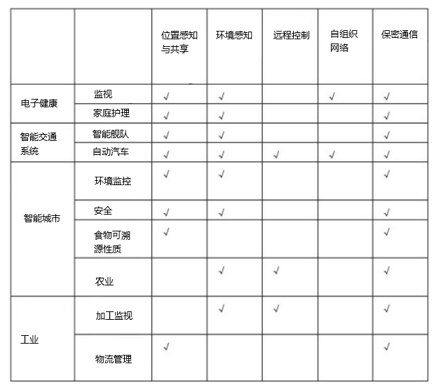
表2 物联网应用概述

3.物联网在中国
A.中国推动物联网发展
我国物联网传感网络的研究始于1999年。物联网被定位为战略性新兴产业之一，并于2010年3月写入政府工作报告。2010年11月发布的《国务院关于加快培育和发展战略性新兴产业的决定》明确指出，将推进物联网研究和应用示范。
2012年，中国工业和信息化部解释了包括物联网发展(2011-2015)在内的国家“十二五”规划[8]。这是中国政府第一个详细发布物联网发展计划。该计划明确提出了2011-2015年物联网的发展目标。到2015年，物联网基本技术、相关应用和标准化应取得重大成就。
《规划》提出了8项主要任务，明确了5项重点工程，包括技术创新工程、标准化加速工程、“10个产业板块100家新企业”产业发展先行工程、重点行业应用示范工程、公共服务平台建设项目。
为解决出现的问题，考虑物联网的长远发展，国务院于2013年2月发布了《关于推进物联网发展跟踪订货工作的指导意见》[9]，明确了物联网的发展目标和思路。

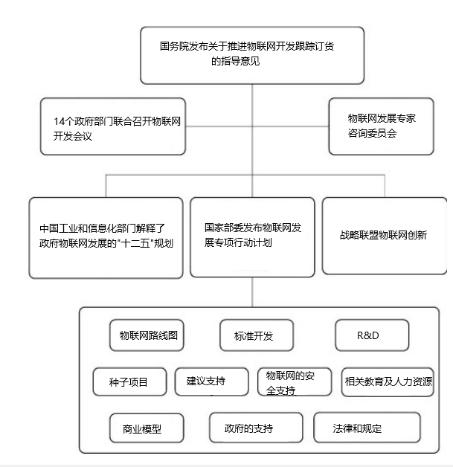
图3.1 特别行动计划概括

全国14个部委, 2013年9月，国家成立物联网发展联席会议，组织物联网发展专家咨询委员会。物联网[10]十大特别发展行动计划，包括:1)顶层设计;2)标准开发;3)技术开发;4)应用推广;5)行业的支持;6)商业模式;7)安全;8)政府的支持;9)法律法规保障;和10)人员培训，是联席会议发出的。作为行动计划的一部分，IoT工业技术创新战略联盟于2013年10月[11]成立。图3.1显示了特殊开发包计划的概要。
B.研发计划
在中国，中央政府设立了支持物联网发展的示范项目和研究项目专项资金。2011年，为支持我国物联网发展，投入物联网相关领域专项资金约5亿元，其中2/3用于物联网的研发和应用;该基金从2011年开始支援了381家相关企业。自2011年以来，中国政府已支持22个国家重大物联网应用示范项目，2013年10月，中国国家发展和改革委员会发布公告。组织开展2014 - 2016年全国特殊区域物联网试点重大应用示范项目。
在研发领域，中国工业和信息化部在“新一代移动宽带”项目下，在智能交通系统(ITS)、电子医疗等体系结构和应用领域立项多项重大技术研究项目。中国科技部还在物联网领域开展了一系列基础研究, 国家重点基础研究发展计划(973)框架下的建筑、基础理论与设计等。
国家层面的物联网研发分布为:运营商、供应商等企业提供物联网的运营和系统开发。高校和研究机构专注于关键技术的研究，标准机构负责物联网标准化。目前，物联网相关产业基本形成，主要分布在渤海湾地区、长三角地区、珠三角地区和中西部地区。图3.2为国家物联网国家研发计划综述。
C.标准化
物联网标准体系包括体系结构标准、应用需求标准、通信协议标准、识别标准、安全标准、应用标准、数据标准、信息处理标准、公共服务平台标准。
提议的物联网标准集相对复杂。在中国，标准化工作始于2010年。中国物联网标准的主要组织有中国通信标准协会(CCSA)、中国传感器网络标准化工作组(WGSN)、电子标签标准技术委员会等。这些标准组织正在引领中国物联网标准化进程。作为《物联网特别行动计划》的一部分，物联网标准化行动包括建立标准体系，制定共同标准、关键技术标准和紧急行业标准，积极参与国际标准化进程，开展标准验证和服务，改进组织结构。
在标准化过程中，我国许多研究机构和企业也参与了国际标准化组织/国际电工技术M2M的国际标准化工作。委员会(ISO/IEC)、国际电联电信标准化部门(ITU- t)、第三代伙伴关系项目(3GPP)。中国是ITU-T和ISO无线传感器网络(WSN)工作组的领先国家之一。CCSA是one M2M的主办机构之一，众多企业正在深入参与3GPP mtc相关标准的开发。
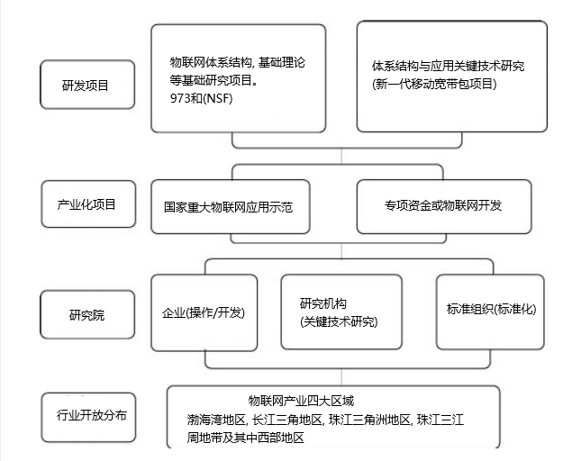
图3.2 中国物联网国家研发计划综述

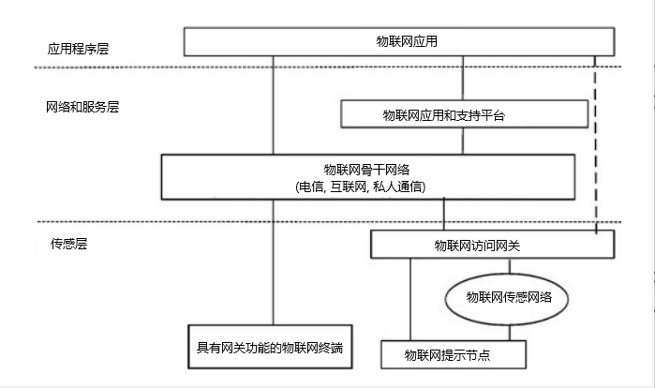
图3.3 CCSA提出了开放通用的物联网架构

4.开放通用的物联网架构
A.动机和一般描述
正如前面对当前物联网的介绍中所看到的，中国的大多数物联网应用都是特定于领域或特定于应用的解决方案。这些物联网系统的架构是支离破碎的，无法将来自不同竖井的数据相互关联和集成;这些孤立的物联网解决方案使用私有协议，在信息共享、技术多路复用、网络管理和升级方面造成了很多问题。这些问题都阻碍了物联网的发展。
为了降低物联网总成本，实现信息共享，需要将多种功能和资源整合到一个更大的系统中。因此，物联网需要使用开放的、通用的、接口和资源开放的物联网架构进行设计，考虑不同的业务场景、基于应用的需求和当前的技术[12]。因此，我们看到了制定物联网集成标准的动机，以减少设备、开发和部署的总成本和时间。
一个开放通用的物联网架构是一个具有互操作性的集成解决方案[13]，[14]。它将具有以下特征。
1)标准接口和协议:通过比较不同的私有物联网系统，通用物联网基础设施具有相同的软硬件接口和协议。
2)公共和运营:部署通用物联网架构，接管具有开放运营能力的公共物联网应用。因此，公共物联网系统可以将多个物联网应用集成到一个体系结构中。
3)开放、可伸缩、灵活:开放的物联网架构具有开放的资源、开放的标准和开放的接口，可以轻松扩展其功能和性能规模。因此，它可以灵活地适应不同的要求，包括技术发展。
B.开放通用的物联网架构
中国通信标准协会(CCSA)提出了物联网的参考模型，包括传感层、网络和业务层、应用层。遵循此参考模型，其开放通用的体系结构如图3所示，分层、开放、灵活。该体系结构包括如下三个功能平台。
1)传感和网关平台:该平台将传感器、控制器、RFID阅读器和位置传感设备(如GPS)连接到物联网网络层。提出了物联网终端、物联网网关、尖端节点的硬件、数据格式和软件接口模块化。物联网终端、物联网网关、尖端节点均可包含灵活模块与控制相结合模块、通用接口模块、通信模块。公共接口模块将各种传感器的物理接口集合成一个公共接口。通用控制模块可以通过通用连接协议连接传感器、控制器、GPS和RFID阅读器。物联网终端和物联网网关的软件和应用参数应具有自配置和自适应能力。模块化、通用接口、智能化操作、自适应、自配置是该平台的重要特点。
2)资源和管理平台:网络和服务层包括骨干网和资源管理平台。骨干网络包括3G、4G、internet、光纤网络、以太网、卫星网络和专用网络。资源和管理平台提供通用功能，可用于不同的物联网应用，如数据处理、数据存储、安全管理和应用支持。这些能力也可以由特定的物联网应用支持能力调用，例如，构建其他特定的物联网应用支持能力。该平台还提供与网络连接相关的控制功能，如接入和传输资源控制功能、移动性管理或对物联网终端、业务、应用、用户和开发人员进行认证、授权和计费等。
3)开放应用平台:该应用平台采用模块化设计，提供通用功能和开放API。物联网应用程序提供商可以使用这些api开发其应用程序。同时，该平台支持应用程序管理。各种应用可以发布到应用平台，用户可以通过该平台获取应用信息和订阅应用。该平台具有易于部署、分布式、灵活的应用环境等特点。
5.中国地区典型应用及部署
A.主要应用领域
在中国，物联网应用将发展在九个领域，包括:1)领域工业应用;2)智能农业;3)智能物流;4)智能交通;5)智能电网;6)智能环保;7)智能安全;8)智慧医疗;9)智能家居，如表5.1所示。
表5.1 中国主要应用领域
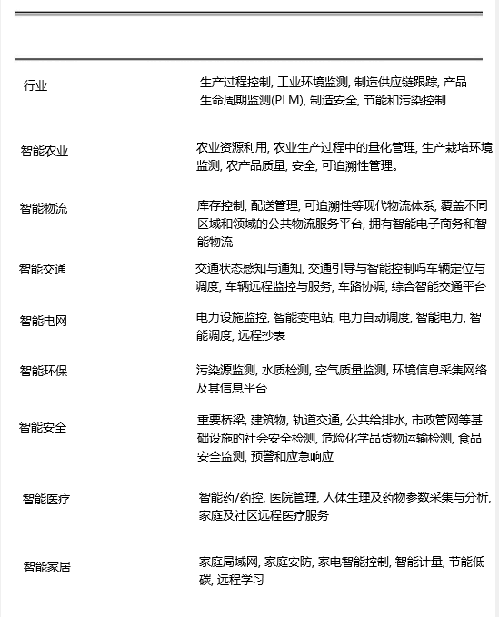
表5.2 来自三大运营商的物联网发展
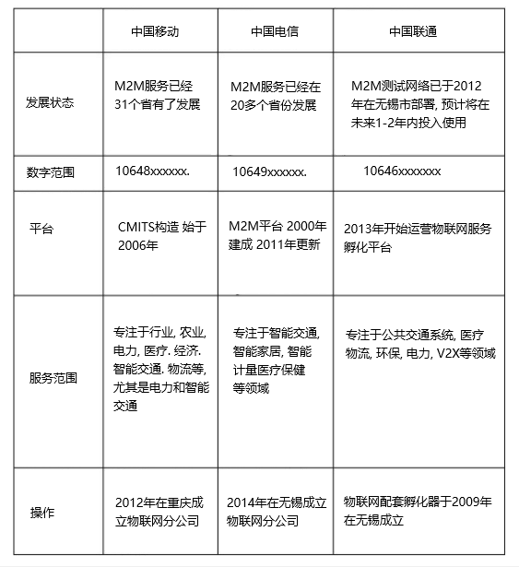

三大运营商:1)中国移动;2)中国电信;3)中国联通宣布了物联网发展计划。物联网已经成为中国电信运营商战略的重要组成部分。
中国移动计划实施集中式平台[中国移动物联网运营支持平台(CMITS)]，并于2012年在重庆成立物联网分支机构。
中国电信计划根据重点行业需求，进一步丰富物联网业务，构建开放的合作平台，推动物联网商业模式创新。2014年在无锡成立物联网分公司。
中国联通计划建立一个物联网的管控平台和运营支持系统。他们还计划提供特定的硬件通信模块。
B.典型应用部署
1)智慧城市:智慧城市是利用物联网、云计算、大数据分析等新技术促进城市系统信息共享与协调的新型城市发展模式。物联网是建设智慧城市的重要手段和工具，是承载智慧城市基础设施建设的重要载体。智慧城市建设依赖于不同行业的大量物联网应用[15]，[16]。
智慧城市发展规划分为三个阶段:1)基础设施初步建设阶段;2)数据处理设施建设阶段;3)后期服务平台建设阶段。大量的智慧城市项目为电信OEM、系统集成企业、数据汇总分析/服务企业、电信运营商提供了巨大的机遇。在中国，一些城市正在着力改善智慧城市项目的基础设施，发展区域智能电子商务和物流，而其他城市则在加大力度改善当地公用事业的管理。据估计，“十二五”期间(2011-2015年)，智慧城市市场总价值将超过2万亿元。
2)智能交通:中国需要利用物联网等新技术解决城市地区交通拥堵加剧的问题。
中国交通运输部宣布了一项计划，到2020年，智能交通系统的发展将在全国范围内安装和使用。未来10年，政府将在智能交通领域投资约4万亿人民币。智能交通系统在我国正处于发展阶段，并保持着较高的增长率。我国城市智能交通控制系统市场增长速度较快，包括电子警察、智能交通信号控制、交通视频监控、智能出租车服务管理、城市公共交通信息技术等。在十二五规划完成之前，中国60%的国道将拥有ETC。在智能城市ITS中安装物联网基础设施，将支持基础技术。
车联网和车联网技术已被认定为提高道路安全和运输效率的关键技术。近年来，车载网络基础设施集成技术受到了广泛的关注;它也将带来不可估量的经济价值，并将在下一代智能交通系统和通信网络的发展中发挥重要作用。另外，由于全球对电动汽车充电供应的需求不断增加，预计到2020年，汽车内置连接将成为消费者的强制功能。政府、大学、汽车厂商、电信厂商等结成联盟发展互联汽车产业，如中国ITS产业联盟、Telematics产业应用联盟等，共同发展互联汽车产业。智能城市物联网基础设施的相关安装也将是基础支撑技术。
C.典型工业应用的部署
1)智能煤矿:2011年，中国国家安全生产监督管理总局和国家煤矿安全监察局规定，到2013年底，中国所有煤矿必须完成“煤矿六对冲安全系统”的建设。六篱地下系统包括:1)通用监控系统;2)人员定位系统;3)应急避难所系统;4)供氧监测系统;5)给排水监测系统;6)矿用电缆和无线通信系统。
上述六种系统都是基于普适感知、感知数据采集、数据实时使用和深度数据事后分析，实际上是基于物联网的。物联网可广泛应用于“六大系统”。“例如，它使用传感器来监测矿工的位置和危险气体的泄漏。图5.3展示了一个典型的地下物联网系统。该系统建立在地下工业环网和工业现场总线的基础上，实际上是一个综合的地下物联网平台，通过工业以太网协议将采矿设备的数据传输到调度中心，从而监控调度中心内部的各种设备和传感器。系统总体设计包括传感与设备层、网络与接入层、应用与信息管理层。该系统实时采集机电设备的参数和安全系统的数据，提高了系统的效率和安全性。为煤矿的正确调度决策提供了有力的保障。
2)智能油田:智能油田(IOF)由分布式系统组成，保存着频繁采集的数据。根据实时信息对数据进行评估和处理。IOF可以降低作业成本，降低资本投资，提高油气产量。图5.4为基于第四节体系结构的IOF系统，该系统将在整个生产过程中采集参数，包括油井和气井、计量房、油站和加油站、油气管网的传感和监测参数。感知数据将被收集并传输到服务平台和网关/终端之间，使用公共连接协议进行进一步的分析。实时的生产数据和设备状态信息支持生产控制中心对生产指挥中心的集中管理和控制。IOF可以提高油气田生产决策的完整性、准确性、及时性和规范性。IOF系统的目标和目的是提高产品过程、决策的准确性和及时性，提高系统管理水平，降低运行成本，降低风险。物联网系统作为IOF中的一个子系统，通过建立一个标准化的通用服务平台，覆盖所有油气井和油气田、计量房、收集和输送站、联合站、处理厂，实现生产数据的自动化采集、远程监控和生产预警支持。该平台还支持生产过程的过程管理。

图5.3 煤矿物联网系统结构
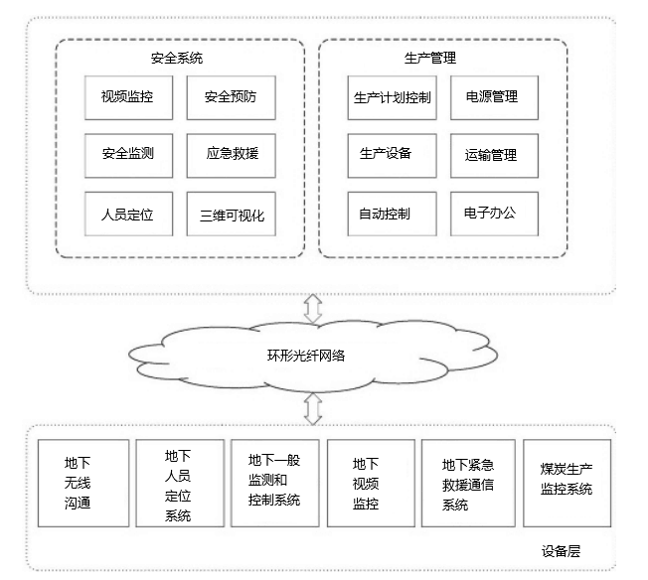
图5.4 智能油田系统
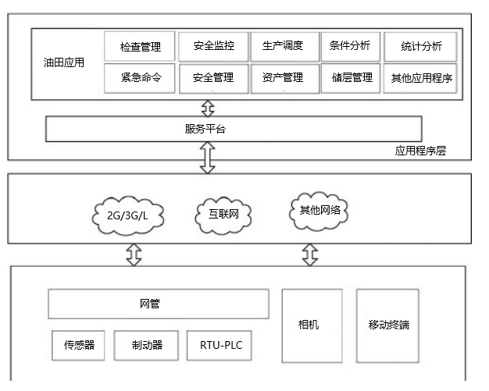
6.物联网的挑战与前景
物联网趋向于统一、无缝和普及。大规模服务部署需要在一组标准中框架化。但由于物联网涉及多家厂商，跨越多个行业，应用场景和用户需求差异较大，影响了相关业务的大规模商用部署。物联网的发展是一个循序渐进的过程。低功耗节点与计算、低成本低延时通信、识别定位技术、自组织分布式系统技术、分布式智能等有待解决的问题还很多。
A.物联网的挑战
物联网在许多应用领域为行业和终端用户提供了许多新的机遇。然而，目前物联网本身缺乏将虚拟世界和真实的物理世界整合到一个统一框架[19]中的理论、技术架构和标准。因此列出了以下主要挑战。
1)架构挑战:物联网包含了极其广泛的技术。物联网涉及越来越多的智能互联设备和传感器(如相机、生物识别、物理和化学传感器)，它们通常是非侵入性的、透明的和无形的。由于这些设备之间的通信需要在任何时间、任何地点为任何相关服务进行，因此这些通信通常采用无线、自主和特别的方式。此外，服务变得更加移动、分散和复杂。因此，在物联网中，不同环境下的数据集成非常困难，将由模块化互操作组件支持。基础设施解决方案将要求系统结合来自不同来源的大量数据，并确定相关特征，解释数据并显示它们的关系，将数据与历史有用信息进行比较，并支持决策。因此，单一的参考体系结构不能成为所有应用程序的蓝图。在物联网中，异构参考体系结构必须共存。架构应该是开放的，并且遵循标准，它们不应该限制用户使用固定的端到端解决方案。物联网架构应该灵活，以适应识别(RFID、标签)、智能设备和智能对象(硬件和软件解决方案)等情况。
2)技术挑战:物联网技术可能因各种原因而变得复杂。首先，遗留问题是异构的
现有的网络技术和应用的架构，例如，不同的应用和环境需要不同的网络技术，蜂窝、无线局域网和RFID技术的范围和其他特点都有很大的不同[20]。第二，固定和移动通信系统、电力线通信、无线通信、短距离无线通信等通信技术，无论固定和移动设备是简单的还是复杂的，都应具有低成本和可靠的连通性。最后，有数千种不同的应用程序;对于需要相互通信的各方、合适的安全解决方案等等，自然会有不同的要求。
总而言之，复杂性和替代技术可能会带来问题;市场上不必要的竞争和部署障碍也可能带来问题;具有不必要依赖关系的系统和通信机制可能会阻碍物联网系统向最经济、最高效的平台迁移。所有这些都可能阻碍物联网连接尽可能多的“事物”。
3)硬件挑战:增强设备间通信的智能设备将导致高度智能化的智能系统。它的自主性使物联网应用的快速部署和新服务的创建成为可能。因此，硬件研究的重点是设计出体积小、成本低、功能齐全的无线识别系统。
由于物联网终端的带宽可能从kbps到mbps不等，从简单的感知值到视频流，对硬件的需求也在分化。然而，有两个要求仍然是必不可少的:一是睡眠模式下的极低功耗，二是超低成本。假设有功时间后的睡眠时间为100万，则物联网终端的泄漏功率至少应小于有功时间的100万倍。到目前为止，物联网终端在睡眠时接收射频信号是不可能的。当使用相对更大的泄漏功率的先进CMOS硅时，这将更加困难。因此，用于睡眠的硬件和协议协同设计成为物联网的第一个硬件挑战。
数十亿物联网终端将被使用;物联网终端的成本必须超低。然而，目前还没有针对物联网的低成本定位解决方案，特别是近程物联网终端的定位精度要求较高。
低有功功率对低成本终端[21]也是一个挑战。传统上，低成本意味着更低的性能或更长的进程延迟。更长的处理延迟最终会导致更高的能量消耗。由于在L波段的较低频段频谱资源非常有限，物联网可能会使用较高的RF，例如高于5 GHz的频段。RF值越高，RF PA的功耗越大。
另一方面，两个使用波段之间的窄带可能必须被未来物联网使用。使用窄带与强功率相邻，无源器件的成本将不会很低，这肯定是未来一个潜在的挑战。
4)隐私与安全挑战:与传统网络相比，物联网的安全与隐私问题更加突出。很多信息都包含了用户的隐私，因此隐私保护成为物联网中一个重要的安全问题。物联网安全由于物联网、服务联网、网络联网三者的结合，需要覆盖比传统网络安全更多的管理对象和层次。现有的安全架构是从人类通信的角度设计的，可能不适合并直接应用于物联网系统。使用现有的安全机制会阻碍物联网中事物之间的逻辑关系。
物联网需要低成本和面向m2m的技术解决方案来保证隐私和安全。在许多用例中，系统的安全性被认为是一个通用的特性。相关研究主要集中在隐私控制方面。低成本、低延迟、高效节能的密码算法和相关的灵活硬件将成为传感器或设备的关键。
5)标准挑战:标准在物联网的形成中发挥着重要作用。必须制定一项标准，使所有行为者都能平等地获得和使用。标准和建议的制定和协调将促进物联网基础设施、应用、服务和设备的高效发展。一般而言，多方合作制定的标准以及标准中的信息模型和协议应是开放的。标准制定过程也应向所有参与者开放，所产生的标准应公开和免费提供。在今天的网络世界中，全球标准通常比任何本地协议更相关。
6)业务挑战:对于一个成熟的应用，它的业务模型和应用场景是清晰的，很容易映射到技术需求。因此，开发人员不需要在与业务相关的方面花费太多时间。但对于物联网来说，在业务模式和应用场景方面存在太多的可能性和不确定性。因此，就业务技术对齐而言，它是低效的，而且一种解决方案不可能适合所有的可能性。物联网是一种具有挑战性的传统商业模式。虽然小规模的应用在一些行业是有利可图的，但当扩展到其他行业时是不可持续的。在物联网发展的初期，从业务方面考虑，降低失败的风险。

B.物联网的前景
随着分布式智能信息处理技术的发展和成熟，物联网系统将通过信息共享和协作，使智能传感得到广泛应用。随着标准体系的逐步建立和完善，物联网必然会进入我们的日常生活。物联网为基于网络的服务创造了机会，从而增强了物联网未来[23]的商业和社会潜力。
物联网的发展正朝着规模化、协同化、智能化的方向发展。在技术、标准化和应用经验的推动下，物联网应用将在不同行业扩大规模，吸引更多的企业进入。
1)互操作性:不同事物之间、不同企业之间、不同行业之间、不同地区或国家之间的信息互操作性;应用模式由封闭向开放转变，构建面向不同行业、不同领域的物联网应用全球化体系。互操作性是跨越物理层、设备层、通信层(协议和频谱效用)、功能层和应用层的基本问题。这些级别通常是用不同的语言和协议构建的。因此，需要级别和领域透明的语言和协议。在解决和解决多个层次的物联网设备和服务的互操作性问题时，需要一种整体的方法。
2)智能系统:物联网将通过快速、可靠和安全的网络为我们的社会带来无缝的商业和社交网络。系统智能将对物联网的发展起到重要作用，其重点将是环境感知和物际信息交换。因此，增加和适应设备层面的智能将是研究的重点，如传感器和执行器的集成、高效、多标准和自适应通信子系统，以及适应性天线。
在上层可以通过微控制单元(MCU)引入智能。然而，到目前为止，物理层还远远落后于所需的智能水平，例如，在不同的无线电基础设施下适应物联网设备。为了适应和/或形成智能物联网设备，物理层有四个部分需要进一步开发，具体如下:
可编程基带处理器将用于适应不同的调制算法、不同的纠错算法、不同的信道带宽和不同的信道场景。
软件控制的射频对于收发机来说是必不可少的，以适应当地的无线电频率要求。
全数字射频放大器将成为一种必不可少的器件，既能降低功耗，又能提供可编程性，以适应无线电传输的要求。
最后，可控集成无源器件将成为将智能半导体器件连接到低成本、小尺寸、低功耗的传感器节点的必要粘合剂。
3)能源可持续性:在未来，节能和自我可持续的系统将是增强物联网的关键问题。必须开发从环境中获取能源的方法。处理和通信的效率也必须通过新的电路、新的编程模式以及进一步开发节能协议和智能天线来提高。新型、高效、紧凑的电池、燃料电池以及耦合能量传输方法或能量收集的新能源发电设备的开发将是自主无线智能系统推出的关键因素。
全球物联网终端的充电、全球物联网接入点和网关的功耗，以及物联网基础设施中物联网数据处理的功耗，将成为未来世界的主要电力消耗之一。作为物联网的一部分，人体网络将获得足够的机械能。太阳能或风能是一种有条件的能源，可能不可靠。它可以用来给电池充电。

7.结论
物联网包括多种技术，如信息技术、认知科学、通信技术和低功耗电子。物联网创造了一个更新的信息社会和知识经济。但来自研究、行业和政府的挑战将继续推动和投资。物联网的发展将依赖于硅尺度和节能设备、从异质来源获取信息、降低成本和提高效率等方面的技术进步。物联网的发展暴露出许多新的挑战，包括缺乏基础理论支持、架构不清晰和标准不成熟。为了迎接这些挑战，我们给出了一个包含三个平台的三层架构。所提出的行为标准有望平衡各方的意愿，为未来的基础理论发展打开大门，并最终促进/规范物联网的发展。近年来，中国政府正在推动物联网的发展。“十二五”规划以来，中国已完成智慧城市、智能交通系统在公共物联网应用、智能煤矿、物联网在工业应用等示范应用项目。预计物联网的未来将是统一的、无缝的和普遍的。大规模服务部署需要在一组标准中框架化。因此，物联网作为一种智能系统的发展可以在互操作性、能源可持续性、隐私和安全方面进行。物联网已经成为信息产业发展的必然趋势，势必给我们的生活带来新的变化。

