Computer Architecture Report of Project 1
Team 08
9962334 陳志杰
9962210 徐丞裕

- Simulator Design
We want to implement with some working stages such as pipelining, so we divide the work as IF, ID, EXE, MEM, WB.
For IF, it requires few functions which are strongly connected with ID. And we combines EXE, MEM and WB together to simplify the design flow. An instruction cycle is a sequence of some function, fetch, decode, then execute just like the reality. We also use a STRUCT to store an instruction, with op, rs, rt, rd, c, func…etc.

- Simulator elaboration
- Source code structure
- main.c
- memoryAccess.h
- instruction : struct
- toLittleEndian : function
- swap : function
- initInstMemory : function
- initDataMemory : function
- loadDataMemory : function
- saveDataMemory : function
- instructionFetch : function
- instructionDecode : function
- instructionType : function
- memoryAccess.c
- Implements memoryAccess.h
- execution.h
- insExecution : function
- util.h
- snapshotGen : function
- errorGen : function

- Function Design Remarks
- swap()
This function is used to swap data in bytes (again, endianness), which is used in data memory.

- toLittleEndian()
This function is used to swap between two endianness.

- initInstMemory()
This function is used to load data from iimage.bin to iMemory, it also generates initial PC value.

- initDataMemory()
This function is used to load data from dimage.bin to dMemory, it also generates initial $sp value.

- loadDataMemory()
This function is used to load data from dMemory, it returns a character array with four units of characters.

- saveDataMemory()
This function is used to write data back to the memory, you can also define the length that writes.

- instructionFetch()
This function is used to fetch the instruction data to an instruction structure, then decode it using instructionDecode().

- instructionDecode()
This function is used to decode an instruction and write corresponding opcode, rs, rt, rd, c, func to the instruction struct by its opcode which is generated by instructionType().

- instructionType()
This function is used to generate the opcode of an instruction.

- insExecution()
This function is used to execute an instruction with accessing memory and write back to registers. It also generates the signal of errors.

- snapshotGen() & errorGen()
These functions are used to generate the output data.

- Program flow
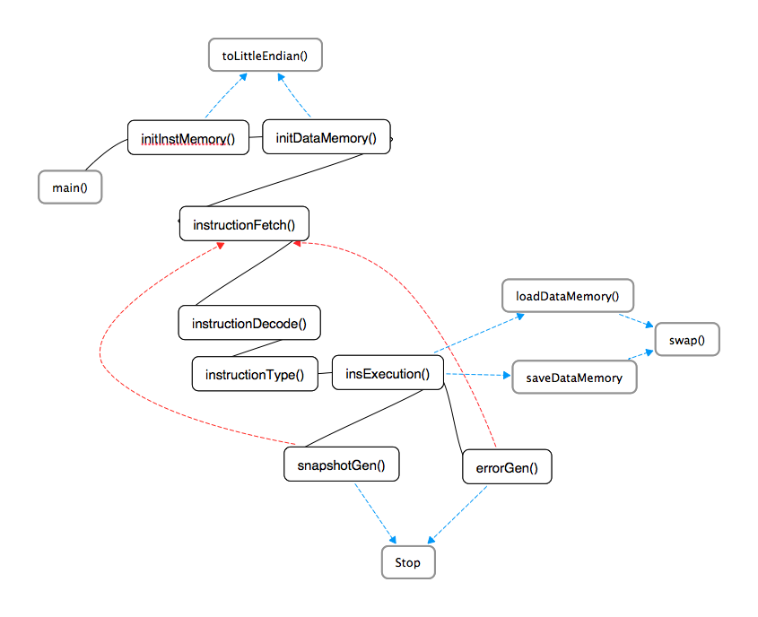

- Test Case Design
We wrote a Hanoi tower in C code, and then we use the command “gcc –S Hanoi.c” to generate assembly code (well, it’s not MIPS). We modified the assembly code to get our MIPS assembly code. We also wrote an automatic tool to translate MIPS assembly code to binary file (of course, there’s a tool for dimage.bin, too).
We modified the original MIPS code to a difficult ones, such as replacing sw with sh…etc. And we also use two kinds of exchanging method (one of them needs a temp variable, while the other doesn’t). The corner cases we targeted at are overflowing issues and signed/unsigned arithmetics (while calculating the address for sw).
Ex: cycle 49 $sp=0xFFFFFFFE and the offset of sw is 2, so neither a number overflow exists nor a address overflow exists.

- Test case elaboration
dMemory design: We used our brains to design the dMem layout, with ascii table to look up the code for alphabets. We also choose a special value for $sp to complete our test case design.
#include <stdio.h>
#include <stdlib.h>

void ht(int, char, char, char);

int main()
{
ht(5, 'A', 'B', 'C');
return 0;
}
void ht(int n,char a,char b,char c){
if(n!=1) {
ht(n-1, a, c, b);
ht(n-1, b, a, c);
} else return;
}

Static Variables
$s0 = $16 = 2 //base mem addr.
$t0 = $8 =1 //hard-wired 1

Function arguments
$a0 = $4 = a of ht()
$a1 = $5 = b of ht()
$a2 = $6 = c of ht()
$a3 = $7 = n of ht()

Labels
ht = 44
LOOP = 68 //LOOP means Recursive, exactly

