**Computer Vision HW1**

**系級：資工碩一 學號：R07922162 姓名：胡嘉祐**

1. **Principle Code and method**

**Part 1:**

Change original to binary image and choose topmost-left pixel as the down-sampled data.

**Code:**

def binarize (img):

blank_image = np.zeros((len(img),len(img[0]),3), np.uint8)

for i in range (len(img)):

for j in range (len(img[0])):

if(img[i][j][0]>=128):

blank_image[i][j][0]=255

blank_image[i][j][1]=255

blank_image[i][j][2]=255

else:

blank_image[i][j][0]=0

blank_image[i][j][1]=0

blank_image[i][j][2]=0

return blank_image

def down_sample (img):

blank_image = np.zeros((64,64,3), np.uint8)

index_i = 0

index_j = 0

for i in range (0,512,8):

for j in range (0,512,8):

#print(i,j,index_i,index_j)

blank_image[index_i][index_j][0]=img[i][j][0]

blank_image[index_i][index_j][1]=img[i][j][0]

blank_image[index_i][index_j][2]=img[i][j][0]

index_j+=1

index_j=0

index_i+=1

return blank_image

**Part 2:**

Use method from slide (CV1_CH6_2018 ,pp.60-63) to find Yokoi Connectivity Number.

**Code**:

def yokoi_4connected (img):

exp_img = expand(img,1)

yokoi_matrix = np.zeros((len(img),len(img[0])), np.uint8)

f_array = ["s","s","s","s"]

for i in range (1,len(img)+1):

for j in range (1,len(img[0])+1):

if(exp_img[i][j][0]==0):

yokoi_matrix[i-1][j-1]=6

else:

yokoi_matrix[i-1][j-1]=f_func(exp_img,i,j)

return yokoi_matrix

def f_func(img,i,j):

f_array = ["a","a","a","a"]

f_array[0]=h_func(img[i][j][0],img[i][j+1][0],img[i-1][j+1][0],img[i-1][j][0])

f_array[1]=h_func(img[i][j][0],img[i-1][j][0],img[i-1][j-1][0],img[i][j-1][0])

f_array[2]=h_func(img[i][j][0],img[i][j-1][0],img[i+1][j-1][0],img[i+1][j][0])

f_array[3]=h_func(img[i][j][0],img[i+1][j][0],img[i+1][j+1][0],img[i][j+1][0])

if (f_array[0]=="r" and f_array[1]=="r" and f_array[2]=="r" and f_array[3]=="r"):

return 5

else:

num = 0

for i in range (4):

if(f_array[i]=="q"):

num+=1

return num

def h_func (b,c,d,e):

if(b==c):

if(d!=b or e!=b):

return "q"

elif(d==b and e==b):

return "r"

return "s"

**Part3:**

main and create txt

**Code:**

img = cv2.imread(sys.argv[1])

b_img = binarize(img)

ds_b_img = down_sample (b_img)

yokoi_matrix = yokoi_4connected(ds_b_img)

text_file = open("yokoi_matrix.txt", "w")

for i in range (len(yokoi_matrix)):

for j in range (len(yokoi_matrix[0])):

if(yokoi_matrix[i][j]==6):

text_file.write(" ")

else:

text_file.write(str(yokoi_matrix[i][j]))

text_file.write("\n" )

text_file.close()

**2. Result :**

**part1:binary image and down sample image**

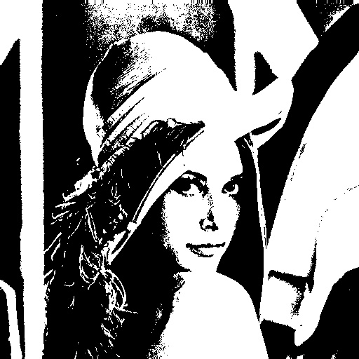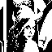

**Part 2 :yokoi matrix**

