TracMass 2

User Guide
K. Magnus Åberg, Erik Tengstrand
Stockholm University, Department of analytical chemistry

What is TracMass?
TracMass is intended for preprocessing of data from chromatography–mass spectrometry to produce data tables with peak abundance information that can be used for statistical analysis, especially for datasets for untargeted screening measurements. TracMass is a suite of programs that run in MATLAB version 7.1 (R14) and later.

Installing TracMass
Copy the TracMass folder to your hard disk and add this local copy to your MATLAB path. Add the folder by selecting file\set path in Matlab. Choose add with subfolders and select the TracMass folder.
You can also navigate to the TracMass folder and type install in the command prompt.
To run TracMass2, type TracMass2 at the command prompt.

Workflow and Summary of Programs
Starting the entire TracMass suite will let you switch between different data processing tasks using the tabs at the top. The program will start in the chromatogram viewer by default. The four data processing tasks are: Chromatogram Viewer, Tracking, Peak Detection and Alignment, and are performed in that order.
The Chromatogram Viewer allows the user to inspect the entire dataset. The purpose of this is to be able to remove outliers at an early stage. The Tracking panel extracts pure ion chromatograms from the dataset, which are much more convenient to do further data processing in since they only have one dimension. The Peak Detection step detects peaks in the pure ions chromatograms. Alignment assigns correspondence between peaks from different samples so that they can be compared in statistical analysis. The Alignment is further divided into four processing steps: Clustering, Warping, a second Clustering and an optional GFHT step.

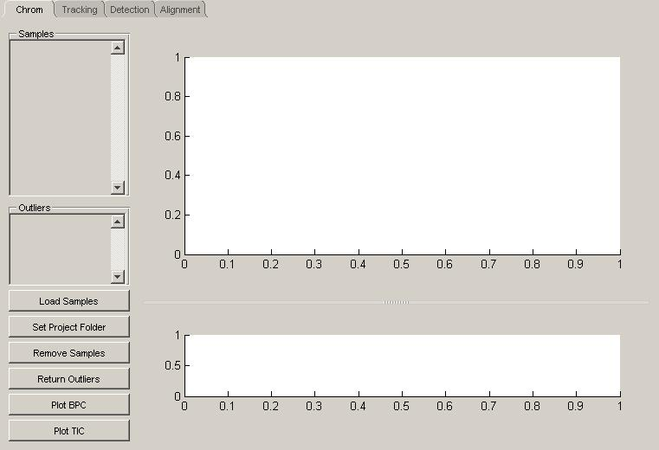
Figure 1. The default start of TracMass. It starts by showing the chromatogram viewer. The other steps can be accessed by the tabs at the top.

The Set Project Folder is used to select a folder where all files will be saved. If the project folder conatins a folder named raw it will attempt to load samples unless you have already loaded samples. If you wish to have samples in other directories directory, Load Samples lets you load samples from them.

The four parts of TracMass are the Chromatogram Viewer, Tracker, Peak Detection and Alignment. They can be started separately by typing ChromatogramViewer, Tracker, PeakDetection or Alignment at the command prompt.

Long processes can be canceled. When canceled, they will finish processing the current file. If restarted later, they will resume after the last finished file.

Figure 2. To the left, files that have been located using the buttons Load Folder and Load Files can be selected. The >> button moves the selected files to the right. The samples in the right box will be loaded when Save and Exit is pushed.

Chromatogram Viewer
The purpose of the chromatogram viewer is to quickly inspect the raw data to be able to discard outliers before starting the data analysis. The chromatogram viewer can be accessed as standalone by typing ChromatogramViewer at the command prompt.

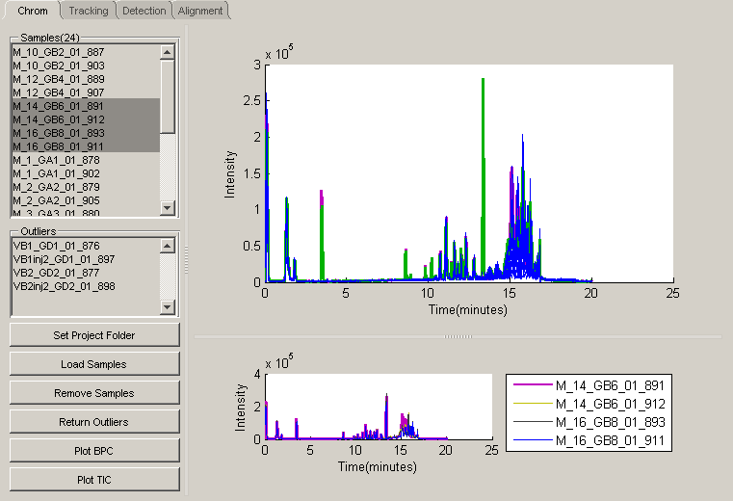
Figure 3. The chromatogram viewer. The upper plot contains the BPCs of all the samples in the dataset. The lower plot contains the BPCs of a few selected samples. The BPCs can be changed to TICs with the Plot TIC button.

The Plot BPC (default) and Plot TIC changes the plot mode to TIC (Total Ion Chromatogram) or BPC (base Peak Chromatogram) respectively.
Selecting one or more samples in the sample list to the left will plot them in the lower plot while removing previously plotted chromatograms. Clicking a chromatogram in the upper plot will plot it in the lower plot while retaining the previously plotted chromatograms. Clicking a chromatogram in the lower plot will remove it from the plot. Clicking a sample in the legend in the lower plot will mark it in both plots. Clicking a marked sample in the legend will unmark it.
The button Remove Samples will remove the samples currently plotted in the lower plot from the sample list and place them in the outlier list. Selecting one or more sample in the outlier list will plot them in the lower plot while clear it from previously plotted samples.
Samples marked as outliers can be plotted in the lower plot by selecting them in the outlier list. The button Return Outliers will return the plotted outliers to the sample list.

Tracking Panel
The tracking panel extracts pure ion chromatograms from the raw data. These pure ion chromatograms are later used for peak detection. The tracker can be accessed as standalone by typing Tracker at the command prompt.

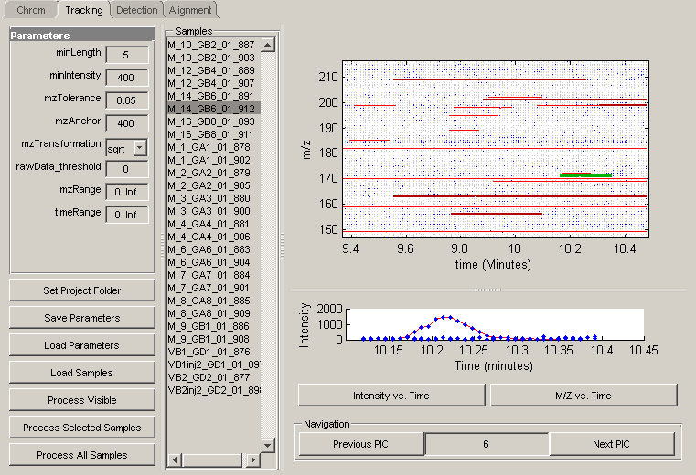
Figure 4. The Tracking panel. The parameters can be set in the panel to the left. The samples are found in the list in the middle. Selecting a sample plots the data points of the sample in the upper right plot. The button Process Visible processes the data visible in the upper right plot, creating red PICs. Selecting a PIC will change its color to green, change the last selected PIC’s color to a darker red, and plot the currently selected PIC in the lower rights plot.

The parameters MinLength and MinIntensity are the minimum length and intensity a PIC can have before it is discarded. The intensity of a PIC is the intensity of the data point with the highest intensity. Their purpose is to prevent a large amount of short PICs which will only contain noise. MinLength should be the shortest width a peak can have, in data points. MinIntensity should be the lowest intensity a peak can have.
mzTolerance is how much the mass may shift in a single PIC. It should be in the same size range as the mass resolution of the instrument. mzAnchor is at which mass the mzTolerance is measured. mzTransformation is whether the mass accuracy is the same, none, or if it is decreasing at higher mass values, sqrt, which transforms the m/z dimension to its square root resulting in that higher mass values have higher tolerance. Time-of-Flight data has lower mass accuracy at higher mass values and should use sqrt.
If the mass accuracy is the same at all mass values, mzAnchor is irrelevant. rawData_threshold is an intensity cut-off in the raw data prior to tracking.

Selecting a sample in the sample list will plot the data in the upper plot. If it already has been processed, the parameters used will be loaded. Pushing Process Visible will plot all PICs in the current window. The plotting is quite time consuming, and should only be done in a small window. Clicking a PIC in the upper plot will mark it and plot it with the raw data in the lower plot. M/Z vs. Time is default but it can be changed to Intensity vs. Time. The aim of the manual inspection is to determine whether the mzTolerance is suitable. A too small mzTolerance may cause the abrupt end to the pure ion chromatograms. It can be seen as peaks where parts have been cut off in the intensity vs. time plot. A too large mzTolerance can cause the tracking panel to create more pure ion chromatograms that are only noise. This will create more data for the Peak Detection to process, but is generally a smaller problem compared to a too small mzTolerance. Since the process uses the closest data point if there are more within the interval, a high mzTolerance will not damage existing pure ion chromatograms.

The buttons Previous PIC and Next PIC as well as the number in between can be used navigate through the PICs in intensity order.
If there are more than 1000 PICs in the visible region, they will not be plotted in full detail, but as lines only.

Peak Detection
The peak detection identifies peaks in the pure ion chromatograms. It can be started as a standalone by typing PeakDetection in the command prompt.

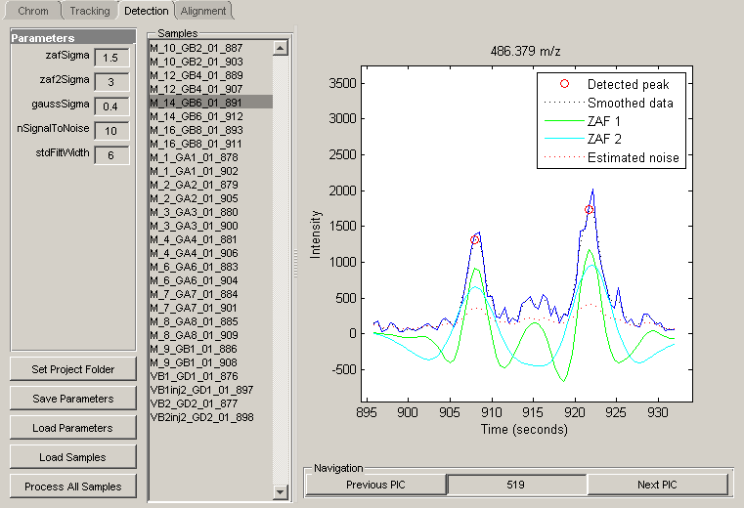
Figure 5. The Peak detection panel. The parameters can be set in the panel to the left. Selecting a sample in the list in the middle will immediately process the first PIC in the sample with the current parameters. The results of the processed PIC will be displayed to the right. Changing the parameters will cause the panel to immediately process the current PIC. The navigation panel at the bottom right allows changing the currently displayed PIC.

Selecting a sample in the sample list will plot its first PIC. Other PICs can be accessed by the navigation panel at the bottom right. If a sample that has already been processed is selected, the parameters used for the processing will be loaded.

A good way of setting the parameters is to start with the gaussSigma. It is the estimation of the noise and is visualized by the red dotted line. Setting it too high or too low will cause it to give a bad error estimate, which increase where there are peaks. A good value is when it is low compared to other values where there are peaks yet smooth at the baseline. It is also used to smooth the data for noise estimation, giving a black dashed line. If the black dotted line does not follow the data closely, the gaussSigma should be set lower unless it gives a large increase in the noise estimate.
Continuing with ZAFSigma and ZAF2Sigma, represented by the green and blue solid lines. These are the zero area filters and well matched filters will improve the peak detection, especially where there is partial peak overlap. Since the peaks tend to be wider at the end of the chromatogram, there are two filters. Good values are half the peak width at half the peak height. Compare the peak width with the ZAFsigma, both for peaks that come early and late in the chromatogram. If there is a large difference, match the first filter to the early peaks, and the second filter to the late peaks.
The parameter stdFilterWidth is the width of the smoothing filter for the noise. A high value will reduce the amount of false peaks, but will mask small peaks, especially just before large peaks. A dataset with many peaks should have a low value (2-4) while a less crowded dataset should have a high value (4-8).
The parameter nSignalToNoise is where the decision limit for detecting peaks is placed. It should be set as high as possible while still identifying real peaks.

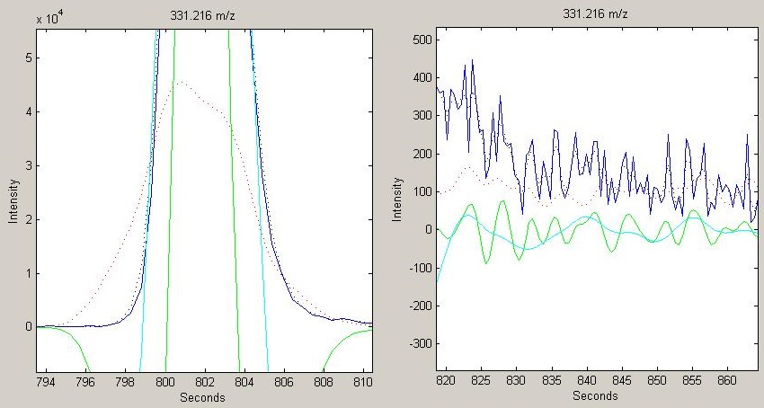
Figure 6. The noise estimate (red dashed line) of a peak and on the baseline.

Alignment
The alignment of peaks proceedure identifies which peaks correspond in different samples and exports the data as comma separated values (.csv). The alignment proceedure can be accessed as standalone by typing Alignment in the command prompt. It is divided into four steps: Clustering, Warping, a second Clustering step and an optional GFHT step. The tabs above the parameters and start button are used to switch between the different alignment steps.

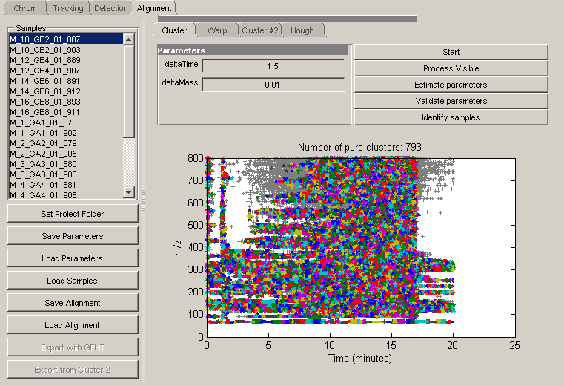
Figure 7. The alignment panel, showing the first clustering step. In this step, the deltaTime should be set to create as many pure clusters as possible.

Save Alignment will save the current results of the alignment. Save Parameters will save the parameters of all the alignment tabs.
The Process Visible will process the part of the dataset which is visible in the plot. Once the dataset has been processed with the Start button, a suitable part can be selected and processed with the Process Visible button to speed up the parameter settings.
The parameter deltaMass is dependent on mass resolution, and does not require much attention, while deltaTime is dependent on the retention time shifts and is a key parameter. Both are set to generate as many pure clusters as possible, but deltaTime is set slightly higher, as an additional peak in a cluster can be resolved later, while a missing peak cannot be recovered in a later step.
The Estimate parameters button clusters the 100 most intense peaks, and estimates parameters from the clusters formed. The resulting parameters are passable, but not optimal. The Validate parameters performs clustering with similar parameters and then suggests in which direction the parameters should be changed, or indicates that the parameters are good. The results of the parameter validation are displayed in the command prompt. Validate parameters is quite time consuming. Identify samples marks the samples that have a peak currently in the window, in the sample list.

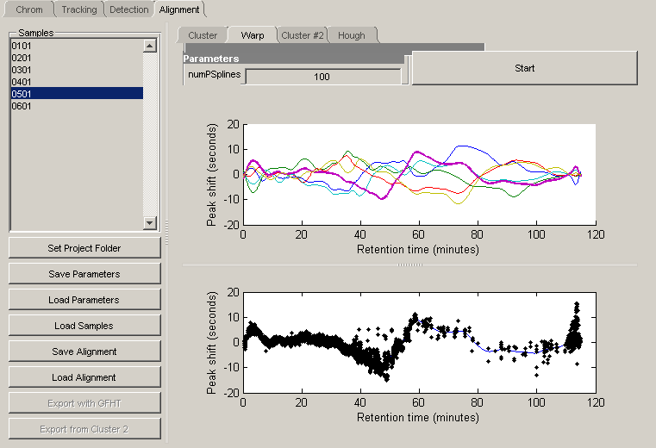Figure 8. The warping panel. The upper plot shows the warping paths of all the samples while the lower plot shows the warping path and peak positions of a single sample.

In the warping step, numPSplines determines how quickly the warping path may change. It should be able to follow the trends of the data without doing sharp turns for only a few peaks.
In the second clustering step, deltaTime is set to create as many pure clusters as possible. At this stage the data can be exported with the unresolved peaks including only the most intense peak from each sample (Export from Cluster 2). A common reason for unresolved peaks is that electrical noise has been erroneously detected as a peak. These noise peaks tend to be much weaker than chemical peaks and will be removed by keeping only the peak with the highest intensity. The .csv file can be further processed in for instance Excel.

Figure 9. The GFHT panel. The upper plot is a plot of the Hough-resolved clusters. The middle plot is a validation plot of a cluster that has been selected in the upper plot. The lower plot shows raw data of the cluster, from samples selected either in the middle plot or in the sample list to the left. Depending on the size of the window, the two lower plots can be small. If this occurs, resize the window or resize the plots.

The Generailzed Fuzzy Hough Transform (GFHT) alignment is an optional fourth step in the alignment procedure. It is used to resolve unresolved clusters from the second clustering if needed. It does a PCA on the nearby clusters and uses to principal components to model the peak shift in the unresolved cluster. The topmost plot displays all unresolved clusters. Above the plot, the percent of displayed clusters can be chosen; the plot will then display the clusters with the highest intensity. If a cluster is selected, it will display the results of the GFHT. The colored markers are the actual peak positions. The dark grey markers are the predicted peak positions, belonging to the peaks with the same markers shapes. The light grey lines are the patterns from the PCA. The lowest plot is a raw data plot. Very broad peaks tend to have inaccurate retention times from the peak detection. The GFHT cannot resolve that inaccuracy. All peak resolved with the GFHT are exported both as a resolved cluster and as an unresolved cluster, to prevent broad peaks from distorting the results.

Components is the number of principal components that are to be used. The explained variance is displayed in the command window. If the predicted peaks match the actual peaks poorly, this can be increased. TimeTolerance is how much a peak can deviate from the predicted pattern and still be considered to belong to the pattern. If peaks (colored) are close to the predicted peaks (grey), but classified as another peak (another symbol and color), this should be increased. Penalty is a penalty for high coefficients to prevent overfitting. If the predicted peak positions (dark grey lines) are going back and forth a lot, especially with only a few samples, the penalty should be set higher.

The Penalty variable reflects the strength of the penalty function in the fitting of the Hough pattern. The penalty function is:
$$\frac{p}{\sqrt{N}}\sum_{j=1}^{M}{e^{k_{j}^{2}}}$$

Where p is the user selected penalty parameter, N is the number of samples, M is the number of coefficients and k is the value of a coefficient. With low coefficients, this function gives low changes in penalty for changes in the coefficients. When the coefficients become high, the penalty becomes severe even for small increases.

Files
TracMass will create a set of folders in your project folder. The raw-dat folder contains memeory mapped files for faster access. The pic folder contains pure ion chromatograms from the Tracker. The peak folder contains the results from the peak detection. If you cancel the tracker or peak detection during a run, you will not need to process the files again (but take care that you use the same parameters). If you process the dataset again with different parameters, the files will be reprocessed. All parameters are saved in the processed file, and the parameters from a .pic or .peak file can be loaded with load parameters.
Lengthy processes have a progress bar and can be canceled. If a process is canceled, it will finish the current file.

