How to use a new image and find relative puzzle piece to puzzle ratio:
1. Download the entire puzzle and name it as “puzzle.png”, place that file into the puzzlesolver folder.
2. Find the relative piece to puzzle ratio, take a random piece of the puzzle and overlay it onto the complete puzzle piece until it overlaps seamlessly (as if the piece was a part of the puzzle). Your puzzle piece should look something like this:
(take note the image below is zoomed in, the puzzle piece is not actually that big, it just looks big because I zoomed in by 200%)
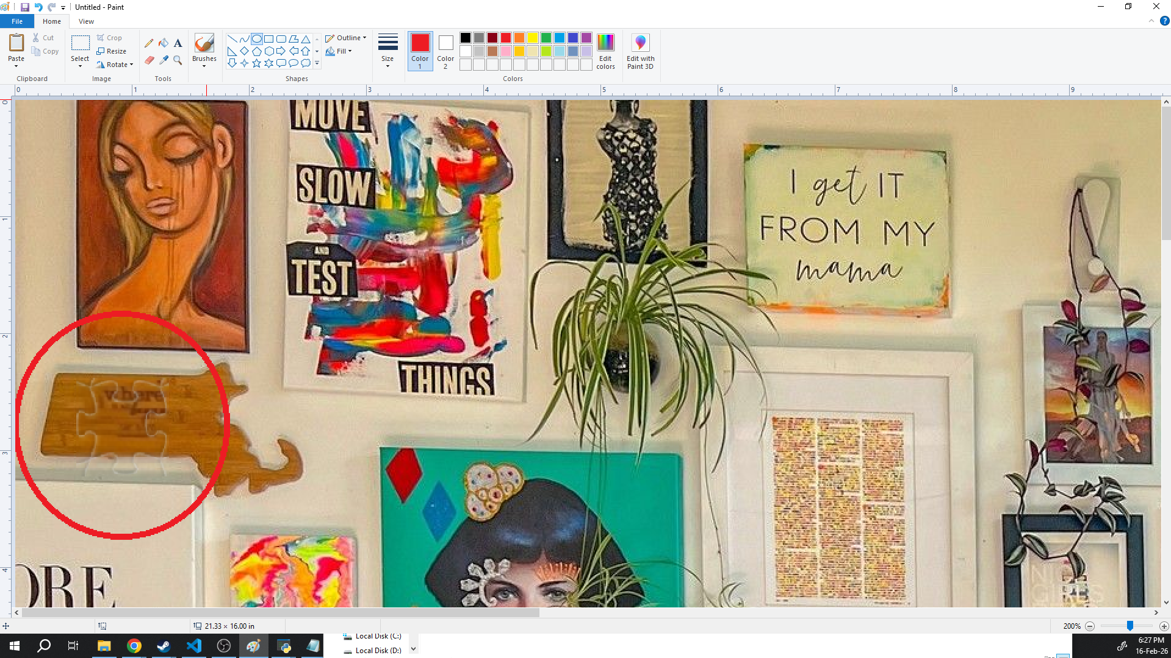

3. Find the width x height of the puzzle piece in pixels (Px). First, we use MS paint’s built-in select tool to highlight and then copy (Ctrl +V) and then paste it into the website below, then measure the width x height of the puzzle piece. In this case, it’s approximately 80x80 pixels. Then we input this puzzle piece size into solver4.py, and input it into this line into "TILE_SIZE = 80".
Beloiw is an image showing the size of the puzzle piece. 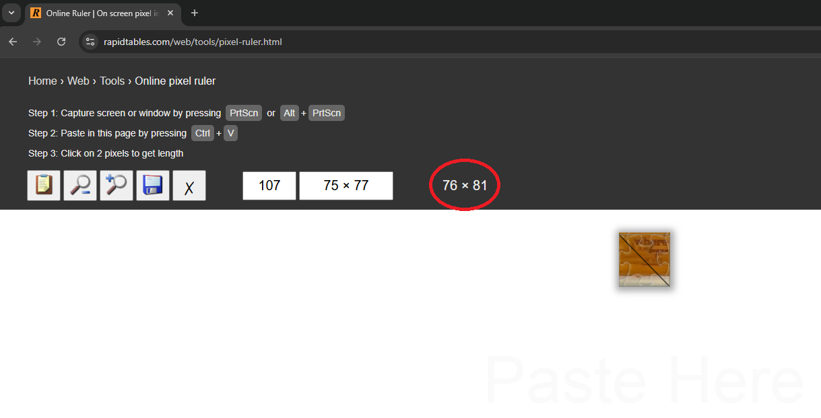
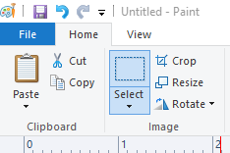
IMPORTANT: Make sure you use the “select” tool to copy paste the puzzle piece and don’t use screenshot, select tool copy pastes the actual pixel size of the piece, while snipping tool only finds the size it shows up on your monitor

4. Then we run the program, on the jigsaw game website, we zoom in all the way into the piece we want to find out the placement of, then we use the snipping tool (Windows + Shift + S) to snip a photo of the piece at full zoom. Then we paste (Ctrl +V) into the GUI, and we shall get 3 approximations of where the puzzle piece goes.
5. Move the piece to the correct position and you’re done!

