THEORY OF ARGUMENTATIONS PROJECT (CC2)
Group 10
Yennipena Jérémie COULIBALY, Michel Junior DELANOUE, [Member 3], [Member 4]

1. Introduction
This report presents the work of Group 10 for the second continuous assessment (CC2) of the Knowledge Dynamics course. The project covers three topics of computational argumentation:
- Part 1: Reasoning with ABA. Implementation of an Assumption-Based Argumentation (ABA) generator handling preferences between assumptions (ABA+), and its deployment as an online application.
- Part 2: Relation-based argument mining. Scraping of the 250 most active and highest ranked Kialo discussions with data exploration, then an approach for relation discovery and relation classification between textual arguments, compared with existing approaches in the literature.
- Part 3: Visualising acceptability degree spaces for gradual semantics. Implementation of the weighted h-categorizer semantics, then visualisation of the space of acceptability degrees of a framework (random sampling of weights, convex hull and heat map) and study of its resilience to re-sampling.
Each part follows the questions of the assignment, and the report ends with a conclusion and the distribution of the work within the group.

2. Part 1: Reasoning with ABA

2.1 Question 1: ABA generator
The generator is written in Python (aba_core.py) and handles preferences with ABA+ (Čyras & Toni, 2016).
- Literals, rules, assumptions and contraries (parse_aba_text): reads the input format of the assignment and checks that the framework is valid (each assumption has a contrary, no assumption is the head of a rule, preferences only on assumptions).
- Conversion to non-circular and atomic frameworks (convert): if needed, the framework is made non-circular (each literal is split into levels x_1, ..., x_k) and then atomic (each non-assumption s in a rule body is replaced by new assumptions s_d / s_nd).
- Arguments and attacks (generate_arguments, compute_attacks): arguments are computed by backward chaining from the rules; attacks are found from the contraries.
- Preferences and normal / reverse attacks (compute_aba_plus_attacks): preferences are closed by transitivity, and each attack is classified as ABA+ normal or reverse.
Results on the example of the assignment:
Element | Result
Arguments (8) | A1: ∅ ⊢ q, A2: {a} ⊢ a, A3: {a} ⊢ p, A4: {b} ⊢ b, A5: {c} ⊢ c, A6: {a,c} ⊢ s, A7: {a,c} ⊢ t, A8: {b,c} ⊢ r
ABA attacks (10) | A6→A4, A6→A8, A7→A5, A7→A6, A7→A7, A7→A8, A8→A2, A8→A3, A8→A6, A8→A7
ABA+ normal (6) | A6→A4, A6→A8, A7→A5, A7→A6, A7→A7, A7→A8
ABA+ reverse (4) | A2→A8, A3→A8, A6→A8, A7→A8

A8 = {b,c} ⊢ r attacks every argument containing a. Since a > b, these four attacks are reversed in ABA+. The attacks of A6 and A7 stay normal.
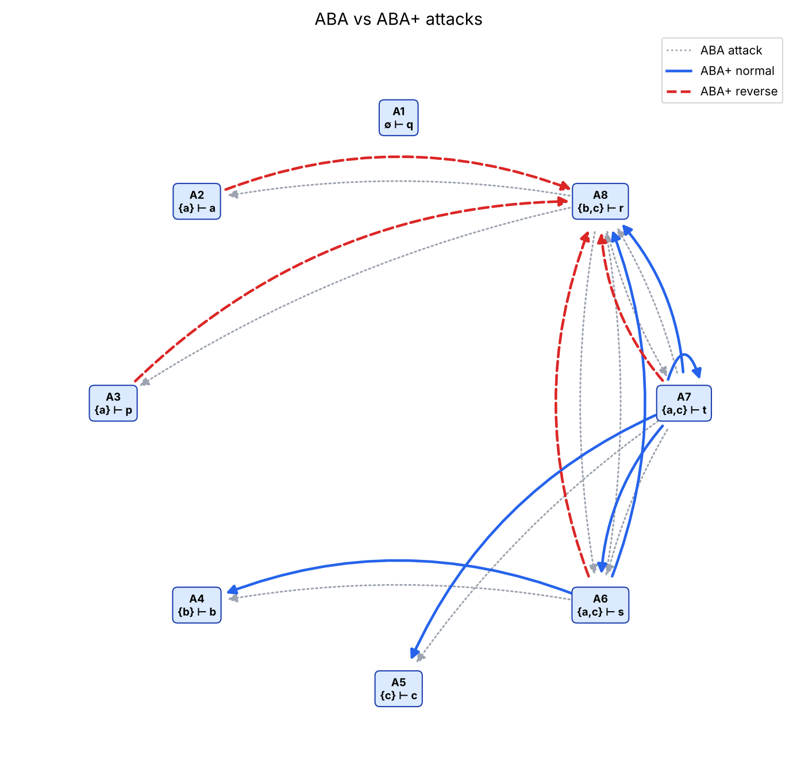
Fig. 1: Attack graph of the example

2.2 Question 2: Online application
The application (Flask, app.py) is deployed on Render: https://aba-generator-group10.onrender.com
Usage instructions.
- Open the link (the first load can take up to a minute if the app was idle).
- Type the framework in the text area using the format of the assignment (## Literals, ## Assumptions, ## Contraries, ## Rules, ## Preferences) or click Example to load the example. Lines starting with # are comments; a fact is written with an empty body ([r2]: q <-).
- Optionally tick Analyse the converted framework (non-circular + atomic) (see Section 2.3).
- Click Run. The page shows the properties of the framework and the conversion, the arguments, the ABA attacks, the ABA+ normal and reverse attacks, and the attack graph. Invalid input gives an error message.
To run it locally: pip install -r requirements.txt, then python app.py (http://127.0.0.1:5000).
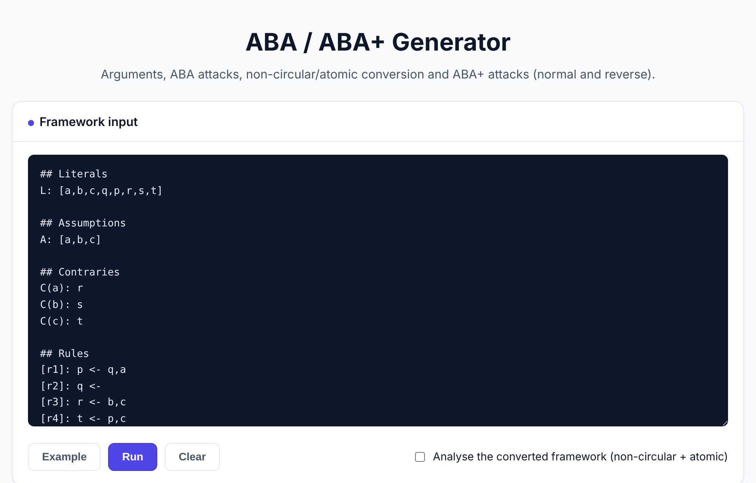
Fig. 2: Input form of the web application

2.3 Analysing the converted framework
By default, the application works on the framework as it is typed. When the box Analyse the converted framework (non-circular + atomic) is ticked, the arguments and attacks are computed on the framework returned by convert. In both cases, the page shows the original and the converted frameworks side by side.
Taking the given example, it is already non-circular, so only the atomic conversion is applied. The non-assumptions p, q and t appear in rule bodies, which gives six new assumptions and the following framework:
A: [a,b,c,p_d,p_nd,q_d,q_nd,t_d,t_nd]
C(p_d): p_nd C(p_nd): p C(q_d): q_nd C(q_nd): q C(t_d): t_nd C(t_nd): t
[r1]: p <- a,q_d
[r2]: q <-
[r3]: r <- b,c
[r4]: t <- c,p_d
[r5]: s <- t_d

Element | Result on the converted framework
Arguments (14) | A1: ∅ ⊢ q, A2: {a} ⊢ a, A3: {b} ⊢ b, A4: {c} ⊢ c, A5: {p_d} ⊢ p_d, A6: {p_nd} ⊢ p_nd, A7: {q_d} ⊢ q_d, A8: {q_nd} ⊢ q_nd, A9: {t_d} ⊢ s, A10: {t_d} ⊢ t_d, A11: {t_nd} ⊢ t_nd, A12: {a,q_d} ⊢ p, A13: {b,c} ⊢ r, A14: {c,p_d} ⊢ t
ABA attacks (16) | A1→A8, A6→A5, A6→A14, A8→A7, A8→A12, A9→A3, A9→A13, A11→A9, A11→A10, A12→A6, A13→A2, A13→A12, A14→A4, A14→A11, A14→A13, A14→A14
ABA+ normal (14) | all ABA attacks except A13→A2 and A13→A12
ABA+ reverse (2) | A2→A13, A12→A13

The supports now contain the new assumptions (for example t is derived from {c,p_d} instead of {a,c}), so there are more arguments and attacks. The effect of the preference a > b is the same: the attacks of {b,c} ⊢ r on the arguments that contain a are reversed.
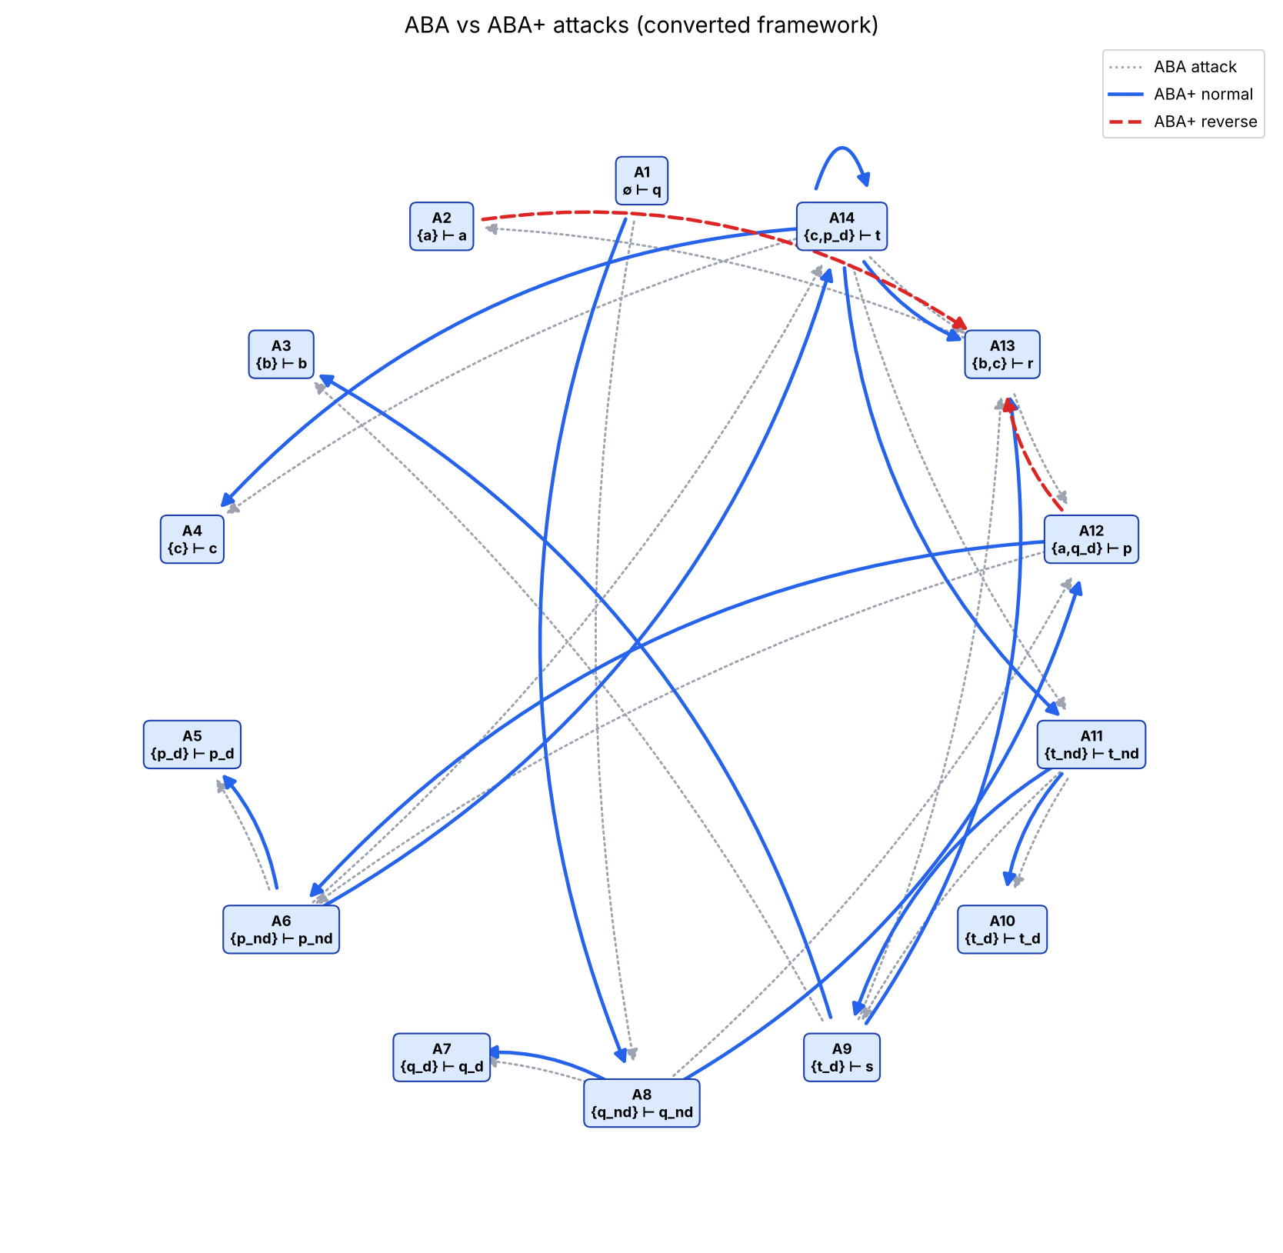
Fig. 3: Attack graph of the converted framework

3. Part 2: Relation-based Argument Mining

3.1 Question 1: Kialo scraping and data exploration
[To be completed]

3.2 Question 2: Relation discovery and classification
[To be completed, including the comparison with existing approaches in the literature]

4. Part 3: Visualising Acceptability Degree Spaces for Gradual Semantics

4.1 Question 1: Weighted h-categorizer semantics
[To be completed]

4.2 Question 2: Acceptability degree space, convex hull and heat map
[To be completed, including the resilience analysis]

5. Conclusion
In Part 1, the ABA generator converts the framework when needed, computes all arguments and ABA / ABA+ attacks, and is available online.
[To be completed with the conclusions of Parts 2 and 3.]

6. Work distribution
Member | Contribution
Yennipena Jérémie COULIBALY | Part 1: Reasoning with ABA (ABA generator and online application)
Michel Junior DELANOUE | [Part 2: ...]
[Member 3] | [Part 3: ...]
[Member 4] | [...]

References
Čyras, K. and Toni, F. (2016). ABA+: Assumption-Based Argumentation with Preferences. In Proceedings of the 15th International Conference on Principles of Knowledge Representation and Reasoning (KR 2016).
[Add the references used in Parts 2 and 3.]

