**电 子 科 技 大 学**

UNIVERSITY OF ELECTRONIC SCIENCE AND TECHNOLOGY OF CHINA

**学士学位论文**

**BACHELOR THESIS**



**论文题目**

**学 院**

**专 业**

**学 号**

**作者姓名**

**指导教师**

摘 要

为了适应日益增长的宽带信号和非线性系统的工程应用，用于分析瞬态电磁散射问题的时域积分方程方法研究日趋活跃。本文以时域积分方程时间步进算法及其快速算法为研究课题，重点研究了时间步进算法的数值实现技术、后时稳定性问题以及两层平面波算法加速计算等，主要研究内容分为四部分。

……

**关键词：**时域电磁散射，时域积分方程，时间步进算法，后时不稳定性，时域平面波算法

ABSTRACT

Revealed by the Calderόn relation and the Calderόn identities in electromagnetic theory, the properties and relation of different integral operators in the computational electromagnetics (CEM) are utilized to construct the Calderόn preconditioning techniques, which are applied in the integral-equation-based methods in this thesis. A thorough and systematic research has been accomplished to cover the Calderόn preconditioning techniques for the perfect electric conductor (PEC) and the dielectric cases. For the PEC case, the Calderόn preconditioning for the electric-field integral equation (EFIE) at mid, low, and high frequencies are constructed and studied. For the dielectric cases, the Calderόn preconditioning for the Poggio-Miller-Chang-Harrington-Wu-Tsai (PMCHWT) integral equation are investigated, and the Calderόn technique for the N-Müller integral equation is developed. Moreover, the accuracy improving technique for the second-kind Fredholm integral equation for both PEC and dielectric cases is also studied in this thesis.

…

**Keywords:** Electromagnetic scattering and radiation, surface-integral-equation-based Methods, Calderόn preconditioning methods, numerical accuracy, Fred-holm integral equations of the second kind

Contents

**Chapter 1 Introduction** 1

1.1 Research Background and Significance 1

1.2 State of Arts 1

1.3 Contents and Innovations of the Thesis 2

1.4 Outline of the Thesis 2

**Chapter 2 Theoretical Basics** 3

2.1 Integral Equations in Electromagnetics 3

2.2 270 MHz Plan Wave Excitation 3

2.3 The Solution of Integral Equations in Electromagnetics 4

2.3.1 General Principle of the Method of Moments 4

2.3.2 Geometrical Modeling and Discretization of Object 4

2.3.2.1 Planar Triangular Model 4

2.3.2.2 Curvilinear Triangular Model 4

2.3.3 The Choice of Basis Functions 5

2.3.3.1 Planar RWG Basis Functions 5

2.3.3.2 Curvilinear RWG Basis Functions 6

2.3.4 The Solution of Matrix Equations 6

2.3.4.1 Direct Algorithms 6

2.3.4.2 Iterative Algorithms 6

2.4 Summary 6

**Chapter 3 Calderόn Preconditioner at Mid Frequencies** 7

3.1 Introduction 7

3.2 Calderόn Relation and Calderόn Identities 7

3.3 Calderόn Preconditioner at Mid Frequencies 7

3.4 Numerical Examples 7

3.5 Summary 7

**Chapter 4 Calderόn Preconditioning Technique for N-Müller** 8

4.1 Introduction 8

4.2 N-Müller Integral Equations 8

4.3 The Derivation of N-Müller Equations 8

4.4 The Discretization of N-Müller Equations 8

4.5 Numerical Examples 8

4.6 Summary 8

**Chapter 5 Conclusions** 9

5.1 Concluding Remarks 9

5.2 Future Work 9

**Acknowledgements** 10

**References** 11

**Research Results Obtained During the Study for Master Degree** 12

**Chapter 1 Introduction**

## **1.1 Research Background and Significance**

Integral-equation-based numerical methods combined with fast algorithms are capable of solving electromagnetic problems of complex structures and material properties with a good accuracy and a high efficiency. They are widely used in a variety of engineering applications, such as the efficient analysis of three dimensional radar scattering problems, the simulation of the input impedance and the radiation properties of antenna systems, the calculation of the input response and the transmission efficiency of microwave circuits, the evaluation of the electromagnetic interference (EMI) between complex electromagnetic systems, and the computer aided electromagnetic compatibility (EMC) designs. The versatility, capability, accuracy and efficiency of the integral-equation-based methods have made them an important and cost effective approach in the analysis and design of electromagnetic problems and applications.

…

## **1.2 State of Arts**

From the 1960s, the numerical methods of electromagnetic analysis have been fast developed because of their versatility and flexibility. Many well-known numerical methods have been introduced during that time, including the finite element method (FEM)(Chew, Jin, Michielssen et al, 2000) and the finite difference time domain method (FDTD) (Sheng Xinqing, 2004; Wang Binzhong, 2001), which are based on the solution to the Maxwell’s equations in differential form, and the method of moments (MoM)(Sheng Xinqing, 2004: 4-6), which is based on the solution to the Maxwell’s equations in integral form. Especially from 1990s, with the fast developments of high performance computing systems, the theories and methods of computational electromagnetics have been advanced dramatically. The increases of the clock speed and the memory size of computer systems and the developments of highly efficient electromagnetic computing algorithms make the numerical methods capable of solving electromagnetic engineering problems.[1]

…

## **1.3 Contents and Innovations of the Thesis**

Based on the Calderόn relation and the Calderόn identities, this thesis has developed several Calderόn preconditioning techniques and investigated their applications in the integral-equation-based computational electromagnetic methods. The research content has covered the Calderόn preconditioning techniques for the perfect electric conductor (PEC) and dielectric cases. For the PEC[2] case, the Calderόn preconditions at mid, low, and high frequencies are investigated. For the dielectric case, the Calderόn preconditioning techniques for the PMCHWT and N-Müller integral equations are developed. The numerical accuracy of the second-kind Fredholm integral equations are investigated and improved in this thesis.

…

## **1.4 Outline of the Thesis**

This thesis is organized as follows.

…

**Chapter 2 Theoretical Basics**

In this chapter, the general methods of constructing the commonly used integral equations in electromagnetics are introduced based on the surface equivalence principle and the volume equivalence principle.

…

## **2.1 Integral Equations in Electromagnetics**

In the integral-equation-based computational electromagnetic methods, the unknown functions in the electromagnetic problems such as the scattering or radiation fields are modeled in terms of the equivalent surface or volume electric/magnetic sources by applying the surface or volume equivalence principles, respectively.

…

## **2.2 270 MHz Plan Wave Excitation**

In order to investigate the its performance in handling electrically very large problems with over one million unknowns, the same numerical example is repeated again by increasing the frequency to 270 MHz, and keeping the incident angle and polarization of the plane wave unchanged. To have a better insight, the memory consumption and CPU time requirements of the EFIE, the CP-CFIE (0.8), and the CP-AEFIE algorithms are given in Table 2-1.

Table 2-1 Comparison of Computational Data of Different Algorithms

|  |  |  |  |  |
| --- | --- | --- | --- | --- |
|  | Total Memory (Mb) | CPU Time | | |
| Setup (h) | Solution Time | |
| Iter. (m) | Tol. (h) |
| EFIE | 3215.84 | 1.14 | 3.18 | >63 |
| CP-CFIE(0.8) | 6386.12 | 7.84 | 7.04 | 27.69 |
| CP-AEFIE | 5750.43 | 6.71 | 7.47 | 19.05 |

All the calculations are carried out on a HP Z400 workstation with a Fedora 10 operating system.

…

## **2.3 The Solution of Integral Equations in Electromagnetics**

### **2.3.1 General Principle of the Method of Moments**

The integral equations constructed in the preceding section can be solved with adequate numerical methods. One of the most commonly used methods in solving integral equations is the method of moments (MoM) introduced by R. F. Harrington in 1968(Wang Changqing, 2005). The general principle and key points of MoM will be reviewed in this section.

…

### **2.3.2 Geometrical Modeling and Discretization of Object**

From the description in the preceding section, it is clear that in order to solve for the unknown equivalent electromagnetic currents defined on the surface or in the volume of an obstruction, the definition domain of the unknown currents, which is the geometry, needs to be described mathematically. This is the so-called geometrical modeling. In computational electromagnetics, geometrical modeling is the basic of electromagnetic modeling and numerical calculation, and its quality will affect the accuracy of the numerical solution directly.

…

#### **2.3.2.1 Planar Triangular Model**

The simplest and most commonly used element in the geometrical modeling is the planar triangle, which is defined by its three vertices (nodes).

…

#### **2.3.2.2 Curvilinear Triangular Model**

The curved surface of an object can be better modeled with curvilinear triangular elements which are the second-order curved surfaces. A curvilinear triangle can be defined by six nodes, three of which are the vertices of the triangle, the other three are the midpoints of three curved edges. Shown in Figure 2-1 is the sketch of a curvilinear triangular element.

The curved surface of an object can be better modeled with curvilinear triangular elements which are the second-order curved surfaces. A curvilinear triangle can be defined by six nodes, three of which are the vertices of the triangle, the other three are the midpoints of three curved edges. Shown in Figure 2-1 is the sketch of a curvilinear triangular element.

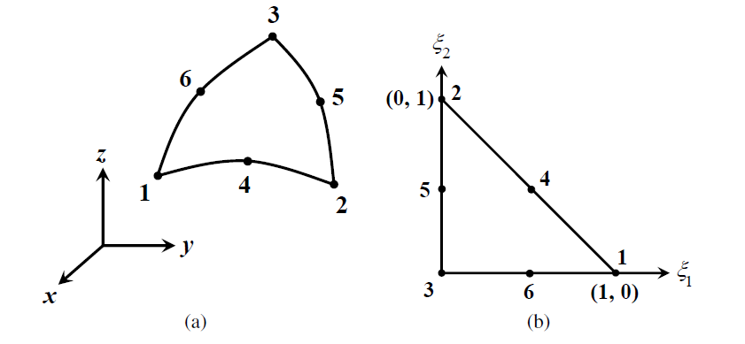

Figure 2-1 The sketch of a curvilinear triangular element. (a)The curvilinear triangle in the coordinate system; (b) The curvilinear triangle in the coordinate system

Using the following coordinate transformation, the curvilinear triangle in the rectangular coordinate system, as shown in Figure 2-1(a), can be mapped onto the triangle defined in a parametric coordinate system, as shown in Figure 2-1(b)

 (2-1)

where denote the rectangular coordinates of the six controlling nodes in Figure 2-1a, ，，are the parametric coordinates varying from 0 to 1, and they satisfy the relation

 (2-2)

From (2-2), it is clear that only two variables out of these three are independent.

…

### **2.3.3 The Choice of Basis Functions**

After the geometrical discretization of the object surface using planar or curvilinear triangular elements, basis functions can be defined on these triangular elements to expand the unknown vector functions.

…

#### **2.3.3.1 Planar RWG Basis Functions**

Introduced by Rao Wilton, and Glisson in 1982, the RWG basis function (Pan Xiaomin, 2006) is defined over two adjacent triangular elements.[3]

…

#### **2.3.3.2 Curvilinear RWG Basis Functions**

In order to give a better representation of curved surfaces, the curvilinear triangular elements can be used. Correspondingly, the curvilinear RWG basis functions [7] can be defined on the curvilinear triangular elements.

…

### **2.3.4 The Solution of Matrix Equations**

The matrix equation can be solved with two types of algorithms, the direct algorithms and the iterative algorithms. They will be introduced briefly in this subsection (Gibson, 2008).

…

#### **2.3.4.1 Direct Algorithms**

The commonly used direct algorithms include the Gaussian elimination, the LU decomposition, and the singular value decomposition (SVD) (Hu Jun, 2000; Martin and Carey, 1973).

…

#### **2.3.4.2 Iterative Algorithms**

When the dimension of the impedance matrix is very large, the direct solution becomes very expensive.

…

## **2.4 Summary**

…

**Chapter 3 Calderόn Preconditioner at Mid Frequencies**

## **3.1 Introduction**

The integral equations (IEs) are used to model the electromagnetic scattering,

…

## **3.2 Calderόn Relation and Calderόn Identities**

In a scattering problem, according to the surface equivalence principle,

…

## **3.3 Calderόn Preconditioner at Mid Frequencies**

Based on the discussion in the preceding section,

…

## **3.4 Numerical Examples**

Two simple examples are given to demonstrate the fast convergence of the Calderόn preconditioner at mid frequencies.

…

## **3.5 Summary**

The Calderόn preconditioner for the EFIE at mid frequencies is reviewed in this chapter.

…

**Chapter 4 Calderόn Preconditioning Technique for N-Müller**

## **4.1 Introduction**

Analysis of low-frequency electromagnetic problems has received more attention,

…

## **4.2 N-Müller Integral Equations**

Consider the problem of electromagnetic wave scattering by a conducting surface,

…

**Theorem 1** …

**Proof:**

Consider the problem of electromagnetic wave scattering by a conducting surface,

…

the problem is proved. ■

## **4.3 The Derivation of N-Müller Equations**

The derivation begins from the preconditioning of the EFIE,

…

## **4.4 The Discretization of N-Müller Equations**

The derivation begins from the preconditioning of the EFIE,

…

## **4.5 Numerical Examples**

In this section, the performance of the N-M¨uller equations is investigated.

…

## **4.6 Summary**

In this chapter,

…

**Chapter 5 Conclusions**

## **5.1 Concluding Remarks**

The accurate and efficient numerical solutions of the Maxwell’s equations have important significance to the analysis of electromagnetic scattering and radiation problems.

…

## **5.2 Future Work**

The researches reported in this dissertation have covered most important areas including the convergence acceleration of the first-kind integral equations and the accuracy improvement of the second-kind integral equations for both the PEC and the dielectric cases. Nevertheless, due to the time limitation, there are still spaces for the future development of the Calder´on-technique-related methods.

…

**Acknowledgements**

On the completion of this thesis,

…

**References**

**（英文文献排前-按照字母顺序；汉语文献排后-按照拼音顺序；此为说明，排版时请自行删除）**

1. Chew, W. C., Jin, J. M., E. Michielssen, et al. *Fast and Efficient Algorithms in Computational Electromagnetics* [M]. Boston: Artech House, 2000
2. Gibson, W. C. *The Method of Moments in Electromagnetics* [M]. New York: Chapman and Hall / CRC, 2008
3. Martin, H. C. and G. F. Carey. *Introduction to Finite Element Analysis: Theory and Application* [M]. New York: McGraw Hill, 1973
4. 胡俊 (Hu Jun).复杂目标矢量电磁散射的高效算法——快速多极子方法及其应用[D].成都:电子科技大学, 2000
5. 吕英华 (Lv Yinghua).计算电磁学的数值方法[M].北京:清华大学出版社, 2006
6. 潘小敏 (Pan Xiaomin).计算电磁学中的并行技术及其应用[D]. 北京:中国科学院电子学研究所, 2006
7. 盛新庆 (Sheng Xinqing).计算电磁学要论 [M].北京:科学出版社, 2004
8. 王秉中 (Wang Binzhong).计算电磁学 [M].北京:科学出版社, 2001
9. 王长清 (Wang Changqing).现代计算电磁学基础 [M].北京:北京大学出版社, 2005
10. 中华人民共和国国家技术监督局.GB3100-3102. 中华人民共和国国家标准--量与单位[S]. 北京:中国标准出版社, 1994年11月1日

外文资料原文

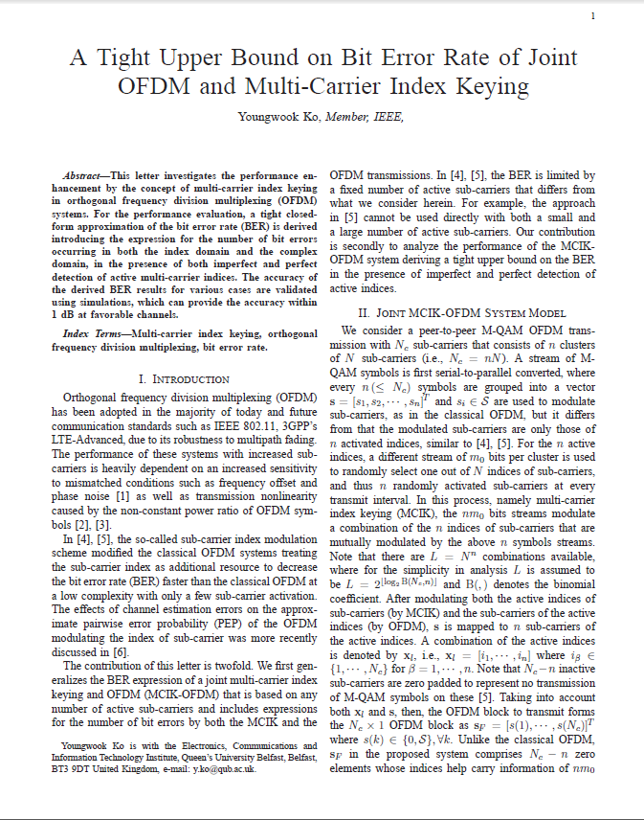

外文资料译文

基于多载波索引键控的正交多路复用系统的误码率上界

二．基于多载波索引键控的正交频分多路复用系统模型

我们考虑一个端到端的M-QAM，Nc子载波的基于多载波索引键控的正交频分多路复用系统有n个簇，每个簇有N个子载波（Nc=nN）。M-QAM的符号流经过串并转换之后每n个符号组成一个相量，是和传统正交频分多路复用一样是用来调制子载波的，但是不同的是只有这n个活跃子载波进行了调制。……

……

1.
2.
3.