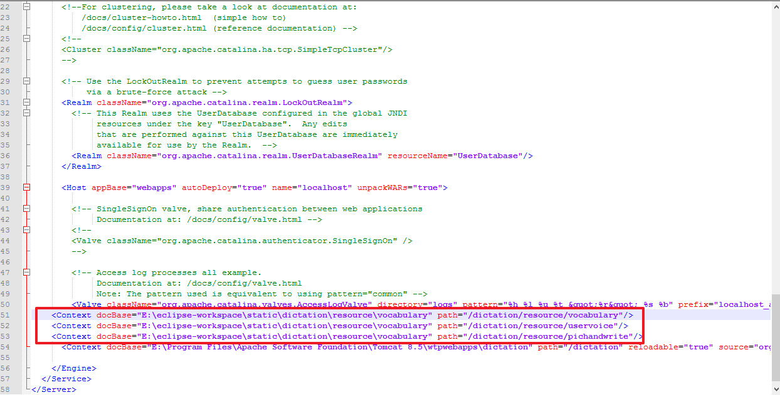

<Context docBase="E:\eclipse-workspace\static\dictation\resource\vocabulary" path="/dictation/resource/vocabulary"/>

<Context docBase="E:\eclipse-workspace\static\dictation\resource\vocabulary" path="/dictation/resource/uservoice"/>

<Context docBase="E:\eclipse-workspace\static\dictation\resource\vocabulary" path="/dictation/resource/pichandwrite"/>