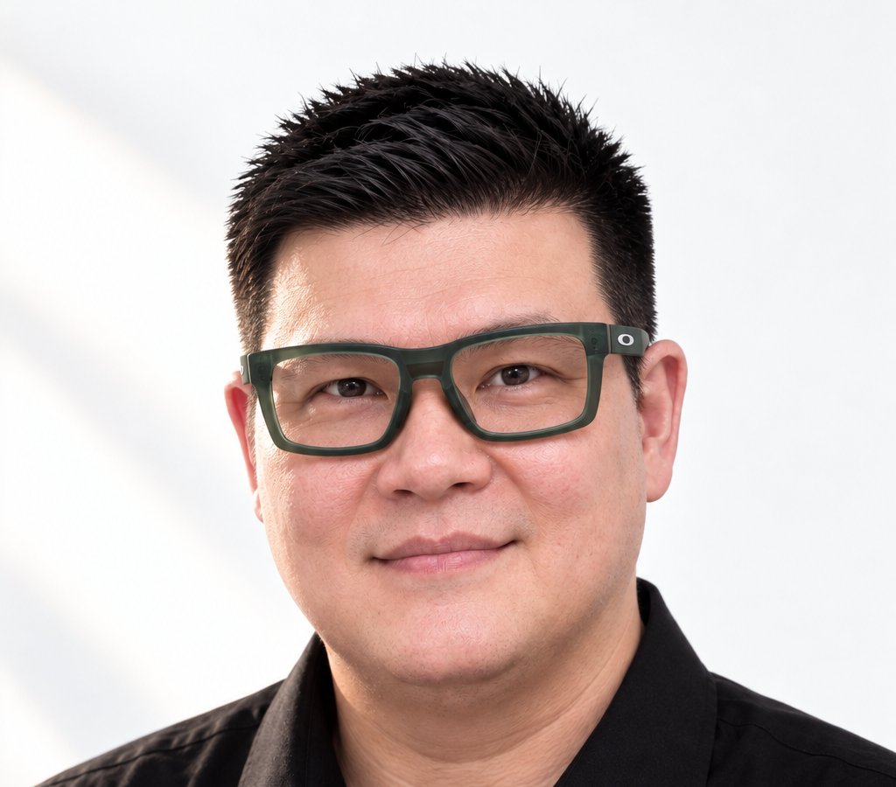 | Charles Yuen  Malaysian / China Green Card holder  Married  Portfolio  Linkedin

PROFESSIONAL SUMMARY
Lead UX Designer with 20+ years of experience across Fintech, Enterprise, CRM, E-commerce, Automotive, and Digital Marketing products. Experienced in UX Strategy, User Research, Interaction Design, Stakeholder Management, and Digital Delivery, with a multidisciplinary background spanning UX, Creative Technology, Motion Graphics, 3D Visualisation, and Product Development. Proven track record of delivering user-centred solutions that align business objectives, user needs, and technical constraints.

CORE EXPERTISE
• UX Strategy
• User Research
• Information Architecture
• Interaction Design
• Design Systems
• Usability Testing
• Stakeholder Management
• Cross-functional Collaboration
• Team Leadership
• Agile Delivery
• Design-to-Development Collaboration
• Technical Feasibility Assessment

SKILLS & EXPERTISE
UX & Product
UX Strategy, User Research, Requirements Gathering, Information Architecture, User Flows, Interaction Design, Wireframing, Prototyping, Usability Testing, Design Systems, Accessibility
Leadership & Delivery
Stakeholder Management, Cross-functional Collaboration, Workshop Facilitation, Agile Delivery, Project Planning, Team Mentoring, Quality Assurance, Design Reviews
Design & Prototyping Tools
Figma, Sketch, ProtoPie, Framer, Axure, OmniGraffle, Overflow
Creative & Visual Design
Adobe Photoshop, Illustrator, After Effects, Premiere Pro, Spline 3D
Technical Knowledge
Front-end Development Principles, HTML/CSS Fundamentals, Responsive Design, Design-to-Development Collaboration, Technical Feasibility Assessment
AI-Assisted Design & Research
ChatGPT, DeepSeek, Perplexity, Midjourney, Stable Diffusion, Sora, Nano Banana, Hailuo, Grok

PROFESSIONAL EXPERIENCE
UX Consultant
Koha Digital | Malaysia | 2025 - Present
Lead UI/UX Consultant / Designer
BreadComb | Singapore | 2022 - Present
Lead UI/UX Designer
Cognixus Technologies | Malaysia | Oct 2022 - Sep 2025
Freelance UI/UX Designer, Mini Program & Ecommerce Consultant
Various Clients | Jul 2019 - Oct 2022
User Experience Lead
Strichpunkt Design | Germany (Remote) | Feb 2018 - Aug 2019

EARLIER EXPERIENCE
Progressed through senior UX, Digital Production, Project Delivery, and Leadership roles across leading international agencies including Ogilvy, JWT, DDB Tribal, MRM, McCann, Profero, TBWA, and Fuel across Singapore, Beijing, and Shanghai.
Led multidisciplinary teams in the planning, design, delivery, and launch of Websites, Mobile Applications, Campaign Platforms, Ecommerce Solutions, CRM Platforms, and Digital Experiences for Automotive, Telecommunications, Enterprise, Retail, and Consumer brands.
Developed a strong foundation in Project Planning, Resource Management, Team Leadership, Stakeholder Management, Creative Technology, Interactive Development, Motion Graphics, Video Production, and 2D/3D Animation, providing a multidisciplinary perspective to User Experience Design and Digital Product Delivery.

EDUCATION
Bachelor of Arts in 3D Animation and Video
University of Art College

Computer Science
ICL Training Centre

ADDITIONAL INFORMATION
Languages
• English (Fluent)
• Mandarin (Conversational)
Residency
• Malaysian Citizen
• China Permanent Resident

