What is UString Class

How does it get initialized by a LPWSTR variable?

What is UStringVector

## Cout CommandString.Size()

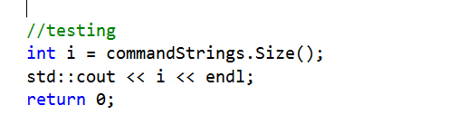

It came with the memory address

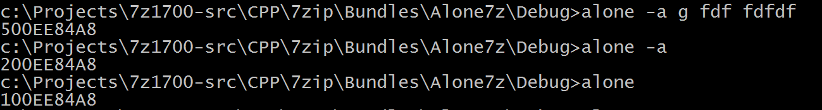

## StringVector lib:

MyVector.h, UStringVector

## Error:

Microsoft.CppCommon.targets(562,5): error MSB6006: "mt.exe" exited with code -1073741819

