Lecture 1: Building blocks: sugars, lipids, amino acids

**Molecular Interactions in Biomolecules:**

* **Van der Waals:** Induced dipole p. 8,9
* Radius of each atom determines distance of minimal energy => two atoms separated by the sum of the vdW radii are **in vdW contact**.
* Weak interactions: magnitude of **thermal energy** (random collisions) much greater: vdW interactions are easily disrupted by those random collisions.
* Addition of vdW interactions can determine overall stabilization
* **Ionic:** between two atoms of opposite charge p. 10-12
* Stabilization energy much greater
* Attractive force makes **optimal distance smaller**
* Electrostatic interaction falls off more slowly with distance increase
* Strongly modulated by shielding from the medium: **water and ions can weaken** electrostatic **interactions strength** and **distance** over which they operate.
* **Hydrogen bonds:** hydrogen with partial positive charge attracted to partial negative charge in covalent bonds (from polarization) p.13,14
* **Distance and angle** dependent (position of donor and acceptor atoms)
* Typical distances: **2.4-2.7 A**
* Depend on environment: **weakened by water molecules**

**Nucleic Acids**

Functional groups: five-carbon sugar, nitrogen-containing aromatic ring system (base), phosphate groups

Nucleotide = Nucleoside (sugar + base} **glycosidic linkage C1 (rotations possible)**) + phosphate} **C5**

Ribose: use of ribose, DNA: use of 2- deoxyribose

* **Pentose:** - adopts a **sugar pucker** conformation.

- Energetically favourable: 4 atoms coplanar and one out of the plane

* **Phosphate:** - mono, di, tri phosphate (alpha, beta, gamma) => placed far away from each other due to electrostatic repulsion.

- negative charge: important for 3D structure of DNA or RNA

* **Base:** - the ring contains lone pairs of electrons in the nitrogen being able to act **as electron pair donors** (Lewis bases)

Pyrimidine: 1 cycle, Cytosine and Thymidine (Uracil in RNA)

Purine: 2 cycles, Adenine and Guanine

* 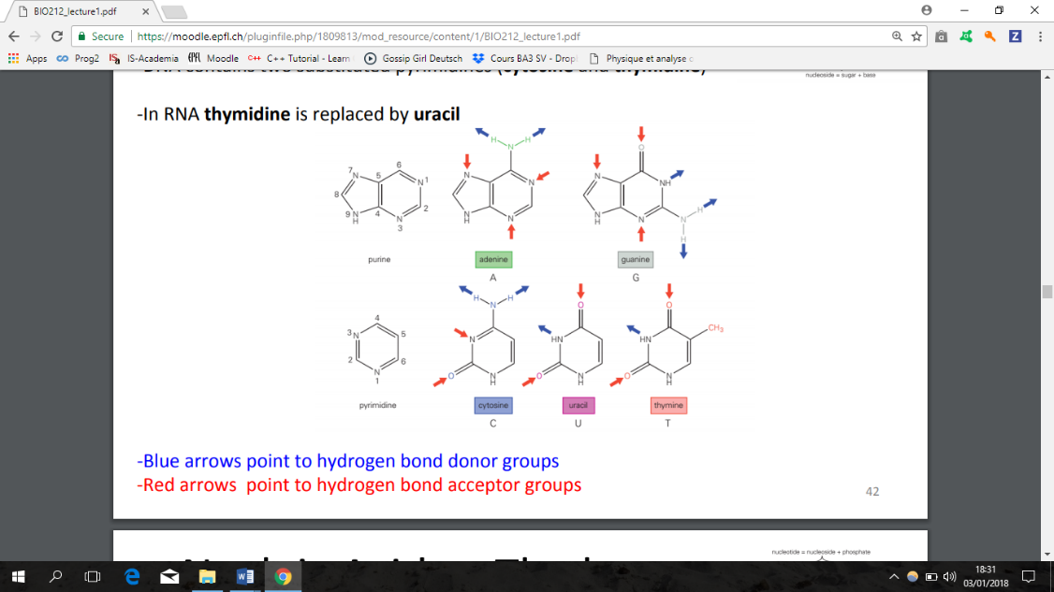**Linkage:** Phosphodiester linkage between **C3** and **C5** of another (3’->5’)

Triphosphate group high in energy and **its hydrolysis** drives the reaction that creates a phosphodiester bond, minus a pyrophosphate

* **3D structure:** 
  + **DNA**: right handed double helix with antiparallel strands, bases on the inside and the phosphate backbone group on the outside

=> **allows interactions with ions and water and minimizing repulsion between phosphates.**

B-form is most common: base pairs perpendicular to axis of helix. Difference with A-form : orientation of phosphate groups

Stabilization by stacking of base pairs: electrostatic and vdW interactions

Radius of carbon 1.7 A and N 1.6 A => **rise per base pair 3.4 A**

Base pairing: A-T (2 bonds), G-C (3 bonds) and A-U (2 bonds)

* **Grooves**: important for DNA recognition by proteins, 4 interactions

Major groove: 15 A, on convex edge, more information

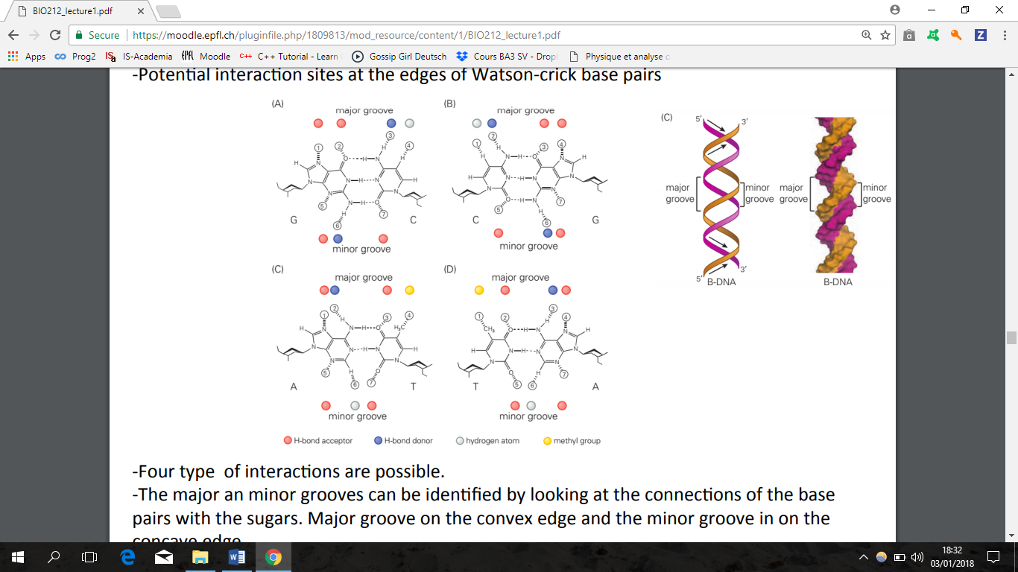Minor groove: 7.3 A, concave edge

**Proteins:**

20 amino acids that can be polar, non-polar, positively or negatively charged (at pH7)

All chiral except glycine, and proline only one with secondary amine (NH2)

Amino group (NH3+), amino acid, carboxyl group (COO-) **(zwitterion at neutral pH):** dipolar molecule containing charged groups but overall neutral

**From N terminal to C terminal**

* **Bond:** peptide bond by condensation reaction where amino group combines with carboxyl group with **elimination of water**, catalysed by **ribosomes** (RNA+proteins)
* **Hydrophobicity:** scale experimentally derived from free energies of transfer from water (polar) to octanol (non-polar): put in AA and see where they go

Hydrophilic groups: polar and can form H bonds with water

Proteins have **hydrophobic cores and hydrophilic surfaces**

Hydrophobic effect = principal driving force underlying **protein folding**

* **Cysteine:** can form **disulfide bonds** by **oxidation** and release of **H2 =>** bonds rarely found inside cell

Disulfide bonds are **covalent** (reversible) and help with protein **stabilization**

* **Secondary structure:** backbone is highly polar (NH and C=O) => alpha helices or beta sheets form to fold protein backbones to interior

**Glycans**:

Carbohydrate (HCOH)n, n=3-9. N=6: glucose, galactose, mannose

**Aldoses** (HC=O end of chain) or **Ketose** (C=O within chain)

Equilibrium mixture of open, linear chain and closed, cyclic form (>99%), most stable conformations: boat and chair (mostly axial or mostly equatorial)

Two projections: Haworth (better for 3D orientation of molecules) and Fischer (stereochemistry)

* **Anomers**: sugar forms differing only in **equatorial (beta)** or **axial (alpha**) position of **hydroxyl group on C5**
* 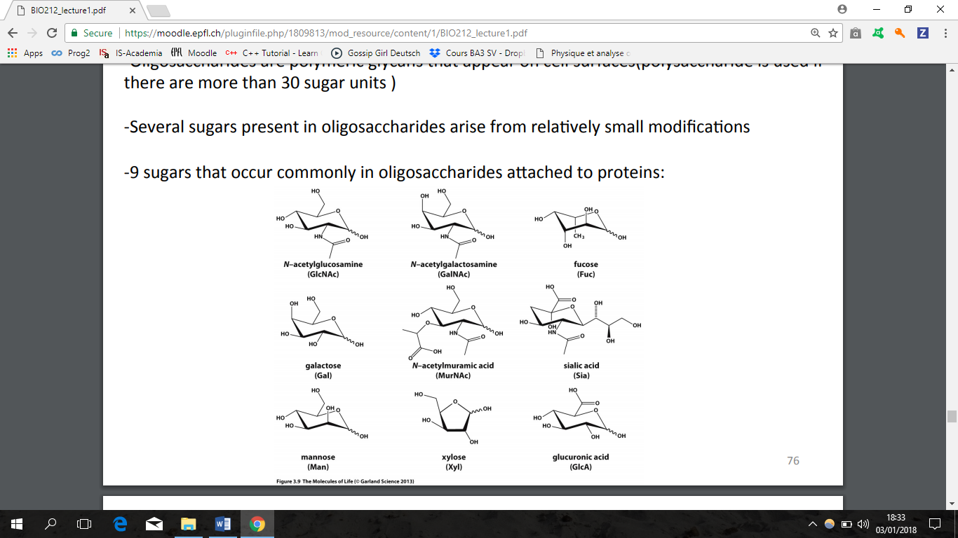**Oligosaccharides**: polymeric glycans that appear on **cell surfaces** (polysaccharides used if >30 sugar units):

image 9 sugars that occur commonly in oligosaccharides attached to proteins

* **Disaccharide linkage:**  elimination of water for glycosidic linkage

Amylose: glucose alpha 1-4 glucose

Glycogen: glucose alpha 1-4 and alpha 1-6

Cellulose: poly (glucose beta 1-4 glucose)

* **Link**: to proteins or lipids.
* **In proteins**: O-linked or N-linked glycosylation (covalent) **=> synthesis of glycans dependent on enzymes, substrates and spatial localization**

Glycan modifications alter properties of proteins: **increase stability and protect against degradation**

Protein-glycan interactions important for **cellular recognition**

**Glycosylation patterns**: determination of blood type

**Lipids**: soluble in nonpolar organic solvents but insoluble in water individually

Strong hydrophobic part (hydrocarbon chain) and hydrophilic (charged or very polar) 🡺 they are **amphiphiles**

Can arrange as lipid bilayers (basis of cellular membranes, partition cells into defined regions) or micelles

Acyl chains can be saturated or not

* **Glycerophospholipids**: most abundant, glycerol unit + phosphate linked to an R group (**head group**: can be derived from AA, sugars of other small groups)
* **Examples**:

**Cholesterol**: important component of eukaryotic cells

**Triglycerides**:important in fat metabolism

**Cardiolipin**: 20% of inner mitochondrial membranes

* 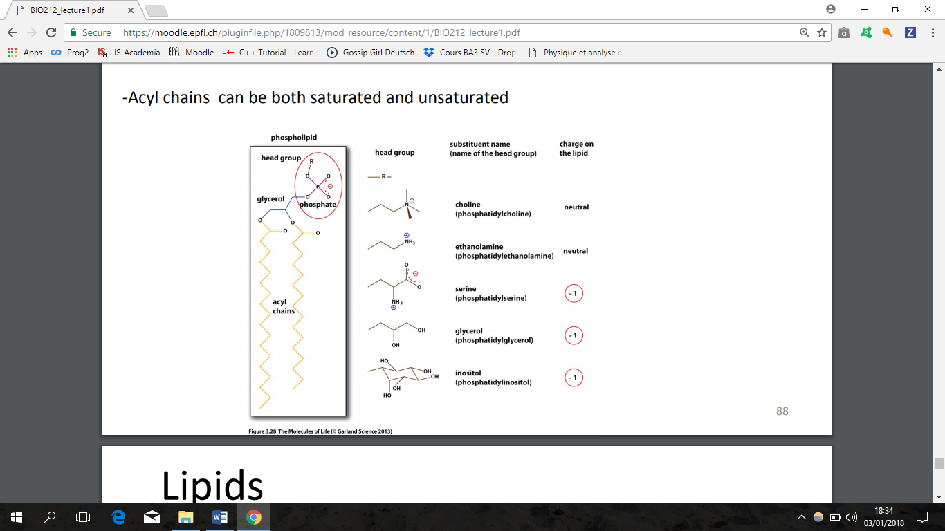**Hydrophobic effect**: causes hydrophobic parts of lipid to cluster together

Lecture 2: Protein structural organization, folding

Lecture 3: Analysis of proteins

Lecture 4: Protein expression and purification

Lecture 5: Advanced protein purification, X-ray crystallography

Lecture 6: Protein structure determination by NMR and cryo-EM

Lecture 8: Energy and intramolecular forces in proteins

Lecture 9: Free energy, thermodynamics, kinetics

Lecture 10: Methods to measure protein-protein and protein-ligand interactions

Lecture 11: Enzymatic catalysis and reaction mechanisms

Lecture 12: Enzyme kinetics

Lecture 13: Principles in metabolism (common reaction mechanisms, ATP, co-factors)

Lecture 14: Selected metabolic pathways (glycolysis, TCA cycle, gluconeogenesis)