# Create Access 2007 Database

The first step in creating an Access 2007 database is to create a blank database file. This is done from the Getting Started Screen when you launch Access. The file is saved onto one of your PCs folders (which you specify). The procedure for doing this is outlined below.

**1. Launch Access**

To begin, launch Access by clicking on the desktop icon, or choose Access from the start menu. ***(Start – all programs – Microsoft Office – Microsoft Access 2007)*** This brings up the GETTING STARTED WITH MICROSOFT OFFICE ACCESS screen.

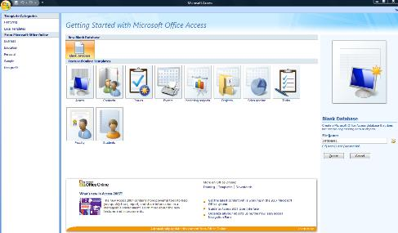

**2. Select Blank Database Template**

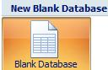

Towards the top left of the screen you will see a "Blank Database" icon. Click this icon to bring up the Blank Database side bar on the right hand side of the screen. This is where you will enter details about the database file that you are about to create.

**3. Enter filename for your Access 2007 database**

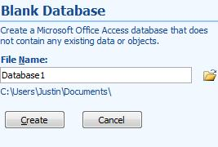

Begin by entering the name that you want to call the database in the filename textbox.

**4. Browse and select folder**

Next click the folder icon and browse for a folder to put your database. Once selected you should see the file path below the textbox.

**5. Click Create**

All you need to do now is click the "Create" command button below, and your database file saves to the location that you specified, and opens for you to work on.

You are now ready to work on your newly created database file. The next step is to [**create an Access table**](http://www.dealing-with-data.net/create-access-table.html)

# Access 2007 Tables

### How Access stores data in Tables

Like all other databases, Access 2007 stores data in tables. They look a lot like the cells of a spreadsheet with columns and rows. Each horizontal column represents a table record, and each vertical column represents a table field. See Table example below:

**A simple Table**

|  |  |  |  |
| --- | --- | --- | --- |
| **ID Number** | **FirstName** | **Surname** | **Age** |
| 1 | John | Jones | 35 |
| 2 | Tracey | Smith | 25 |
| 3 | Anne | McNeil | 30 |

In the example Table above, there are four fields containing information about an individuals: ID number, first name, surname and age. Below the field headings there are 3 records containing information or data for each individual. As such, a database table is a list with each column containing the same specific sort of information. Each row of information is an individual record that might relate to a particular person, a business, or a product etc.

When planning a database table, most database designers will decide which column headings or fields they are going to use. This is the basis of the table structure. The actual data is added later and is not a part of the design process.

### Create Access Table

#### 1. Open database file

If you have created a blank Access, you are now ready to create a new table. Begin by opening your existing database file if it is not already open. Do this loading Microsoft Access the getting started screen again. You should see the file name that you just created towards the top of the right hand side bar (If you cant see it, click the folder icon to browse for the file). Click on the file name to bring up your blank database.

If, at this stage, you get a security warning underneath the ribbon, click where it says options, select the "enable this content" radio button (in the pop-up window), and then click ok.

Your blank database file should now be fully open.

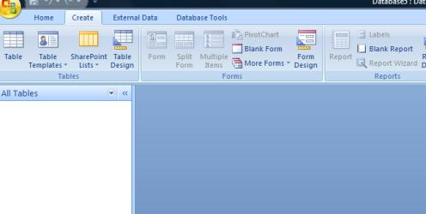

#### 2. Create Access Table

Select the CREATE tab on the Access ribbon. Next select the TABLE DESIGN icon from the TABLES group. This creates a new table.

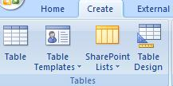

#### 3. Create fields in DESIGN VIEW

This brings up the TABLE DESIGN GRID where you enter each field name and its data type. The first field we are going to create is the ID field which is going to contain a unique reference number for each record. Enter the name "ID" into the first column of the first row in the grid. Because we want Access to automatically generate a unique reference number, select AUTONUMBER from the drop down list in the data type column. You can also enter a description for each field, but this is not essential.

On the next row the field is going to be called FIRSTNAME and the data type is going to be TEXT. On the third row the field name is SURNAME with the data type again being TEXT. And finally, the last field name is AGE and the data type here is going to be NUMBER.

Before you save the table you will need to choose the Primary Key, which in this case is ID. To do this, select the ID row by clicking on it, and then simply click the primary key symbol on the Ribbon.

Primary Key Symbol

The table design grid should now look like this:

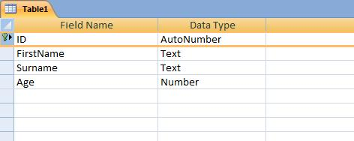

You can now save the table by clicking the save icon on the top left of the screen above the Access Ribbon. To view your table select DATASHEET VIEW from the VIEWS group under the DESIGN TAB. This brings up the datasheet view of the table that you have just created. You should see your field headings running across the top of the table.

Datasheet View Symbol

#### 4. Data entry in DATASHEET VIEW

Although entering data onto the datasheet table is not a part of the design process, the table now exists as a database object, and you can test it by entering some information into the cells.

Select the first cell in the FIRSTNAME column and enter the name JOHN. For SURNAME enter JONES, and for AGE enter 35.

NB just ignore the column underneath the heading ADD NEW FIELD. We created all the fields we needed in design view.

You have now entered the first record in the table - record 1 for John Jones aged 35. You can now press the return key and the record will save automatically. You are now ready to enter the second record on the next row - TRACEY SMITH 25. Press return and then fill in the data for the last record we are going to do for now - ANNE McNEIL 30

Your datasheet table should now look like this:

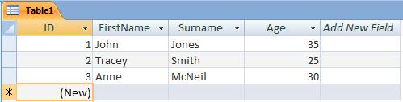

## Working with Access Tables

Once you have an Access Table populated with data, you have the option to work with it right away. Indeed, some people may not go on to create forms, queries, and reports once they have created their first table. With a single table you can, for example, store, edit, filter, search, and calculate a set of database records. Now that you have created your first table and stored a number of records. You can populate your table up as shown below.

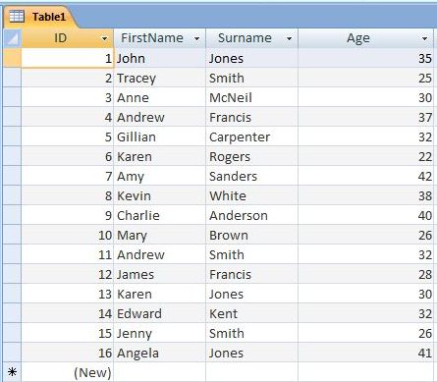

**Edit Data**

Editing data in an Access table is a relatively simple task. Just click the cell containing the data you wish to change. Delete or type over the old information and enter new data as required. As you do so you will notice a pencil symbol appear on the far left of the table on the row you are editing. This indicates that you are in the process of editing a record and the changes have yet to be saved to the database table. This symbol will remain while you update any other field in the same row. Once you move out of the row, the changes will be saved automatically and the pencil will disappear. The thing to remember is that when you edit data in a field, the whole record will be saved once you have finished.

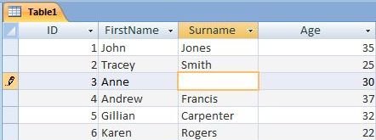

A table record in the process of being edited. Notice the pencil symbol on the left of the table. The cell being edited is highlighted in orange. Once the new data has been entered and the row is moved out of, this record will be saved.

**Sort**

The Sort feature of Access 2007 allows you to reorder a list of data in your table. This can be done alphabetically or numerically, in ascending or descending order. It is a useful feature when you want to sort your records into, say, surname order, or maybe in age order, for example.

To sort your records into surname order, click any cell in the surname column of your table. This tells Access that your records are going to be sorted by this particular field. Next, look for the **AZ Icon** in the **Sort & Filter** group of the **Home Ribbon**. To sort in ascending order, click the AZ Icon, or to sort in descending order, click the ZA Icon below. To remove the sort and get your original list back in its original order, click the **Clear All Sorts** Icon, which is the lowest Icon of the three.

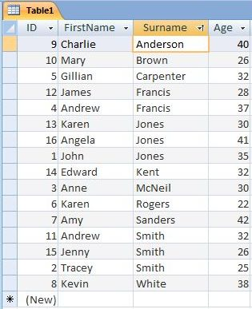

Sorted into alphabetical order by the surname field.

**Calculating Data**

The **Totals** feature of Access 2007 allows calculations to be performed directly on a database table. At its simplest, the totals feature can be used to count the number of records, or add a column of numbers in a table. It can also be used to calculate **Average**, **Maximum/Minimum** values, **Standard Deviation** and **Variance**.

To use this feature, open your table and click the **Totals** icon which is located in the Records group of the Home Ribbon. This produces an extra row at the bottom of the table with the word Total in the left hand column.

To perform a calculation on your table, select which column you want to process, and click the cell for that column on the new Total row. When the arrow tag appears, click it to produce a drop down list of functions. We are going to find out the average age in our table, so we shall select the Average function from this list. The result of our calculation is then displayed in that cell (ie the Age column of the Total row). If we add an additional record to our table, the totals row will recalculate the result automatically to take account of the new data. You then have the option to save the table with the new totals row and any calculation it is set to perform.

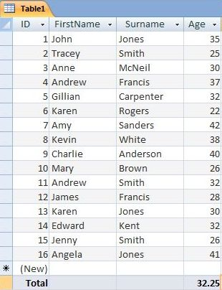

**Access Totals** - calculation of average age in list.

# Access 2007 Forms

### Access FORMS are user friendly

In the previous lesson, you created an Access Table and entered three records. However, to get the most out of Accest it makes sense to create a data entry FORM. By doing so you are making your database more user friendly. It is easier and quicker to enter data onto a form than it is into a table, not least because you have more control over the layout and labelling of your form. In this lesson we will learn how to create a FORM that uses your newly created table as the DATA SOURCE.

### Create Access form

There are a number of ways to create an Access form. In this lesson we are going to use the ACCESS FORM WIZARD.

#### 1. Select form wizard

Open your database if it is not already open. Click the CREATE tab on the ACCESS RIBBON and then select MORE FORMS from the forms group.

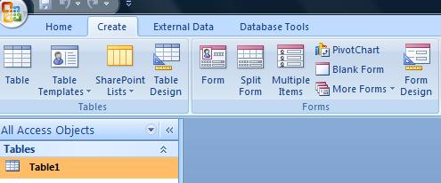

A drop down list of form types appears. You need to select FORM WIZARD from this list.

#### 2. Select table and fields

The Form wizard then opens as the pop up window below.

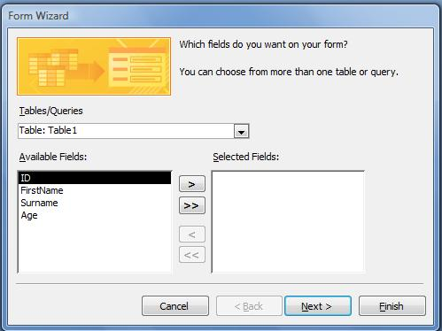

On the first page of the form wizard we select which table we are going to use as the DATA SOURCE. Since there is only one table in this database so far, it should already be selected for us in the TABLES/QUERIES combo box.

Underneath there is a list of the four fields in your table. You could select each field individually by highlighting the field name and clicking the single arrow >. We can, however, select all four just by clicking the double arrow >>. Once they have been transfered into the right hand box they are selected. We can now click NEXT to go to page 2 of the form wizard.

#### 3. Form Layout

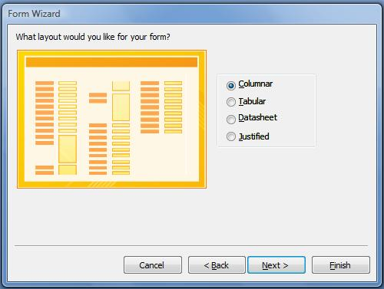

This is where we choose the FORM LAYOUT. We are going to leave this on the default setting of COLUMNAR. Click NEXT again to move onto page three of the form wizard.

#### 4. Form Style

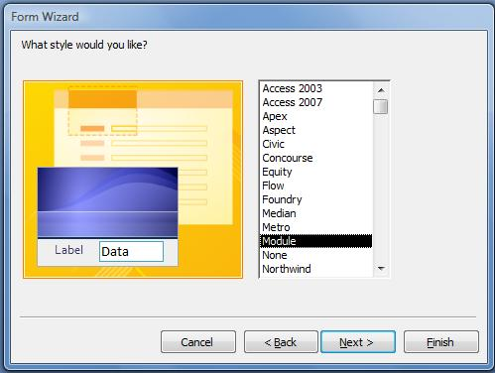

Here we select a style that from the list box. Preview a style by clicking on its name. This step just determines how the form looks aesthetically. Once you have selected a style to your taste, click NEXT again.

#### 5. Form Title

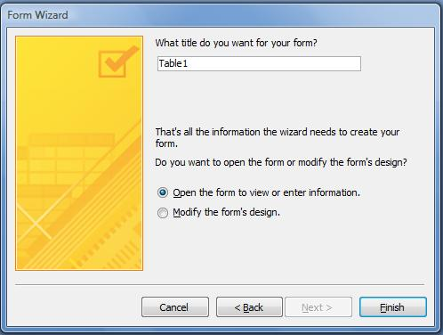

This is the last stage of the wizard. Here we are going to choose the name for our form - lets say FORM1. We are going to leave the radio button selected for OPEN THE FORM TO ENTER OR VIEW INFORMATION

All we need to do now is click FINISH and our form should like something like this:

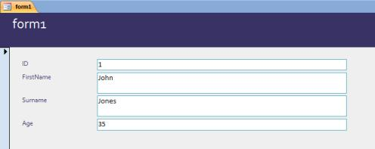

#### 6. Navigate Records via Access Form

As you can see, the form opens with the first record in your original table displayed. You can navigate through each record using the NAVIGATION BUTTON at the bottom left of the form window.

Navigation Buttons

To move to the next record click the right arrow button on the navigation control. To move to the last record click the >| button on the navigation control. To move backwards through the recordset use the left arrow buttons. You could edit any record from the form, which will update the data in your table. For now, though, just try navigating through the three records without changing any data.

#### 7. Create New Record via Access Form

Now that you know how to move through the recordset, lets finish off by adding two more records. To do this click the star button on the right of the navigation control. This should bring up a blank record. Add JOE for firstname, BROWN for surname, and 39 for age. Click the star again to bring up a new blank record, and enter SUE MOORE 33. When you have finished click x on the form window to close.

This tutorial lesson has shown you how to create an Access Form using the form wizard, and how to navigate and add records using Access Forms. There are also other ways to [Create an Access Form from Scratch](http://ms-access-tips.blogspot.com/2009/11/creating-access-2007-form-from-scratch.html) or [Customize an Access Form](http://ms-access-tips.blogspot.com/2009/11/access-form-design-tips.html), but this is as far as we are going to go in this particular lesson. The next lesson in the tutorial is going to be [Access 2007 queries](http://www.dealing-with-data.net/create-access-query.html).

# [Create Access 2007 Queries](http://www.dealing-with-data.net/create-access-query.html)

### Access Queries Process Data

If you have been following the previous lessons in this tutorial, you will have created a table with five records. In this lesson we are going to create an Access 2007 QUERY, which will process the data below which you have entered into your table.

|  |  |  |  |
| --- | --- | --- | --- |
| **ID Number** | **FirstName** | **Surname** | **Age** |
| 1 | John | Jones | 35 |
| 2 | Tracey | Smith | 25 |
| 3 | Anne | McNeil | 30 |
| 4 | Joe | Brown | 39 |
| 5 | Sue | Moore | 33 |

What we want Access to do is extract all the records in the above table where the persons age is greater than or equal to 35. Access Queries can do far more than this, of course, but this simple task should serve as a useful learning exercise.

### Open the Query Design Grid

The first stage is to select the CREATE TAB and then go to the OTHER group on the far right of the ribbon. Then click on the QUERY DESIGN ICON to bring up the query design grid.

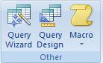

#### Select Table for Query

The next stage is to select which table you are going to use in this query. When the query design grid opened, the SHOW TABLE pop up window should also have opened. If necessary you can open this window manually by clicking the SHOW TABLE icon in the QUERY SET UP group on the Access Ribbon.

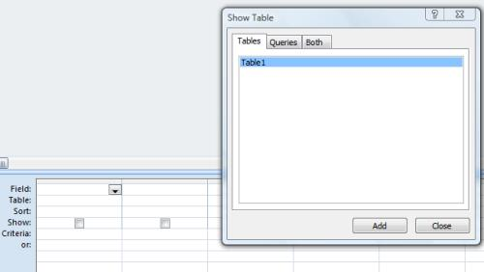

So far there is only one table in your database - TABLE1. This should be highlighted when the window opens, but if not, just click on it once. Next click ADD. When you close the pop-up window by clicking x,you should see a box labelled TABLE1 above the query design grid.

#### Select fields from Table

In the table1 box, you will see a list of its field names. We are going to use all the fields in this query, so select each one individually by double clicking on their names. You will now see the field names at the top of each column in the Query Design Grid.

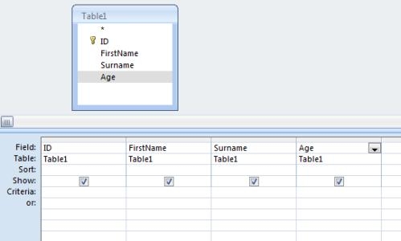

#### Enter query criteria

As you may remember, the purpose of our query is to extract records where the persons name is greater than or equal to 35. To do this we enter the criteria into the appropriate cell of the query design grid. In this case you need to go to the AGE column of the CRITERIA row, and enter the formula >=35.

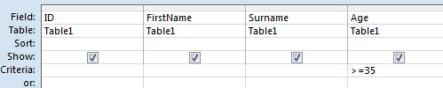

#### Save and Run Query

Click the save icon above the Access Ribbon. When prompted for the query name, just use the default QUERY1. To run your query, click the RUN icon in the RESULTS GROUP of the Access Ribbon. You should now be presented with a datasheet displaying your query results - JOHN JONES 35 and JOE BROWN 39.

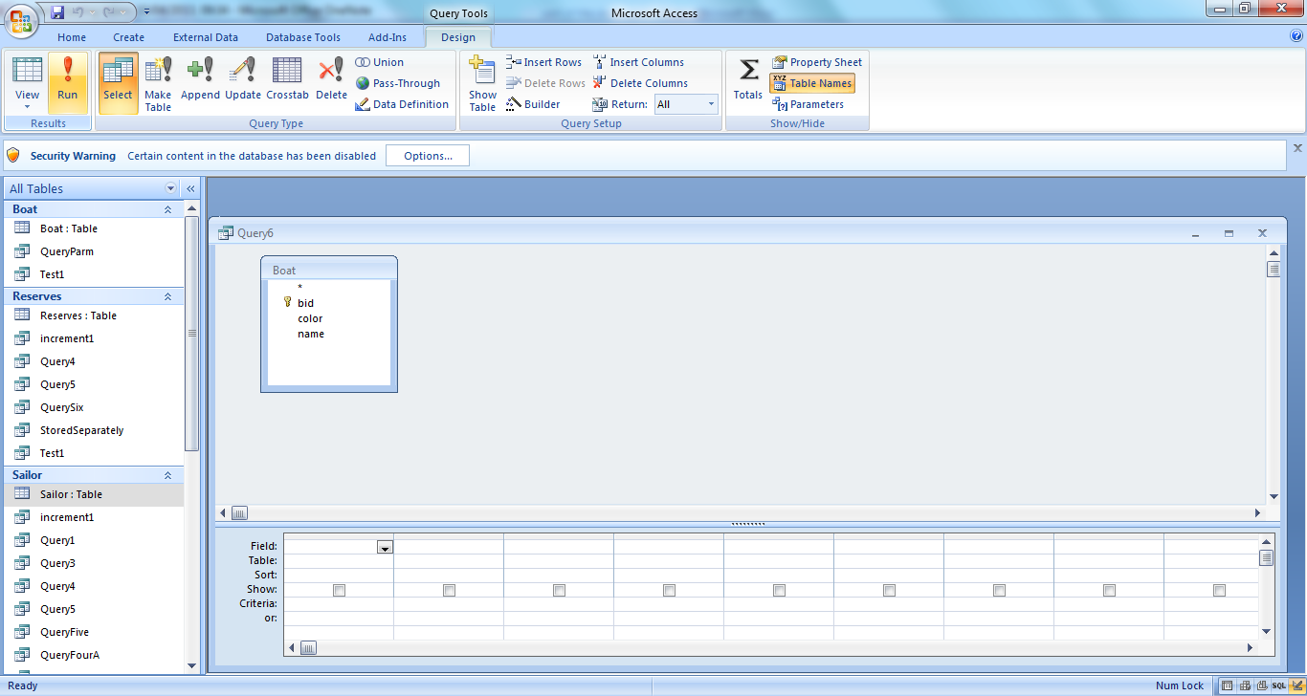

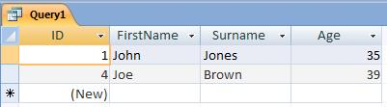

You have now created and run your first query. The next lesson in the tutorial is about [Access 2007 Reports](http://www.dealing-with-data.net/create-access-report.html).

# [Create Access 2007 Reports](http://www.dealing-with-data.net/create-access-report.html)

### Access Reports Present Data

Access REPORTS are a way of displaying and printing information from your database. Developers often use Reports to display the results of a Query, which is what we are going to do next.

Like other Access database objects, there a number of ways to create an Access REPORT. We are going use the REPORT WIZARD. Our task is to display the results of QUERY1 which we created in the previous tutorial lesson.

#### 1. Open Report Wizard

Begin by selecting the CREATE TAB on the Access Ribbon. Then click REPORT WIZARD from the REPORTS group to open the pop up window.

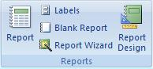

#### 2. Select Report Data Source and Fields

The first page of the Report Wizard is almost identical to that of the Form Wizard. On this page we will select QUERY1 as the DATA SOURCE for the Report. This is done by selecting the query from the list in the TABLES/QUERIES combo box. Then select all fields from QUERY1 by clicking the double arrow to the right of the text box labelled AVAILABLE FIELDS. The field names will now appear in the SELECTED FIELDS text box on the right. Click next to go to the second page of the wizard.

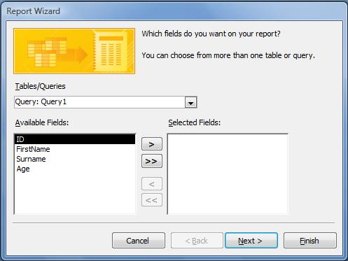

#### 3. Report Grouping Levels

Page two of the wizard is where you can add grouping levels if required. So we could, for example, group each person in our report with others of the same age. We don’t need to do this for this particular example, but it is certainly a useful feature that we might want to learn more about later. But for now, just click next.

#### 4. Record Sort Order

Page three of the wizard is where you determine what order the records are displayed in your report. So for example you might want to display records in ascending order of age. For this example, however, we are going to put your records into alphabetical order for SURNAME and FIRSTNAME. Begin by clicking the top drop down box and selecting SURNAME, and in the box 2 below select FIRSTNAME. This means that records are sorted alphabetically by surname, and if two surnames are the same, the FIRSTNAME is used to determine which record comes first etc. Click Next

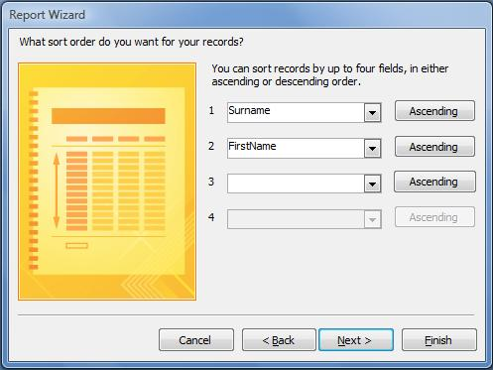

#### 5. Report Lay Out

This page of the Wizard is where you set the lay out for your report. There are various lay out options, but in our case we shall keep to the default setting of TABULAR.

Click next.

#### 6. Style

For style, select Access 2007 from the list and click next.

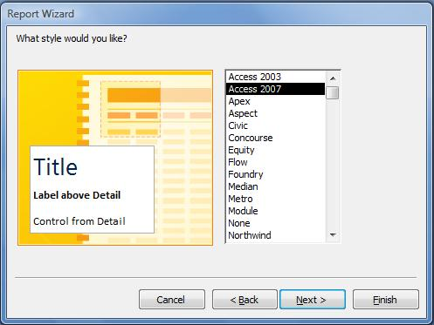

#### 7. Name of Report

Name your report REPORT1 and then click FINISH. Your access report will now be displayed on the screen, and should look something like this:

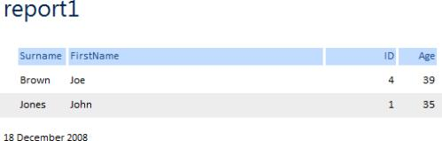

This is the end of the tutorial. I hope this has given you a basic foundation in Access Development Skills.

**Advanced Reading:**

### **[The One to Many Relationship](http://ms-access-tips.blogspot.com/2011/03/one-to-many-relationship.html)**

In this post we are going to take a look at the One to Many Relationship in Access 2007. We will go through the process of setting up a One to Many Relationship, but first, lets consider why they are necessary.

You may well be familiar with the term 'Relational Database' already, but perhaps don't understand what it means. If that is the case, then, hopefully, this should put you on the right track to penetrating the meaning of the term. Relational Database design is all about how database tables are connected with each other. Whilst the novice database designer will create one single table with lots of fields, the relational database designer will look at the the data that needs to be stored and will put it together in a number of groups. Each group is then made into a separate table. But because the subjects of the data stored in separate tables are connected in the real world - for example **customers** and **orders -** we need to create a relationship between the tables within the database itself.

Lets take a look at how we go about doing this in practice. We will use a simplified example of a customer/order database.

Imagine we have a number of customers who order electronic products by email, and we want to create a database to record both the customer's details and their orders. As we mentioned in the example above, we would go about this by separating the customer details and orders into two separate groups which we then make into tables. We do this for the simple reason that if a given customer makes more than one order, we only have to enter the customer details once in the customer table. Because we are going to create a relationship between the customer table and the orders table, all orders for individual customers will be connected with the correct persons' customer details. This is made possible by connecting the **primary key** field of the customer table with the corresponding **foreign key** field in the orders table. If you remember, [Primary and Foreign Keys](http://ms-access-tips.blogspot.com/2010/10/exploring-primary-keys.html) were covered in my last blog post.

1. The first step is to [create a new Access Database](http://www.dealing-with-data.net/create-access-database.html). Lets call it Customer Orders.
2. Next [create a new table](http://www.dealing-with-data.net/create-access-table.html) called **tblCustomers** with the following fields - ID (autonumber, primary field), FIRSTNAME (text), SURNAME (text), ADDRESS1 (text), CITY (text), and POSTCODE (text).
3. Create a new table called tblOrders with the following fields - ORDERID (autonumber, primary field), ITEMORDERED (text), DATE (date), PRICE (number, set the format property to currency), CUSTOMERID (number). CustomerId is going to be the foreign field when we create the relationship.
4. To create the relationship, select the DATABASE TOOLS RIBON and click the RELATIONSHIPS icon (from the SHOW/HIDE group).  
     
   [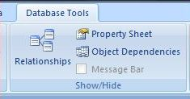](https://lh5.googleusercontent.com/-en4K2iI74cU/TYo6hgQIZtI/AAAAAAAAAWg/oULXvD1Uaqs/s1600/relationships.JPG)
5. This opens the RELATIONSHIPS window. You will also see the pop up SHOW TABLE form the first time you open the window. We are now going to select which tables are going to be used in the relationship.[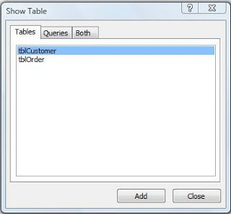](https://lh4.googleusercontent.com/-DYKMdGqLgmk/TYo9uXpc3jI/AAAAAAAAAWk/RHFT9OeQWnE/s1600/show-table.JPG)
6. There are just two tables in our example database. Click on **tblCustomer** to highlight it in blue if it is not highlighted already. Then click add. Do the same for **tblOrder**, then close the pop up SHOW TABLE form.You should now see the two tables represented as separate box's in the RELATIONSHIPS window. You will notice in the diagram below that each box has it's fields listed and primary keys indicated.   
     
   [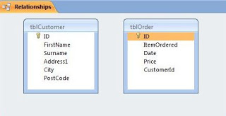](https://lh3.googleusercontent.com/-_zm-UY-xsGE/TYpALVyjpEI/AAAAAAAAAWo/iNBYpKOIoHo/s1600/relationships-window.JPG)
7. We will now click the ID field in **tblCustomer** and drag it to the CUSTOMERID field in **tblOrder**. Notice the mouse pointer image changes from a circle with a line across to a plus sign as it hovers over the fields in tblOrder. When you release the mouse button at the end of the click and drag operation, a new EDIT RELATIONSHIPS pop up form opens.  
     
   [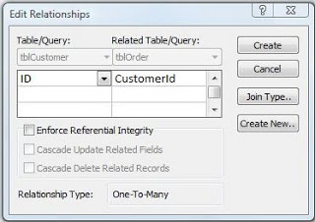](https://lh4.googleusercontent.com/-YXiOju58y-A/TYpD2chYhvI/AAAAAAAAAWs/ve-PUSfubaI/s1600/edit-relationships.JPG)
8. Click the three tick boxes which say ENFORCE REFERENTIAL INTEGRITY, CASCADE UPDATE RELATED FIELDS, and CASCADE DELETE RELATED RECORDS. We won't be going into what these do in this blog post.
9. Click the CREATE BUTTON. Our table relationship is now in place. This is what the database window looks like now. Note the line drawn by Access between the ID field of **tblCustomer** and the CUSTOMERID field of **tblOrder**.

[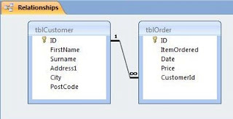](https://lh6.googleusercontent.com/-_uQFni7nyCA/TYpGONnP1jI/AAAAAAAAAWw/MDmj1N6iXXc/s1600/table-relationship.JPG)

All we need to do now is enter some data and test out the relationship. Try entering this data from the image below into **tblCustomer**:

[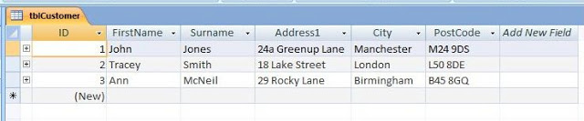](https://lh3.googleusercontent.com/-KPxWkbyjIS8/TYpO0DhU6vI/AAAAAAAAAW0/Pt9JuoXuFvU/s1600/customer-data.JPG)

Then enter this data from the image below into **tblOrder**:

[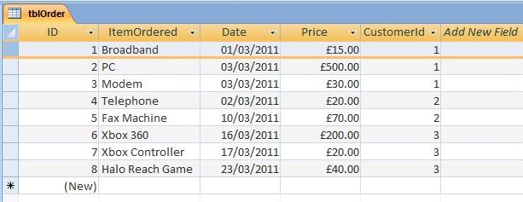](https://lh3.googleusercontent.com/-sMhT9UFd9o4/TYpPHwpJ3oI/AAAAAAAAAW4/52b1NZIaCkc/s1600/order-data.JPG)

Notice that each order in **tblOrder** has a CustomerId corresponding to one of the customer ID's in **tblCustomer**. This is how we link each order to a particular customer. To prove that this works, open up the **tblCustomer** table and click the + sign's (left of table) on each customers row. This shows that Access has automatically linked each order from **tblOrder** to it's corresponding customer in **tblCustomer**.